The Direct Sample Level Compensation for Symbol Synchronization of Zigbee Modem

USANG LEE, HAKSUN KIM, TAJUN PARK
Radio Frequency Laboratory
Samsung Electro-Mechanics
Maetan 3Dong, Youngtongu, Suwon, Kyunggi
KOREA

Abstract: the main issue of symbol synchronization in Zigbee modem is how to find low cost and low complexity synchronization method for Zigbee application. The traditional method is too complex for low cost Zigbee modem. So this paper introduces extremely low complexity symbol synchronization method named direct sample level compensation (DSLC). DSLC does not use band-pass filter, correlator, VCO as traditional symbol synchronization method. DSLC doesn’t perform phase tracking. DSLC just estimates frequency offset during preamble period and compensates frequency offset on incoming signal samples. The frequency estimation performs through differential complex conjugated multiplication between incoming sample and delayed sample. This differential style receiver is common for non-coherent detection of Zigbee signal. Thus frequency-offset estimation doesn’t need any additive component except receiver itself. Compensation is performed by one sample adding or discarding. This direct sample level compensation can be realized with 1~2 register for a control of samples and simple look-up table for determine control point. If we accept slight performance degradation compare to perfect symbol synchronization, this method would be best choice for Zigbee modem.

Key-Words: - Zigbee, IEEE 802.15.4, symbol synchronization, timing recovery, timing synchronization

1 Introduction
In the next few years, it is expected that low rate wireless personal network (LR-WLAN) like Zigbee will be used in a wide variety embedded application and sensor network, including home automation. Zigbee has influence on consumer electronic fields, especially home automation equipment. So this paper introduces the cheapest method in Symbol synchronization architecture of Zigbee modem.
Zigbee specified 32-chip spreading codes mapped by 4bit data symbol [1]. Zigbee modem initially starts searching the packet preambles using PN sequence estimator. This function is similar to CDMA searcher. This searching process of preamble code is generally performed through sample-by-sample operation. If Zigbee modem correctly detected packet preamble, this sample-by-sample operation means that the phase of sampling clock is synchronized with incoming signal at least. Thus we can think that the acquisition process of symbol synchronization is completed, not tracking.
Zigbee allows maximum 40ppm frequency-offset of crystal but real frequency-offset is 80ppm (transmitter 40ppm+receiver 40ppm). Many modem designers neglect this frequency-offset effect on symbol synchronization because they think the maximum packet length of Zigbee is too short (127 bytes). But large frequency offset leads to large phase offset on the end of Zigbee packet. It causes serious performance degradation to Zigbee receiver. Thus continuous phase tracking is needed during packet reception. This continuous phase tracking generally can be acquired by traditional symbol synchronization method.
Symbol synchronization can be classified in two basic groups [2] [3]. The first group consists of the open loop synchronizer and the second group comprises the closed loop synchronizer. Open-loop symbol synchronizers generate a frequency component at the symbol rate by calculating incoming base-band signal with a combination of filter and nonlinear device. The primary disadvantage of open-loop symbol synchronization methods is that there is an unavoidable large tracking error in low signal to noise ratios, as wireless environment. Otherwise the Closed-loop symbol synchronizers measure the incoming base-band signal and a locally generated clock to bring the locally generated signal into synchronism with the incoming data transitions [4]. Among the most popular of the closed-loop symbol synchronizers is the early/late gate. Tau-dither loop also is included in closed loop symbol synchronization [5]. Bluetooth receiver faced similar problem because Bluetooth specification uses same 2.4GHz and 1M data rate [6]. We can find other theorems of synchronization in [7], [8].
These closed-loop symbol synchronizers need more precise control to their loop filter and detection. The these methods are too complex for low cost Zigbee modem because it needs also filter, vco and arithmetic function block like square operation. Thus this paper introduces new novel frequency offset compensation method named direct sample level compensation (DSLC) simulating traditional symbol timing recovery. It would be well matched differential style receiver of Zigbee because it uses results received during preamble interval. The result value during preamble means estimated frequency offset between transmitter’s crystal and receiver’s crystal frequency. Since Zigbee system use same crystal for carrier generation and symbol timing clock, the above assumption is true.

2 Frequency Offset Estimation

  - Differential Style Receiver
General differential style receiver implied using a differential decoder to receive the data encoded in transmitter. But the differential operation in this paper means the multiplication of incoming signal and time delayed signal. The time delayed signal is conjugated and multiplied having the form of base-band complex envelope. The receiver performs differential complex multiplication to remove carrier phase offset for non coherent reception. Since Zigbee channel is analyzed to flat fading channel having constant signal delay, the differential operation can remove carrier phase offset.
If transmitted base-band signal is, received signal having frequency offset and phase offset is (1).
(1)
where is transmitted symbol (PN sequence).
We need time delayed signal to compute differential complex conjugated multiplication.
(2)
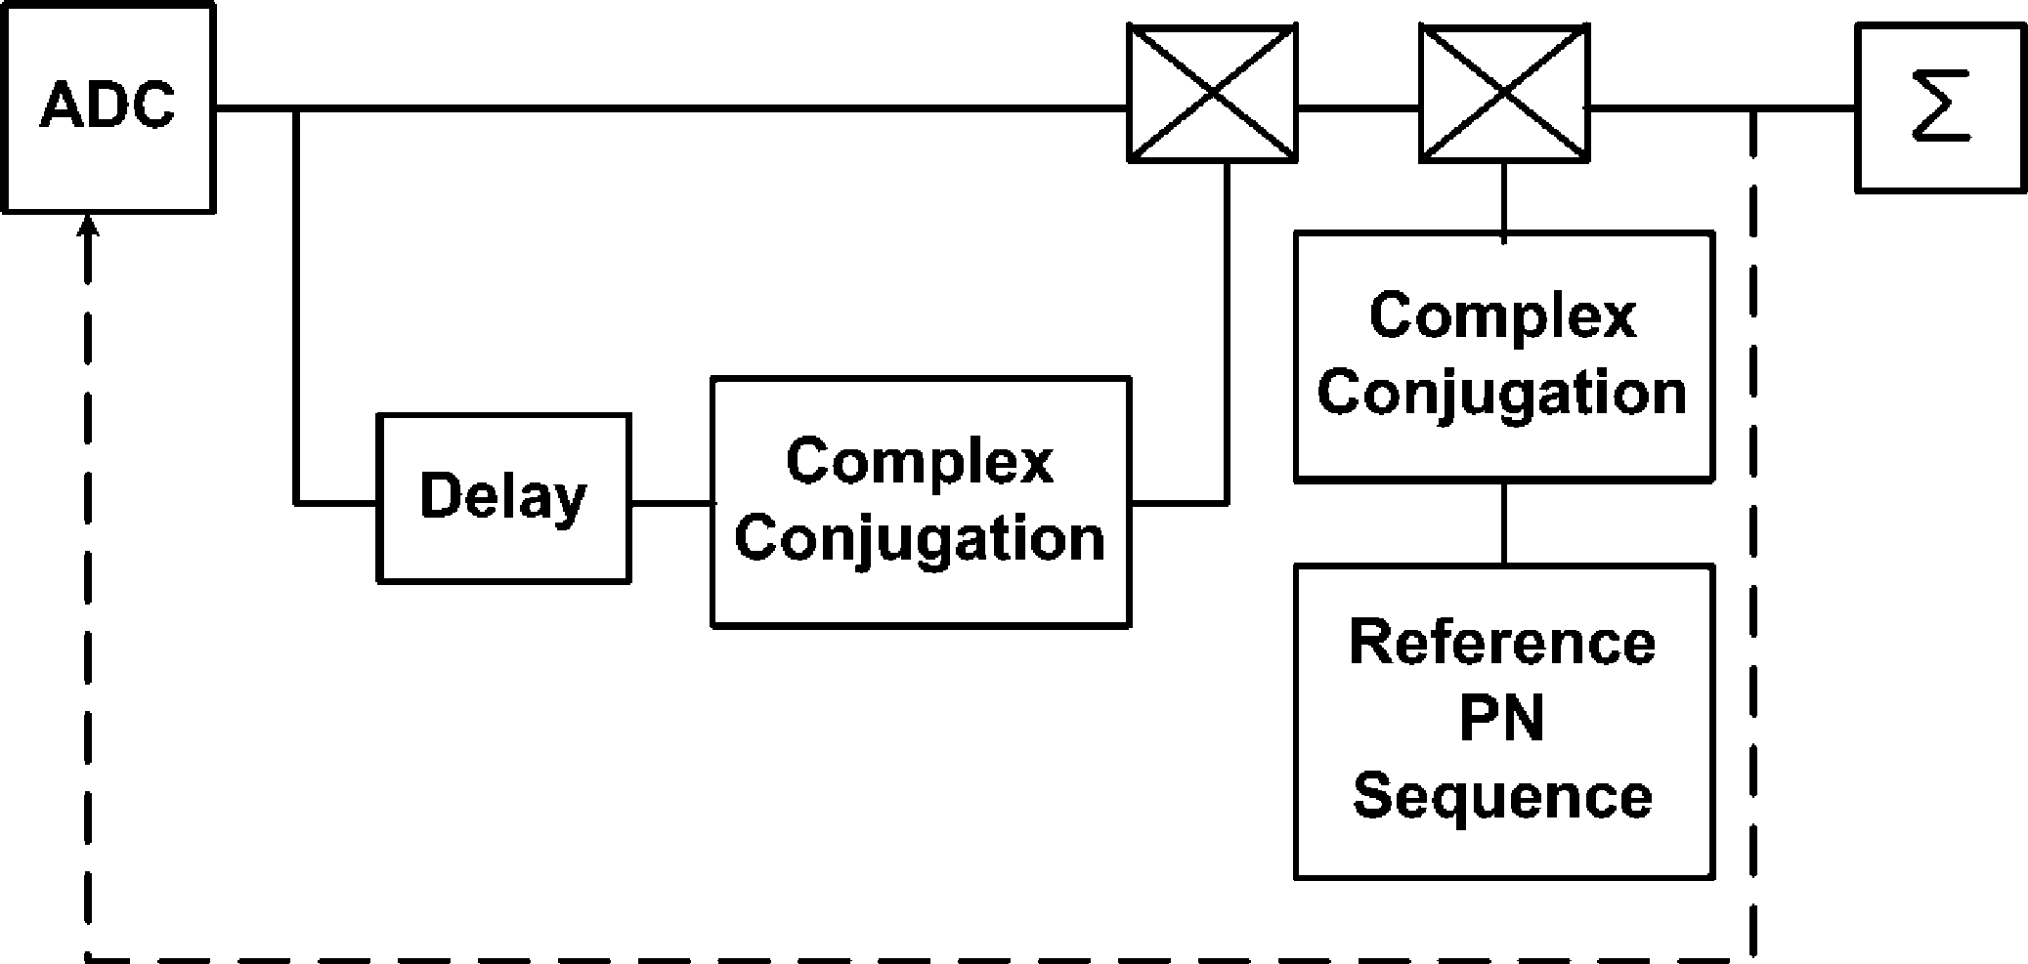

Fig 1. Differential Style Receiver. ADC clcok detemines Symbol Synchronization. So general symbol synchronization focus on controling ADC clock.

where Tc is 1 chip time delay. Differential complex conjugated multiplication signal is described in (3)
(3)
So if phase offset is constant during many symbol interval,. Thus will be like (4)
(4)

is reference signal (symbol) to compare with incoming received signal. has only pure symbol with no frequency and phase offset. It is described (5)
(5)
Then we correlate received differential signal and reference differential symbol . (6) shows the result of correlation.
(6)
If transmitted symbol is and reference symbol is , each symbol correlation value will always be auto correlation value, signal power 1. Thus
(7)
For removing of frequency offset , squaring operation is performed.
Fig 1 didn’t describe squaring operation. After that, integration is followed during Symbol (32 chip) interval time for detection of transmitted symbol.

  - Frequency Offset Estimation
The differential operation has another function which converts carrier frequency offset to phase offset. Then the signal after differential operation will be multiplied with reference signal for detection of transmitted symbol. Receiver has the different 16 reference symbol (PN sequence). So if we know exact transmitted symbol, we can acquire carrier frequency offset. Thus we read the value before squaring operation during preamble, (7) value is frequency offset. the value from (7) corrupted by channel noise in real condition but the integration of correlation process after squaring sufficiently mitigates the channel noise during whole preamble interval (8 symbol length).
This estimated carrier frequency offset is same to the clock frequency offset of analog to digital converter (ADC) because it is clear that RF system and ADC of Zigbee use same crystal. In other words say, since ADC’s clock variation completely determines symbol synchronization in general digital Zigbee modem, we can say that the obtained carrier frequency offset indicates the ADC’s clock frequency offset for symbol timing synchronization

- Direct Sample Level Compensation
Symbol synchronization is performed by the two processes, acquisition and tracking. The Zigbee’s acquisition process of symbol synchronization is performed by packet searcher (frame synchronizer).
Zigbee modem must implement packet searcher for the searching the packet’s start point. So the acquisition process of symbol synchronization and packet synchronization is performed at the same time.
Since the most of Zigbee modem realizes the packet synchronization in digital domain, the knowing packet’s start point means that the acquisition process of symbol synchronization is completed and phase offset problem is cleared. Therefore we just concentrate on the frequency offset problem for tracking of symbol synchronization. Fig 2 shows correlation value at 80 ppm frequency offset. As times goes, correlation value is decreased.
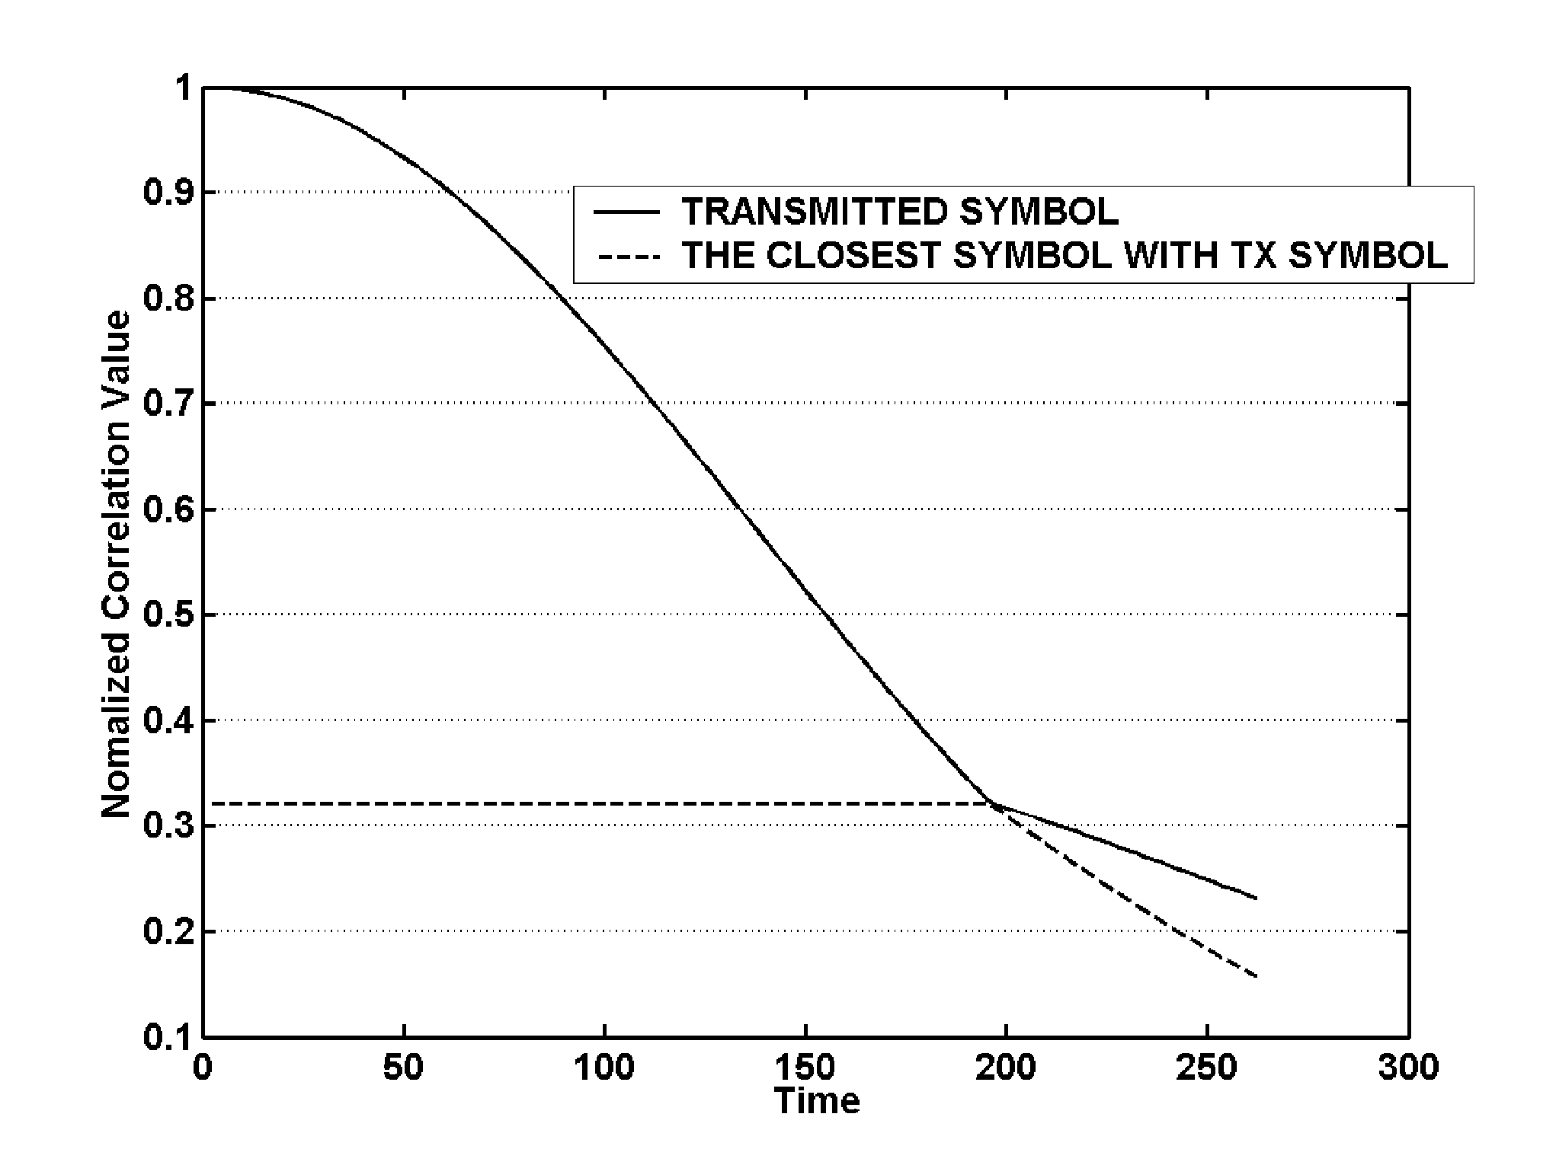
Fig 2. Correlation Value: Transmitted Symbol and the closest symbol at 80 ppm frequency offset of ADC Sampling clock. We can find that as times go, correlation value is decreasing.
Since the most of Zigbee modem realizes the packet synchronization in digital domain, the knowing packet’s start point means that the acquisition process of symbol synchronization is completed and phase offset problem is cleared. Therefore we just concentrate on the frequency offset problem for tracking of symbol synchronization. Fig 2 shows correlation value at 80 ppm frequency offset. As times goes, correlation value is decreased.
As above described in the introduction, the closed loop symbol synchronization needs clock generator like voltage controlled oscillator (VCO). The clock generator performs the tracking with the command from timing offset estimator. The clock generator is more expensive and complex and the command signal should be well controlled. So this paper introduces the new compensation method called direct sample level compensation (DSLC).
DSLC does not control ADC sampling clock like closed loop method. DSLC directly control the incoming signal sample. If a sample of incoming signal sample stream is added or removed, the rest samples after adding/removing operation will show 1 sample time shift compare to each reference symbol samples (16 PN sequence).
Fig 3 shows DSLC how compensate correlation value. This 1 sample adding/removing operation adds intentional timing offset to incoming signal samples. If we can correctly estimate the frequency offset of ADC clock, the compensation point (intentional timing offset) would be the time when the accumulation of incoming signal’s timing offset is over 0.5 sample time.
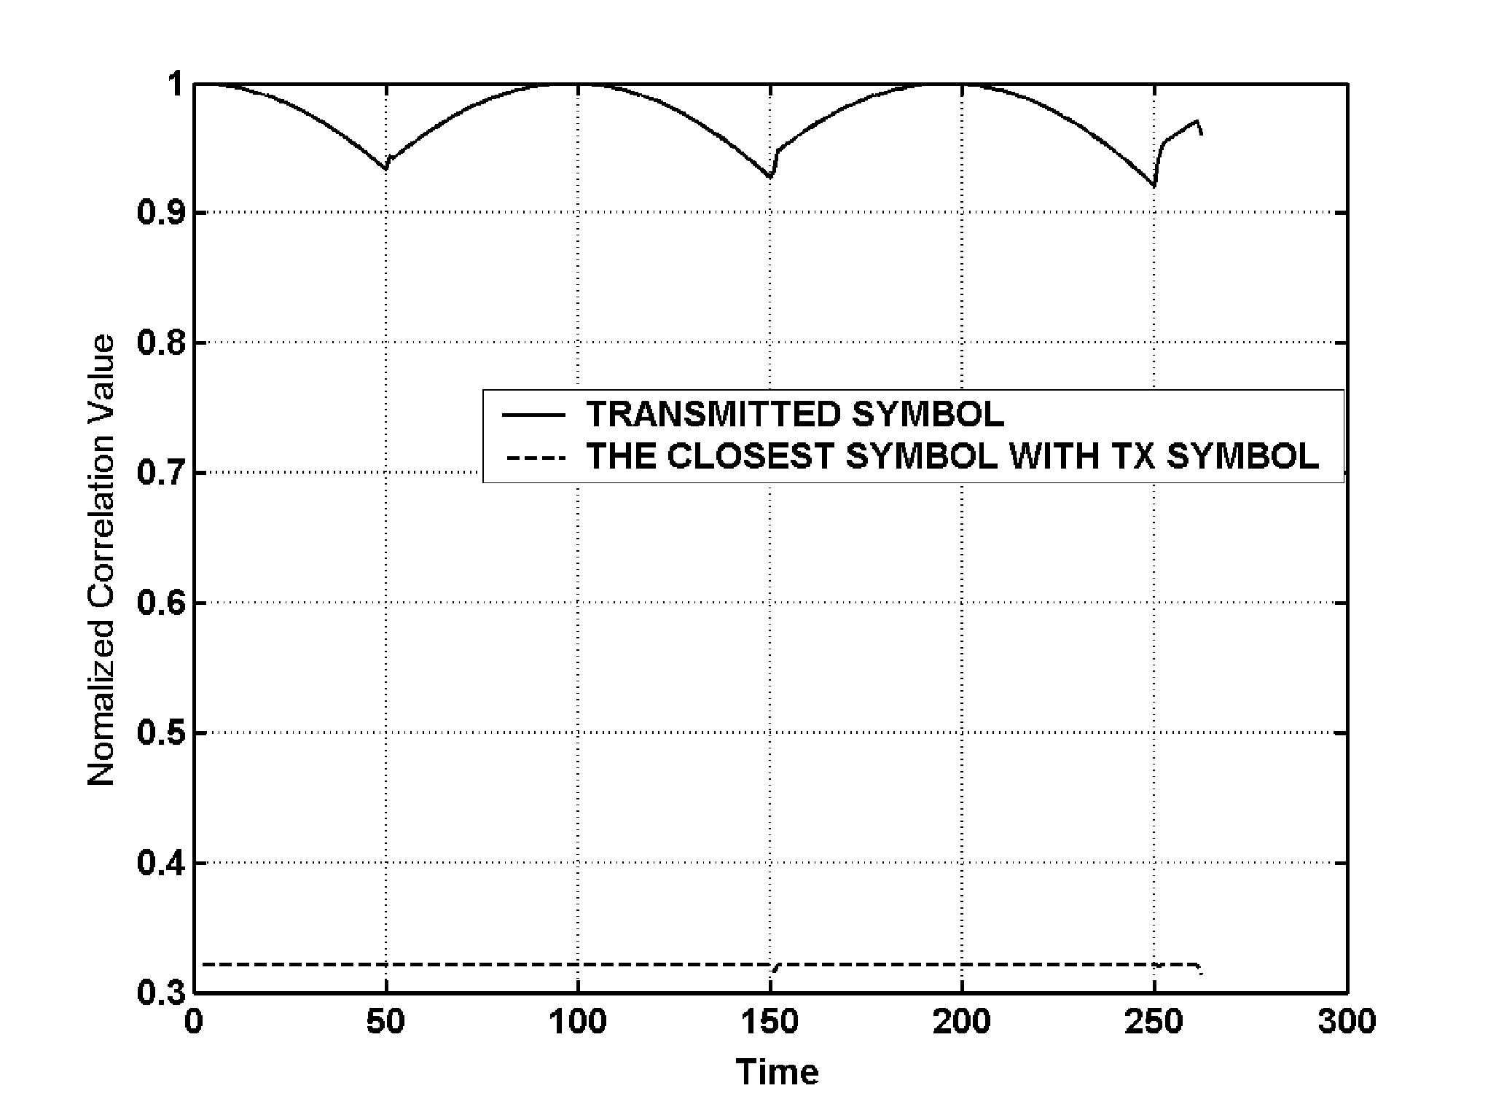
Fig 3. Correlation Value: After Timing offset compensation, the decreasing of correlation value of transmitted symbol diminished. So we can ensure more noise margin between transmitted symbol PN sequence and the nearest symbol PN sequence.
DSLC regard the effect of the timing offset accumulation within 1 sample time as neglect. Thus as sampling time is fast, the performance of DSLC is higher.

- Simulation
Simulation performs BER test at each frequency offset condition: 0~80ppm. Receiver structure was selected to differential style non coherent receiver. Payload of ZigBee packet (frame) was 127 byte to consider the worst case.
Fig 4 shows error floor as frequency offset of ADC timing clock is higher. ADC sample clock frequency was 8 MHz.
Fig 5 shows improvement of BER performance after frequency offset compensation through 1sampling adding/removing. Compensation look-up table has only 16 steps in this simulation. Each table component means some length register on the view of implementation. In this simulation, simulation code was designed the register to have 16 bit length and 4ppm step.

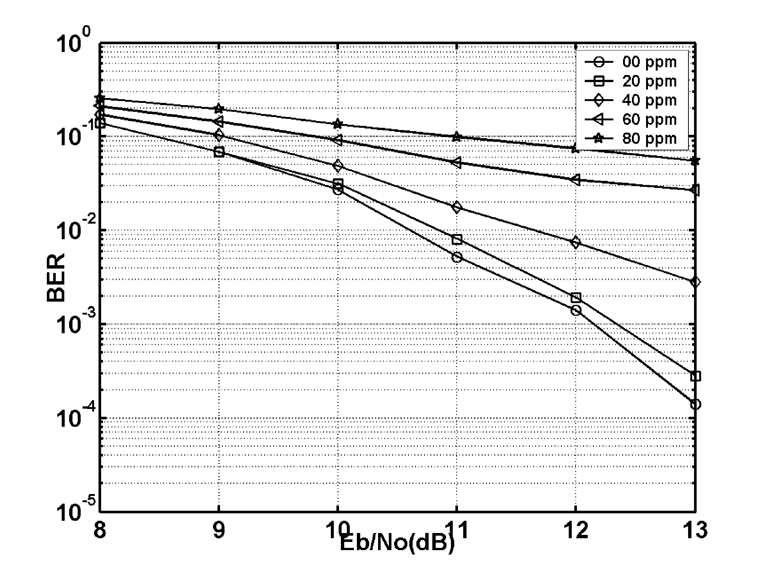
Fig 4. BER performance before compensation at each frequency offset of ADC sampling clock. 0ppm frequency offset means perfect timing synchronization. The most severe condition 80 ppm shows error floor in a receiver performance.
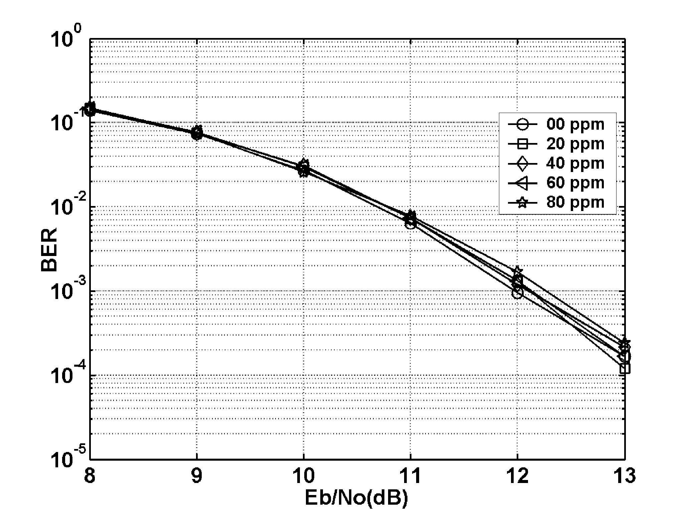
Fig 5. BER performance after DSLC at each frequency offset of ADC sampling clock. 0ppm frequency offset also means perfect timing synchronization. The BER is approximated to perfect ADC sample timing synchronization in severe condition. The most severe condition 80 ppm shows error floor in a receiver performance.

4 Conclusion
ZigBee is low cost solution for low rate wireless personal network. So if we should require lower cost than the cost of general wireless solution though slight performance degradation, DSLC would be best choice because this DSLC of symbol timing needs only look-up table in receiver. If differential style receiver was adopted, there is nothing to need for frequency offset estimation. So we can save components like VCO, loop filter, correlator and some logic gates for symbol synchronization. It just only needs to read the calculated frequency offset from receiver output during preamble interval. After that, refer look-up table to determine compensation sample point and add/remove 1 sample at control point notified in look-up table.
If reducing of slight BER degradation compare to perfect synchronization is required, increase sampling clock or look-up table step. As sampling clock goes higher, compensated BER performance shows more similar performance to perfect symbol synchronization.

References:
[1] IEEE Std 802.15.4 – 2003.
[2] Bernard. sklar, Digital Communications: Fundamentals and Applications. Prentice-Hall Inc., 2002
[3] John G. Proakis, Digital Communications. McGraw-Hill Companies, Inc., 2001
[4] K.H. Mueller and M. Muller, Timing Recovery in digital synchronous data receivers, IEEE Trans. Commun., vol COM-24, pp.516~531, May 1976.
[5] Holmes, J. K., chen C. C., Acquisition Time Performance of PN Spread-Spectrum Systems, IEEE Trans. Commun.., COM-25, August 1977, pp. 778~783
[6] Chia-Sheng Peng; Ming-Hung Chang; Kuei-Ann Wen, Early-late gate receiving for Bluetooth packet VLSI Technology, Systems, and Applications, 2001. Proceedings of Technical Papers. 2001 International Symposium on 18-20 April 2001 Page(s):57 – 60
[7] R. A. Scholtz, “Frame synchronization techniques,” IEEE Trans. Commun., vol. COM-28, pp. 1204–1212, Aug. 1980.
[8] J. L. Massey, “Optimum frame synchronization,” IEEE Trans.Commun., vol. COM-20, pp. 115–119, Apr. 1972.

