Artificial Neural Networks Approaches for Multidimensional Classification of Acute Lymphoblastic Leukemia Gene Expression Samples

Nuannuan Zong, Malek Adjouadi, and Melvin Ayala
Center for Advanced Technology and Education
Department of Electrical & Computer Engineering, Florida International University
10555 W. Flagler Street, Miami FL 33174
United States of America

Abstract: - Accurate classification of human blood cells plays a decisive role in the diagnosis and treatment of diseases. Artificial Neural Networks (ANNs) have been consistently used as a trusted classification tool for this type of analysis. In the present case study, two approaches are implemented on two different parametric data clusters in a multidimensional space using ANNs trained with cross-validation. Beckman-Coulter Corporation supplied flow cytometry data of numerous patients as training sets for the first approach to exploit the physiological characteristics of the different blood cells provided. The goal was to establish a programming tool for the identification of different white blood cell categories of a given blood sample and provide information to medical doctors in the form of diagnostic references for the specific disease state that is considered for this study, namely Acute Lymphoblastic Leukemia (ALL). Successful initial results of this first approach have been published. The second approach is focusing on the gene expression profiling of ALL to classify its six subtypes. Generated by the oligonucleotide microarrays, this data provides additional insights into the biology underlying the clinical differences between these leukemia subgroups. With the application of the hypothesis space, along with the learning bias, the system is also trained to assess the inherent problem of data overlap and be able to recognize abnormal blood cell patterns. An analysis of the systems regarding computational load and receiver-operating characteristic (ROC) was conducted. The algorithms as proposed provide solutions to data overlap from our initial results. And by applying ANNs, the classification accuracy of the first approach is remarkably improved up to 100% and 92% for the second approach.

Key-Words: - White Blood Cell, Acute Lymphoblastic Leukemia (ALL), Gene Expression Profiling, Microarrays, Artificial Neural Networks (ANNs), Cross-Validation, Receiver Operating Characteristics (ROC) Analysis

1 Introduction
Normal white blood cells include lymphocytes, neutrophils, eosinophils, basophils, and monocytes that are produced by bone marrow to help the body fight infection and other diseases. Abnormal white blood cells include blasts, immature granulocytes, and atypical lymphocytes. One method of determining that a medical abnormality may exist in the blood of a patient is to note when the subpopulations exceed the acceptable abnormal white blood cell population. A normal blood cell subpopulation map is a priori established as a standard platform based on statistical analysis of patient flow cytometry data. This model is often regarded as an “average case”, representing the expected locations and types of blood cells that will appear whenever a blood sample is analyzed by a flow cytometer and displayed as a dot plot with the dimensional parameters of absorbance and volume. In this well established model [1], normal and abnormal cell types and their locations are as shown in Fig.1.
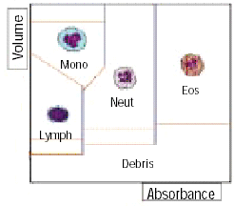
Fig.1: Representation of cell subpopulations: (Courtesy of Beckman-Coulter Corporation)
For instance, ALL is a condition characterized by an accumulation of abnormal lymphocytes in blood and bone marrow. This departure from the normal distribution of white blood cells may be used as an initial indicator for the disease [2]. ALL is a heterogeneous disease with subtypes that differ markedly in their cellular and molecular characteristics as well as their response to therapy and subsequent risk of relapse [3].
The goals of this study are to apply ANNs to classify real blood samples obtained from Beckman Coulter Corporation in two categories (normal and abnormal) and accurately identify the known prognostic subtypes of ALL using gene expression profiling. These six subtypes include T-cell lineage ALL (T-ALL), E2A-PBX1, TEL-AML1, MLL rearrangements, BCR-ABL, and hyperdiploid karyotypes with more than 50 chromosomes.

2 Description of the Problem
As a practical case, acute lymphoblastic leukemia is a common disease with thousands of new cases found each year in the U.S. alone. An acute lymphoblastic leukemia patient's marrow makes too many blast cells (immature white blood cells). So many blast cells appear that the marrow no longer has the ability to produce suitable quantities of normal red blood cells, white blood cells and platelets. Because of the extremely large number of blood cells that exist in a given sample, compounded with the many variant configurations of the data clusters as shown earlier in Fig.1, the classification process of blood cells has remained a complicated problem, especially since the cluster distributions are often complex necessitating high order nonlinear decision functions which must also contend with the ubiquitous problem of data overlap.
The approaches are based on applying Neural Studio, an ANN simulator which has been designed for such neural network-based applications.

3 Data Acquisition

3.1 Flow Cytometry Data
The Beckman-Coulter data files are generated by the flow cytometer instrument, which uses a Fluorescence Activated Cell Sorter (FACS) to distinguish different cell types by tagging them with fluorescent dyes. A laser system illuminates the cells and permits cell types to be quantitated and physically separated into various subpopulations. An illustration of the flow cytometer instrument is provided in Fig.2.
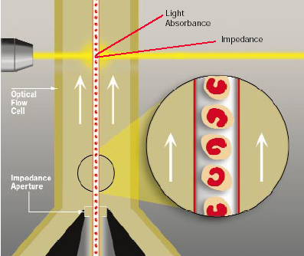
Fig.2: A Simplified representation of the flow system (Courtesy of Beckman-Coulter Corporation)
The laser increases the resolution and allows the researcher to produce different wavelengths with different lasers. These signals are then collected and analyzed by the optical and electronics system to provide the essential parameters for the user as shown in Fig.3.
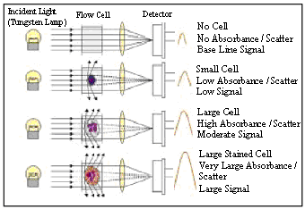
Fig.3: Example of the light scattering phenomena
The output signals from the focused flow impedance and the light absorbance measurements are combined to define the white blood cell differential population clusters which are as depicted earlier in Fig.1.

3.2 Gene Expression Profile
Efficient use of the large data sets generated by gene expression microarray experiments is a quite promising direction to better understand the bioinformatics. To determine if the additional expression data provided by microarrays would both enhance the ability to accurately diagnose and subclassify pediatric ALL, and provide additional insights into the underlying biology of the different genetic subtypes of ALL, the total of 104 data samples for training and testing purposes was selected. Affymetrix HG-U133A and HG-U133B oligonucleotide microarrays (Affymetrix, Santa Clara, CA) are used to evaluate the representative ALL samples. Similar like the idea of flow cytometer, arrays were scanned using a laser confocal scanner (Agilent, Palo Alto, CA) and then analyzed with Affymetrix Microarray Suite 5.0 (MAS 5.0). Affymetrix internal controls were used to monitor the success of hybridization, washing, and staining procedures. After the application of the variation filter to hundreds of diagnostic leukemia samples, 12627 probe sets from combined U133A and B microarrays remained. Those data samples for this study are available at http://www.stjuderesearch.org/data/ALL1 [3].

4 Software Approach for Visualization of ALL Data
Each blood cell contained in a Beckman-Coulter data file is represented by specific parameters. Given the data provided, each cell is described by 24 parameters. Among these parameters, 12 principle parameters are directly collected using the flow cytometer; while 12 others are derived using log functions on the 12 principal parameters. The parameters experimentally deemed as most important are the three parameters defined in Table 1.

Table1: Parameter definition list
Par | Name | Par. Definition
P1 | DC | Direct Current Impedance: Light Scatter detectors obtain the morphology and internal structure information of the cell.
P2 | OP | Opacity: Measurements related only to the internal structure of the cells.
P3 | Rls-Soft | Rotate Light Scatter: It is obtained through rotation of the medium angle light scatter parameter.
To appreciate visually flow cytometry data, a specialized software program known as WinList used by Beckman-Coulter Corporation has impressive display and analysis capabilities. The 2-D plots, which show information of any combination of two parameters, are termed “dot-plots”, and are the most common types used. Illustrative examples of dot plots using different sets of parameters are depicted in Fig.4.
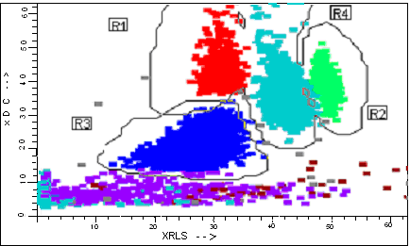
RLsSoft vs. DC (R1: Mono. R2: Eos. R3: Lymph. R4: Neut.)
Fig.4: Illustrative examples of normal blood samples using WinList displays
Fig.4 shows normal blood samples where the different cell subpopulations can be clearly identified. But when lymphocytes progressively accumulate in acute lymphoblastic leukemia, they do not perform their functions as normal ones would, and do interfere with other blood cells. This case is shown in Fig.5, representing too many immature lymphocytes that are highly overlapped, thus complicating the classification process.
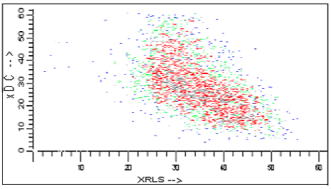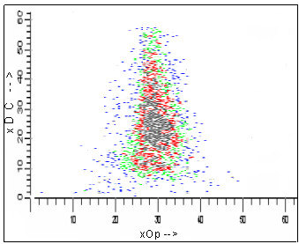
Fig.5: Illustrative acute lymphoblastic leukemia examples using WinList displays with extensive overlap between the different subpopulations.

5 Introduction of Neural Studio
In this study, the classification optimization was simulated by using ANNs with several hidden layers in anticipation. To illustrate the network topology and provide the implementation flexibility, a programming tool named Neural Studio [4] was developed at the Center for Advanced Technology and Education at Florida International University.
Among all the challenging disciplines of Artificial Intelligence, such as fuzzy logic, evolutionary computation and genetic algorithms, etc, ANN is the one that is viewed as most intriguing. This is in part because ANN designs are an attempt at modeling the functionality of the human brain and its neuronal connectivity in terms of decision making.
Neural Studio is a powerful ANN simulator highly suitable for both educational purposes and research, where users can freely design different types of networks and simulate their functionality. The simulator is designed to contain an editor for a multilayer perceptron and also consists of information panels, editing and processing tools as well as an input/output table. The implementation of a supervised training on a network can be achieved via different learning rules (Hebb rule, Perceptron rule, delta rule, and backpropagation rule). In this particular study, the backpropagation rule is used for implementation.

6 ANN Approach for Flow Cytometry Data

6.1 Feature Extraction
For the first approach, three parameters (DC, OP and RlsSoft) of the samples have been used, in order to optimize both the convergence rate and the accuracy. Because all the data samples provided by Beckman-Coulter Corp. are contained in matrixes of size 8192 × 3, which are too large for processing as vectors, feature extraction is done to drastically reduce the size of the data sets. The feature space is created by representing the entire sample of 8192 × 3 by a 5 × 3 matrix representation instead, where the five computed features in each row are the mean, peak, standard deviation, skewness and kurtosis of the histogram for each dimension (principle parameter).
The five computed features, as shown in Table 2, have been extracted from the histogram of each of the 3 parameters (DC, OP and RlsSoft) to be used to feed into the network.
Table 2: Data format after feature extraction
Computed Feature | DC | OP | RlsSoft
Mean | 1885.73 | 1120.51 | 561.37
Peak | 4095.00 | 3423.00 | 4095.00
STD | 706.95 | 457.57 | 407.64
Skewness | -0.58 | -0.43 | 1.6048
Kurtosis | 2.88 | 2.48 | 9.49

6.2 Network Design and Activation Function Selection
The same features which are listed in Table 2 were used to represent the input neurons. Consequently, for each sample, 15 neurons appear in the first layer shown as N_{1.1}, N_{1..2, …}N_{1.15}. Since the objective of the approach is to classify the acute lymphoblastic leukemia samples from the normal samples, they are defined as two classes, class 1 (abnormal sample) and class 0 (normal sample) which are represented by two neurons in the output layer in Fig.6.
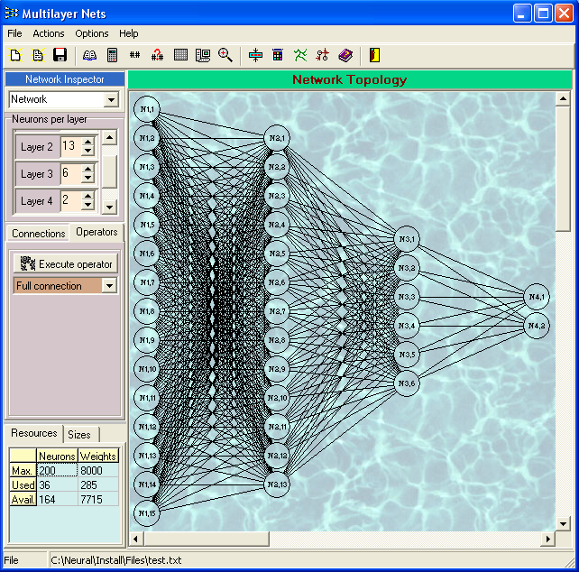
Fig.6: Proposed multilayer feed forward network with topology 15-13-6-2 shown on Neural Studio’s perceptron module
Because of the complexity of the acute lymphoblastic leukemia data, more hidden layers are necessary to configure the network. In this case, 13 neurons are used for the first hidden layer, and 6 neurons are utilized in the second hidden layer. Weights and biases were initialized with random values between 0 and 1.
For better performance, the training sets were normalized and activation functions for the output units were also carefully chosen so as to cover the range of the targets in order to circumvent convergence problems, such as local minima traps, or even monotonically increasing errors.
The selection and parameterization of the activation functions could be considered as the most sensible tasks in this study. Several trials where needed before the right parameters where found. For the hidden units, logistic sigmoidal activation functions were used with the following parameters:
$f(x)= (y_{\text{max}} − y_{\text{min}}) ⋅ \frac{1}{1 + e^{−α(x − β)}} + y_{\text{min}}$
with a shape parameter  = 3 and a location parameter  = 0 and minimum and maximum output ranges of y_{min} = -0.1 and y_{max} = 1.1. For the input and output units, linear activation functions were used.

6.3 Training and Testing Procedure
With 20 normal samples and 30 abnormal samples, 44 samples were used in the training phase and 6 samples, not included for cross-validation, were used in the testing phase. The training process is aimed to find the optimum weights and biases that produce the best ANN response which best represent the desired behavior. When the desired solution is a set of targets, the goal of the training process is to minimize an accumulated error between the current ANN outputs and the targets.
During supervised training, a general learning rate of 0.01 was applied for all units in the network. Additionally, cross-validation was performed by separating the 44 patterns into 5 subsets. It was so configured such as to test a subset after processing the remaining subsets twice for training. The final results were obtained by averaging the 5 optimum solutions.

6.4 Results for Classifying Flow Cytometry Samples with ALL using Neural Studio
Both training and testing errors were observed to gradually decrease during training. Testing error decreased to 0 % after about 2195 iterations; after that, it started to increase. At this point, training was stopped in order to avoid over-fitting, and the previous network configuration was saved as the optimum one. For this final solution, a 9.09 % training set error and a 0.00 % testing set error were obtained. Surprisingly, both the true positive fraction and the false positive fraction during testing yielded 100 % in this approach.

7 ANN Approach for Gene Expression Profiling

7.1 Feature Extraction
As we discussed above, data samples analyzed by Affymetrix oligonucleotide microarrays contain 12627 probe sets in the data file. Because of the extremely large number of the data size, feature extraction is needed to reduce the calculation.
A CSIRO Bioinformatics technology Gene-Rave is used for the analysis of gene expression microarray data. The technology is able to find small sets of genes with the same or better predictive accuracy than the usually much larger sets found by existing technology. Building models using multinomial regression, Gene-Rave produces a probability prediction for a sample being from one of the six classes, using only ten genes. The ten genes are CD2, CD3ε, CD4, CD5, CD7, CD8α, CD8β, CD10, CD19, and CD22 [5].
Table 3: Probe sets details of selected genes
Gene Name | Probe Sets Detail
CD2 | 40738_at
CD3 | 36277_at
CD4 | 856_at, 1146_at, 35517_at, 34003_at, and 37942_at
CD5 | 32953_at
CD7 | 771_s_at
CD8α | 40699_at
CD8β | 39239_at
CD10 | 1389_at
CD19 | 1096_g_at and 1116_at
CD22 | 38521_at and 38522_s_at
Those total 16 probe sets are used as features for classification of ALL in this paper.

7.2 Network Design and Activation Function Selection
To successfully treat pediatric acute lymphoblastic leukemia, the individual patients need to be accurately assigned to various risk groups. The artificial neural network learning models built are all feed-forward and fully connected. In the topology of the network for this approach, the 16 features are considered as the input units in the input layer. One hidden layer with 32 units, and an output layer that contains six units, which represent the six subtypes are designed to deal with nonlinear and overlapping situation. In a preprocessing step all input data was normalized before training and testing. The logsig activation function was applied to the hidden layer. The apparent error was estimated using 3-fold cross-validation. That is, for each training procedure, the training samples were randomly shuffled and divided into three groups of approximately equal size. A model was built with two of the groups and the third group was set aside for validation.

7.3 Training and Testing Procedure
In this approach, the total of 104 patients is applied to simulate by Neural Studio. Training set consisted of 79 cases with distribution: 12 T-ALL, 13 E2A-PBX1, 15 TEL-AML1, 11 BCR- ABL, 15 MLL, and 13 hyperdiploid with more than 50 chromosomes. Testing set included 25 samples: 2 T-ALL, 5 E2A-PBX1, 5 TEL-AML1, 4 BCR- ABL, 5 MLL, and 4 Hyperdiploid with more than 50 chromosomes.

Table 4: Data samples for training and testing
Subgroup | Training set | Test set | Total
BCR- ABL | 11 | 4 | 15
E2A-PBX1 | 13 | 5 | 18
Hyperdiploid with more than 50 chromosomes | 13 | 4 | 17
MLL | 15 | 5 | 20
T-ALL | 12 | 2 | 14
TEL-AML1 | 15 | 5 | 20
Total | 79 | 25 | 104

7.4 Results for Classifying Gene Expression Profiling Samples with ALL using Neural Studio
Table 5: Classification accuracy
 |  | Classification
 |  | correct | error | Accuracy
Actual | Training(79) | 77 | 2 | 97.47%
Actual | Test(25) | 23 | 2 | 92.00%

The classification accuracy of the implemented algorithm provided in Table 5 shows that for the 79 training patients, only two sets were misclassified yielding an accuracy of 97.47%; while for the 25 test sets, 2 of the sets were misclassified, yielding an accuracy of 92.00%. Given the subtle behavior of data clusters of gene expression profiling data and the ubiquitous problem of data overlap, these results were most encouraging at this stage of the algorithm development process. As noted above, the implemented ANN approach attained impressive classification accuracy.

8 Discussions and Conclusion
This study demonstrates that ANNs for pattern classification are powerful tools for the analysis of ALL data sample. The obtained results prove that when a neural network classifier is well configured and trained with cross-validation, it can perform very well.
In aggregate, these studies have not only raised the possibility of achieving a more accurate diagnosis of clinical disease ALL, but have also suggested that a diagnostic platform may be obtainable for its six subtypes. With the representation of gene expression profiling placed on microarrays, there is a greater potential for achieving a better understanding of the formation of the acute lymphoblastic leukemia disease.

ACKNOWLEDGEMENTS
The authors gratefully acknowledge the support from the National Science Foundation grants: EIA-9906600, CNS 042615, HRD-0317692, and the Office of Naval Research: N00014-99-1-0952.

Reference:
[1] Beckman-Coulter Corp., FL, AcV Differential and Case Studies, Monograph. Available: http://www.beckman-coulter.com.
[2] University of Leicester, Department of Microbiology & Immunology, Cells of the Blood. www-micro.msb.le.ac.uk/MBChB/bloodmap
[3] Mary E. Ross, Xiaodong Zhou, Guangchun Song, Sheila A. Shurtleff, Kevin Girtman, W. Kent Williams, Hsi-Che Liu, Rami Mahfouz, Susana C. Raimondi, Noel Lenny, Anami Patel, and James R. Downing, Classification of pediatric acute lymphoblastic leukemia by gene expression profiling, Blood, Oct 2003; 102: 2951 - 2959.
[4] Adjouadi M. and Ayala M., Introducing Neural Studio: An Artificial Neural Networks Simulator for Educational Purposes, Computers in Education Journal, July-September 2004, Vol. 14, No. 3, July-September 2004, pp. 33-40.
[5] CSIRO Bioinformatics, Gene-Rave predicts leukemia subtype using only ten genes, Http://www.bioinformatics.csiro.au/stjudes.shtml
[6] Adjouadi M., Reyes C., Vidal P., Barreto A., An Analytical Approach to Signal Reconstruction Using Gaussian Approximations Applied to Randomly Generated Data and Flow Cytometric Data, IEEE Transactions on Signal Processing, October 2000, Vol. 48, No. 10, pp. 2839-2849.
[7] Reyes C. and Adjouadi M., A Directional Clustering Technique for Random Data Classification, Journal of Cytometry, February 1997, Vol. 27, No. 2, pp. 126-135.

