International Videoconferencing - Experience Exchange of Teaching Practices

MARJAN KRASNA, SMILJANA GARTNER
Center for Computer Science and Multimedia in Education, Department of Philosophy
Faculty of Education, University of Maribor
Koroska cesta 160, 2000 Maribor
SLOVENIA

Abstract: - It is impossible to train teachers without classroom and students. In most cases training begins with the learning of the theory, continues with the preparation and testing in the controlled environment, and then practical observation of the lecturer. The process ends with training lectures performed by the student lecturer. This process requires presence of student lecturers and students observers in the classroom. It is hard to put student lecturers into the classroom and expect authentic behavior of tutees. A large number of "foreign" people among tutees (e.g. primary and secondary school children, university students ...) change the observed environment. In our effort to minimize the disturbance effect we set the test classroom where only: remote control camera was present; teaching trainee; and pupils' teacher. Didactical expert and students lecturers who used to be present inside the classroom are now in the remote location. A different attitude of students was noted in this occasion. In our case pupils were more relaxed and more cooperative with the lecturer. Initial pilot test was success.
This test was a part of the project where we want to exchange video stream across different teacher training facilities in Europe. We wanted to provide the training ground for student teachers to receive cross cultural information about teaching procedures in other participating countries.
In the article the pilot project and future topics for research are presented. Legal and ethical obstacles are also addressed in the article because we want to know where the observation limits are.

Key words: education, video streaming, classroom, multi-language, ethics

- Introduction
When we receive first videoconferencing equipment in 1998 we search the way how to use it in the education. Those early videoconferences were only point to point and suitable for small number of people. Technology and communication line did not provide sufficient quality for broad audience. [1] In 2001 the first large scale video conference were conducted on a proven audience of computer teachers. [2] We perform multipoint ISDN videoconference on five locations. It is estimated that more than 20 lecturers participated in the conference. The conference lasted for three days. Lecturer was in one geographical location and its lecture was transmitted to the four different locations. We identify many problems during the lecture. The picture quality was low, we constantly experience the sound breaking but we learn a lot from the first large scale test. We learned that most important topic in videoconference is sound. When the internet infrastructure enables high speed access we started experimenting with the IP videoconferences. Late-evening's tests were excellent. Internet lines were relatively free for video transmission but daytime tests were poor. Lack of QoS (Quality of Service) aware network equipment made conference unstable. But with the time the infrastructure evolved and enables Gbps backbone and even individuals are able to acquire couple of Mbps download at their homes. The latest analysis shows that around 53% of our students have permanent internet connection and at least 512 Kbps download speed. [3] We are now able to transmit sufficient quality video stream to most of our students.
Our students are future teachers in primary or secondary schools. During their study they have to learn the technology and didactical approach how to use the technology in the classroom. Only practical exercise in the classroom gives them ability to test the theory they learn. Testing the theory in practice means multiple attendances in the classroom with children. They start their training observing of the teacher and continue with their own lectures. Their lectures are first tested on their colleagues and later in the classroom full of children. When one student gives the lecture their colleagues listen to the lecture and observe classroom's atmosphere. Afterward the didactical analysis is performed where strong and weak points of student performance in the classroom are highlighted.
This traditional approach has at least one flaw. The classroom is full of children and observers. The behavior of the children changes depending on the visitors in the classroom. If we want to experience the authentic atmosphere of the classroom we need to be outside the classroom and have the ability to see inside behavior. [4].
In the EU countries there are great effort to standardize the education processes. [5] Countries have different education system and they need mutual analysis of their system. We must enable students to see the principles and procedures used in other countries.. The technology provides us the means to go beyond these differences and enable students from all countries to participate in the analysis process.
Our Faculty of Education is involved in many international projects. One of the projects was also to provide the knowledge and support for Serbia and Monte Negro in their effort to modernize their educational system. They started the project called STEP (Serbian Teacher Education Development Programme) with the support of Finland.. We joined the project to exchange knowledge between our educational institutions.
It is common practice that our students are recorded during their training lectures and video is used in didactical analysis. So we provide Serbians access to our video database. These videos would be used to show our procedures to their students and later they would establish equivalent system. Their results would be also very interesting learning material for our students.
In the project we planned to establish video communication between research laboratories. But when Serbians see the tests we conduct in our local environment they immediately want to make some changes in the project plan and include also student to student videoconferencing. This gives us courage to expand our local research beyond our national border.

- Legal and Ethical Consideration
Today's world gives great ability in the information exchange. But information exchange is not always positive. Within this computerized society there are three potential abusers of information: business, government and mass media - De George focuses only on the first two [6]. When we analyzed the whole “International classroom video network” (ICVN) project, the question that we had was - is there any abuse of information? The issue that is most widely exposed in the information age is the nature of privacy concerning individuals, the analogical secrecy and the espionage of corporations. Taking into account the whole ICVN (we divided it into three phases: (i) taking videos of pupils in a classroom, (ii) a video streaming and (iii) a processing data) we are going to focus on the right of privacy of individuals. But before answering the question if this test is morally and legally right we would like to introduce privacy as one of the most important values in the information age, especially because there are people who claim that we have become paranoiac about it.
Even if we define privacy as a matter of individual preference or cultural relative this does not mean that we should not protect it. Moore J. says that in every society there must be core values that are necessary for humans in order to be rational beings and to be able to survive in the society, but also for the society itself. In a large computerized culture where lots of personal information is becoming accessible to others it is almost inevitable that privacy emerges from security. Therefore, privacy is not the core value but the expression of it. [7] With the unauthorized entry into different zones of privacy we deal with an invasion, interference and information access to others. A possible scenario of consequences is that an agent’s private information (an agent represents an actor in the Unified Modeling Language) can be damaging for her when it became public, that is, she can lose a basic capacity for making choices in order to directing her life without interference, which is one part of basic ethical principles of persons, i.e. autonomy. It is manifested as a voluntary participation and informed consent (as a process and documentation) which means that it should be known and clear to agents about when and how their personal data are going to be used. [8][9] Therefore, we are not paranoiac, we just want to have a control over our privacy.
Taking into consideration that in the pilot test of the ICVN project we pay no attention to the consent of agents (beside a student lecturer) the project is morally wrong. Not only morally. When we examine, for example, the Slovenian, German and Israel law we see that there must be a written consent of agents if we want to use their personal data. [10] An argument against this position is that a taking video or video streaming cannot count as personal data. But according to the first, second, third and fifth paragraph of article six of the ZVOP, a recorded video from this project can count as personal data and working with it as a processing data base. [11] Therefore, in the ICVN project's pilot test we were confronted with both, moral and legal limits.
A personal consent means allowing every one to see and hear you on the net and that this video can be used over end over again for different purposes. Taking this into consideration we lose the main goal of the project, i.e. an authentic atmosphere and natural behaving in a classroom.
We should not forget that the agent we are talking about here is a pupil that does not have absolute freedom or autonomy, which means that their parents are the ones that should give the consent. We can predict that they would like this idea since it allows them to follow child when she is in school. But then, how can we aspect from children to become autonomous individuals if we (parents and the whole society) have a total control over them?

- Educational Video Conference
It takes time from the idea to the application, especially when project requires expensive equipment.
The tests begin when one of our primary school apply for government funds to become an e-school and gain the funds. Each school in our country has internet connection. But depending on geographical location some have higher and some lower connection speed. When a school applies for government fund to become an e-school government provides funds for permanent high speed internet connection and equipment which enable the school to communicate with other schools inside the country or beyond the country's border. Coincidence was that school which gains the funds was also our testing school where our students perform teaching trainings. It was geographically close so we could easily travel between two locations but still not close enough to transfer a group of students.
Searching the way how to speed up the process of training and lower the transportation cost we come up with the idea we could broadcast video from the classroom. When we manage to negotiate the time schedule to prepare the tests between two educational institutions we conduct initial tests. Testing equipment's compatibility we find out some minor problems. Despite the technical reference accompanying the equipment we discover that it is not entirely standardized. Equipment should comply with the standard H.232. But during the tests some differences in the voice and video compression were noticed. When we solved the technical problems we were ready for a real life test. We find out that we need at least one operator of the equipment at the training school beside the student lecturer.
Didactics team speculates that this procedure would not change the established training process. But lowering the cost of transportation was something they willing to accept as sufficient reason to conduct the test. Their experience was that in the primary school pupils were only partially distracted by the visitors and this only occurs at the beginning of the lecture. Later children should lose the interest on visitors who were (should be) only passive observers in the classroom. At the secondary school problem is somehow different but not too much. Graduate students report that the class performs differently when they are alone.
The test was prepared in the special computer classroom where all necessary installations were present. Lecture was word-processing. Camera operator hides himself in the belonging cabinet and he controls the camera remotely. The only disturbance factor in the classroom was remote controlled camera (see Fig. 1)
We were able to establish 768 kbps link at the beginning but it fall back to 256 kbps at the end. In our conferences we achieve best possible sound quality with the sound mixer and multiple directional microphones. The speaker was equipped with wireless microphone. But despite the problems we face in the connection speed (occasionally garbled video) we could perceive different behavior of the children.

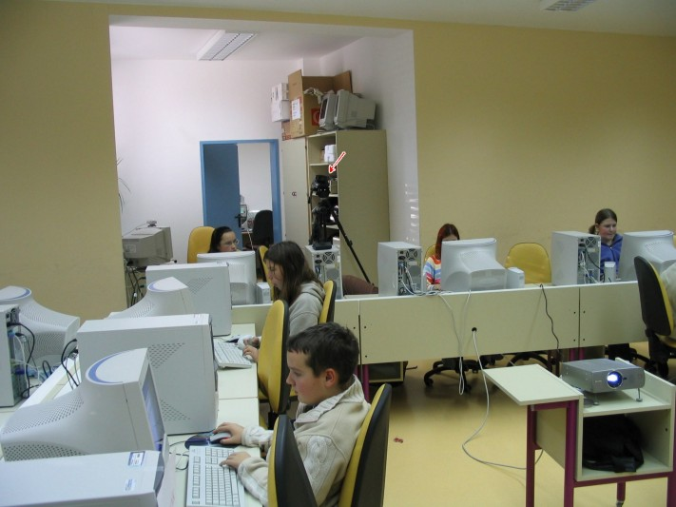
Fig. 1: Remote controlled camera in the classroom

Post analysis shows the following results:
- We should have more remote controlled cameras
- We need the video signal from the lecturer's computer
- We need higher bandwidth (at least 512 kbps ideally 768 kbps or more) and
- We need to provide the loop back to the student lecturer

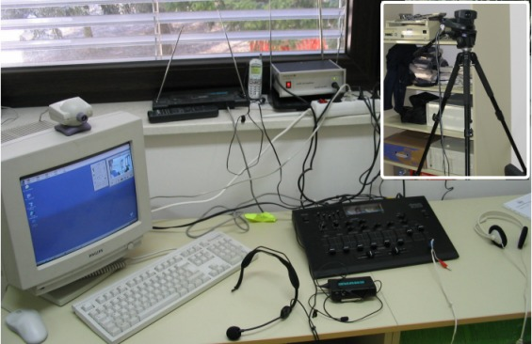
Fig. 2: Operators working place

We use only one remoter controlled camera in our experiment. We find out that one camera alone could not sufficiently cover the whole area of the classroom. This is especially important when we want to show the work of different team of the children. With the higher bandwidth (512 kbps per video stream) we could transmit multiple video streams at the same time and the viewers could pick the stream they want to watch. It is essential that we provide the video signal from the lecturer's computer. Adaptation time when camera faces the projected picture on the projector screen is too long and contrasts are so high that auto focus is unable to provide the clear picture. In the traditional procedure the student lecturer often watches the didactic expert in the classroom and observes his facial expression. It rarely happens that student forget about the time. But in our first case the student lecturer extend the lecture for a whole 7 minutes. This is unacceptable in the school schedule. The student got unsatisfactory grade but we agree this problem must be addressed different. Later we set an alarm clock that starts signaling 5 minutes before the end of the lecture and enable its normal completion.

- International Video Transmission
Our research team is an active partner in multiple international projects. We collaborate with the countries in the Balkan region, Western European Countries and also USA. One of our projects is bilateral project with the Serbia and Montenegro where we provide our knowledge and experiences of appliance of ICT in education. We joined the STEP project mentioned early in the article. The Serbian partner wants to establish national distance education teachers' network. We cooperate in the preparation of learning material, development of infrastructure and provide our knowledge about the distance learning. But when we successfully conduct the videoconferencing test (in our local environment), and present it to our project partners, it was incorporated into the project.
This was done particularly because students from both countries could sufficiently communicate in their natural languages. At least in the teaching of computer science we could estimate that students are capable to totally understand lectures. After Serbian's didactics experts review our recorded tests they agree that it would be valuable upgrade to the learning process. Students gain different perspective if they are able to watch teaching procedures from other countries and comment actions afterward.
The whole experiment was well prepared but the technical requirements were too high. Even if internet infrastructure is well developed in one country the bottlenecks are the international links (we could establish only 128 kbps stable link). The bottlenecks prevented us to establish high quality videoconference between our two educational institutions. Therefore at the present the only high quality solution is multiple ISDN links and reflector for multipoint videoconference calls.
Tests we conduct show better results in broadcast (one way transmission only). The quality of video and audio was almost acceptable. Occasionally we experience the stream interruption because of dynamic situations in the internet which is beyond our ability to control. But we expect this to end in the near future. The broadcast has additional benefit. We are able to transmit video stream to multiple location and end points does not need any costly equipment. Students are able to observe theirs colleagues at home.
Our current established system can be described by the schema on Fig. 3.
If we want to transmit video to larger amount of individual clients we have to prepare different architecture. The best solution is to install cascading proxy video server. Proxy video server requires only one incoming video stream but it can transmit multiple unicast of multicast streams. By cascading proxy video servers we can transmit video to huge amount of clients.

Fig. 3: Configuration schema

- Didactical Analysis
Technical and organizational aspects are not only two topics which are important for classroom video transmission. The main reason for classroom video transmission was different. We wanted to show our students more authentic atmosphere of the classroom. It was known for quite some time that a group of people sitting at the back of the classroom presents disturbance. But in many occasions we have no other means then in class observation.
Before we test the classroom video stream we could only speculate about the changes we may encounter. But when conduct the test and see the results we were able to grasp the new reality. Despite the fact that camera was remote controlled and it moves from time to time we find little distraction in the children behavior. Probably we were able to "hide" the camera beyond their visual field. We also disable the operation camera LED which indicates that camera is running.
The results are based on assessment of viewers and didactics expert. But in the future we will conduct a pedagogical experiment. The results can be grouped in three categories: classroom attendees (pupils in our case), student lecturer and technical issues.
Classroom attendees were not so retained, and were more collaborative. They were more focused to the lecture. Since school does not use bells any more they missed the lecture's deadline.
Teaching student knows he was recorded. In the old system he always looked to their fellow students and didactics expert to see eye signs from them. But in the experiment he could receive feedback only from the children. That gives him false reading of time which is unacceptable. The same thing may happen to the new teachers when they start their career. It is often hard to plan the lecture up to the minute precision. When students need to perform individual actions they might be slow. Sometimes even technical glitches might prevent planned lecture. But every teacher knows he/she must advance through prescribed procedure and pass the knowledge to his/her students. If he/she loses five minutes at each lecture these accumulate and students do not receive all prescribed knowledge.
Post analysis of the lecture over the videoconference (see Fig. 4) enables communication between student lecturer, didactic expert and other students. Teaching student admit he lost track of time and he also admit he lose too much time helping individual pupils to complete their tasks.

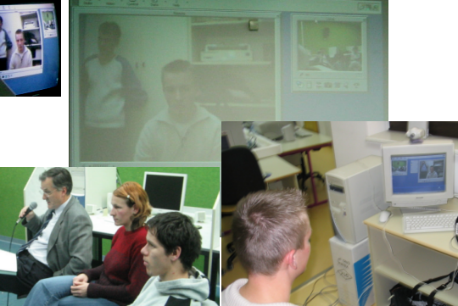
Fig. 4: Post analysis of the lecture

We gain also one thing we never thought before. Didactics expert was able to comment student lecturer's actions immediately. This was something unthinkable in the traditional approach because it would disturb lecture. Previously didactics expert takes notes and later explain comment to students what was wrong. In many occasions students did not notice or remembered events or actions which were didactically questionable.
Analysis also reveals that we need more than one camera in the classroom. Capturing video from the projected screen was over exposed and distance viewer could hardly see what was projected in the classroom. For didactical purposes this must be solved at all costs.
By now we managed to transmit video from the computer classroom because transportation of equipment and ICT infrastructure to other classrooms are not easy task. In the future another multipurpose classroom will be equipped with the video conferencing equipment and different lectures (language, biology, chemistry, history ...) will be transmitted.
We still have not solved the problem of language translation. Should we apply interpreter or we prepare translation of the lecture in advance? But we could transmit video from English class anywhere.

- Conclusion
Throughout the Europe we hear the need to standardize the education systems. Bologna declaration will in the near future change the university and higher education. But the education starts at the lower level in primary and secondary schools. Therefore teachers of the near future will need to know the differences in lower education between countries as well. International classroom video transmission is only a start in the new type of global education. It enables students to see different style of lectures in different countries. Even if we have only few video transmissions a year this is still better than nothing. Recorded transmission can be used many times for different purposes. Despite the promising results we have we must pay attention to the privacy rights of individuals and obey the law in this matter.

References:
- Krašna Marjan, Gerlič Ivan, "Videoconferences in education", Research project report, Faculty of Education, 2000
- Gerlič Ivan, Bratina Tomaž, "Didactical requirements for video learning material - workshop", Computer Summer School, CoLoS, Maribor, 1. - 5. july 2002. Maribor, 2002.
- Krašna Marjan, Gerlič Ivan, "ICT trends in education", Informatics, Educational Technology and New Media in Education, Sombor 1. - 2. april, 2005, Sombor
- Bratina Tomaž, Krašna Marjan, "Implementation of videoconferencing systems in organizing of hospitations", Informatics, Educational Technology and New Media in Education, Sombor 1. - 2. april, 2005, Sombor
- Haug Guy, "Trends and issues in learning structures in higher education in Europe", (Final version - revised after the Bologna meeting of 18-19 June 1999)]
- De George, R. T., "Business Ethics and the Information Age", Ethics and Values in the Information Age, 2002, pp. 23 – 33.
- Moor, J., "Toward a Theory of Privacy in the Information Age", Ethics and Values in the Information Age, 2002, pp. 289 – 319.
- Day L. A., "The media and privacy: A Delicate Balance", Ethics in media communications: cases and controversies, 2000, pp. 121 – 163.
- Armstrong, R., "Human Subject Research and the Internet: Ethical Dilemmas", Office of Research Administration, 2003.
- Cvetko, A., "Človekove pravice do zasebnosti v delovnem pravu" (eng. Human privacy rights in labor law), Podjetništvo in delo, 1998, pp. 1 – 43.
- Personal data protection act (ZVOP) – The Official Gazette of the Republic of Slovenia, Number 86-3836/2004, pp. 10389

