Ranking regions through cluster analysis and posets

RESTREPO, GUILLERMO
Laboratorio de Química Teórica
Universidad de Pamplona
Ciudad Universitaria
COLOMBIA
http://www.unipamplona.edu.co/upw_pdf/hv_grestrepo_esp.pdf

BRÜGGEMANN, RAINER
Department Ecohydrology
Leibniz-Institute of Freshwater Ecology and Inland Fisheries
Müggelseedamm 310 , D-12587 Berlin
GERMANY
http://www.igb-berlin.de/weborg/frames_abtlg/igbabtframeset_d.html

Abstract: - An important step in the chemical analysis of chemical sets Q is the establishment of the order among the elements in Q. An example of this appears in environmental chemistry where it is important to rank the objects of the set to try to establish priorities in the analysis or in the procedures to recover a contaminated place. We showed how a set Q of objects defined through their properties can be classified in order to find equivalence classes in the set. Such equivalence classes can be obtained through the use of cluster analysis where the classes are similarity classes in Q. We showed that it is possible to extract a representative of each class in order to rank the elements of the set and finally to obtain a Hasse diagram. We applied our methodology to a set of 59 regions of Baden Wuerttemberg, Germany, monitored with respect to Pb, Cd, Zn and S pollution in the herb layer. That example showed 26 equivalence classes (26 representatives) using cluster analysis. Thus, we built up a Hasse diagram that indicated the degree of contamination of the 26 representative regions.

Key-Words: - Cluster analysis, Principal components analysis, Partial order, Mathematical chemistry

1 Introduction
Normally, the chemical procedures yield a huge amount of data per analysis. This is evident in all the fields of chemistry. In analytical chemistry, for instance, it is usual to have several samples to analyse. From each sample it is possible to produce a particular set of data (i.e. a chromatogram). From this particular set it is also possible to produce more data (MS, UV-VIS, NMR, IR spectra). In organic and inorganic chemistry the situation is similar (reaction conditions). Quantum computational chemistry shares the same feature with experimental chemistry (amount of numbers produced calculating quantum properties of the molecules). In general, chemistry is a science based on data. For this reason we have at this moment two branches of chemistry specialised in this respect. They are chemometrics [1] and chemoinformatics [2].
One of the aims of these two disciplines is to develop methods to manage the data through 1) their reduction or 2) selection of representative data from the original set. One of the most common methods to achieve the first goal is the Principal Components Analysis [3] that made linear combinations of the original data and assigns to each combination a value of variability. The reduction results from the selection of the combinations (principal components) that contain a high-accumulated variability. The tool used to achieve the second target (selection of representative data from the original set) is the classification of data or the classification of the elements under study. One of the most common classification method is the Cluster Analysis (CA) [4]. Suppose we have a set Q of objects (elements or properties), then CA calculates the similarities among all the objects and then builds up groups or clusters of similar objects. Then, CA allows reducing the time of analysis because the objects that belong to a particular cluster share their properties (they are similar) [4]. In this case, if we need to study the behaviour of the objects of the set, then we can, thanks to CA, select an object of each cluster as the representative of their similar elements. Note that often it is a good strategy to select an object that represents the cluster at best. According to Bock [5], one can select central points of the cluster (the centroids of the cluster (see below)) and measure their degree of representativity by indices [6]. Thus, we can reduce the time and cost of several chemical procedures. This particular sort of research in chemistry has been further used in drug design and QSAR studies with satisfactory results [7]. But, this sort of chemical research is not new; the first use of the similarities as a tool to predict chemical facts was the development of the Periodic Law and its graphical representation, the Periodic Table [8,9]. It was using the similarities among the chemical elements that Mendeleev could predict the properties of unknown elements.
Another point of view of the selection of representative data (elements or properties) from a set is to consider the total set of data as made from equivalence classes. The inclusion of these classes implies the inclusion of equivalence relations [10]. This point of view provides a wide spectrum of possibilities to select the criterion to establish divisions or groups in the original set. Under this general point of view, the clusters in CA show objects that have a similarity relationship as the equivalence relation. Thus, every group of objects can be regarded as a particular equivalence class in the set Q of objects. Examples, as the one of the chemical elements, abound in chemistry, i.e. functional groups, chemical reactions, poisons, medicine, etc [11].
Then, the establishment of equivalence classes in the set under study and the latter extraction of a member of each class is a way to reduce the number of measures done in the set. Thus, once we have a member of each class, it is possible to rank these members with the aim of determining which of them is the most important to start the analysis on [12]. Ranking can be seen as a problem of Multivariate Statistics, as each chemical or object is described by many characteristics. Often the decision, which chemical is of the main importance is based on subjective preferences by which the characteristics of the chemicals are aggregated to get a ranking index, which is a one-dimensional quantity. Here the introduction of subjectivity is to be avoided by application of simple concepts of the partial order theory [13]. This mathematical theory ranks the selected representatives of equivalence classes and according to the final rank (Hasse diagram) determines the priority of the objects to start the analysis. According to the applications of posets in chemistry [12,14], it is possible to define every object as a tuple of its properties (same procedure to define an object in CA).
In this paper we combine the results of CA to build up a Hasse diagram of a set 59 regions of Baden Wuerttemberg, Germany, where each one was monitored with respect to Pb, Cd, Zn and S pollution in the herb layer.

2 Methods
Due to the fact that CA and posets are based on the concept of set relations and classes, we discuss these concepts in the following: In ordinary contexts the idea of relation is regarded as a sort of connection between items. In mathematical terms such idea may be defined as a set of ordered pairs.
Definition 1. Let R be a relation from a set A to a set B. Thus, the relation R from A to B assigns to each pair (a,b) in AB exactly one of the following statements [10]:
i) “a is related to b”, written aRb,
ii) “a is not related to b”, written a(-R)b.
On the other hand, a relation that is reflexive, symmetric and transitive in a set is an equivalence relation on that set. Some ordinary examples are the relation of identity, the relation of parallelism between straight lines and the relation of congruence between figures, among others [15]. The chemical concept of isoelectronic compounds is another example. The importance of the equivalence relations is that they justify the application of a general principle of abstraction [15]: objects that are equivalent in some respect generate identical classes. Thus, as we mentioned above, the analysis of equivalence classes of objects rather than of the objects themselves is often much simpler, easy and economic.
Definition 2. A relation R in a set A is called an equivalence relation, iff it satisfies the following axioms:
i) $∀a∈A$, (a,a)$∈$R (reflexive),
ii) If (a,b)$∈$R$⇒$(b,a)$∈$R (symmetric),
iii) If (a,b)$∈$R and (b,c)$∈$R$⇒$(a,c)$∈$R (transitive).
Definition 3. The equivalence classes of an equivalence relation R on A are the sets R[a]={x$∈$A : aRx}. The set {R[a] | a$∈$A} of all the equivalence classes is called the quotient of A by R and written A/R [16].
To discuss the application of these definitions in CA and posets it is necessary to introduce a set of objects that we will call Q.
Definition 4. Let Q={c_{i} | i$∈$I} the set of work, where the index set I is the set of positive integers. Every c_{i} is an object.
Definition 5. Let IB={q_{j} | j$∈$I} the set of properties. Every q_{j} is a property (The symbol IB comes from the name information basis mentioned by Brüggemann et al. [12]).
Definition 6. Let c_{i}={q_{j}(c_{i}) | j$∈$I } the i-th chemical object, where q_{j}(c_{i}) means the property q_{j} for the object i.
In this way each chemical object is defined through its properties. The number of properties is the cardinality (number of elements) of the set IB.
Our intention is to show how CA can be used to build up equivalence classes in Q. Then we will show how we can use the clusters (classes) to extract one representative of the cluster and start the rank of the classes through the poset theory.

2.1 Finding classes through CA
The procedure of CA starts calculating the similarity among the objects in Q. This is made using a similarity function (SF), commonly a metric (distance) [17]. The distance is calculated between every couple of c_{i}$∈$Q taking advantage of the order of each c_{i} (tuples). Thus, if |IB|=n, then c₁={q₁(c₁),q₂(c₁),...,q_{n}(c₁)} and c₂={q₁(c₂),q₂(c₂),..., q_{n}(c₂)} and the metric selected to calculate the similarity between c₁ and c₂ operates over q₁(c₁)-q₁(c₂), q₂(c₁)-q₂(c₂),... and q_{n}(c₁)-q_{n}(c₂) respectively. Finally, if |Q|=m, then we obtained a similarity matrix of dimension mm. Afterwards, we apply a grouping methodology (GM) to build up the clusters in Q [9]. This GM is a way to calculate the distance between an object and a set. The final product of this procedure of searching for similarities is a 2-dimensional plot called a dendrogram (tree) that may be considered as a map of neighbourhoods (Figure 1). According to the chemotopological procedure [18] it is possible to extract different neighbourhoods for the elements in Q by the selection of a natural number n to do cuts on the tree. In this way every selection of an $1≤n≤|Q|$ produces a particular branch of the dendrogram. Such a branch is a neighbourhood or equivalence class for the elements that belong to it. A selection of n=1 produces the following neighbourhoods: {c₁}, {c₂}, {c₃}, {c₄}, {c₅}, {c₆} and {c₇}. On the other hand a choice of n=2 produces these neighbourhoods: {c₁,c₂}, {c₃}, {c₄,c₅}, {c₆} and {c₇}. Thus, for a set Q we have |Q| different possibilities to extract neighbourhoods or similarity classes of the dendrogram.
Figure 1. A dendrogram (tree).

However, an open question of the CA is the way to select clusters [4]. Commonly this selection depends on the knowledge that the researcher has regarding the set Q under study. This fact introduces subjectivity in the interpretation of the dendrogram. Restrepo et al. recently [19] developed a mathematical method (selection number) to extract clusters from a dendrogram using the chemotopological approach and the number and population of the clusters obtained by the selection of an n.
Definition 7. Let Q be a non-empty set and TSPn the collection of neighbourhoods for a given $1≤n≤|Q|$. GP_{n} is called the geometrical population of TSPn if $∀D_{\text{jn}}∈{\text{TSP}}_{n}$, ${\text{GP}}_{n}=\prod{|D_{\text{jn}}|}$.
Definition 8. Let $S=(|{\text{TSP}}_{n}|⋅ {\text{GP}}_{n})$the selection number.
Method. Given a non-empty set Q, a dendrogram T on Q and the selection number S. The value of n for doing cuts on T to obtain the clusters D_{n} of Q is the one that produces the maximal value of S.
Thus, for the dendrogram shown in figure 1 the value of n for doing chemotopological cuts is n=3 (due to n=4 produces the same clusters). The values of S for each n appear in Table 1.

n | 1 | 2 | 3 | 4 | 5 | 6 | 7
S | 7 | 20 | 24 | 24 | 15 | 12 | 7
Table 1. Values of S for the dendrogram of figure 1.

In mathematical terms that we found through CA are equivalence relations that we call P. For the dendrogram of figure 1 we have the following equivalence classes for n=3: P[c₁]=P[c₂]=P[c₃]={c₁,c₂,c₃}, P[c₄]=P[c₅]={c₄,c₅}, P[c₆]={c₆} and P[c₇]={c₇}.
Now, to start a ranking process we need to select a representative of each class. We can do this extracting the member of each class that is near the centroid of the class; in other words, the member of the cluster nearest the centre of the cluster.

2.2 Ranking representatives
Once we have the representatives of each class we can rank the c_{i} according to their properties q_{j}$∈$IB as follows:
Definition 9. Let c₁, c₂$∈$Q and q_{j}$∈$IB, then c₁ ≤ c₂ ⇔ q_{j}(c₁) ≤ q_{j}(c₂) for all q_{j} of IB is called a product- (or component-wise- ) order if it obeys the following axioms of order:
i) reflexivity (an object can be compared with itself)
ii) antisymmetry (if an object c₁ is better than c₂, then c₂ is worse than c₁),
iii) transitivity (if c₁ < c₂ and c₂ < c₃ then c₁ < c₃; c₁,c₂,c₃ ∈ Q).
It is important to note that these axioms are different from those of equivalence relation. The machinery of ordering and of comparing of objects arises from the axiom of antiysymmetry.
If only one property is regarded, then for all objects a "lower than or equal"-relation can be established. In general, several properties do not perfectly correlate, hence the product order cannot be established for -at least- some objects. We called such objects “incomparable” [12]. A standard text about this kind of order relation can be found in reference [13]. The product order can be used to derive a digraph, where the vertices are the objects and after reducing relations, due to the transitivity, all remaining relations correspond to an arrow. Often this digraph is drawn in a way that an object c_{x} worse than c_{y} is located above c_{y}. Hence, the direction of the arrow (pointing to the worst object) can be derived from the location of c_{x} and c_{y}. This kind of visualisation is known as a Hasse diagram [12,13].
Considering the dendrogram shown in figure 1 and its equivalence classes, suppose that we extract as representatives of each class: c₂, c₅, c₆ and c₇ respectively. Now, according to the properties q_{j}$∈$IB of each of these representatives, we can build up a rank (Hasse diagram) for the representatives. A hypothetical ranking of these objects is the one in figure 2.
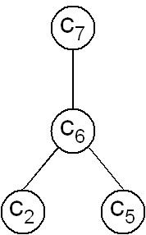
Figure 2. A Hasse diagram.

In this case, if the objects are chemicals, we can conclude that we need to pay particular attention to the object c₇, then c₆ and finally c₂ or c₃. We show in the following the application of this procedure to a set of regions of Baden Wuerttemberg, Germany, monitored regarding Pb, Cd, Zn and S pollution in the herb layer.

3 Results
We applied the procedure mentioned above to a set Q of 59 regions of Baden Wuerttemberg, Germany, monitored with respect to Pb, Cd, Zn and S pollution in the herb layer (the labels of the regions are 1-54 and 56-60) [23]. Thus, each region, the set Q and IB could be defined as follows:
Definition 10. Let IB={q_{j} | j$∈${Pb,Cd,Zn,S}} the set of properties.
Definition 11. Let c_{i}={q_{j}(c_{i}) | j$∈${Pb,Cd,Zn,S}} the i-th region, where $1≤i≤\text{59}$.
Definition 12. Let Q={c_{i} | $1≤i≤\text{59}$} the set of regions.
We applied Principal Components Analysis (PCA) to the set Q. We found correlations r<0.7 among the four properties which means no linear dependences among them. We generated four principal components with the following percentages of variability PC₁=51.9%, PC₂=24.7%, PC₃=18.2% and PC₄=5.2%. Thus, the three former PCs contain the 94.8% of the variability. However, the majority of regions c_{i} are concentrated near the centre of this space of three PCs and for this reason we do not show such a figure. On the other hand, we found that the PC₁ is sensitive to the content of Pb and Zn in the regions, PC₂ shows mainly the content of Cd and PC₃ the content of Pb and S.
Afterwards, we applied CA using the Euclidean distance (1) as SF and the unweighted average linkage (2) as GM. In this way we obtained the dendrogram shown in figure 3.
$d(c_{k},c_{l})={\left\langle \sum{|q_{\text{jk}}−q_{\text{jl}}|^{2}}\right\rangle }^{1/2}$ (1)
$f(r,s)=\frac{n_{A}}{n_{A}+n_{B}}f(A,s)+\frac{n_{B}}{n_{A}+n_{B}}f(B,s)$ (2)
A,B and s means the regions c_{i} to group, r is the reunion of A and B; f(A,s), f(B,s) and f(A,B) are the Euclidean distances between A and s, B and s and A and B, respectively [1].
Afterwards, we applied the chemotopological approach taking advantage of the selection number S. In this way we extracted the clusters or equivalence classes from the dendrogram. The maximal value of S occurred when $1≤n≤\text{59}$ was equal to 4. The classes that we obtained appear in table 2. The final procedure in the CA study was the selection of a representative per class. To do this, we calculated the Euclidean distance (1) between each member of each class and the centroid of the class. We selected as representative of the class the furthest region to the centroid. In the case of having classes of just two regions, we calculated the Euclidean distance (1) among each member of the class and the centroids of the other classes. Once again, we selected the furthest region. The representatives of the 26 classes appear in table 2.
The next step of our study was the construction of a Hasse diagram taking into account the properties q_{j} of the representatives selected. The objects were organized in four levels (Figure 4), as the longest chain contains four elements (the chain me1-11-20-24). Some objects are located in the third level, just for the sake of clear visibility. In comparison to the Hasse diagram, containing 59 regions (not shown) a by far more simple Hasse diagram is obtained by applying CA. The interpretation is facilitated by extending the object set Q by four fictitious elements me<i> and one element me (Figure 4).
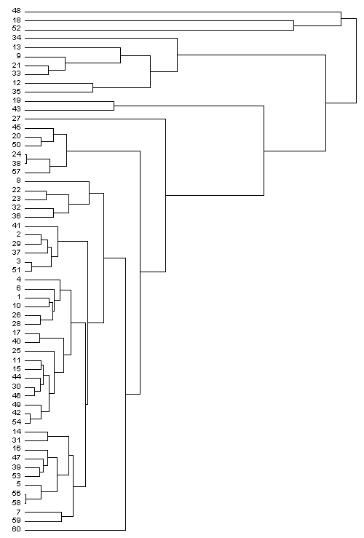
Figure 3. Dendrogram of the 59 regions studied.

Class | Repres. | Class | Repres.
{48,18,52} | 18 | {4} | 4
{34} | 34 | {6} | 6
{13,9,21,33} | 13 | {1,10,26,28} | 28
{12,35} | 12 | {17,40} | 17
{19,43} | 19 | {25} | 25
{27} | 27 | {11,15} | 11
{45,20,50} | 20 | {44,30,46} | 46
{24,38,57} | 24 | {49,42,54} | 42
{8} | 8 | {14,31} | 14
{22,23,32,36} | 23 | {16,47,39,53} | 53
{41} | 41 | {5,56,58} | 56
{2,29,37} | 29 | {7,59} | 59
{3,51} | 51 | {60} | 60
Table 2. Classes obtained for the set Q and their representatives.

The elements me<i> have the mean value of the i-th attribute taken over all 59 objects, and zeros for the other attributes. The fictitious element me is characterised by mean values in all its four properties.

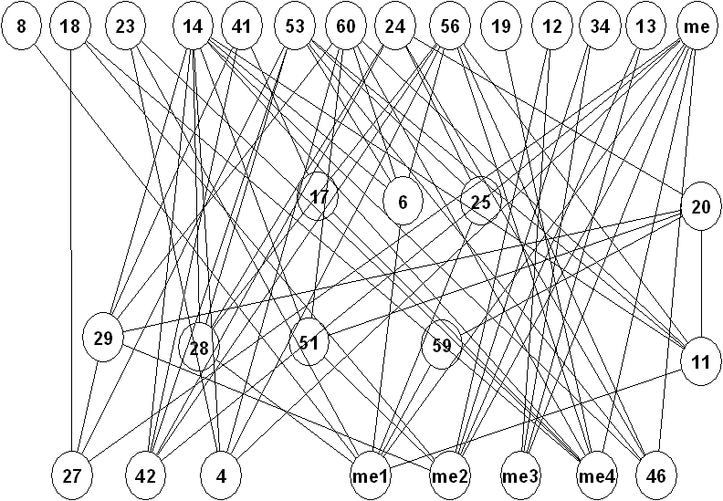
Figure 4. Hasse diagram of the representatives, supplied by fictitious elements.

It can be seen that me is a maximal element. Therefore, there is no object that has larger values simultaneously in all four chemical elements than the mean-values. Region 8 is only connected with me1. That means that region 8 has in Pb larger values than the mean value taken over all 59 objects; however, region 8 has smaller values than the corresponding mean values in the remaining three elements. Similarly, region 19 is only connected with me4; hence, region 19 has a pollution pattern with S-values larger than the mean of S. However, region 19 has fairly low values in all other chemical elements. Four regions (4, 27, 42, 46) must have lower values than the means (however, clearly no zero-values; in that case they should be located below one of the me<i>-objects). As a final example, we analysed the outgoing valencies of the digraph: me3 has the valency of four; hence, at least four regions must have larger values in Zn than the mean of Zn. Beyond this, comparing it with other me<i>-objects it has a strikingly low valency. Therefore, the pollution pattern of both Cd, Zn above the mean values can only appear four times. It can be easily checked by the digraph shown in Fig. 4 that this pollution pattern is realised by the regions 12, 34 and 13. Since the fourth valency is assigned to another fictitious object "me", all representatives are found having this peculiar pollution pattern. Adding the equivalent regions (table 2) there are 7 regions out of 59 showing this Cd, Zn-pattern. This fact can be interpreted due to former mining activities.

4 Conclusion
In some chemical analysis it is important to reduce the number of data considered in the analysis. It is common to classify the data to select representatives of each class and achieve the reduction. However, in some cases a classification is not satisfying. The reason is that sometimes it is necessary to know the order of the data to establish a priority in the analysis or to pay particular attention to a certain sort of data. When the order is necessary, it is possible to do a Hasse diagram for the data. However, the consideration of the whole set of data to build up such a diagram can produce a very difficult Hasse diagram. In spite of this, we can consider the set of the representatives to reduce the set under study. In this paper we showed as an example of this procedure the analysis of 59 regions of Baden Wuerttemberg, Germany, monitored with respect to Pb, Cd, Zn and S pollution in the herb layer. We applied CA using the Euclidean distance as SF and the unweighted average linkage as GM. In this way we obtained a dendrogram using the chemotopological procedure to select clusters (selection number). We found 26 equivalence classes (clusters). Then, we selected a representative of each cluster calculating the nearest member of each class to its centre. In this case we extracted 26 representatives from the original set Q of 59 regions. Then, we built up a Hasse diagram for these 26 regions and we found that we can organise the representatives in four levels in their degree of pollution. Also, we found that there is no region that has larger values simultaneously in all four chemical elements than the mean-values. On the other hand we showed that region 8 has a larger value of Pb than the mean value taken over all the 59 objects. The same occurred with region 19 that has a pollution pattern with S-values larger than the mean of S. We also found four regions (4, 27, 42, 46) with lower values than the means.

References:
[1] Otto, M. Chemometrics: Statistics and Computer Application in Analytical Chemistry; Wiley-VCH: Weinheim, 1999; pp 148-156.
[2] Bajorath, J. Chemoinformatics: Concepts, Methods and Tools for Drug Discovery (Methods in Molecular Biology); Humana Press: Totowa, 2004, 524pp.
[3] Dunteman, G. H. Principal Components Analysis (Sage University Paper series on Quantitative Applications in the Social Sciences, No. 07-069). Sage Publications: Newbury Park, 1989; 96 pp.
[4] Everitt, B. S. Cluster Analysis. Arnold Publishers: Cornwall, 2001; pp. 1-6.
[5] Bock, H. H. Automatische Klassifikation, Vandenhoeck&Ruprecht, 1974.
[6] Goodall, D. W., Deviant index: A new tool for numerical taxonomy. Nature, 210, 1966, p. 216.
[7] Shen, Q.; Jiang, J.-H.; Jiao, C.-X.; Huan, S.-Y.; Shen, G.-l.; Yu, R.-Q. Optimized Partition of Minimum Spanning Tree for Piecewise Modeling by Particle Swarm Algorithm. QSAR Studies of Antagonism of Angiotensin II Antagonists. J. Chem. Inf. Comput. Sci. Vol. 44, 2004, 2027-2031.
[8] Mendeleev, D. I. Sootnoshenie svoistv s atomnym vesom elementov. Zh. Russ. Khim. Obshch. Vol. 1, 1869, 60-77.
[9] Restrepo, G.; Mesa, H.; Llanos, E. J.; Villaveces, J. L. Topological Study of the Periodic System. In: Rouvray, D. H.; King, R. B. (Ed.), The Mathematics of the Periodic Table; Nova: New York, In press, chapter 5.
[10] Lipschutz, S. General Topology, McGraw-Hill: New York, 1965, p. 226.
[11] Rouvray, D. H. Definition and Role of Similarity Concepts in the Chemical and Physical Sciences. J. Chem. Inf. Comput. Sci. Vol. 32, 1992, 580-586.
[12] Brüggemann, R., Halfon, E., Welzl, G., Voigt, K., Steinberg, C. Applying the Concept of Partially Ordered Sets on the Ranking of Near-Shore Sediments by a Battery of Tests. J. Chem. Inf. Comp. Sc. Vol. 41, 2001,pp. 918-925.
[13] Trotter, W. T. Combinatorics and Partially Ordered Sets Dimension Theory; John Hopkins Series in the Mathematical Science; The J. Hopkins University Press: Baltimore, 1991.
[14] Voigt, K., Brüggemann, R., Pudenz, S. (2004). Chemical Databases Evaluated by Order Theoretical Tools. Anal Bioanal Chem. 380, 2004, pp. 467-474.
[15] Suppes, P. Axiomatic set theory, Dover: New York, 1972, p. 80.
[16] Potter, M. Set Theory and its Philosophy. Oxford: Oxford, 2004; p. 129.
[17] Willett, P.; Barnard, J. M.; Downs, G. M. Chemical Similarity Searching. J. Chem. Inf. Comput. Sci. Vol. 38, 1998, pp. 983-996.
[18] Restrepo, G.; Mesa, H.; Llanos, E. J.; Villaveces, J. L. Topological Study of the Periodic System. J. Chem. Inf. Comput. Sci. Vol. 44, 2004, 68-75.
[19] Restrepo, G.; Llanos, E. J.; Villaveces, J. L. Trees (Dendrograms and Consensus Trees) and their topological information, in: Basak, S.; Sinha, D. K. (Ed.), Proceedings of the Fourth Indo-US Workshop on Mathematical Chemistry, University of Pune, Pune, India, 2005, pp. 39-62.
[23] Brüggemann, R.; Voigt, K.; Kaune, A.; Pudenz, S.; Komoßa, D.; Friedrich, J. Vergleichende ökologische Bewertung von Regionen in Baden-Württemberg, GSF-Bericht 20/98 (Final report of a project , Id-no: 209501.02 of the Landesanstalt für Umweltschutz des Bundeslandes Baden-Württemberg, Germany.)

