How Deep in Molecular Space can Periodicity be Found?

KEN LUK, RAY HEFFERLIN, GABRIEL JOHNSON
Physics Department
Southern Adventist University
Collegedale, Tennessee 37315
UNITED STATES OF AMERICA

Abstract: - We find occasional echoes of periodicity, i.e. the trends found in the chart of the elements, in several-atom (up to 32) molecules and use it to make forecasts for molecular data, some of which have been confirmed.

Key-Words: - molecular periodicity, data mining, binary compounds, halogenated organic compounds

1 Introduction
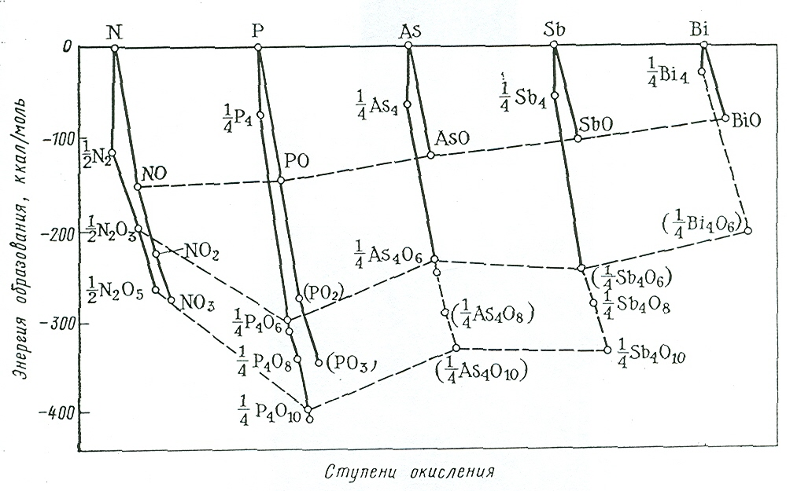
What is to be done if, due to lack of resources or interest, data for a needed molecular property is not provided by experiment (including combinatorial chemistry) or theory (including schemes to identify closed-shell species [1,2], molecular dynamics, or quantum mechanics)? In that case data mining may come to the rescue by providing at least approximate values. The simplest form of data mining is inter-polation, for instance between known molecules that are isoelectronic or isovalent (“horizontally” or “vertically” isoelectronic) or both [3]. More generally, data mining involves the identification of trends in known data for the property, trends that can be employed to make forecasts for the new data.
To determine a trend, data can be studied by their dependence on a function of the atomic numbers [4]; this semi-theoretical approach did, however, not yield precise forecasts for spectroscopic properties of diatomic molecules. Molecular data can be arranged with the sums of the period and group numbers of the atoms in the molecules. This arrangement led to the creation of Kong’s [5,6] extremely elegant periodic systems. These systems and the multi-dimensional systems of which they are projections have been successful in predicting values for spectroscopic properties of diatomic and triatomic species, but the sparseness of data for larger molecules makes it extremely unlikely that the work can be extended. Thirdly, data can be associated with topological indexes such as Balaban’s J_{het} index [7]. Finally, data can be analyzed as a function of the oxidation states of the central atoms in binary or ternary series; Russian chemists at Saint Petersburg University [8] amassed a library of such graphs showing heat of atomization (such as Fig. 1) and standard enthalpy of formation.
The quite striking similarities among these graphs, for central and ligand atoms from various groups, demonstrate that the periodicity can be found when one burrows deeper into molecular space. In this paper we report results from investigations that build on the Russian approach.
Fig. 1. The heat of atomization H_{a} (the energy, negative, required for the formation of free molecules from free atoms) as a function of oxidation state for group 5 central atoms. The data are normalized to one central atom; thus the ordinate for 1/2N₂O₅ is half the tabulated value.

2 Goals
The goal of this research is to find evidences of periodicity among molecules by plotting and analyzing quality tabulated data. We realize that such periodicity is imperfect (e.g., the five groups of points in Fig. 1 differ) and may for larger molecules become more and more difficult to find; we must determine in what kinds of molecules the trends can be recognized. The second goal is to use periodicity to forecast new molecular data. The forecasts, if confirmed, will strengthen the case for periodicity.

3 Plausibility argument
Consider any atom in a molecule, and suppose that we can change its atomic number Z sequentially. When Z becomes one of the atomic magic numbers, there should be a decrease in the stability of the molecule or even a loss of the atom. By extension, periodic changes might occur between these magic numbers.

4 Hypothesis
Let there exist molecules A_{l}B_{m}C_{n} … , where A is (are) the central atom(s) and where B and C are ligands. The oxidation state of A is defined by m and n; so if B is oxygen, then each increment of m adds two to the oxidation state and if C is hydrogen, then each increment of n reduces the state by one.
We define the periodicity of the molecules, operationally, as follows:
- Let there be data for several molecules plotted vs. a descriptor of atom A. The descriptor may be the number of times atom B or C replaces hydrogen in an organic molecule. It may be the location of the replacement(s), or a topological index, or the oxidation state of atom A, as in nitrogen and its oxides (Fig. 1).
- Let there also be data points for the same independent variable of molecules having different atoms A chosen from the same atomic group in which it is a member, as in P to Bi and their oxides (Fig. 1).
- Then, to the extent that lines drawn between or through the data are similar, the periodicity of the molecules is established with respect to the atoms in the group containing atom A, in this instance N to Bi.
It is the first hypothesis of this work that traces of periodicity will be found deep in molecular space.
Alternatively,
- Let there be a plot of data for several molecules vs. the various atoms in the same group as atom A, with the indices of B and C (m and n) fixed, e.g., a plot of difluorides on an axis having Be through Sr (Fig. 2).
- Let there also be on the plot several data points for molecules having different atoms B or C (or both) that are chosen from the same group(s), for example with dichlorides replacing difluorides (Fig. 2),
- Then, to the extent that lines drawn between or through the data are similar, the periodicity of the molecules is established with respect to atom B or C (or both).
It is an alternative formulation of the hypothesis of this work that this second manifestation of periodicity exists deep in molecular space.
In either event, it is the second hypothesis of this work that if a point is missing between other points along one of the lines, then a data forecast can be made by interpolation using graphical, least-squares, or neural network techniques.

5 Tests
Ref. [7] contains graphs like Fig. 1 for group 1(O, for oxides), Mg and Ca (O), 3 to 12 (O), 13(X, for halides, and H), 14 (O and H), 15(O and H), 16(O, S, and H), 17(F, O, and H), and 18(F), and graphs of H_{f}º(298.15K) for many of the same species. We have also plotted several of these binary series, using newer data from Ref. [9], in various ways.
Fig. 2. Standard enthalpy of formation for gaseous difluorides, dichlorides, dibromides, and diiodides, as dependent on the central atom, from bottom to top. The data come from the JANAF tables [10].

The N and P portions of Fig. 1 have been replotted. The data [9] (not normalized) for each value of l are quite linear with respect to oxidation state. From the linear fits one finds approximate values of H_{a} for the missing data: N₂O (-1164 kJ/mol), N₂O₂ (-1406 kJ/mol), P₂O (-1008 kJ/mol) and P₂O₂ (-1511 kJ/mol). No confirmation is found.
From Fig. 2 one may estimate H_{f}º(298.15K) for gaseous BeBr₂ to be approximately 210 kJ/mol; from a least-squares fit to the 15 data one obtains 207.5±16 kJ/mol; the NIST WebBook [11] gives 229.28 kJ/mol.
Graphs like Fig. 3, showing H_{f}º(298.15K) [12] for polyhalomethanes, display first and second periodicity (the slightly higher than expected data for abscissa 2, or period 3) and may allow forecasts.
Fig. 3. Standard enthalpy of formation for poly-halomethanes formed when the atoms shown on the abscissa are with CF₃, CCl₃, CBr₃ and CI₃.
Data H_{f}º(298.15K) [11] have been plotted for gaseous and liquid (Fig. 4) polyhalobenzenes. The isomers with two to four substitutions fall very close together on the plot (note the squares at abscissa 2). A least-squares fit to the bottom data in Fig. 4 yields -516.3 kJ/mol for C₆H₃F₃ and an analogous fit to the data for the gaseous phase gives -477.63 for C₆H₃F₃ and -112.9 kJ/mol for C₆H₅F; the CHERIC database [13] gives -116.6 kJ/mol, a reasonable confirmation. No confirming data have been found for either phase of C₆H₃F₃. The F, Cl, Br, I sequence shows periodicity at least at abscissa 2.
Fig. 4. Standard enthalpy of formation for gaseous fluorobenzenes (bottom) to iodobenzenes (top).

Now we consider another property, the boiling point [12], and larger molecules: monohalogenated biphenyls. Fig. 5 shows these species plotted against the halide being substituted for hydrogen atom number 2, 3, or 4. We see that if the datum for fluorine substituted into position 4 were lowered to be in the vicinity of 540K then there would be quite good periodicity (fluorine to bromine from bottom to top). As yet, no confirming or contradicting datum has been found.
Fig. 5. : 2-mono-, : 3-mono-, and : 4-mono-halogenated-1,1’-biphenyls as functions of the one substituted atom.

6 Conclusions

We find periodicity in molecules beyond triatomics. For H_{a} and to a lesser extent for H_{f}º(298.15K), the central atom and also the electronegative ligands of many binary and ternary compounds are periodic. For H_{f}º(298.15K), polyhalomethanes and poly-halobenzenes are periodic. The boiling points of 1,1’-biphenyl may be periodic. Several forecasts are made and two have so far been confirmed.

References
[1] L. Schulz, Catagories in Chemistry and Chem-ical Computers, Journal of Chemical Structure, THEOCHEM, Volume., year, and page numbers not known.
[2] C. J. Walters, K. Caviness, and R. Hefferlin, Global Molecular Identification from Graphs. IV. Croatica Chemica Acta, Vol. 77, 2004, pp. 65-71.
[3] R. Hefferlin and J. Knoll, On the use of Laplace’s Equation for Global Predictions of Inter-nuclear Seprations and Dissociation Energy, Journal of Mathematical Chemistry, Vol. 28, 2000, pp. 1-3.
[4] J. L. Gazques and R. G. Parr, Universal dissociation energy relationships for diatomic molecules Chemical Physics Letters, Vol. 66, 1979, pp. 419-422.
[5] F.-A. Kong, The Periodicity of Diatomic Molecules, Journal of Molecular Structure, Vol. 90, 1982, pp. 17-28.
[6] F.-A. Kong, An Alternative Periodic Table for Triatomic Molecules, in R. Hefferlin, Periodic Systems and their Relation to the Systematic Analysis of Molecular Data, Edwin Mellen Press, 1989, pp. 396-413.
[7] A. T. Balaban, Chemical Graphs, Part 48, Topological Index J for Heterotaom-Containing Molecules Taking into Account the Periodicities of Element Properties, MATCH, Vol. 21, 1986, pp. 115-122.
[8] S. A. Shchukarev, Neorganicheskaya khimiya, Vols. 1 and 2, Vysshaya shkola, 1970, 1974.
[9] L. V. Gurvich, Termodinamicheskie svoistva individual’nykh veschestv, Vols. 1A-4B, Nauka, 1978, 1979, 1981, and 1982.
[10] M. W. Chase, C. A. Davies, J. R. Downey, D. J. Frurip, R. A. McDonald, and A. N. Syverud, JANAF Thermochemical Tables, Third edition, Journal of Physical and Chemical Reference Data, Vol. 14, Supplement 1, 1985.
[11] http://webbook.nist.gov/chemistry/
[12] D. R. Lide, editor, Handbook of Chemistry and Physics, 84th edition, CRC Press, 2003-2004.
[13] http://www.cheric.org/board/view.php?code=f0
2&seq=10027&page=11

