A worm early detection system based on multi-similarity

HUI HE, MING-ZENG HU, WEI-ZHE ZHANG, HONG-LI ZHANG
Department of Computer Science and Engineering
Harbin Institute of Technology
Room C410, Dorm 10, Harbin 150001
CHINA

Abstract: - Internet worms are becoming a major threat to the security of today’s large-scale networks. The fast spreading nature of worms calls for a worm monitoring and early detection system. In this paper, an effective algorithm for early detection of the active worms and the corresponding detection system are proposed. The detection engine is the key components to the system, and the early detection algorithm based on multi-similarity is discussed in detail, which is the core of the engine, that integrates the worms’ behavior attributes with their traffic distribution and detects abnormal behavior by their similarity distribution change of some attributes. Our simulation experiments show that the system can detect the presence worms intrusion when attacks don’t arouse the sharp changes of the network traffic. It can detect the worm attack ahead of its overspreading on the large-scale network.

Key-Words: - Abnormal detection; worm detection system; early warning; multi-similarity

1 Introduction
Recent years, Internet worms are becoming a major threat to the security of today’s large-scale networks. Worms, like Code-Red, Nimida[5] and Slammer, spread all over the world in a few minutes. Almost explosive propagation of each worm has led to striking cost to our society. Such as, in the evening of November 2, 1988, Morris worm spread up to six thousands servers, which cost more than ten million dollars. On July 19, 2001, the Code-Red I [2][3], was widespread of the world. More than 250 thousand computers were attacked only in nine hours, It wasted more than 20 billion dollars. Later on, the Code Red II worm[4] cost more than 12 billion dollars.
And as the Internet grows, there are more potential targets to infect when the next worm break out. So an early warning system is essential in fighting against the Internet disasters, a just-in-time warning can be invaluable in saving money and limiting damages.
In this paper, we propose an early detection system based on multi-similarity, which integrate a novel technique that detects the concerted scan activity of an ongoing worm attack earlier. Especially, when the probing traffic are covered by the background, it has no effect on the overall traffic yet.

2 Related works
Recently, people have paid more attention to the necessity of monitoring Internet for worms’ behavior and its detection system. Using Internet traffic measurements to detect worms, Zou et.al.[1], proposed a Kalman-fiter-based detection algorithm. Wu et al. [11] proposed a victim counter-based detection algorithm. Jung [8], David Moore[9,12] proposed “network explore” to detect the abnormal event and worms propagation. Recently, in [6], Guofei Gu proposed early warning based on local victim information. Xuan Chen[10] proposed DEWP, which detects worm probing traffic by matching destination port numbers and Vincent Berk [7]introduced the idea of monitoring the number of ICMP destination unreachable packets generated by routers to its detection system, when Internet worms probe many vacant IP addresses.
These methods above mainly focus on the single character matching such as ICMP unreachable packets, TCP SYN packets or TCP RST packets and destination ports. Single character match may identify some legitimate traffic as potential worm traffic. As for the other method, they depend on the attacking traffic large enough. Or they mainly focus on the detection of local network, not of the large-scale network. In order to detect worm more effectively, there are two factors lies in as following. First, in the time aspect, we consider the earlier we find the attack behavior, the better detection method we get. Second, in the scale degree, it is important to consider how much the attack traffic is. The less attack traffic percentage comparing to the background we find it, the better detection method we have. In this paper, our research mainly focuses on the later. And to some degree, worms probing traffic is always too small to sense it. And the probing behavior is just at the very early stage of worms attack. So if we well solve the later problem, we also contribute to the former one to some degree.

3 Worms and Similarity
3.1 Definition
Definition 1: (similarity coefficient). The similarity coefficient is denoted as , where X: {x₁, x₂…. x_{n} | x_{i} R} and Y :{ y₁, y₂…. y_{n} | y_{i} R } are two stochastic variable sequences, Cov(X, Y) is the covariance between X and Y, DX and DY are the variances of the stochastic variable sequence X and Y respectively.
Definition 2: (traffic attribute space) Let TAS = {A₁, A₂….A_{n}} be the set of traffic attributes such as port number, packet size, protocol, IP address…etc, which characterize the traffic flow. Concerning different attribute factor A_{i}, its value space may be different. For example, A_{port number} = {a_{i}| a_{i} N}, while A _{packet size} = {a_{i}| a_{i} R}.
Definition 3: (attribute distribution sequence) Given an attribute factor A TAS, there is {a₁, a₂ …a_{n}} {A} at time τ. The attributed distribution sequence of A at time τ can be denoted as (τ_{1,} τ_{2,} τ_{3….} τ_{n}) where τ_{i} denotes the percentage of the a_{i} traffic to the overall traffic.
Definition 4: (s-similarity) Given an attribute factor A TAS and two different attribute distribution sequences at time τ and τ’, then is defined as s-similarity of τ’ according to τ.
Definition 5: (m-similarity) For all the A_{i} TAS, is defined as m-similarity of τ’ according to τ. is defined as the contributor factor, which reflects the changing magnitude of s-similarity of A_{i}. is defined as the selector factor, where , if the changing scope is above a threshold ξ during a span of time, then , inversely . (ξ is a parameter described in Section 4).

3.2 Worm behavior and similarity
A worm is a form of maleware that spreads from host to host without human intervention. A worm locates vulnerable hosts by generating a list of address to probe and then contacting them. We summarize the operational steps of an Internet worms: targets selection, probing, attack, and self-propagation. And the stages of probing and attack depend on the Internet and have much effect on it. For example, worms spread increases network latency remarkable, by sending a great number of TCP RST or ICMP host-unreachable packets.
Probing is the first thing that worms perform to find vulnerable hosts. Depending on how worms choose their scan destinations from a given address space.Firstly, whichever they select to take into action, they all take advantage of hosts operating system or protocol vulnerability, which is always relate to a certain port. So when worms begin to attack a network, a great many of packet aiming to a certain port must sharply increase. Thereby, it destroys the port distribution of the overall traffic. Hence, in our research, we introduced port similarity into our detection framework. Secondly, scans may take the form of TCP connection requests or UDP packets. Generally, the packet size of SYN is fixed size, and also a worm is a program fixed size when it spread itself. So we can see that when worm is scanning or spread itself over the network, a fixed size of packets will increase hardly, so as to broke the balance of packet size distribution. And that’s why we take packet size into account in our detection work. Finally, when worms scan the a network, on one hand, it will send TCP SYN or UDP packets, at the moment, traffic of TCP or UDP protocol will increase, and on the other hand it will select targets to be attacked before worm probing. In this stage, it always randomly selects hosts for increasing its scanning speed. So if the destination host does not exist or the destination port is not open .An ICMP host-unreachable packet is returned, and if a SYN packet is sent to a non-existing host, a TCP RESET packet is returned. As a result it will make a great change on the traffic distribution of protocol. Hence, in our experiment, we also considered the protocol factors.
From the analysis above, we find that when worms start to probe, there will be a great difference between the traffic distribution of port, packet size or protocol sampling at previous time and at the next time.
Our goal is to quickly detect worms on the Internet while making the false alarm probability as low as possible. In the following section 5, we present how to employ the algorithm into worms’ detection, which called Multi-similarity detection algorithm.

4 Worm early detection system
4.1 System Architecture
Our architecture, shown in Fig.1, makes use of four components: worm-detection sensors, processors, detection engines and alarms. The worm-detection sensors are responsible for receiving the traffic data and generating the traffic attribute queues, such as port queue or protocol queue etc. Processors are used to compute the similarity value of single attribute related to the attribute queue. And the detection engines are the key to the system, which is composed by the module of coarse analysis and fine analysis. In the paper, the detection engines is discussed in detail, which employed the multi-similarity detection algorithm in order to find out the worms attack earlier ahead of its overspread.
Fig. 1 Architecture of Worm Early Detection system

4.2 Detection Engine
The multi-similarity detection algorithm is the key of the detection engine, which consists of three parts: threshold selection, worms detection based on multi-similarity and fine analysis.

4.2.1 Threshold selection
Adaptive threshold T is needed to determine whether traffic is abnormal or not. And it is important to judge when a similarity surge is large enough. If the similarity downwards scope is larger than threshold, then we consider it is as abnormal, in reverse, we look it as a normal jitter of network. How to select an appropriate threshold? We usually employed the following two methods. One is static threshold and the other is dynamic ones. Recently, as we know, the internet is a complex huge system; none can predict its status of traffic on the next time. So, according to the above analysis, the dynamic threshold is subjected to be selected,which is expressed in formula (1):
T_{new} = (1.0-β) * T_{old} + β * decline of similarity (1)
For adaptive threshold is not effective until the program is running for a short period of time, so we consider the value of initial threshold as 1. β is denoted as a weighted coefficient, which is specified as old threshold ratio to new ones. In the experiment, the ratio of old threshold to new ones is 0.5. It means that old threshold is equal to the scope of similarity decline as to gain the new threshold.

4.2.2 Detection based on multi-similarity
After analyzing the aggregation result of the real-world data, we can see that the distribution of traffic employed to similarity is relatively stable. The similarity curve is level off, although with a little jitter. That is, we can’t find out sharply download without worms traffic. And when the worms traffic is inject, similarity curve will change also. The change is as following:
Firstly, when worms start to probe, there will be a great downwards in the curve of similarity and the range is larger enough than the threshold. It is the first step we can judge it abnormal.
Secondly, after the attack has happened for a few seconds, the traffic with malice flow is stable again, and at this moment, we have other two changes in the similarity curve. One is there is a visibly upwards to previous values. And the other is the curve become into stabilization again.
The following with its description in detail(denote as false cold)：
BEGIN
Alert=0
IF（the difference of similarity at previous time and at next time>threshold)
Alert=1；
IF（have no great upwards during attack persistence）
Alert=0；
ENDIF
IF（have great upwards during attack persistence）
Alert=0；
ENDIF
ENDIF
IF（ALERT=1）
Find out attribute _{k}； // Abnormal
Write attribute _{k} into log；
Start the Fine analysis module；
ENDIF
END

4.2.3 Fine analysis
After detecting the abnormal based on multi-similarity. we also need to know the event which is result from. And also we need to filter some normal behavior that brought about change of the similarity. Such as a server provided services to a great many of hosts in the moment, it will also destroy the balance of certain port traffic distribution and result in the change of similarity. Likewise, while the communication between two high bandwidth computers, it can also bring about the change of similarity. So it is necessary to introduce the fine analysis module to filter these normal events and decrease the rate of false alarm.
Then we take the port abnormal event for example to indicate how to filter out the normal behavior. After the coarse analysis module detected abnormal, it is needed to trace these suspicious port behavior in the next period of time. If a server provided services to many clients, the destination ports of their connection request packets are certain, such as 80, 25 and 21 etc. but the source ports of the request packets are random. Likewise, the destination ports of their reply packets are random which is different from worms scan packets with certain ports. Hence, it will be filtered out by the step of fine analysis. Otherwise, if two high bandwidth computers are sending data to each other in the moment, we find out the destination and source port of their transfer packets are all certain, that isn’t accord with the worms behavior too. So, it will also be filtered out by the step of fine analysis.

- Experiments
In this section, we evaluate our worm detection and early warning methods based on the traffic characteristic similarity. We study the following problems: Is the worm detection method based on s-similarity suitable for fast early warnings? What is the effectiveness of worm detection method based on m-similarity comparing with based on the s-similarity? We use network simulation experiments to answer these questions.

5.1 Environmental setup
In order to assure that the experimental environment is controllable and results can be playbacked, we set up a local network test platform as shown in Fig.2. The configuration of the testbed is: (1) Four 800 MHZ dual xeon CPU Dawning workstations, equipped with 2 GB memory, 24 GB disks and 100M Ethernet Card. (2) One CISCO Router 3524. All the three workstations connected by the router and are running Red Hat Linux 8.0 as their operation system. The detection engine is run on one of the workstations. The background traffic replay and the simulated worm traffic are assigned on the other two machines respectively. Meanwhile, the router plays an important role, which synthesizes and mirrors all the background traffic and the simulated worm traffic to the detection engine.
Based on the theory analysis in section 3, we conclude that it is crucial on detecting worm activity at its earlier stage. Hence, we have conducted two experiments, summarized in Table 1, whose worm traffic simulates the first and second phase behavior of worm spread in order to warn ahead of its spread.
Fig.2 Local network simulation testbed
The background traffic trace is the real-world data gathered from the backbone of CERNET, in September 2004 using TCPDUMP. The total traffic is about 35MBps to 45MBps. It is injected into the simulation platform by TCPREPLAY, a tool of replaying the traffic data. The worm traffic simulation program can send packets to random IP addresses or a range of addresses, to a certain port or a range of ports. Moreover, it can generate packets of any type of protocol (such as TCP, UDP, ICMP etc.) and the scanning speed is under control. The difference between Experiment I and Experiment II lies in attack intensity and scanning rule. In Experiment I, worm simulation program scans a network before its spread out by sending a great number of packets to a group of machines of the same ports, which just simulate the first phase behavior of worm spread. In Experiment II, it simulates worms next stage. Worms scan a network with a list of IP addresses including a great many of invalid IP address. There will be a great many of ICMP no response or unreachable packages generated.
Table 1 Summary of experiment configuration
 | Experiment I | Experiment II
Begin time-End time(attack) | 7:17 am - 7:22 am | 18:27pm - 18:32 pm
Attack intensity | 5 thread | 10 thread
Rule of attack | Port, Packet Size | Packet Size, Protocol(ICMP)
Total traffic（attack on going） | 280Mbps-320Mbps | 320Mbps-400Mbps
Percent of victim port traffic | 1.5% - 2% | 0%
Percent of victim packet size traffic | 2%-5% | 10%-12%
Percent of victim protocol traffic | 0% | 1.5%-2%

5.2 Single-similarity experimental results
The effect of port, packet size and protocol similarity are shown in the Fig. 3 after the worms injected scanning packets into the background traffic in the scenario of Experiment I. In detail, the Fig. 3(a) presents the trend of port similarity values, as can been seen from the diagram, great change have taken place at about 7:17. That is because the worms begin to scan the network at that moment and it destroys the balance of port traffic distribution and resulted in the great change to the similarity value on cure. And from Fig. 3(b) and Fig. 3(c), we see that the similarity value of packet size and protocol approximately remain to be one line. It shows that its similarity distribution is still stable. It is because the worms attack focuses on port scanning with constant size of packets that the port similarity is effective in this scenario.
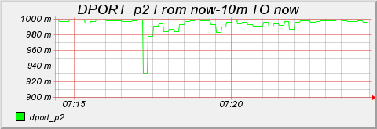
- Effect of port s-similarity
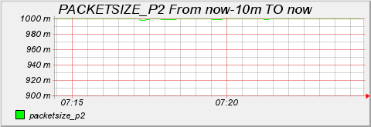
- Effect of packet size s-similarity
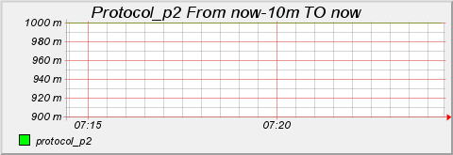
- Effect of protocol s-similarity
Fig. 3 Effect of s-similarity in Experiment I
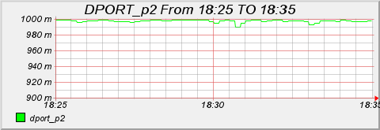
(a) Effect of port s-similarity
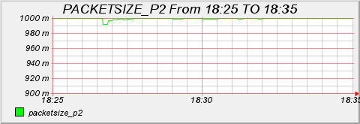
(b) Effect of packet size s-similarity
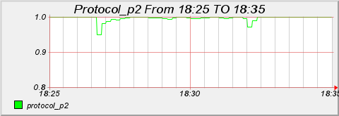
(c) Effect of protocol s-similarity
Fig. 4 Effect of s-similarity in Experiment II

5.3 Multi-similarity experimental results
Comparing with the above six graph of a single attribute similarity in Fig. 3 and Fig. 4, we can find that no single similarity can detect worms attack effectively and independently without the other ones. That’s why we introduce the following detection method.
We have two kinds of multiple similarity methods. In order to verify their effects, we also conducted in the above experiments. One is the static weighted average similarity; the other is the dynamic weighted average similarity, which is called multi-similarity in our paper, which described in section 3 in detail. As for the static weighted average similarity, we designate that the weight value of each is a constant 1/3. Namely, the port similarity, packet size similarity and the protocol similarity are equally weighted. Although it considers all of these effective factors, it is not feasible to the real detection because it is hard to know the exact probability that which one works more or not.
Multi-similarity approach aims to avoid the problem mentioned above. We take all necessary attributes into account for our detection. It integrates the characteristic according to its contribution by computing Parameter ξ according to its percentage of changing proportion and adjusting its value in dynamic. In our experiment, we consider the attribute of port, packetsize and protocol. According to Definition 5, there is {port, protocol, packetsizeTAS, so we have. And we got the result expected. That is, we can see in Fig. 5 and Fig. 6, by comparing the result of static weighted similarity and multi-similarity. When we use static weighted similarity, we have a lower downwards in Fig. 5 (a) than Fig. 3 (a) in experiment I, the same to the experiment II. It is because the static similarity method weakens the change of abnormal and decreases the precision of detection. But on the contrary, seeing from the Fig. 5(b), the downward is even larger than the single port similarity without saying of static weighted similarity. It can be further proved to be effective in experiment II. Hence, we can make a conclusion that multi-similarity is better than s-similarity especially on unknown characteristic worms’ detection. It can capture the abnormal exactly and effectively enlarge it. So we can sense the abnormal change under a less speed of the traffic. That’s why we can effectively detect worms scanning earlier against the large-scale network traffic.
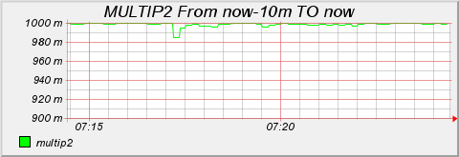
- Effect of static weighted average s-similarity
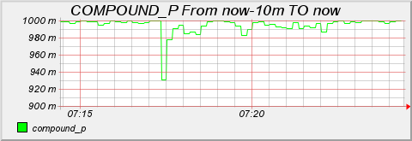
- Effect of dynamic weighted m-similarity
Fig. 5 Effect of m-similarity in Experiment I
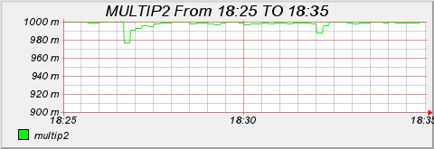
(a) Effect of static weighted average s-similarity
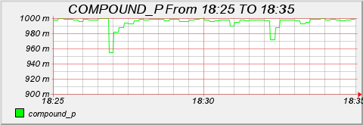
- Effect of dynamic weighted m-similarity
Fig. 6 Effect of m-similarity in Experiment II

6 Conclusion and future work
This paper proposes a worm early detection system based on multi-similarity. From above experiment result, we prove that this method can obtain good effect of detection on an on-going worm attack before it is propagated across the Internet, which means worms can be detected in their early-burstout stage by the method.
Further studies on the correlativity analysis of attack behavior are needed in the stage of fine detection module, and further experiments are needed to do on the other ISP network, such as CHINANET. We also need to improve the capacity of data collection especially at the interface of high bandwidth network, in order to increase the speed of detection.

References:
[1] C. C. Zou, L. Gao, W. Gong, and D. Towsley, Monitoring and early warning for internet worms, In Proceedings of the ACM conference on Computer and Communication Security, pages 190{199, Washington D.C., USA, October 2003. ACM.
[2] David Moore, Colleen Shannon, Jeffery Brown, Code-Red: a case study on the spread and victims of an Internet worm, In Proceedings of the ACM SIGCOMM Internet Measurement Workshop, pages 273{284, Marseille, France, November 2002. ACM.
[3] D. Moore and C. Shannon, The spread of the code-red worm (CRv2), Technical report, CAIDA, the Cooperative Association for Internet Data Analysis, 2002.
[4] R. Russell and A. Mackie, Code red II worm, Incident analysis report, Security Focus, August 2001.
[5] A. Mackie, J. Roculan, R. Russell, and M. V.Velzen, Nimda worm analysis. Incident analysis report, Security Focus, September 2001.
[6] Guofei Gu, Monirul Sharif, Xinzhou Qin, David Dagon, Worm Detection, Early Warning and Response Based on Local Victim Information, 20th Annual Computer Security Applications Conference
[6] Guofei Gu, Monirul Sharif, Xinzhou Qin, David Dagon, Worm Detection, Early Warning and Response Based on Local Victim Information, 20th Annual Computer Security Applications Conference
[7] V. Berk , G.Bakos., and R. Morris, Designing a Framework for Active Worm Detection on Global Networks, In Proceedings of the IEEE International Workshop on Information Assurance ,pages 13-23, Darmstadt, Germany, March 2003. IEEE
[8]JUNG,J.,Paxson,V.,Berger,A.W., Fast Portscan Detection Using sequential Hypothesis Testing, In proceeding of the IEEE Symposium on Security and Privacy( May 2004).
[9] David Moore, Colleen Shannon, Geoffrey M. Voelker, and Stefan Savage, Internet quarantine: Requirements for containing self-propagating code, In Proceedings of the IEEE Infocom, pages {San Francisco, CA, USA, March 2003. IEEE
[10] Xuan Chen and John Heidemann, Detecting Early Worm Propagation through Packet Matching, February 2004
[11] J. Wu, S. Vangala, L. Gao, and K. Kwiat, An efficient architecture and algorithm for detecting worms with various scan techniques, In Proceedings of the 11th Annual Network and Distributed System Security Symposium (NDSS’04), February 2004. [12] D. Moore, Network Telescopes: Observing Small or Distant Security Events, In USENIX Security, 2002.

