INDOOR WIRELESS POSITIONING USING WLAN

Ι. ΚΟURIS, Α. ΚΑRΑΚΟS
Department of Electrical Engineering and Computer Engineering
Democritus University of Thrace
Vas. Sofias 12 - 67100 – Xanthi
GREECE

Abstract – The continuous progress of the computer technology, the decrease of the dimensions and the power consumption that has taken place during the last decades, has enabled large computer companies to design new products that take advantage of the possibilities that the wireless networks offer. A very interesting implementation is indoor localization. The exact localization of a portable device is a complex process, considering that the signals arriving to the device are reflected and distorted, so that the exact location of the device cannot be precisely calculated. The aim of this work is to study the possibilities that the Wireless Local Area Networks (WLAN’s) offer to indoor localization and to implement an application that will help to localize a device equipped with a WLAN’s card supporting the IEEE 802.11b protocol. The application we composed (Wlib) uses a database with signal strength values stored and a mathematical model in order to estimate the position of a wireless device in the university library.

Key-Words : wireless, WLAN’s, indoor localization techniques, signal strength, Wlib

1. Introduction
The wireless devices become day by day cheaper because of the new technologies used that have significantly decreased their cost. Meanwhile, their processing power is at an acceptable level.
The embedding of wireless capabilities in portable devices seems to become one of their main characteristics. A lot of wireless technologies are packed in every device, in order to extend the connectivity. The main wireless technologies used today in the portable devices are: the GSM technology (mobile telephony networks), UMTS (3rd generation of mobile telephony networks), Bluetooth (wireless data networks for short range) and IEEE 802.11 networks (data transmission using the TCP/IP protocol) [1][2][3].
Indoor localization underlies a useful tool for the developers to write applications that will take advantage of this technique. Suggestively, somebody can mention their use in areas such as tourism (presentation of dynamic map and interesting places), use inside exposition areas and museums (instant information about art works, monuments, corporation kiosks etc), search databases and represent the position of the objects and of the user (search the database of a storehouse or a library), security applications (continuous tracking of valuable objects), health applications (track medical equipment and doctors), confront disasters (track trapped persons inside buildings) and many more applications [3][5][6]. Our application searches the university library database and represents the location of the user and of the book selected by the user. The dot that flashes and shows the user’s place on the floor plan is changing dynamically as the user moves around the library.

2. Localization Techniques
Localization techniques are based on two methods. The first takes advantage of the time delay between the transmission and the reception of the signal, and the second uses the power loss of the transmitted signal. [1][2][6][7]
a. The first method is largely used at the GPS systems [9]. The time a signal needs to travel from the satellite to the device used for localization is counted and then the user’s average position is represented. In order the results to be precise the satellite and the device must be perfectly synchronized. Also, the device must have visual contact with at least four satellites. The portable GPS devices used today offer decent precision for the average user but also there are devices that give more precise results and are used by the army and the geographical agencies around the world. The technique GPS use cannot be used for indoor localization, due to the fact that the device must have direct contact with the satellites.
b. For the indoor localization, where the distances are shorter, comparing to the ones used at the GPS systems, there can be used techniques that are based on wireless data networks like Bluetooth or IEEE 802.11. Using these technologies, the method used to localize a device counts the power loss of the transmitted signal, the noise of the received signal or the signal to noise ratio [2][7].
The wireless networks of short range (like IEEE 802.11) use frequencies of 2.4 , 5.2 and 5.5 Ghz and perform the specifications for low power emission from the aerials, in order to be approved for indoor use and in order to have low power consumption [2][6][9][11].
The techniques proposed for these implementations are mainly the following four:
i. The first method is based on the recording of the data received by the wireless device at various spots in a place, creating a map with the signal values, and storing them in a database. The data to be stored included the signal strength, the noise and the signal to noise ratio of every specific spot. Afterwards, the program that searches the user’s location, compares the current and the recorded data and draws the possible position of the user.
ii. The second method that can be used for the estimation of the user’s location, does not use a database to store the signal values. This method has an advantage over the first one because it can be installed in any place without needing a previous preparation, like the map created at the first method. In that way the installation time is reduced. The disadvantage of this method is that the errors are frequent because of the signal diffusion.
iii. The third method used is a compilation of the two previous methods. During the localization process the results exported from the database search are compared with the ones resulted from the signal estimation process of the second method. The advantage of that method is obvious. The estimated results are compared in order the result to be more precise. This method has been used in many research works, which all use variations of the same algorithm [1][2][3].
iv. The fourth method that can be used for the localization of a wireless device uses a more complex technique. That method is based on the use of fixed transmission bases that use directional than omnidirectional aerials. The user’s device must also be able to detect the angle of reception and then the software will process the data with the appropriate algorithm and will export the estimated position [12]. This last technique in combination with the third one will give better results [13].

3. Implementation
For our research work we chose to use the first method proposed. It was chosen in order to examine if a simple mathematical model can produce accurate results. This method is based on recording the values of the signal power at different points inside a room. The number of the points is defined by the configuration of the room and the discreteness of the system. The discreteness of our implementation gives accurate results for a distance of around 4 meters between the points. Afterwards, the signal values are normalized and are stored in a file that contains a) the signal power, b) the signal noise, c) the signal to noise ratio and d) the MAC address of the access point from which the signal is recorded. Then, the program compares the current and the recorded values of the signal. We found that the aerial install on our device gives different signal strength values for different orientations and we decided to measure the value for each location at different orientations.
The algorithm is as follows:
- The signal power values are stored in a temporary memory. In the temporary memory are stored also the values recorded by the receiver turned to different orientations. The value that is finally recorded in the database is the average value of all the signals recorded at the same point. The value to be recorded is counted by the equation:

$p_{f}=i^{−1}\sum_{1}^{i}{p_{i}}$ (1)

where p_{f} is the power value to be recorded, p the value of the power at every different orientation of the receiver and i the number of times the user records the signal value at each point.
- The current signal power values are normalized in order to be compared with the stored values and then the program counts the difference between the values stored and the current one. The equation that compares the values is:

$s=|\left(x_{c}+y_{c}+z_{c}\right)−\left(x_{s}+y_{s}+z_{s}\right)|$ (2)

where s is the difference, x, y, z the normalized values of the power from each access point and the indicator c is for the current, where s is for the stored values.
- The position of the user is estimated by selecting the point with the least declination from the signal power value.
The trustworthiness of the algorithm will be discussed later, comparing the results of our work with other implementations.
In order to test the results this algorithm can give, a number of applications were written in C++ language. These applications helped us to make measurements of the signal value in different places. Then we chose to use the method described before for our final implementation. In the same time we examined the potentials of the WLAN’s and specifically we examined the range of the networks, the transfer rates and the security the IEEE 802.11b protocol can offer [3][5][6][9]. After that first part of the research process, the specifications of the final program were specified and then the program was composed. The program reads the values of the signal at different points of a room and stores them and afterwards it estimates the user’s position in the room. The implementation is capable to represent the position of a book in the central library of the Democritus University of Thrace in Xanthi and in the same time shows the current user position. The dot that flashes and shows the user’s place on the floor plan is changing dynamically as the user moves around the library.

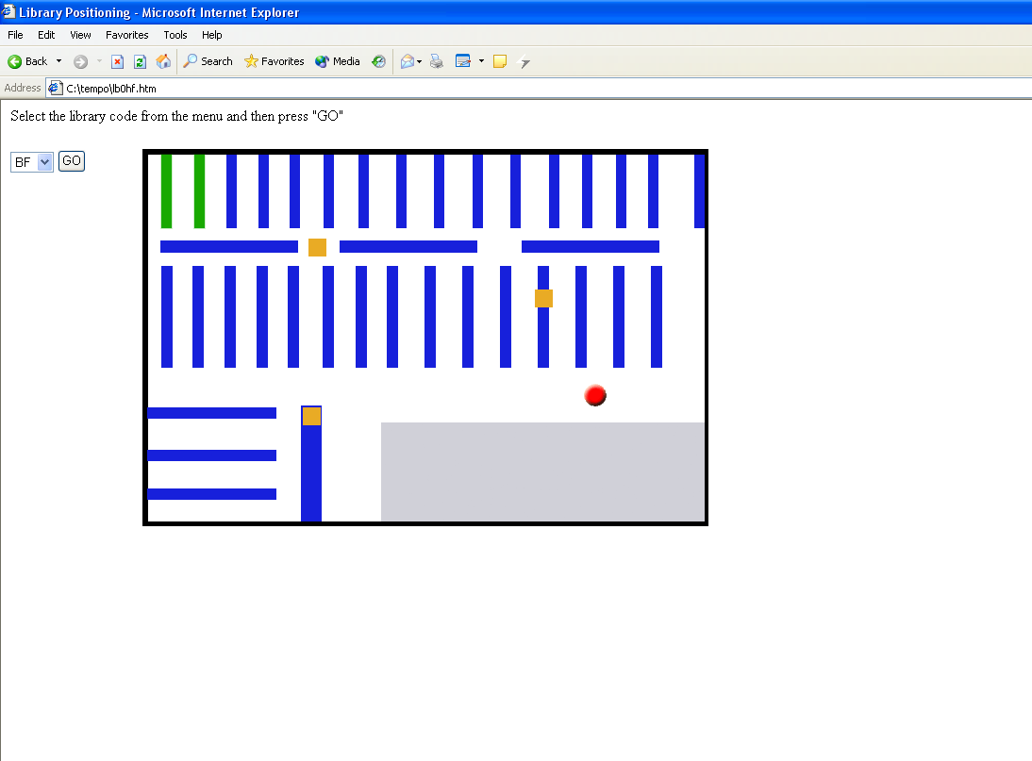
Fig. 1. Representation of the book and the user position in the library

In the background the program written in C++ is executed and estimates the user position. The graphical results are represented as a web page, in HTML language [10]. The user searches the library database and then chooses the library code where the book is stored. An image with the floor plan is shown on which the library with the book has green color and the user’s position is pointed with a blinking red spot (Fig. 1).
During the testing period and the program development, we used three (3) access points supporting the 802.11b protocol and a tablet pc with a wireless adapter installed from Orinoco™ Corp. The program is running in MS Windows™. In order the results to be valid, the following methodology was followed.
After testing, the value of the signal power was chosen to be used, because it has more levels than the signal to noise values and the results would enable a more precise estimation. The program that stores the signal value gives the user the option to choose how many measurements will be done at each position. This gives the user the ability to record the values the device reads at the same point for different orientations.
Specifically, the routine that creates the database with the signal values stores the signal value that arrives from each access point separately. The user chooses the number of the repeats for each point and starts walking in the room. He stops at the points where he wants to record the value and records the values. The best results are exported for a number between four and eight repeats. At each point, for example, for a number of eight repeats, the device can be oriented at eight different positions and record the value for each one.
A routine, included in Wlib application, estimates the position of the user by comparing the stored and the current values and represents the user’s position.
The applications were tested at different places with only static or both static objects and people moving around. For better results, the access points were installed at three consecutive positions, e.g. for a corridor at the beginning, in the middle and at the end, or in a square room at three corners. The tests’ result was that the best estimation is for an interval between the points of 2.5~3 meters. For closer points there were many errors. In rooms with closely placed objects, the discreteness of the system was 3~5 meters.
In that way, the final program that searches the user’s position in the university library (Wlib) gives results with less precision, for the following reasons:
A) The room is short and the access points could not be installed at high places from where the reception would be better
B) The shelves of the library are to close each other and the signal transmitted to the tablet pc is distorted and wrong results can be produced.
The procedure followed in order to examine the trustworthiness of the system is the following:
- The access points are installed at positions where all the room can be covered.
- The room is virtually sliced in areas with almost the same surface.
- The measurements for each virtual area are made, with eight repeats for each point.
- The routine that estimates the position runs and tries to locate the user. The errors are recorded.
- The procedure is repeated reversely (if it was done clockwise, it is repeated counterclockwise)
- If the errors are small the procedure is repeated for shorter areas.
- When the error is less than 15%, then the discreteness of the system can be specified.

Implementation | Discreteness (meters)
RADAR [3] | 2,94 ~ 4,3
Advanced Wavelan Position Project [1] | 2,8 ~ 7,3
Amulet [2] | 3 ~ 5
WLib | 3 ~ 5
Table 1. Compared results of location estimation techniques.

Our implementation in comparison with the results of other similar works [1][3][11] that used position estimation with the use of WLAN’s, are shown in table 1.

4. Conclusion – Future Work
The localization of a wireless device is a section where further research has to be done, in order the techniques to improve the accuracy of the results. In parallel, WLAN’s are continuously improving and their specifications are enhanced. We think the combination of more complex algorithms and more than one wireless network technologies will help to create a more accurate localization technique. The IEEE 802.11 protocol networks, the RFID devices and Bluetooth networks can be mixed to provide better accuracy and discreteness [14].
Examining the results of table 1 it is shown even though the technique we used for our program does not uses a complex mathematical model, it can produce acceptable results. In rooms with many objects seems to be better to install more access points or to use a combination with another technique.
The future work of the indoor localization must combine the advantages of each technique to produce a result with the least possible error.

References:
[1] A. Byström, T. Dahlroth, J. Eriksson, L. Fernandez, D. Holmgren, T. Johansson, Advanced WaveLan Positioning, Lulea University of Technology, 2001
[2] A. Harter, A. Hopper, P. Steggles, A. Ward, and P. Webster, The anatomy of a context-aware application, MOBICOM 1999, pp. 59-68
[3] Bahl Paramvir, Padmanabhan Venkata, RADAR: An In-Building RF-based User Location and Tracking System, Infocom 2000, pp 1-10
[4] Matthew Gast, 802.11 Wireless Networks: The Definitive Guide , O’Reilly, 2002
[5] Proxim, ORiNOCO 802.11b Client PC Card, Proxim Corp, 2004
[6] F.Calì, M. Conti, E. Gregori, , IEEE draft standard P802.11D2.1, IEEE Infocom Conference, 1995, pp. 209- 218
[7] Ladd, Andrew, et al. Using Wireless Ethernet for Localization, IEEE/RSJ IROS, University of Southern California 2003
[8] Castro P., Nibble Location System, Ubicomp, 2001
[9] Geoffrey Blewitt, Basics of the GPS Technique, University of Newcastle, 1997
[10] A.Williams, K.Barber, P.Newkirk, Active Server Pages Black Book, The Coriolis Group, 1998
[11] F.Calì, M. Conti, E. Gregori, IEEE 802.11 Wireless LAN: Capacity Analysis and ProtocolEnhancement”, IEEE Infocom Conference, 1997, pp 1-8
[12] Blake M. Harris, Amulet: Approximate Mobile User Location Tracking System, University of Rochester, 2002
[13] D.Niculescu, B.Nath, VOR Base Stations for Indoor 802.11 Positioning, Rutgers University, 2004
[14] J.Hightower, R.Want, G.Borriello, SpotON: An Indoor 3D Location Sensing Technology Based on RF Signal Strength, University of Washington, 2000

