Optimal solution of linear machine layout problem using ant colony system

FOUNTAS CHRYSOSTOMOS & ARISTIDIS VLACHOS
Department of Informatics
University of Piraeus
80 Karaoli & Dimitrioy Str, 185 34 , Piraeus
GREECE

Abstract: - This paper examines the analysis for the production of units (objects) with the lowest possible cost, which is the most important goal for many manufacturing companies. We use the linear programming model for minimal backward-flow, to determine the optimal linear machine sequence in a manufacturing cell. We apply a modified ACS algorithm, based on the conditions and parameters for the linear machine layout problem, which is a difficult Combinatorial Optimization Problem. Computational results demonstrate that ACS is an effective meta-heuristic algorithm for the linear machine layout problem.

Key-Words: - Linear machine layout problem, Ant colony system, Meta-heuristic

1 Introduction
A method that has progressively attracted the attention of innovating manufacturing firms is the cellular manufacturing system. As the name suggests, a series of cells is created which has the aim to produce the parts we desire. When a cell has been created for a family of parts, the next problem is to arrange machines within the cell. Linear layouts, exist in various forms, such as a U-shape, a straight line, and a circular loop. Although a linear layout may not be the optimal design choice, the desire for simplicity in production and material handling problems, make it a popular choice [1]. Four types of flow movements can be observed: repeat, in-sequence, bypassing, and backward-flow. Among these flow movements, in-sequence movement is the most desirable because of its unidirectional movement. Backward-flow is the least desirable, since it creates the most unnecessary complications in the workflow. The main goal of flow analysis is to minimize the total amount of backward-flow movements. We shall use this model in conjunction with the Ant Colony System (ACS) which is a particular heuristic solution of ant colony optimization (ACO). Our aim is to present an optimising method based on ACS for the linear layout problem.

2 Problem Formulation

2.1 Linear layout analysis
There is an array of algorithms for linear layout analysis. Most of them allow duplicate machines in a flow line. Carrie [2] was the first to deal with this issue. He proposed a process which begins by setting up a line that contains a sufficient number of workstations so that the flow of every product can be accommodated without incurring any backward-flow movements. The algorithm then eliminates uneconomical workstations and reroutes their operations to other workstations. Typically, an array of solutions can be generated after the elimination process. In the end, computer simulations are used to select the best ones. The approach of Aneke and Carrie [3], uses a method by which a flow line from both ends of the flow line is created. If the products in question have similar workstation requirements at their early and later processing stages then this approach has a superior performance. Lee [4] proposed a method that constructs the flow line based on the sequence of similarities in a product flow line. This algorithm starts by selecting the product that has the highest sequence similarity with the flow line constructed so far. It then modifies the flow line to accommodate the sequence of the newly selected product. Finally, the elimination of infeasible or uneconomic workstations is performed.

  - Minimal backward-flow model

2.2.1 Description

The basic principle of determining the sequence of machines is to minimize the total amount of backward-flows in a manufacturing cell [5]. The following assumptions are adopted:
(1) Only one machine of a certain type is allowed in a flow line.
(2) The cost of material flows is proportional to the number of parts and the distance of flows.
(3) Each machine is regarded as a point, and the distance between adjacent machines is '1', the unit distance.
The graphical presentation of a machine sequence is shown in Figure 1. In the minimal backward-flow model, the following notations and definitions will be used throughout the paper.
n = the number of machines in a manufacturing cell
m = the number of items of parts to be produced in a manufacturing cell
dj = the demand of part j, j= 1,2,..., m.
xi = the distance between vertical reference line (vrl) and machine i, i = 1,2,..., n.

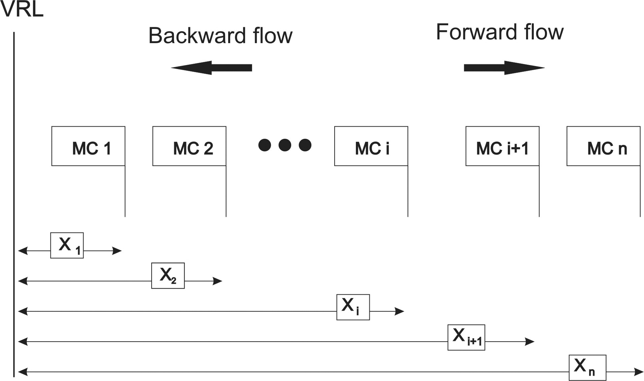

Fig. 1

The distance between the initial input point of parts, which is the distance between the Vertical Reference Line (VRL), and the first machine in sequence is also regarded as the unit distance, '1'. Then, the minimal backward-flow model utilizing linear programming is stated as follows:
(1)

(2)

(3)

The objective function represented by equation (1), illustrates the sum travel distance for all the parts to be produced in a manufacturing cell. Equation (2) represents a constraint that warrants that no two machines in the layout overlap. Equation (3) represents the decision variables. In the objective function, the sum of the total travel distance is the sum of forward-flow distances and backward-flow distances that occur in a machine sequence. In a manufacturing cell, the forward-flow distances in a machine sequence do not affect material flows, thus the material flows are abridged easier when the sum of backward-flow distances of all parts in a manufacturing cell is minimized. It follows that the objective function must be converted in order to minimize the sum of backward-flow distances of all the parts in a manufacturing cell. This is the reason why the model presented in this paper is called ‘the minimal backward-flow model’.

    - Solution Procedures
The minimal backward-flow model [5] is not a standard form of linear programming. Therefore, it should be technically transformed into a standard form of linear programming.
Let array A be and:

(4)

Now suppose that is a weighted frequency considering demand .Then is given by:
(5)
Therefore, the objective function of the primal model is transformed into:

(6)

Equation (6) gives the total travel distance of all parts to be produced in a manufacturing cell. The total travel distance consists of forward-flow distances and backward-flow distances. However, the forward-flow distances have no effect on the flow-line in a manufacturing cell. Therefore, the objective function is transformed to minimize the sum of backward-flow distances as follows:

(7)

Then the minimal backward-flow model can be restated as follows:

(8)

Such that :
(9)
However, the above model is still not a standard linear programming model, since it includes absolute values in the objective function and constraint. In order to transform the above model into an equivalent zero-one integer programming, define
(10)

then it is obvious that:
(11)

(12)

(13)

(14)
where M = a large number and or 1. The zero-one integer programming of the minimal backward-flow model is restated as follows:

(15)
st.

(16)

(17)

(18)
(19)

(20)

(21)

3 The Ant Colony System (ACS)

3.1 The background of ACS
The ACS is a particular heuristic solution of ant colony optimization (ACO), [6], for solving discrete optimization problems. The first ACO system was introduced by Dorigo, called Ant System (AS), [7], has been applied to the Traveling Salesman Problem (TSP), [8]. The ACS has its roots in the observation of the behavior of ants in real life ant colonies, in particular the way in which real ants find the shortest path between food sources and their nest. Ants release a substance called pheromone along the path they follow, which forms a pheromone trail. This trail attracts other ants to follow the path that has the biggest quantities of pheromone. Pheromone concentration on the path, acts as a communication medium between real ants. The greater the concentration of pheromone on the path, the higher the probability that an ant will choose this specific path.
Where there is a shorter path from a food source to the nest, the ants will reach the end of the path in a quicker time compared to the ants that followed the longer path. This means that the pheromone trail will be accumulated at a faster rate on the shorter path which in turn causes more ants to choose the shorter path, which also causes a greater level of pheromone. In time all ants will have the tendency to choose the shorter path.
In the ACS artificial ants (agents) are used. In the artificial ant colony systems, the following assumptions are made:
- Each artificial ant in the ACS has a memory of limited capacity, called the tabu list. The memory is used to define, for each ant κ, the set of cities that the ant has still to visit when it is on city i (in the beginning, contains all the cities but i). By exploiting an ant κ can avoid visiting a city more than once.
- Artificial ants live in an environment in which time is discrete.
- Artificial ants are not completely blind. They move according to the same probability function determining the next move. Like in the colonies of real ants, this function depends on the parameters corresponding to the distance of the nest from a source of food, and the amount of (artificial) pheromone released on the path.

Recently the Ant Colony Optimization (ACO), meta-heuristic has been proposed which provides a unifying framework for most applications of ant algorithms which relate to combinatorial optimization problems. In particular, ant algorithms have been applied to problems such as the quadratic assignment problem [9], the vehicle routing problem [10], the graph coloring problem [11], and the partitioning problem [12].

3.2 Ant colony system
ACS [13], has recently been shown to be competitive with other meta-heuristics on the symmetric and asymmetric traveling salesman problems. ACS differs on four modifications of Ant System: a different transition rule, a different pheromone trail update rule, the use of local updates of pheromone trail to favor exploration, and the use of a candidate list to restrict the choice of the next city to visit.

ACS state transition rule

When building a tour in ACS, an ant k at the current position of node i chooses the next node j to move to by applying the state transition rule given by the following equation

(22)

where q is a random variable uniformly distributed over [0,1], q₀ is a tunable parameter (0≤ q₀ ≤1) and J is a random variable which gives the probability with which ant k in node i chooses to move to node j that is selected according to the probability distribution, called a random-proportional rule, given in the following equation:
(23)
Where:
is the set of cities which ant Κ has already visited when being located in city i.
: is the amount of pheromone trail on the edge (i,j) at time t ,
n_{ij} : is the visibility of city j from city i and equals 1/d_{ij} , where d_{ij} is the distance between cities i and j,
β : is a parameter which controls the relative weight of pheromone trail and visibility,
J : is a city drawn by using the probabilities

When building their tours, the chosen edges are guided by both heuristic information and pheromone information. The state transition rule resulting from Equations (22) and (23) favour the choice of nodes connected by shorter edges with a greater amount of pheromone. Every time an ant in node i has to choose a node to move to, it samples a random number q. If , then the best edge (according to Eq. (22) is chosen (exploitation), otherwise an edge is chosen according to Eq. (23) (biased exploration).

ACS local updating rule

While constructing a tour, ant changes the pheromone level to its visited edges by applying the local updating rule as follows:

(24)

Where: is the initial pheromone level and 0 < ρ < 1 is the pheromone evaporating parameter.
It has been found that best results occur when:

(25)

Where n is the number of cities and Lnn is the length of a route created by the Nearest Neighbour Heuristic algorithm, but various initial levels of pheromone can be used.

The effect of local updating rule is to make the desirability of edges change dynamically in order to shuffle the tour. If ants explore different paths, then there is a higher probability that one of them will find an improved solution than all searching in a narrow neighbourhood of the previous best tour. Every time an ant constructs a path, the local updating rule will make its visited edges pheromone trail diminish, thus becoming less attractive. Hence, the nodes in one ant's tour will be chosen with a lower probability in building other ants' tours. As a consequence, ants will favour the exploration of edges not yet visited and prevent converging to a common path.

ACS global updating rule
Global updating rule is performed after all ants have completed their tours. In order to make the search more directed, global updating is intended to provide a greater amount of pheromone to shorter tours and reinforce them. Therefore, only the globally best ant that found the best solution (i.e., the shortest tour) up to the current iteration of the algorithm is permitted to deposit pheromone. The pheromone level is modified according to:

(26)

and
(27)

Where (i,j) are the edges belonging to T , the best tour since the beginning of the trail. The parameter ρ represents the pheromone evaporation, and L is the length of T.

4 Description of the algorithm
As we have mentioned in the previous chapter the problem has no cost in the case where we have a ‘movement in front’ for the production of part. For example in figure 1 if an activity requires the use of machine 1 (MC1) and machine i (MCi) the “cost” will be zero even if other machines exist between them. On the other hand, if an activity requires the use of machine 2 (MC2) and then machine 1 (MC1) the “cost” will be equal to the unit for distance between the machines multiplied by the quantity of the product that should be produced. For example, if we want to manufacture ten pieces of a particular part the cost will be 1*10=10.
Based on the above cost formula, some “local” distances will be calculated. This is presented in a matrix form and it will be used as a parameter for the solution of the algorithm. If we have m machines then a matrix m× m will be created, where each element will represent the cost of passing from machine i to machine i+1.
In order to make clearer the method by which the distances are calculated, which are the elements of this matrix, we mention the following example with only 2 activities and 3 machines. Let us suppose that the two activities that appear below are used for producing two products (Part1, Part2), and for their production machines 1-2 and 3 are needed in the following linear arrangement, demonstrated below in table 1.

Part | Process | Demand
Part1 | 1-2-3-2-3-1 | 10 pieces
Part2 | 3-2-1-3-2-3-1-2 | 15 pieces

Table 1
From table1 we derive matrix F, which shows the quantity of parts that should be moved by a machine to the next without the intervention of others.

 |  |  | To i+1
 |  | M1 | M2 | M3
 | M1 | 0 | 25 | 15
From i | M2 | 15 | 0 | 35
 | M3 | 25 | 40 | 0

Matrix F

The matrix that includes the “costs”, which occur for backward flow, for a local movement is the inverse of the original table. It can be calculated by moving from the end of the process to the beginning, or from the original moving inversely. In the software which was created, the user gives the matrix and the inverse matrix is calculated automatically.

 |  |  | To i
 |  | M1 | M2 | M3
 | M1 | 0 | 15 | 25
From i+1 | M2 | 25 | 0 | 40
 | M3 | 15 | 35 | 0
Matrix D

The logic for the creation of the matrix is simple. If a process from machine 1 should move to machine 3 then we have backward flow costs. In the layout we put the one next to the other but in an inverse way, first M3 and afterwards M1, thus we will have backward flow in the line, because every machine cannot exist more from one time. Matrix D can be calculated, using algorithmically, in just two loops. We initialise all the elements of table to 0. The outer loop will run from the first to the last process, while the inner loop will run every process and the number of the machine that comes first will be used as the first vector of the element and the number of machine that follows will be used as the second vector. The parts from each process produced are added. As an example we begin the algorithm and have the two processes that appear and then:

Fig. 2

When both matrices F and D are calculated we can implement ACO. We must remark that, because the calculated cost is local, it does not counterbalance with the total cost layout. This is calculated at the end and after the ant completed its way.
If we decide to set the machines in the linear arrangement shown in figure 3 , then:

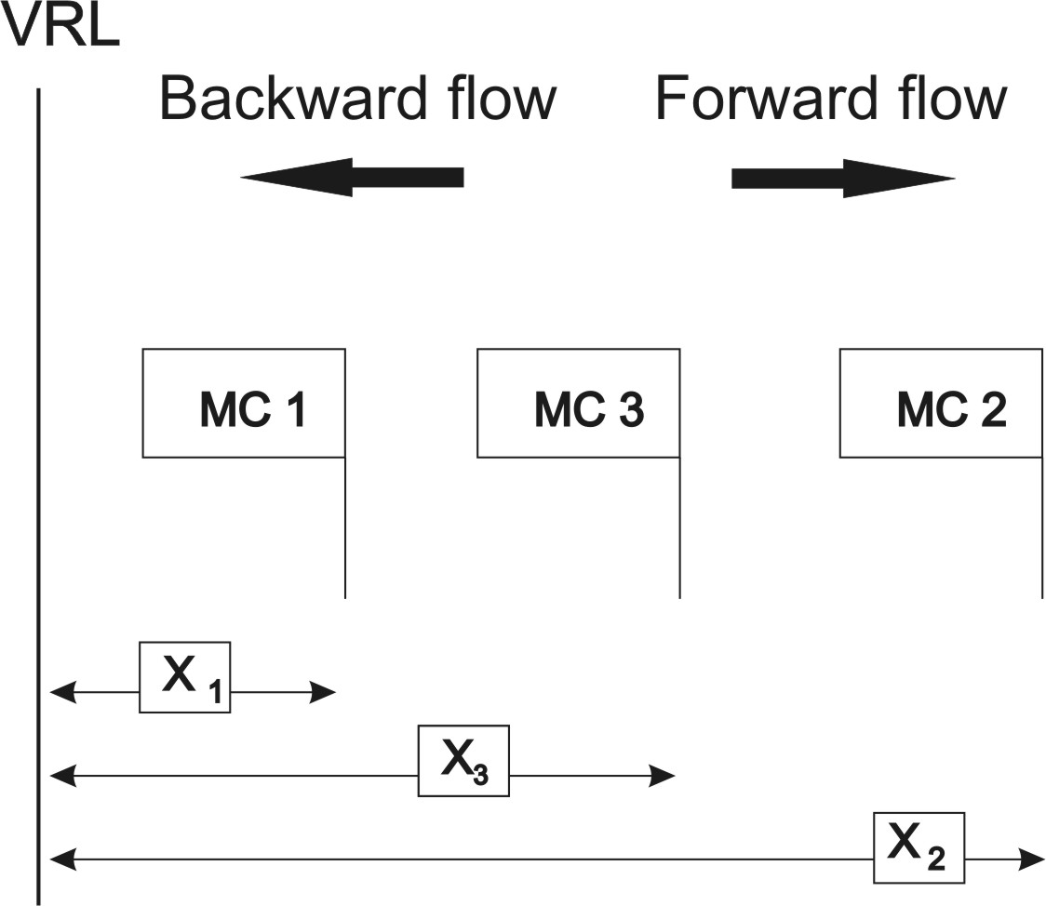

Fig. 3

From the layout above for the first process we have:

 | Sign | Calculation | Result
VRL to M1 | + | X1 | 1
M1 to M2 | + | X2-X1 | 2
M2 to M3 | - | X2-X3 | 1
M3 to M2 | + | X2-X3 | 1
M2 to M3 | - | X2-X3 | 1
M3 to M1 | - | X3-X1 | 1
 | Sum of negatives |  | -3

Cost for  Process 1 | Demand | Total Cost for Process 1
3 | 10 | 30

Table 2: Process of finding the cost for the first process
In the table above the sings show forward and backward movement. We sum only the negatives as they represent backward flow (which is the flow that creates costs). We then invert that number and multiply it by the demand for that process. We have a declared demand in table 1 of 10 pieces that must be produced from this process. Thus the cost of process 1 is 30. The activity is repeated for each process in order to find the total cost (that is the sum for all the processes of production). It is suggested to use equal number of ants and production machines are used. This is in proportion with the use of equal number of ants with the cities that they should visit in the travelling salesman problem. That has been shown to be the most optimal choice. Therefore if m machines are used m number of ants must be used.

  - Requirements of algorithm

Transition rule

If an ant k, is in a machine I, and selects the machine j to move to using the following rule.

(28)

Where:
$τ_{\text{ij}}(t)$ is the pheromone trail of edge (i,j)
is the heuristic desirability
is a random variable uniformly distributed over [0,1]
is a determined from the user, parameter in interval [0,1]
J is a machine that is selected according to the following equation :

(29)

are the machines where the ants have already visited before the machine i
is the inverse “distance” between two machines (matrix D)
is the pheromone quantity that is found in the edge that links two machines. At time t=0 (first iteration), pheromone is placed in an initial price which is too small.
Pheromone update rule

(30)

Where (31)
With the “minimal” cost as it is calculated at the end of arranging the machine layout and is the corresponding layout of machines. Also we have with it is the parameter of pheromone evaporation.

We present the development of the algorithm for the solution of problem as also and corresponding pseudo code (Appendix).

Start Algorithm

Step 1
Initialize pheromone in all the possible combinations for the machines. Calculate matrix D, place an ant in every machine

Step 2
For each ant, we select the next machine that it will visit using the transition rule mentioned above, until it visits all the machines (until it creates a layout).

Step 3
Compute the cost for all the layout-paths and store the best.

Step 4
Update the pheromone with the rule that was reported above.

Step 5
We repeat the process from step 2 until the number of iterations previously defined by the user is reached or until a criterion is satisfied (for example, the cost from backward flow it falls under a threshold that we want).

End algorithm

The following figure shows the flowchart of the algorithm used.

Fig.4 The flowchart of our algorithm
5 Case study
We suppose that we have five parts P1, P2, P3, P4, P5 that are submitted to be produced, we use three and six machines, 1,2,3 the first time and machines 1,2,3,4,5,6 the second time. The demands and the sequence of processes for every part are given in tables 2 and 3. The size of problem, the number of machines (ants) and procedures, pheromone quantity, the best cost that the user wishes to have for the production of particular objects as well as number of iterations are entered by the user. The program will give the most optimal sequence of machines that was found so that the best cost can be achieved. A very important factor in any implementation of the ant colonies optimization algorithm, is the appropriate definition of the initial quantity of pheromone, which will favor the best paths, against the rest. That usually is a constant and a very small quantity. Similarly to many ACO implementations, certain variable values were decided based on the experimental observation such as the value of parameter β. It is obvious, that the quality of the results is directly connected to the initially defined values of the simulation, and as a result, important variation will be observed even with a small change of these values. We set it the initial pheromone level equal to 0.1 and parameter β equal to 2 but these are parameters that are adjustable.

For three machines we have:

Parts | Process | Quantity
P1 | 1→3→4 | 10
P2 | 2→1→2→1→2 | 20
P3 | 3→4→1 | 15
P4 | 3→4→2→1 | 35
P5 | 3→2→4→2→1 | 25

Table 3. Data for each part

# machine number = 3
# part number = 5

Table 4. Problem Size

Process information | Demand Information
P[1] {1, 3, 4} | P[1] = 10.000
P[2] {2, 1, 2, 1, 2} | P[2] = 20.000
P[3] { 3, 4, 1} | P[3] = 15.000
P[4] {3, 4, 2, 1} | P[4] = 35.000
P[5] {3, 2, 4, 2, 1} | P[5] = 25.000

Table 5. Process route & Demand Information

In the following matrix the distances between the machines are given.

To i+1

From i $\left[\begin{matrix}0 & \text{25} & \text{15} \\ \text{15} & 0 & \text{35} \\ \text{25} & \text{40} & 0\end{matrix}\right]$ F Matrix

Below is given the matrix with backward-flow distances which is calculated by the program.

To i+1

From i $\left[\begin{matrix}0 & \text{15} & \text{25} \\ \text{25} & 0 & \text{40} \\ \text{15} & \text{35} & 0\end{matrix}\right]$ D Matrix
Finally after the execution of the program we will be presented with the optimal sequence for each part, shown in Table 6. In this table the total backward flow, that is calculated for each part (best cost) and the machine-ant which was found to produce the best cost are shown.

Part | Best Cost | Machine-Ant | Machine sequence
1 | 20 | 3 | 3-1-2
2 | 40 | 1 | 1-2-3
3 | 15 | 3 | 3-1-2
4 | 70 | 3 | 3-1-2
5 | 75 | 2 | 2-1-3

Table 6. Results for 3 machines

For six machines we have:

Part | Process | Quantity
P1 | 1→3→4 | 10
P2 | 2→1→2→1→2 | 20
P3 | 3→4→1 | 15
P4 | 3→4→2→1 | 35
P5 | 3→2→4→2→1 | 25

Table 7. Data for each part

# machine number = 6
# part number = 5

Table 8. Problem Size

Process information | Demand Information
P[1] {1, 3, 4} | P[1] = 10.000
P[2] {2, 1, 2, 1, 2} | P[2] = 20.000
P[3] { 3, 4, 1} | P[3] = 15.000
P[4] {3, 4, 2, 1} | P[4] = 35.000
P[5] {3, 2, 4, 2, 1} | P[5] = 25.000

Table 9. Process route & Demand Information

Part | Best Cost | Machine-Ant | Machine sequence
1 | 0 | 1 | 1-3-4-6-5-2
2 | 80 | 2 | 2-4-1-3-6-5
3 | 0 | 3 | 3-4-1-6-5-2
4 | 105 | 2 | 2-4-1-3-6-5
5 | 100 | 2 | 2-4-1-3-6-5
Table 10. Results for 6 machines
The program iterates until it finds the best cost. When the program ends, a file chainout.txt is created, where it shows the progress for every ant-machine and the cost for each one. An example of this file is shown in the table 11 for 3 machines-ants.

Iteration 1
Ant 1 cost 140
Machine Arrangement: | 1 | 2 | 3
Ant 2 cost 105
Machine Arrangement: | 2 | 1 | 3
Ant 3 cost 70
Machine Arrangement: | 3 | 1 | 2

Table 11: Results for 3 machines-ants.

The result which is given in this case is:
Best cost=70
Ant =3 (from machine 3)
Machine sequence=3-1-2
In the graph below we observe the results obtained for 3 machines-ants. The best cost is found from machine 3.
Fig. 5: Graphic representation

However, there is the case where the best cost is not found by the last machine in line. This appears in the following table.

Iteration 1
Ant 1 cost 200
Machine Arrangement: | 1 | 3 | 4 | 6 | 5 | 2
Ant 2 cost 100
Machine Arrangement: | 2 | 4 | 1 | 3 | 6 | 5
Ant 3 cost 175
Machine Arrangement: | 3 | 4 | 1 | 6 | 5 | 2
Ant 4 cost 225
Machine Arrangement: | 4 | 1 | 3 | 6 | 5 | 2
Ant 5 cost 150
Machine Arrangement: | 5 | 1 | 3 | 4 | 6 | 2
Ant 6 cost 100
Machine Arrangement: | 6 | 1 | 3 | 4 | 2 | 5

Table 12: Results for 6 machines-ants.

As we observe in the above table the best cost is found in machine 2 and 6. As result is declared that of machine 2 because is the first in line that finds the best result. This appears in the following graph.

Fig. 6: Graphic representation

Screenshots of the output file are shown in the appendix, for 3 and 6 machines-ants.

6. Conclusion
The main aim of this research was to explore the potential of ACS heuristic for linear machine layout problems. Since ACS is a versatile and robust heuristic the proposed algorithm of this study can be applied to different layout problems and other combinatorial optimization problems with minor modifications.

We utilised the linear programming model for minimal backward-flow, to determine the optimal linear machine sequence in a manufacturing cell. The algorithm was modified for the linear machine layout problem, which is a difficult Combinatorial Optimization Problem. The modified ACS algorithm based on the conditions and parameters of the problem studied has the property that it may not use all the iterations entered by the user for finding the best solution. This establishes the efficiency of the algorithm.

A very important factor in any implementation of the ant colonies optimization algorithm, is the appropriate definition of the initial parameters, such as the quantity of pheromone which will favor the best paths against the rest, or parameter β which is a parameter that controls the relative weight of the pheromone trail and visibility. The flexibility of the system is based on these parameters.

Computational results demonstrate that ACS is an effective meta-heuristic algorithm for the linear machine layout problem.

References:

[1]. J.L. Burbidge, Production Flow Analysis for Planning Group Technology, Journal of Operations Management, 10, (1991), 5-27.
[2]. A.S. Carrie, Layout of Multi-Product Lines, International Journal of Production Research, 13, (1975), 541- 557.
[3]. N.A.G. Aneke and A.S. Carrie, A Design for the Layout of Multi-product Flowlines, International Journal of Production. Research, (1986), 24, No 3, 471-481.
[4]. Lee, C.E.C., An Integrated Methodology for the Analysis and Design of Cellular Flexible Assembly Systems,Ph.D. Dissertation, Purdue University, West Lafayette, IN, USA, (1991).
[5]. Won, You-Dong, A Linear Programming Approach to Linear Machine Layout Problem, The Journal of the Industrial Mathematics Society, 47, (1997), Part2.
[6]. D. Corne, M. Dorigo, F. Glover. New Ideas in Optimization, MC-Graw Hill, New York, 1999, 9-19.
[7]. M. Dorigo, A. Maniezzo, A. Colorni, The Ant System: Optimisation by a colony of cooperating Agents, IEEE Transaction on Systems, Man and Cybernetics : Part B, 26(1), (1996), 29-41.
[8]. M. Dorigo, L.M. Gambardella, Ant Colonies for the Travelling Salesman Problem, BioSystem 43, (1997), 73-81.
[9]. M. Dorigo, V. Maniezzo, A. Colorni, The Ant System Applied to the quadratic Assignment Problem, Tech. Rep. IRIDIA/94-28, 1994, Universite Libre De Bruxelles, Belgium, E.U.
[10]. L.M. Gambardella, E. Taillard, G. Agazzi, ACS-VRPTW : A multiple Ant Colony System for Vehicle Routing Problems With Time Windows. In Corne D., Dorigo M., and Glover F., editors, New Ideas in Optimisation, pp.63-77, Mc Grow-Hill. 1999.
[11]. D. Costa, A. Hertz, Ants can color graphs, Journal of the Operational Research Society, 48, (1997), 295-305.
[12]. P. Kurtz, D. Snyers, Emergent Colonization and Graph Partitioning. In Proceedings of the Third International Conference on Simulation of Adaptive Behavior: From Animal to Animals 3., MIT press, Cambridge, MA, 1994.
[13]. E. Bonabeau, M. Dorigo, G. Theraular, Swarm Intelligence, From Natural to Artificial Systems, Santa Fe Institute Studies In the Sciences of complexity, (1999), 46-55.

Appendix

Pseudo code 1.
Ant Colony System for the Linear Machine Layout Problem

Start

//Initialize
for i,j:1 to m
set
end for

for i,j:1 to m ( otherwise a division by zero will take place)
end for

for k:1 to m
set every ant to one machine
end for.
Initialize minimum Cost, (a very large value)

//Main Loop
for t: 1 to maximum iterations
for k=1to m
reinitialise Tabu list (erase the list that has been created during the previous iteration)
for i= 1 to m-1
select next
machine (using the transition rule)
Put next machine in Tabu list:
End for
Compute Cost,
If < set = and keep edges of best layout:
End for
For i,j=1 to m
Update pheromone trails by applying the pheromone update rule
End for
End for

Print

Stop

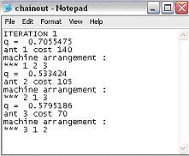

Screenshot 1: Output for 3 machines-ants.

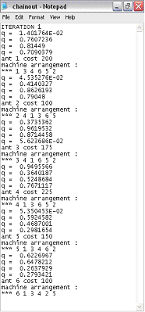

Screenshot 2: Output for 6 machines-ants.

