The Control of Motion of Unmanned Underwater Vehicle

Operated Near to the Bottom Sea

BOGDAN ŻAK, ZYGMUNT KITOWSKI

Department of Mechanical and Electrical Engineering
Naval University of Gdynia

81-103 Gdynia, Smidowicza 69

POLAND

Abstract: - In the paper are presented two methods of underwater vehicle position’s stabilization. There has been defined application useful for both methods taking vehicle equipment and sea bottom profile into consideration. For both methods has been defined the principle control to use for distance stabilization process.

Keywords: underwater vehicles, control motion, stabilization.

- Introduction
The basic problem during exploitation of underwater vehicle is to ensure them the right maneuver characteristic, it means problem of adaptation to changing environment and selection of such control to ensure precision and safety of motion. The mathematical description of vehicle motion is often presented as special algorithms, which involves parameters of environment and position of vehicle or its derivatives [5], [6]. Every algorithm which ensure the specific movement of vehicle is realized in specific condition it means that it is necessarily to consider every situation in which vehicle can be and which appearance is highly probable especially during moving near to sea bottom. If situation is changing the algorithm of moving is changing too. In this way is reached the required adaptation of vehicle to the changing environment conditions. Vehicle’s system is making situations’ classification, algorithms’ changing and measurements of position and speed deviation from given values. Thus algorithms of vehicle’s adaptive moving has kinematic characteristic. It is associated with that on beginning it is accepted what the movement should be, not to take into consideration his depend on control forces. To realized this moving it is indispensable that vehicle can work out values of required control forces. Mostly only way to control vehicle is his thrusters which configuration determines the numbers of degrees of freedom in which vehicle can be controlled. Therefore algorithms of vehicle moving have to take into consideration the necessary number of controlled degrees of freedom. The problem of thrusters structure and configuration choice is based only on experience [2], [4]. There is no theoretical justification of thruster structure and configuration to realize given tasks. The proposed algorithm for given structure and configuration of thrusters, allow to identify the dynamics’ parameters of vehicle in real time. It allows for continuous taking in consideration the changing of dynamics parameters and stochastic environment influence in control algorithms [5].

- Dynamics of underwater vehicles
The dynamics of underwater vehicle is useful to present as six dimension of freedom rigid body movement in Cartesian coordinates system. To describe this movement it is necessary to use two coordinate system one movable fixed with vehicle $(\text{Gxyz})$ and second inertial fixed with earth $({\text{Ox}}_{0}y_{0}z_{0})$ which was shown on Fig.1 [1], [3].
The movement of body-fixed reference system is described in coordinate system related with the Earth which is called the earth-fixed reference system. It is suggested that orientation of vehicle is described in body-fixed frame meanwhile angular and linear velocities should be described in earth-fixed frame. Magnitudes of movement are described according to SNAME notation how it was introduced in table 1.

Table.1 Notation using to describe movement of underwater vehicles
DOF | Name of movemet | Forces and moments | Linear and angular velocity | Positions and Euler angels
1 | Surge | X | u | x
2 | Sway | Y | v | y
3 | Heave | Z | w | z
4 | Roll | K | p | φ
5 | Pitch | M | q | θ
6 | Yaw | N | r | ψ
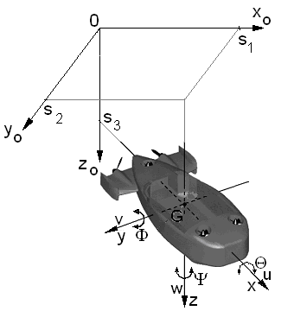
Fig.1. Body-fixed and earth-fixed reference systems
The non-linear equations of underwater vehicle’s movement treated as rigid body can be written as follows:
$\begin{aligned}m[\overset{˙}{u}−υr+ωq−x_{G}(q^{2}+r^{2})+ \\ +y_{G}(\text{pq}−\overset{˙}{r})+z_{G}(\text{pr}+\overset{˙}{q})]=X \\ m[\overset{˙}{υ}−ωp+\text{ur}−y_{G}(r^{2}+p^{2})+ \\ +z_{G}(\text{qr}−\overset{˙}{p})+x_{G}(\text{qp}+\overset{˙}{r})]=Y \\ m[\overset{˙}{ω}−\text{uq}+υp−z_{G}(p^{2}+q^{2})+ \\ +x_{G}(\text{rp}−\overset{˙}{q})+y_{G}(\text{rq}+\overset{˙}{p})]=Z \\ I_{x}\overset{˙}{p}+(I_{z}−I_{y})\text{qr}+ \\ +m[y_{G}(\overset{˙}{ω}−\text{uq}+υp)−z_{G}(\overset{˙}{υ}−ωp+\text{ur})]=K \\ I_{y}\overset{˙}{q}+(I_{x}−I_{z})\text{rp}+ \\ +m[z_{G}(\overset{˙}{u}−υr+ωq)−x_{G}(\overset{˙}{ω}−\text{uq}+υp)]=M \\ I_{z}\overset{˙}{r}+(I_{y}−I_{z})\text{pq}+ \\ +m[x_{G}(\overset{˙}{υ}−ωp+\text{urp})−y_{G}(\overset{˙}{u}−υr+ωq)]=N\end{aligned}$(1)
where:
$m$– vehicle mass;
$I_{x},I_{y},I_{z}$– moments of inertia in relation to symmetry axis of vehicle;
$x_{G},y_{G},z_{G}$ – co-ordinates of centre of gravity.
Describing move of vehicle in vertical plane (not taking into consideration roll) is useful to use the equations of forces relatively to $x$ and $z$ axis and equations of moment relatively to $y$ axis.
$\begin{aligned}m[\overset{˙}{u}−υr+ωq−x_{G}(q^{2}+r^{2})+ \\ +y_{G}(\text{pq}−\overset{˙}{r})+z_{G}(\text{pr}+\overset{˙}{q})]=X \\ m[\overset{˙}{ω}−\text{uq}+υp−z_{G}(p^{2}+q^{2})+ \\ +x_{G}(\text{rp}−\overset{˙}{q})+y_{G}(\text{rq}+\overset{˙}{p})]=Z \\ I_{z}\overset{˙}{r}+(I_{y}−I_{z})\text{pq}+ \\ +m[x_{G}(\overset{˙}{υ}−ωp+\text{urp})−y_{G}(\overset{˙}{u}−υr+ωq)]=N\end{aligned}$(2)
The general representation of equation of movement in body-fixed frame can be written as:
$M\overset{˙}{v}+C(v)v+D(v)v+g(η)=τ$ (3)
where:
$η$– vector of state;
$τ$– vector of the input functions;
$v$– vector of velocities;
$M$– the matrix of vehicle masses and added water masses;
$C(v)$– the matrix of centripetal and Coriolis forces;
$D(v)$– the matrix of hydrodynamic dumping;
$g(η)$– the matrix of restoring moments and forces.
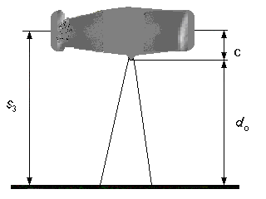
Fig.2. Position of vehicle relatively to sea bottom.
Position of vehicle is described by $G$ point coordinate in inertial earth-fixed frame and by three Euler’s angles. Lets signify coordinate of $G$ point as $(s_{1},s_{2},s_{3})$, angle of course as $Ψ$, trim as $Φ$ and heel as $Θ$. In this case the position of vehicle relatively to sea bottom can be described as:
$\begin{aligned}s_{3}−c=d_{0}=\text{const} \\ Θ=0 \\ Φ=0\end{aligned}$ (4)
where:
$c$– distance of installed on vehicle active sonar from vehicle’s center of gravity
$d_{0}$– distance from sea bottom (Fig. 2).

3. stabilization of underwater vehicles on given distance from see bottom
Using underwater vehicle to observe sea bottom and searching object which are lying on sea bottom is involved with moving vehicle in given distance from the sea bottom. In general this movement is realized by vehicle’s maneuvering in space such the vehicle during realizing given task will avoid underwater obstruction. The vehicle should be equipped with systems which gives his position and detects the movables or non-movables obstruction in sea space. The simplest variant of system control which allow for moving in given distance from sea bottom should consist of course stabilization system, which is working regardless of sea bottom profile and given distance from sea bottom stabilization system which is using active sonar which gives information about sea bottom profile and eventual obstructions. Avoiding not large obstructions ensure using one active sonar but only if vehicle has very good maneuver characteristic. If the sea bottom profile is difficult it is required to measure its angel continuously. This can be realized using scanning active sonar or few (two or three) active sonar which are configured in different angle. Using results of distance measurements vehicle has information about sea bottom profile and can generate control signal which ensure keeping given distance from sea bottom and avoiding sea obstruction. During formation mathematical model which is describing avoiding obstruction process the following guidelines should by made:
- profile of sea bottom is represented by single or grouped obstruction with any shape
- as model trajectory which is used by vehicle during obstructions avoiding is curves with constants distance from sea bottom. Vehicle position of center of gravity relatively to sea bottom is described by distance $d_{0}$ in perpendicular direction to vehicle’s longitudinal axis
- main task of stabilization is keeping given distance from sea bottom, keeping minimal, acceptable, safe distance from obstruction and keeping orientation of vehicle’s longitudinal axis according to shape of sea bottom profile or obstruction
- the distance are measured by active sonar which are configured in given angle.

3.1 Stabilization using one active sonar and measurement of angles’ inclination
Stabilization of vehicle’s distance from see bottom in case when sea bottom slope is not big is quite easy. It is realized similar to depth stabilization. The difference lies in kind of using detectors and stabilization precision.
Lets consider the simplest variant of vehicle movement on given distance from bottom, realized using one active sonar and measurement of angle’s inclination. Change of water depth under keel is equal to distance $d_{3}$ (in perpendicular direction) to sea bottom which profile is described by function $ϑ\left(x\right)$ and can be written as:
$d_{3}=υ\text{sin}\left[ϑ−ϑ\left(x\right)\right]$ (5)
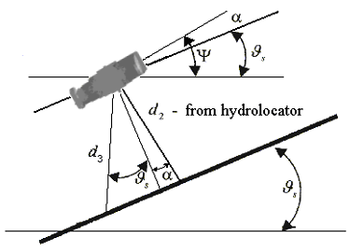

Fig.3. Definition of distance from sea bottom
We assume that sea bottom profile $ϑ\left(x\right)$ is flat with not big slope (steep $ϑ\left(x\right)=ϑ_{s}$). Stabilization task is that real trajectory of vehicle motion should recreate bottom profile with given precision simultaneously with keeping given distance. During vehicle movement along slope is important to keep values $ϑ=±ϑ_{s}$ and $d_{3}=d_{3z}$. In practice it is difficult to realizing values of $d_{3}$ measurements. There for the simplest is to take as distance from sea bottom value $d_{2}$ along to perpendicular longitudinal axis, which is measured by active sonar hardly joined to vehicle (Fig. 3). In this case is generated additional inadvertence which is result of measuring distance not perpendicular to sea bottom. The measured value of $d_{2}$ is involved with $d_{3}$ by equation: $d_{2}=d_{3}\text{cos}ϑ_{s}/\text{cos}α$ where $α$ is angle of attack during vehicle moving along to sea bottom.
In case when sea bottom has big slope the difference between measured value $d_{2}$ and depth along the vertical line $d_{3}≈d_{2}\text{cos}Ψ\left(1+\text{tg}Ψ\text{tg}ϑ_{s}\right)$ can be much greater. On the Fig. 3 could be saw that change of value $d_{2}$ during movement should fulfill:
$d_{2}≈υ\text{sin}α≈\text{υα}$ (6)
In established state for control rules:
$M_{\text{zster}}=k_{Ψ}Ψ+k_{d}Δd=k_{Ψ}Ψ+k_{d}\left(d_{2}−d_{2z}\right)$ (7)
we have: $α=0,$$ϑ=Ψ=ϑ_{Z}$and $Δd=−\frac{k_{Ψ}+M_{0}}{k_{d}}ϑ_{s}$,
from this follows that inadvertence of control which is proportional to angle of sea bottom slope is negative during surface and positive during dive of vehicle.

3.2 Stabilization using many sonars
Possibility of vehicle maneuvering in vertical plane is characterized as maximum trajectory’s angle slop and involving with them maximum allowed distance from obstruction. The control system is quite easy if minimal distance from obstruction, angle of trajectory and slop angle of sea bottom profile are described by values of measured distances received from few active sonars positioned in bow of vehicle (they are orientated forward and down with angle $δ$ to the vehicle’s vertical axis). Lets consider presented above way of control (Fig.4).
Distances $d_{1},d_{2},d_{3}$ are measured adequately in vehicle’s longitudinal axis, with $δ$ angle to normal axis and in perpendicular direction to the vehicle’s moving direction. Stabilization of moved vehicle’s center of gravity basis on trajectory’s angle during vehicle is moving along to sea bottom profile means keeping direction of speed vector parallel to the direction of tangent to sea bottom profile in any time. Condition when this requirements are fulfill is to keep right value of attack angle $α$ which is calculated from measured values $d_{2}$ and $d_{3}$:
$\text{tg}α=−\text{ctg}δ+\frac{d_{2}}{d_{3}\text{sin}δ}$ (8)
This equations is received by changing the profile of sea bottom included between two lines of measuring $d_{2}$ and $d_{3}$ by straight line. Approximation is possible if measured values will be averaged in time so called “ray sliding”. During controlling vehicle using difference between angles $α$ and $δ$ it should be calculated proportional control signal to the:
$α=\text{arctg}\left(\frac{d_{2}}{d_{3}\text{sin}δ}−\text{ctg}δ\right)$ (9)
which ensure constants given direction of forward speed vector.
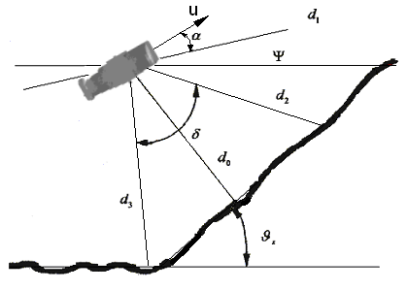
Fig. 4. Scheme of distance measurement by three sonars.
Where: $Ψ$ - angle of trim,
$d_{0}$ - the smallest distance,
$d_{1},d_{2},d_{3}$ - distances measured in sonar monitoring direction,
$α$ - angle of attack, angle between normal to longitudinal axis and line of middle sonar monitoring.
Because the vehicle moving with attack angle different from zero, the longitudinal vehicle’s axis is not parallel to sea bottom’s slope. It cause that inadvertence of vehicle’s stabilization in given distance from sea bottom is proportional to angle of sea bottom slope. It also cause that for example when the camera video is used which observation’s line is perpendicular to vehicle’s longitudinal axis will not directed perpendicular to sea bottom. There for there become problem of vehicle control not using angle of attack (angle of trajectory) but using orientation of vehicle longitudinal axis. Condition when vehicle longitudinal axis is parallel to sea bottom slop can be written as:
$d_{3}−d_{2}\text{cos}δ=0$ (10)
Difference $d_{3}−d_{2}\text{cos}δ$ can be used as one of control signal. Values of $δ$ angle is such selected that during ‘ray slide” along sea bottom the reflection signal will be sufficiently strong. This condition is fulfill when $δ$ angle value is near to ${\text{45}}^{o}$.
Proportional signal to $d_{3}−d_{2}\text{cos}δ$ ensure good quality of control for segment with softly changing sea bottom profile. The sonar positioned in vehicle longitudinal axis have to ensure detection of obstruction in time which allow to make safe move of avoid. For this is given value of critical distance. When vehicle riches this value is making maneuver such way so his axis is directed for peak of obstruction. Turn about required angle is made by calculation of proportional to $d_{2}−d_{1}a_{1}$ control signal where parameter $a_{1}$ is choosing from condition where given value is going to zero during no signal $d_{1}$ (there is no obstruction on course) on strength line moving $\left(d_{1}≥d_{1\text{max}}\right)$ it means:
$a_{1}=\frac{d_{3z}}{d_{1\text{max}}}=\frac{d_{2z}}{d_{1\text{max}}\text{cos}δ}$ (11)
where:
$d_{2z},d_{d3z}$ – given values of distance,
$d_{1\text{max}}$ – range of sonar positioned on vehicle’s bow.

During approach to obstruction signals $d_{2}−d_{1}a_{1}$ and $d_{3}−d_{2}\text{cos}δ$ are working in opposite direction, there for it is necessarily to turn him. It is made by bringing distance’s $d_{1}^{0}$ punishment function and determining sign of $d_{1}−d_{1}^{0}$.
For keeping vehicle in given distance from sea bottom to the rule of control is added signal of difference between actual values of three measured distances and his given values which are multiplied by given coefficient adequately to direction of sonar monitoring line. This is equal to stabilization averaged distance $d_{1}$ instead of stabilization the minimal distance from trajectory. Sum of positioned signal is described as:
$\sum_{i=1}^{3}{\left(d_{i}−\frac{d_{2z}}{a_{i}}\right)}$ (12)
where: $a_{1}=\frac{d_{3z}}{d_{1\text{max}}}, a_{2}=\frac{d_{2z}}{d_{3z}}=\text{cos}δ, a_{3}=1\text{.}$
Finally the rule of vehicle’s control in vertical plane has form as above:
$σ=A\sum_{i=1}^{3}{\left(d_{1}−\frac{d_{2z}}{a_{i}}\right)}+BΨ+C\left(d_{2}−d_{1}a_{1}\right) \text{for} d_{1}≤d_{1}^{0}$ (13)
where: $A,B,C$ are constants coefficients which ensure demanded dynamics characteristics.
Choice of control rules’ parameters for given type of underwater vehicle which is realizing task of constants distance stabilization from sea bottom using presented above control methods is easy to realize using the mathematical models.

- Simulation research
It was researched simulations for underwater vehicle in case of avoiding the water obstruction which was hill high 60 meters. The research was made for stabilization using one active sonar and measurement of angle inclination and assumed that product speed of vehicle was constant. The results are presented on ‘Fig.5’ to ‘Fig.9’.
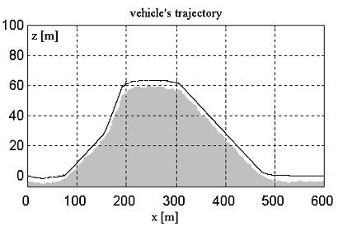
Fig. 5. Trajectory of vehicle during water obstruction avoiding.
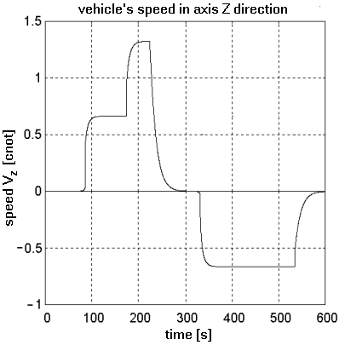
Fig. 6. Plot of vehicle speed in Z axes during water obstruction avoiding.
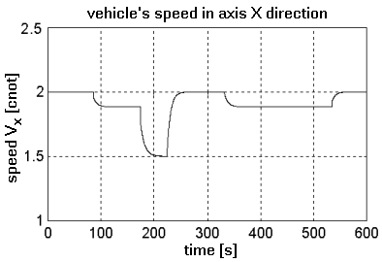
Fig. 7. Plot of vehicle speed in X axes during water obstruction avoiding.
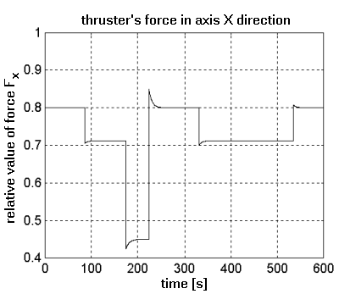
Fig. 8. Plot of forces operated in X axes during water obstruction avoiding
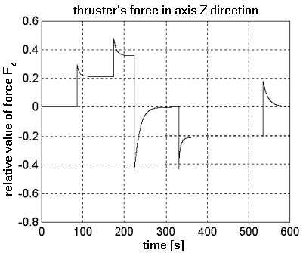
Fig. 9. Plot of forces operated in Z axes during water obstruction avoiding.
5. Conclusion
Main influence on quality of underwater vehicle motion control has exterior forces which acts on its frame in particular the water stream. This influence can be especially saw during vehicle is moving very slow and is positioning dynamically because of limitations of propeller’s power and limitations given for control signals. Taking into consideration in control principle form the sea bottom profile, inclination angle and attack’s angel with suitable coefficients is making quality of underwater vehicle control much more effective. During maneuvering the regulation time and over-regulation is decreasing more over the transitional process become of aperiodic. From research the following conclusion can be draw:
- application of one active sonar and measurement of angles’ inclination for stabilization the vehicle in given distance from sea bottom is fulfilling task for angle of slope bellow 30⁰
- if propellers are right selected then during maneuvering the components of speed $v_{x}$ and $v_{z}$ are changing without over-regulations
- the main influence for precision of driving underwater vehicle by given trajectory has the dynamics of applied propeller.

References
- Fossen T.I.: Guidance and Control of Ocean Vehicles. John Wiley and Sons Ltd., Chichester, 1994
- Garus J., Kitowski Z.: Sliding control of motion of underwater vehicle. Proc. of the 4th Int. Conference on Marine Technology III ODRA’99, Computational Mechanics Publications, Southampton, 1999, pp. 603-611
- Haley A.J., Lienard D.: Multivariable Sliding Mode Control for Autonomous Diving and Steering of Unmanned Underwater Vehicles. IEEE Journal of Ocean Engineering, No. 3,1993, pp.
- Kitowski Z., Garus J.: A self-Adapting control system of underwater vehicle’s motion. First International Conference on Marine Technology, Szczecin, 1995, s.159-164.
- Kitowski Z., Żak B., Pekala J.: About method of determine underwater vehicle’s motion trajectory. International Conference on Communication, Signal and System. Brno, Czech Republic, 1996, s. 347-351.
- Yoerger D.R., Slotine J.E.: Robust Trajectory Control of Underwater Vehicles. IEEE Journal of Oceanic Engineering, No. 4,1985, pp. 462-470

