A Cascade Lattice IIR Adaptive Filter Structure Using
Simultaneous Perturbation Method

IVAN MEDINA-MARTINEZ⁽¹⁾, MARIKO NAKANO-MIYATAKE⁽¹⁾,
KAZUSHI NAKANO⁽²⁾, HECTOR PEREZ-MEANA⁽¹⁾
(1) Mechanical and Electrical Engineering School
National Polytechnic Institute of Mexico
Av. Santa Ana 1000, Col. San Francisco Culhuacan 04430 Mexico D. F.
MEXICO
http://calmecac.esimecu.ipn.mx
(2) Department of Electronic Engineering
The University of Electro-Communications
Chofu-shi Tokyo
JAPAN

Abstract: - A new IIR adaptive filter algorithm is proposed in which the filter structure is constructed as a cascade of a transversal structure and an all pole lattice structure. The filter structure is adapted using the Steiglitz-McBride method in which the transversal section and lattice sections are updated using the simultaneous perturbation method. Proposed algorithm preserves the stability of the IIR adaptive filter during the adaptation with a lower computational complexity than conventional algorithms. Simulation results show the desirable features of proposed scheme.

Key-Words: - IIR adaptive filter, simultaneous perturbation method, Steiglitz-McBride approach, Cascade lattice

1 Introduction
Over the last two decades, substantial research efforts have been carried out to derive reliable adaptive infinite impulse response (IIR) adaptive filtering algorithms. This is motivated by the potential reduction in the computational complexity and the ability of model sharp resonances with a much smaller number of filter coefficients as compared with their FIR counterparts. Unfortunately, there are a number of problems associated with IIR adaptive filters that must be solved, namely, slow convergence, potential filter instability and mean square error function with multiple local minima [1]-[5].
In sufficient order applications, where the adaptive filter has an enough number of filter coefficients to identify the unknown system, some IIR adaptive filters lead to biased parameters, where the unbiased parameters are those of the unknown system. These drawbacks have prevented that the IIR adaptive filters be used in a larger number of applications. One particular implementation of an adaptive feedback controller adds an adaptive filter to a standard linear quadratic Gaussian (LQG) controller to enhance disturbance rejection in a feedback control loop [2]. This controller is called a hybrid controller and has shown that the addition of a feedback loop provides to the damped adaptive filter a faster convergence rate and lower filter order for the same performance, compared with the undamped case [3], [4].
The FIR adaptive filters are the most widely used in most adaptive filter applications, although they have limitations to model systems with infinite impulse responses. These limitations become particularly important when the adaptive system is required to model acoustic impulse responses in acoustic echo cancellation or other physical processes where model of infinite impulse response is required. One of advantages of adaptive IIR filters is that they can model better these rational transfer (pole-zero) functions than the FIR ones. Another advantage of IIR filters is that they can provide significantly better performance with same number of coefficients than its FIR counterparts. However the IIR adaptive filters also present several drawbacks such as stability problems, convergence to local minimum of the mean square error surface when gradient-search-based algorithms are used and slow convergence rates, etc. These problems must be solved before reliable IIR adaptive structures can be used in practical applications.
To overcome some of these problems several structures have been proposed using cascade, parallel and lattice structures, etc. Among them, some of the most successful algorithms use a cascade of FIR transversal filter and AR lattice structures updated with LMS-type adaptive algorithms to avoid stability problems. However, in general the lattice-based filters have a larger computational complexity than the transversal structures. To reduce the computational complexity of lattice-based IIR adaptive filters, this paper proposes a cascade IIR adaptive filter structure, in which the coefficients vector is updated using the simultaneous perturbation stochastic approximation.

- Cascade Lattice IIR Adaptive Filter
Consider the output signal of cascade IIR adaptive filter structure shown in Fig. 1, which is given by

$y(n)=s(n)−\sum_{k=1}^{N}{a_{i}x_{i}(n)}$ (1)

$\begin{aligned}y(n)=s(n)−\left(a_{1}(n) a_{2}(n)\text{.}\text{.}\text{.}a_{N}(n)\right)T_{N}(n−1) \\ \text{ * }\left(\begin{matrix}y(n−1) \\ \\ \\ \\ y(n−N)\end{matrix}\right)\end{aligned}$ (2)
where

$s(n)=\sum_{i=0}^{N}{b_{i}x(n−i)}$ (3)

is the output signal of direct-form FIR filter, and T_{N} is the transformation matrix from the space of direct form structure into that of a two multiplier lattice structure [1]. Taking the z transform of eqs. (2) and (3), and using the unit delay operator, q⁻¹, instead of the frequency domain operator, z⁻¹, it follows that

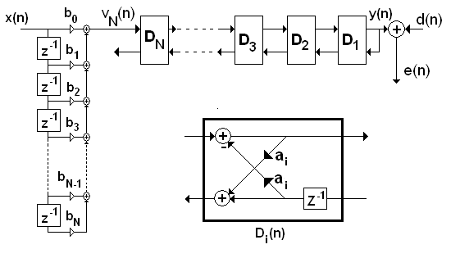Fig. 1. Cascade IIR filter structure with transversal and two multiplier lattice sections.
$y(n)=\frac{B(q^{1},n)}{A(q^{−1},n)}x(n)$ (4)

where [1]

$\begin{aligned}A(q^{−1},n)=\left(1 a_{1}(n) a_{2}(n)\text{.}\text{.}\text{.}a_{N}(n)\right)\left[\begin{matrix}1 & 0 \\ 0 & T_{N}(n−1)\end{matrix}\right] \\ \text{ * }\left(\begin{matrix}1 \\ q^{−1} \\ \\ \\ q^{−N}\end{matrix}\right)\end{aligned}$ (5)

is the transfer function of the all pole lattice section and
$B(q^{−1},n)=\left(b_{0}(n),b_{1}(n),\text{.}\text{.}\text{.}b_{M}(n)\right)\left(\begin{matrix}1 \\ q^{−1} \\ \\ \\ q^{−M}\end{matrix}\right)$ (6)

is the transfer function of the transversal section. Thus, from eqs. (4)-(6) it follows that the output signal of the IIR adaptive filter is given by

$v_{N}(n)=\sum_{j=0}^{M}{\text{bj}(n)x(n−j)}$ (7)

$y(n)=v_{0}(n)=u_{0}(n)=v_{1}(n)−a_{1}(n)v_{0}(n−1)$ (8)

for m=1, 2, 3,…,N

$u_{m}(n)=a_{m}(n)v_{m−1}(n)+u_{m−1}(n−1)$ (9)

$v_{m−1}(n)=v_{m}(n)−a_{m}(n)u_{m−1}(n−1)$ (10)

- Adaptive algorithms
Two different adaptive algorithms will be used to update the IIR filter coefficients vector, which will be derived assuming that the adaptive filter is of strictly sufficient order; the filter structure is persistently excited. The measurement noise has bounded variance, it is independent of the input signal, x(n), and finally the adaptive filter is assumed to be stable [1], [3], [4].
Next sections provide the adaptive algorithms used to update the adaptive filter coefficients vector.
  - IIR LMS-SPSA algorithm
One of the most widely used adaptive algorithm is the Least Mean Square (LMS) algorithm, in which the filter coefficient at time instant n+1 are given by

$a_{m}(n+1)=a_{m}(n)−2μe(n)\frac{∂e(n)}{∂a_{m}},$ (11)

$b_{j}(n+1)=b_{j}(n)−2μe(n)\frac{∂e(n)}{∂b_{j}},$ (12)

where e(n) is the output error

$e(n)=d(n)−y(n)$, (13)

m=1, 2,..., N and j=1, 2,...,M.
The simultaneous perturbation stochastic approximation (SPSA) [6], [7] is a very low computational complexity adaptive algorithm allowing solving difficult multivariate optimization problem in an efficient way, such as eqs. (11) and (12), especially when lattice structures are used. To this end, firstly, define the perturbation vector C_{n},

$C_{n}=(k_{n}^{1},k_{n}^{2},\text{.}\text{.}\text{.},k_{n}^{N},c_{n}^{1}\text{.}\text{.}\text{.}c_{n}^{M})^{T}$, (14)

which will be use to estimate the derivatives required by eqs (11) and (12), where n denotes the time index, the perturbation vector components $c_{n}^{i}$and $k_{n}^{i}$are random numbers uncorrelated among them with cero mean and uniformly distributed in the interval$\left([−c_{\text{max}},−c_{\text{min}}],[c_{\text{min}},c_{\text{max}}]\right)$. Thus using the simultaneous perturbation method, firstly we estimate the output error e(n) using the eqs. (7)-(10) and (13). Next the perturbed output error e(n,C) is estimated substituting $a_{m}(n)=a_{m}(n)+k_{n}^{m}$ and $b_{m}(n)=b_{m}(n)+c_{n}^{m}$ in eqs. (7)-(10) and (13). Finally, using e(n) and e(n,C), the filter coefficients are updated as follows:

$a_{m}(n+1)=a_{m}(n)−2μe(n)\frac{e(n)−e(n,C)}{k_{n}^{m}}$ (15)

$b_{j}(n+1)=b_{j}(n)−2μe(n)\frac{e(n)−e(n;C)}{c_{n}^{j}}$ (16)

  - SPSA-based Steiglitz-McBride type IIR adaptive algorithm.
Figure 2 shows the IIR output error adaptive structure proposed by Steiglitz and McBride [2], which has been used in the development of several IIR adaptive filtering algorithm. Some of the most successful algorithms use a cascade of FIR transversal filter and an AR lattice structure updated using an LMS-type adaptive algorithm to avoid stability problems. To reduce the computational complexity of this structure, while keeping its desirables properties, the IIR coefficients vector is updated using the simultaneous perturbation stochastic approximation in which the following criterion is minimized

$ε(n)=E\left[e^{2}(n)\right]$ (17)

where e(n) is the output error given by [1]

$\begin{aligned}e(n)=A(q^{−1},n)\left(\frac{d(n)}{\hat{A}(q^{−1},n−1)}\right) \\ −B(q^{−1},n)\left(\frac{x(n)}{\hat{A}(q^{−1},n−1)}\right)\end{aligned}$ (18)

where A(q⁻¹,n) and B(q⁻¹,n) are given by eqs. (5) and (6) respectively. Assuming that A(q⁻¹,n-1) remain constant, the minimization can be done with respect to the parameters a₁(n), a₂(n), …,a_{N}(n), b₀(n), b₁(n), b₂(n),…,b_{M}(n). Thus, using a LMS type adaptive algorithm, a_{m}(n+1), m=1,2,..,N, and b_{j}(n+1), j=1,2,…,M are updated as follows

$a_{m}(n+1)=a_{m}(n)−2μe(n)\frac{∂e(n)}{∂a_{m}},$ (19)

$b_{j}(n+1)=b_{j}(n)−2μe(n)\frac{∂e(n)}{∂b_{j}},$ (20)

where m=1,2,...,N; j=1,2,...,M and e(n) is given by eq. (18).
The gradient estimation required by eqs. (19) and (20) especially that involving the lattice stages requires a relatively large computational effort. To reduce the computational the SPSA can be used. To this end, firstly, define the perturbation vector C_{n} as shown in eq. (14). Thus using the simultaneous perturbation method, firstly we estimate the output error, which from eq. (18) and Figs. 2-4 is given as follows:

$v_{N}(n)=x(n)$ (21)

$v_{0}(n)=v_{1}(n)−a_{1}(n−1)v_{0}(n−1)$ (22)
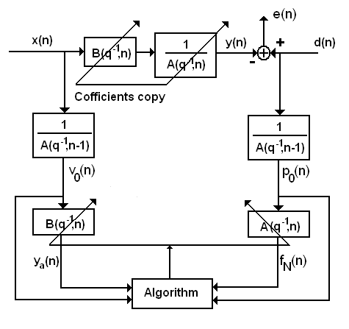
Figure 2. SM IIR adaptive structure.

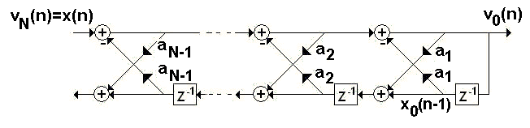
Figure 3. Prefiltering stage using reflexion coefficients estimated at time n-1.

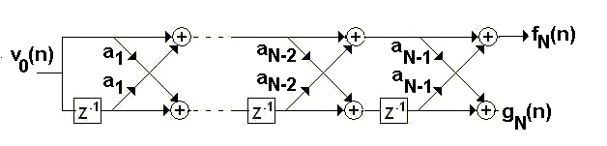
Figure 4. All zero lattice filter stage used to update the IIR filter coefficients vector.

$x_{0}(n)=v_{0}(n)$ (23)

for m=1 to N

$x_{m}(n)=x_{m−1}(n−1)+a_{m}(n−1)v_{m−1}(n)$ (24)

$v_{m−1}(n)=v_{m}(n)−a_{m}(n−1)x_{m−1}(n−1)$ (25)

$f_{0}(n)=g_{0}(n)=v_{0}(n)$ (26)

for m=1 to N

$f_{m}(n)=f_{m−1}(n)+a_{m}(n)g_{m−1}(n−1)$ (27)

$g_{m}(n)=a_{m}(n)g_{m−1}(n−1)+f_{m−1}(n)$ (28)

$p_{N}(n)=d(n)$ (29)

$p_{0}(n)=p_{1}(n)−a_{1}(n−1)p_{0}(n−1)$ (30)

$r_{0}(n)=p_{0}(n−1)$ (31)

for m=1 to N-1

$p_{m−1}(n)=p_{m}(n)−a_{m}(n−1)r_{m−1}(n−1)$ (32)

$r_{m}(n)=r_{m−1}(n−1)+a_{m}(n−1)p_{m−1}(n)$ (33)

Next, using eqs. (19) and (24) the output error is given by

$e(n,A,B)=f_{N}(n)−\sum_{j=0}^{M}{b_{j}(n)p_{0}(n−j)}$ (34)

Using eqs (21)-(34), with $a_{m}(n)=a_{m}(n)+k_{n}^{m}$ and $b_{m}(n)=b_{m}(n)+c_{n}^{m}$, estimate e(n,A,B,C). Finally, using e(n,A,B) and e(n,A,B,C), the filter coefficients are updated as follows:

$a_{m}(n+1)=a_{m}(n)−2μe(n,A,B)\frac{e(n,A,B)−e(n,A,B,C)}{k_{n}^{m}}$
(35)

$$b_{j}(n+1)=b_{j}(n)−2μe(n,A,B)\frac{e(n,A,B)−e(n;A,B,C)}{c_{n}^{j}}$$
(36)

from m=1,2,..N and j=0,1,2..,M, respectively.

4. Simulation results
The actual performance of proposed algorithm was evaluated using system identification configuration, in which the unknown system used is the same reported in [1], whose transfer function is given by

$H(z)=\frac{−0\text{.}\text{097}−1\text{.}\text{337}z^{−1}+1\text{.}6z^{−2}}{1\text{.}0−1\text{.}\text{19}z^{−1}+0\text{.}7z^{−2}}$ (37)

where, the input signal was a white noise sequence. The convergence factor was equal to 0.001 which minimize the use of the stabilization mechanism that keeps the poles inside the unit circle. The variance of the measurement noise was -10.0 dB. The filter weights are initialized using N uniformly distributed random numbers with zero mean and unit variance, and the perturbation factors used to update the filter weights are uniformly distributed random numbers in the interval ([-0.01 +0.01] except [-0.001, 0.001], i. e. Cmax=0.01 and Cmin=0.001. in eq. (14).
Fig. 5 shows the convergence performance of proposed LMS-based IIR adaptive algorithm using the simultaneous perturbation stochastic approach (SPSA). The convergence performance of conventional LMS-based IIR adaptive algorithm is shown for comparison in Fig. 6.

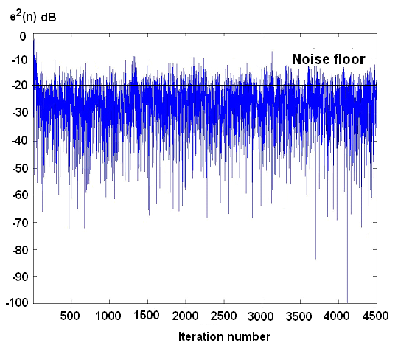
Fig. 5 Convergence performance of proposed LMS-IIR-SPSA algorithm.
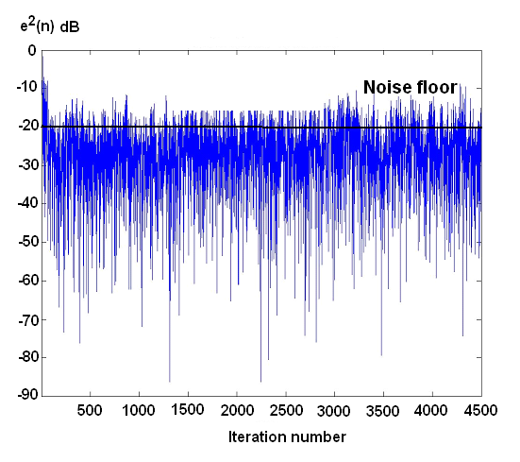
Fig. 6 Convergence performance of convetional LMS-IIR-SPSA algorithm.
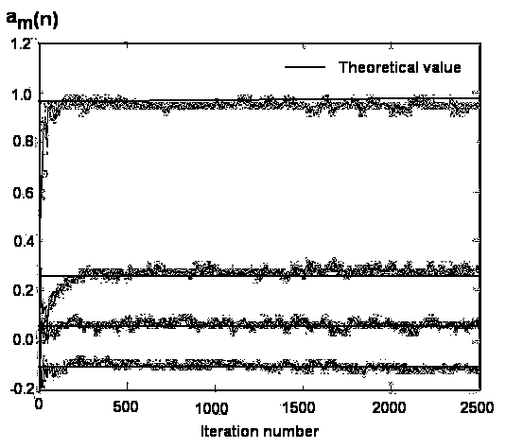
Fig. 7 Tap parameters of proposed SM type algorithm

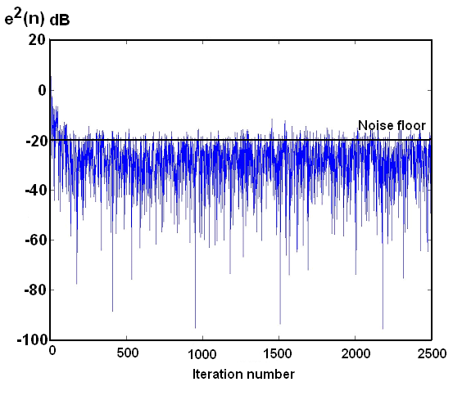
Fig. 8 Convergence performance of proposed SM type adaptive algorithm with SPSA

Figures 7 and 8 show the convergence performance of proposed LMS-SPSA-based SM type IIR adaptive algorithm. Fig. 9 shows, for comparison, the convergence performance of a previously proposed algorithm LMS based SM IIR adaptive algorithm. Simulation results shown that proposed algorithm performs fairly well with a far little computational complexity than similar structures previously proposed.
Simulation results show that the proposed algorithms using the simultaneous perturbation method provides similar convergence performance that previously proposed IIR algorithms with less computational complexity.
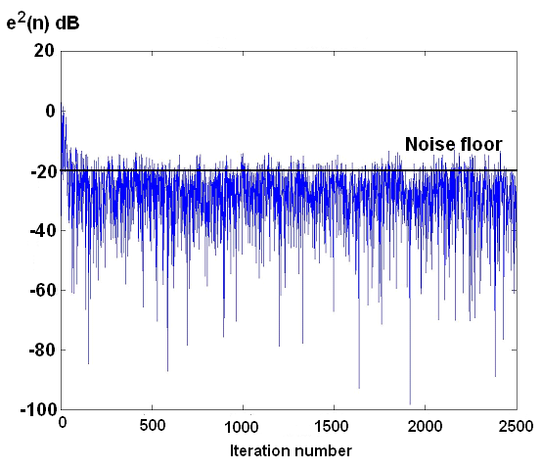
Fig. 9 Convergence performance of conventional SM Cascade type IIR adaptive algorithm.

5. Conclusions
Two different adaptive algorithms for updating an IIR structure consisting of a cascade of transversal and lattice stages were proposed, whose parameters are updated using the SPSA method. The first one using an IIR-LMS approach and the second one a Steiglitz-McBride type IIR adaptive algorithm. The main advantage of proposed approaches with respect to the other previously proposed LMS-IIR and Steiglitz-McBride based IIR filter structures is an important reduction of the computational complexity. Computer simulations show that proposed algorithms provides a quite similar convergence performance than the previously proposed algorithms with a much lower computational complexity.

Acknowledgements. We thanks the UEC of Japan and to CONACyT of Mexico for the support provided during the realization of this research.

References:
[1] K. Miao, H. Fan and M. Doroslovacki, Cascade lattice IIR adaptive filters, IEEE Trans. on Signal Processing, Vol. 42, No. 4, 1994, pp. 721-742.
[2] L. Pasquato and I. Kale, Adaptive IIR initialization via Hybrid FIR/IIR Adaptive combination, IEEE Trans on Instrumentation and Measurements, Vol. 50, No. 6, 2001, pp. 1830-1835.
[3] P. Regalia and M. Mboup, Undermodeled adaptive filtering,: An a priori error bound for the Steiglitz-MacBride Method, IEEE Trans. on Ciscuit and Systems- II Analog and Digital Signal Processing,, Vol. 41, No. 2, 1996, pp. 105-116.
[4] P. Regalia, Stable and Efficient lattice algorithms for IIR filtering, IEEE Trans. on Signal Processing, Vol. 40, No. 2, 1992, pp. 375-388.
[5]. J. Cousseau and P. Diniz, New adaptive IIR filtering algorithms based on the Steiglitz–McBride method, IEEE Transactions on Signal Processing, Vol. 45, No. 5, 1997, pp. 1367-1371.
[6] Y. Maeda and Y. Kanata, Learning rules for neuro-controller via simultaneous perturbation, IEEE Trans. on Neural Networks, Vol. 8, No. 5, 1997, pp. 1119-1130.
[7] Y. Maeda and Y Kanata, Learning rules for recurrent neural networks using simultaneous perturbation and their application to neuro-control, Trans of The IEICE, Vol. 113-C, No. 4, 1993, pp. 402-408.

