A Robust Watermarking Algorithm for
Visually Recognizable Pattern

VICTOR HERNANDEZ, MARIKO NAKANO, HECTOR PEREZ

Graduate Section of ESIME Culhuacan
National Polytechnic Institute
Av. Santa Ana 1000, 04430 Mexico D.F.
MEXICO

Abstract: - In general, visually recognizable watermarks offer to the digital material’s owner a stronger impact at the copyright claiming time. However due to a larger amount of the watermark information, watermark transparency and robustness cannot be easily obtained. To accomplish this difficult task, many watermarking algorithms performed in the transform domain have been proposed in the literature. Specially, DWT (Discrete Wavelet Transform) based watermarking algorithms shown their better performance compared with algorithms based on other domain, such as spatial, DCT (Discrete Cosine Transform), DFT (Discrete Fourier Transform) domain algorithm. However in the most DWT-based algorithms, digital material’s owner must keep a lot of information, such as original unmarked image, order information of the DWT coefficients, information about watermark pattern, etc., to extract his embedded watermark pattern (logo-type image). In this paper we propose a robust watermarking algorithm based on the DWT, in which the material’s owner must keep only original unmarked image and a secrete key. The watermark image size attended in the proposed algorithm is not limited. Experimental results show the proposed algorithm is more robust compared with other watermarking algorithm reported in the literature.

Key-Words: - Watermarking, DWT, Perceptual significant watermark, DCT, Significant Trees, Robustness

1. Introduction
The watermarking has been considered as an alternative solution for the copyright protection of digital materials, such as digital image, video and audio. During the last decade, several watermarking algorithms have been proposed in the literature. In the early approaches, watermarking was realized in the time or spatial domain [1], [2], however in these approaches, it is difficult to get imperceptibility and robustness of the watermark at the same time. Therefore, recently more robust watermarking algorithms have been developed in the transform domain.
Two types of watermarks are basically used for the digital images protection: one of them is the pseudo random sequence and another one is the two-dimensional visually recognizable watermarks such as a logotype. In General the pseudo random sequence is generated by using a secret key, which is related to the owner or provider [3],[4], while the second one, a two-dimensional watermark, represents directly the ownership of the provider as a logotype form. For this reason, the second type of watermarks has a stronger impact than the first one at the ownership claiming time. However, in general, the information amount of the second type of watermark is much more than that of the first one.
Due to this fact, it is difficult to provide an invisible and robust watermarking system using second type of watermarks. To overcome this difficulty, some adaptive watermarking algorithms based on DCT domain were proposed [5],[6]. In [5], Just Noticeable Difference (JND) was calculated using DCT coefficients to determine coefficient’s position and maximum watermark insertion energy while keeping imperceptibility of the watermarked image. In [6], texture information of each block of the image is used to embed watermark pattern in lower frequencies region of the DCT coefficients.
Also many DWT-based algorithms to embed visually recognizable pattern in digital image have been proposed [7],[8]. In [7], Qualified Significant Wavelet Trees (QSWTs) are found in the multiresolution wavelets coefficients and watermark data are embedded in some elements of the QSWTs, and in [8], JND information of wavelets coefficients and Chaotic Mixing method proposed by [9] were used to embed gray-scale watermark in the imperceptible manner. Both algorithms perform fairly well, however to extract watermark from the watermarked image, many additional information such as Significant Tree position and order data of the watermark, etc. These data together with original unmarked image must be stored in the secure place by the material’s owner.
In this paper, we propose a DWT-based watermarking algorithm using significant tree of the wavelets coefficients, in which DCT is applied to the visually recognizable watermark pattern to be able to reduce embedding data size. In the proposed method, material’s owner must only conserve unmarked original image, and visually recognizable watermark can be any size gray-scale or binary image. The computer simulation results show the robustness of the proposed algorithm when the watermarked image is suffered by intentional and no-intentional attacks.

2. The Proposed Algorithm

2.1 Watermark Embedding Process
The watermark embedding process is shown by the Fig. 1.

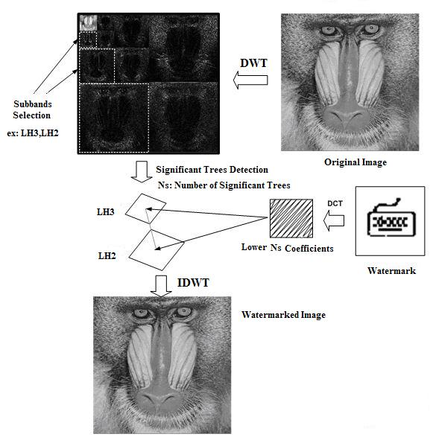
Fig. 1 Watermark Embedding Process

The steps of the watermark embedding process are as follows:

Step 1: DWT decomposition
The original image is realized three level decomposition using 2D-DWT to get 10 subbands (LL3,LH3,HL3,HH3,LH2,HL2,HH2,LH1,HL2,HH1). We use two subbands (LH3, LH2) or (HL3,HL2) for embedding because some modification in these subbands causes fewer perceptible degradation and wavelets coefficients in these subbands survive common attacks.
Step 2: Significant Trees Detection
Significant Trees have same concept of the QSWTs proposed by [7] and inverse concept of Zero Trees used for image compression EZW by [10]. We consider the wavelets coefficients of the coarser subband and its correspond finer subband create a Significant Tree, if and , where and are (i,j)-th coefficient in LH₃ and (k,l)-th coefficient in LH₂, respectively, and T₁,T₂ are threshold determined by eq. (1).

(1)

where N and M are number of coefficients in the subband LH₃ and LH₂, respectively.

Each Significant Tree contains five elements, which are one parent (coefficient in LH₃) and four children (four coefficients in LH₂). After all Significant Trees are detected, total number of the Significant Trees is saved in Ns. Naturally, total number of Significant Trees is depend on the original image.

Step 3: DCT application to the Watermark
Watermark (gray-scale or binary) image is transformed to the frequency domain by 2D-DCT and DCT coefficients are arranged in zig-zag manner from lowest frequency (DC component) to the highest frequency coefficient as shown by Fig 2. First Ns coefficients are selected to embed.

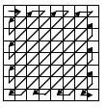
Fig. 2 DCT coefficients embedding order

Step 4: Sorting Significant Trees
All Significant Trees are sorted in descending order by sum of absolute value of parent coefficient and maximum absolute value of four children, as given by eq. (2).

(2)

Step 5: Embedding

Ns lower DCT coefficients of the watermark image embed to the sorted Significant Trees, this process is given by eqs. (3) and (4).

(3)

(4)

where is parent of the q-th sorted Significant Tree and is one child of the q-th Significant Tree, whose absolute value is maximum between four children. The embedding factor α is inversely proportional to DC component of the watermark image to conserve same imperceptibility without regard to size of the watermark. It is given by (5)

(5)

where DC is DC component’s value and f is the embedding energy of the watermark.

Step 6: Inverse DWT

Finally DWT coefficients are transformed by inverse DWT to get watermarked image.

2.2 Watermark extraction process
Watermark extraction process is shown by Fig. 3. In this process not only watermarked image but also original image are required. Both images are decomposed ten subbands by applying 2D-DWT. Significant Trees are detected from subbands (LH3 and LH2) of original image. After Significant Trees are sorted, we can extract DCT coefficients of the watermark image using eqs. (5) and (6).

(5)

(6)

where α is watermark energy used in the embedding process.

The q-th coefficient of the watermark image is the average of extracted coefficient from parent element and extracted coefficient from maximum child element of the q-th sorted Significant Trees.

After extracted all coefficients of the watermark image, these are rearranged in zig-zag manner to get a matrix with size of d1xd2=Ns. Finally the matrix is applied by inverse DCT to get extracted watermark image.

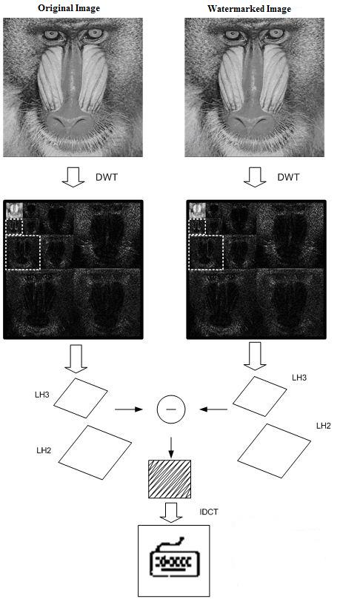

Fig. 3 Watermark extraction process.

3. Computer Simulation Results
The Figs 4 and 5 show watermarked image (512 x 512) with different size of watermark and extracted watermark image. In the Fig. 4, watermarks are 8-bits gray-scale images with different size (64x64, 96x96 and 128x128), while in the Fig. 5, watermarks are binary pattern. Total number of Significant Trees detected in subbands LH3 and LH2 of the original image is 3602, which means the embedding capacity without truncate the DCT coefficients of the watermark is 60 x 60. The PSNRs of the watermarked images are approximately 41 dB (41.2, 40.8 and 40.7 respectively, for gray-scale watermark and 41.5, 40.9 and 40.8 for binary watermark). The Fig. 6 shows the relations between degradation of the watermarked image respect to the original one and watermark pattern size.

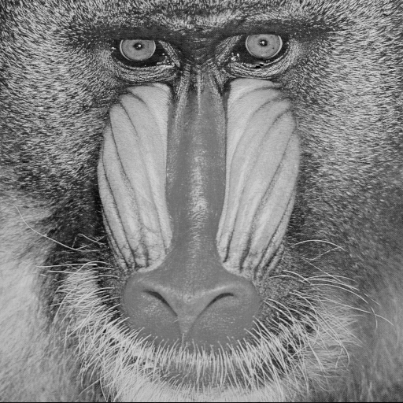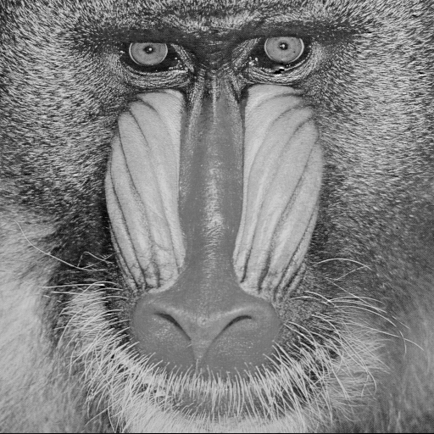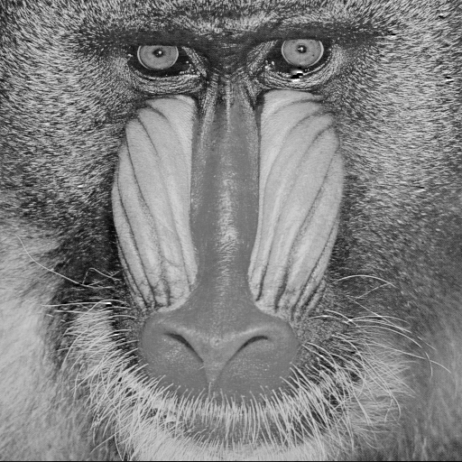
(a) (b) (c)

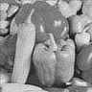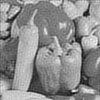
(d) (e) (f)
Fig. 4. (a),(b),(c) are watermarked image with different size of gray-scale watermarks. (d) is extracted watermark (64x64) from (a), (e) is extracted watermark (96x96) from (b), and (f) is extracted watermark (128x128) from (c).

(a) (b) (c)


(d) (e) (f)
Fig. 5. (a),(b),(c) are watermarked image with different size of binary watermarks. (d) is extracted watermark (64x64) from (a), (e) is extracted watermark (96x96) from (b), and (f) is extracted watermark (128x128) from (c).

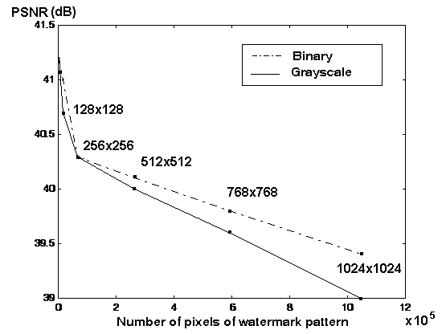
Fig. 6 Relation between PSNR of the watermarked image and size of watermark.

From the figures, we can observe that watermarked images suffered minimum distortion in spite of the large size of the watermark.
The Figs. 7 and 8 show robustness of the proposed algorithm, when JPEG compression is applied to the watermarked image. In the Fig. 7, watermark is 8-bits gray-scale image, and in the Fig. 8, watermark is binary image. In both cases, watermark size is 64 x 64. In the Fig 9, the relation between PSNR of extracted gray-scale watermark image respect to the original one and JPEG compression ratio is shown, and the Fig. 10 shows the normalized correlation (NC) of original binary watermark and extracted one, when JPEG compression ratio is changed from 2 until approximately 33.

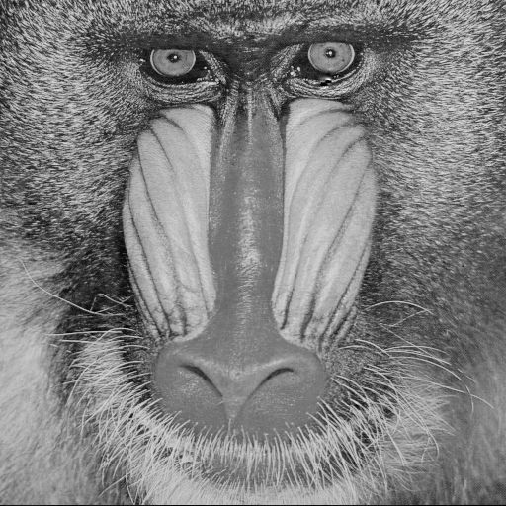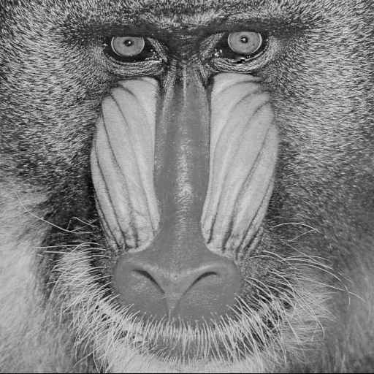
(a) (b) (c)

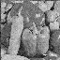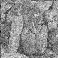
(d) (e) (f)
Fig.7. Robustness against JPEG compression, (a), (b) and (c) are watermarked compressed images by JPEG compression with quality factor 80, 40, 20, respectively, and (d), (e) and (f) are extracted watermark from (a), (b) and (c), respectively.


(a) (b) (c)


(d) (e) (f)

Fig.8. Robustness against JPEG compression, (a), (b) and (c) are watermarked compressed images by JPEG compression with quality factor 80, 40, 10, respectively, and (d), (e) and (f) are extracted watermark from (a), (b) and (c).

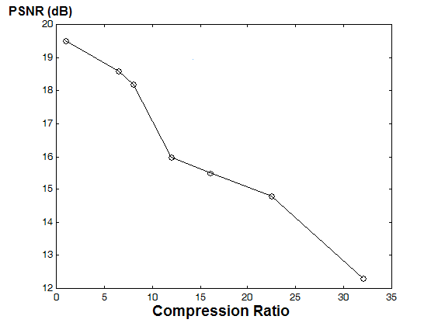
Fig. 9 Relation between compression rate and PSNRs of extracted gray-scale watermark respect to the original one.

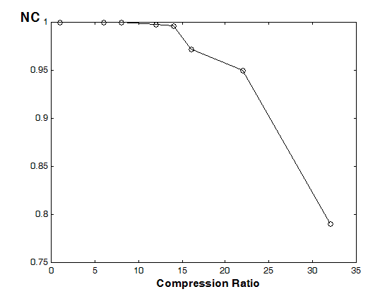
Fig. 10 Relation between compression rate and normalized correlation (NC) of extracted binary watermark and original one.

The Figures show that embedded watermark survived after high ratio JEPG compression, the gray-scale watermark survived after compression with compression ratio 15.4 (it is equivalent to quality factor 20), and binary watermark survived after compression with it’s ratio 22.1 (it is equivalent to quality factor 10) .
The Fig. 11 shows cropped watermarked image and extracted binary watermark. We can observe the proposed algorithm is also robust to cropping operation.


(a) (b) (c)
Fig. 11 (a) original image, (b) watermarked and cropped image and (c) extracted watermark binary image.

4. Conclusion
In this paper we proposed a DWT-based watermarking algorithm, in which watermark is perceptual significant gray-scale image or binary image. In the proposed algorithm, size of the watermark is not limited, due to the application of DCT to the watermark. Imperceptibility of the watermark can be controlled by the DC component of the watermark. The proposed watermark algorithm is robust some common attacks such as JPEG compression, corruption by noise, etc.
In the watermark extraction process, the original unmarked image is required, but information about the watermark such as sorting order, etc. is not necessary.

References:
[1] N. Nikolaidis and I. Pitas, “Copyright protection of images using robust digital signatures”, Proc. IEEE ICASSP’96, 1996, pp. 2168-2171.
[2] M. Swanson, B. Zhu and A. Tewfik, “Robust Data Hiding for Images”, Proc. IEEE Digital Signal Processing Workshop, 1996, pp. 37-40.
[3] A. Piva, M. Barni, F. Bartolini, V. Cappellini, “DCT-based Watermark Recorvering without Resirting to the Uncorrunpted Original Image”, Proc. of IEEE Int. Conf. of Image Processing, Oct. 1997, pp. 5210-523.
[4] J. Cox, J. Killian, T. Shamoon, “Secure spread spectrum watermarking for multimedia”, IEEE Trans. On Image Processing, vol. 6, no. 12, 1997, pp. 1673-1687.
[5] B. Corona, M. Nakano, H. Pérez, “Adaptive Watermarking Algorithm for binary Image Watermarks”, Lecture Notes in Computer Science, Springer, 2004, pp. 207-215.
[6] S. D. Lin, C.F. Chen, ”A Robust DCT-Based Watermarking for Copyright Protection”, IEEE Trans on Consumer Electronics, Vol.46, No.3, 2001, pp.415-421.
[7] M. Hsieh, D. Tseng, “Hiding Digital Watermarks Using Multiresolution Wavelet Transform”, IEEE Trans. on Ind. Elect. vol. 48, no. 5, 2000, pp. 875-881.
[8] C-S. Lu, S-K. Huang, C-J. Sze and H-Y Liao, “A New Watermarking Technique for Multimedia Protection”, in Multimedia Image and Video Processing, Ed. L. Guan, S. Kung and J. Larsen, CRC Press, London, 2000.
[9] G. Voyatzis and I. Pitas, “Digital Image Watermarking using Mixising System”, Computer Graphics, vol. 22, no. 3, 1998, pp. 405-416.
[10] J. M. Shapiro “Embedded Image Coding Using Zerotree of Wavelet Coefficients”, IEEE Trans. on Signal Processing, vol. 41, no. 12, 1993, pp. 3445-3462.

