Fuzzy Logic Controller Design Applied to Servo-Drive Systems

ALDO PARDO GARCIA¹, JORGE LUIS DÍAZ RODRÍGUEZ²
Universidad de Pamplona
Ciudadela Universitaria, Pamplona, Norte de Santander
COLOMBIA

http://www.unipamplona.edu.co

Abstract: - This paper presents a Fuzzy Logic Controller (FLC) design procedure for a DC motor servo-drive system. The fuzzy controller is synthesized using information from a previous modeling and simulation for the servo-drive system. A conventional speed control scheme with a PI controller was achieved, taking into account optimality criteria and anti-windup action. Both, conventional and fuzzy control schemes were analyzed and compared via computer simulations.
Key-Words: - Motor Control, PI Controllers, Windup, Fuzzy Logic Controllers, Servo-Drive Systems Simulation

1 Introduction
Direct Current (DC) motors have been the most used option, when electrical drives that operate in a wide rank of speed, are needed. This is due to its operational properties and their control characteristics. The only essential disadvantage is the mechanical commutator, which restricts the power and the motor speed, increases inertia and the axial length and make the motor needs periodic maintenance.
Alternating Current (AC) motors are fed with static frequency converters; the commutator is eliminated, but associated costs and complexity are considerable.
There exist many schemes of DC motor control. One of them, which is described in this work, is the armature control of a independent field DC motor using a controlled rectifier, with speed control using current subordination and limit in a cascade scheme (multi-loop control) [4], which has relative complexity and a wide speed rank. In this work a fuzzy logic controller (FLC) design procedure for a DC motor is presented. FLC is synthesized using information from previous modeling and simulation. The efficiency of the proposed scheme is illustrated with computer simulations and it is compared with a conventional control scheme using a PI controller.

2 DC motor modeling
The figure 1 shows a DC motor equivalent circuit, where it is possible to distinguish its two main parts, the stator, the field circuit in charge of providing the excitation flux (which usually remains as constant and equal to its rated value) and the rotor, the armature circuit, which is responsible for torque generation which allows load movement and make the rotor turn.

Field Circuit Armature Circuit

Fig. 1 DC motor equivalent circuit

The electrical and mechanical relationships can be obtained from the equations that rule the dynamic behavior [3]:

$R_{a}⋅i_{a}+L_{a}⋅\frac{d i_{a}}{\text{dt}}+E_{a}=U_{a}$ (1)
$E_{a}=k_{1}⋅Φ_{e}⋅w_{r}$ (2)
$J⋅\frac{d w_{r}}{\text{dt}}=M_{e}−M_{c}$ (3)
$M_{e}=k⋅Φ_{e}⋅i_{a}$ (4)
$R_{e}⋅i_{e}+N_{e}⋅\frac{d Φ_{e}}{\text{dt}}=u_{e}$ (5)
$Φ_{e}=f\left(i_{e}\right)$ (6)
$M_{c}=k⋅Φ_{e}⋅i_{c}$ (7)

Where:
$R_{a}$, $R_{e}$ Armature and field resistances.
$L_{a}$ Armature Inductance.
$u_{a}$, $u_{e}$ Armature and field voltages.
$e$ Electromotive Force (Emf).
$Φ_{e}$ Field flux.
$i_{a}$, $i_{c}$, $i_{e}$ Armature, load and field current.
$w$, $ε$ Shaft speed and position.
$M_{e}$, $M_{c}$ Motor and load torque.
$N_{e}$ Field winding turn ratio.
$k$ Emf and torque constant.
$J$ Motor and load inertia.

A block diagram for the DC motor is presented in Figure 2

Fig. 2 DC Motor Block Diagram

Where:
$T_{a}=\frac{L_{a}}{R_{a}}$ $T_{m}=J\frac{R_{a}}{{\left(k⋅Φ_{e}\right)}^{2}}$ (8)
are the electrical and mechanical time constants, respectively.

- Open Loop Control
Simulations for open loop armature voltage control scheme were achieved, placing a voltage converter (controlled rectifier) in cascade with the motor. Figure 3 and Figure 4 illustrate the time evolution of current and speed with this open loop scheme

Fig. 3 Open loop model for DC motor and converter.

Where:
$T_{c}$, $K_{c}$ Time constant and converter gain.
$R_{c}$, $L_{c}$ Equivalent converter resistance and inductance.
$R_{\text{sys}}=R_{a}+R_{c}$, $L_{\text{sys}}=L_{a}+L_{c}$ Total motor - converter
resistance and inductance.
$T_{\text{as}}=\frac{L_{\text{sys}}}{R_{\text{sys}}}$, $T_{\text{ms}}=J_{T}\frac{R_{\text{sys}}}{{\left(k⋅Φ_{e}\right)}^{2}}$ Time constants.

Time (Sec)
(a)
Time (Sec)
(b)
Fig. 4 Open loop Responses. (a) Current Response and (b) Speed Response.

A set-point change, equal to the rated voltage divided by the converter gain, was applied with zero load current. At time instant t = 0.6 sec. was applied a step load change to the rated current.

- Conventional Closed Loop Control
The armature closed loop control is implemented with the aim of static voltage converters (controlled rectifier). These converters may work in the fourth quadrant, where they can invert the terminals potential difference, allowing the fourth quadrants control corresponding to mechanical characteristics. In the whole control scheme, the armature control loop was achieved using conventional current and speed cascade control. For values lower then the rated speed, the field works with maximum and constant flux, therefore, the controllers design was achieved for the armature circuit. There are two classic PI controllers, tuned by optimal methods, using for the current controller the optimal module method and for the speed controller the symmetrical optimum method [3, 4]. Figure 5 illustrate the closed loop control scheme.

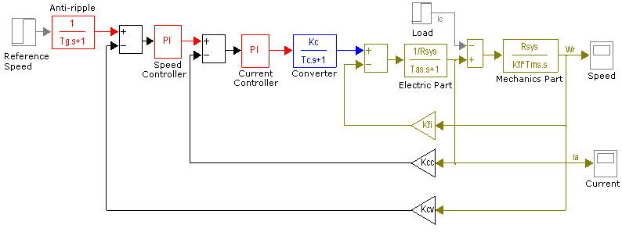
Fig. 5 Conventional Closed Loop Control Scheme

Where:
- The anti-ripple block is a pre-filter to smooth effects due to set-point changes, allowing to reduce the maximum over-shoot from 43.4% to 8.1 %, and also to reduce the setting time.
- The current controller was tuning using Optimal Module Method.
- The speed controller was tuning using Symmetrical Optimum.
- Kcc and Ksv are the current and speed feedback sensors gains.

Figures 6 illustrate simulation results for the conventional closed loop scheme.

Time (Sec)
(a)
Time (Sec)
(b)

Fig 6. (a) Close Loop Current Response (b) Closed Loop Speed Response.

A set-point change, equal to the rated voltage divided by the converter gain, was applied with zero load current. At time instant t = 0.3 sec., the load current was increased with a step change to the rated current. This simulation results illustrate the efficiency of the conventional closed loop scheme, to regulate the system when load changes are applied. Nevertheless, this design does not have too many practical application because the starting current demand is too high (approximately 750 A), which could probably cause damage to the motor. Hence, the need to limit the starting current; this may be obtained limiting the speed controller output to an established value (in this case the twice of the nominal current). This is known as current limit, doing this, it is not necessary the anti-ripple block. In order to obtain a better response applying the saturation strategy, windup effect should be also considered; to avoid a system undesired behaviour.

4.1 Saturation and the windup effect
The method is based on saturating the speed controller output, which does not allow the armature current exceeds the permissible maximum limit associated to the motor specifications. This, however, brings undesirable effects due to the PI controller integral component.
When the controller is saturated, practically there is no feedback because although the process output changes, the actuator (converter) remains saturated. In the meantime, the controller continues integrating the error. Nevertheless, if the controller is well tuned, it produces an output, although constant, in the correct polarity. When the error is reduced, the value of the integral can be high and a large time is required in order to the integrator get back a normal value.
This effect considerably increases the setting time and may produce oscillations before reaching the stable state. This situation is well-known as “windup effect". A solution based on stopping the integration when the controller is saturated, may reduce the undesired effects [3]. See figures 7 and 8.

Fig. 7 PI Controller with Current Limit and Anti-Windup Action.

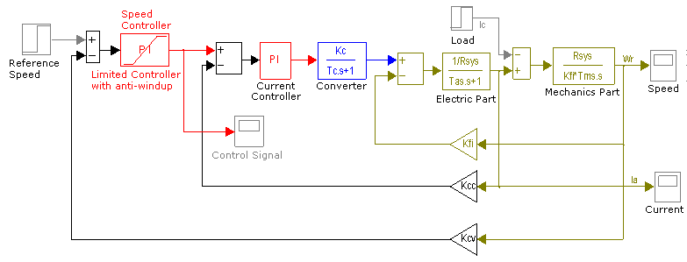
Fig 8. Closed Loop Control Sheme with Current Limit and Anti-Windup Action.

A set-point step change, equal to the rated voltage was applied with zero load current. At time instant t = 0.6 sec. the load current was increased with a step change to the rated value. See figure 9

Time (Sec)
(a)
Time (Sec)
(b)
Fig 9. Closed Loop Responses with Current Limit and Anti-Windup action. (a) Current Response, (b) Speed Response

5 Fuzzy Logic Controller Design
During the past few years there have had a rapid growth in the number and variety of fuzzy logic applications. The applications range from consumer products such as cameras, camcorders, washing machines, and microwave ovens to industrial process control, medical instrumentation, decision-support systems and servomechanism applications. [6]

In this section it is presented a procedure for fuzzy logic controller design for a servo drive system using The Matlab® Fuzzy Logic Toolbox, which is an effective tool for the conception and design of fuzzy systems.

There exists several ways for fuzzy logic controller design [1, 5]. In this section is presented a very simple step by step design procedure, based on Mamdani linguistic models [7]

5.1 Fuzzy Logic Controller for a DC Motor. Design Procedure

5.1.1 Discourse Universe Definition:
In this step the fuzzy logic controller inputs and outputs are defined. For this application the conventional speed PI controller with anti windup and saturation strategies, is substituted by the fuzzy controller in the closed loop scheme. According to the before mentioned, the input variables to the fuzzy system are the speed error, speed error derivative and the output is the current set point for the slave current PI controller.

Inputs: Error [-300,300],
Error Derivative [-300, 300]

Output: Output (Current Set Point) [-175,175]

5.1.2 Inputs/Outputs Fuzzy Characterization:
According to the servo drive simulation, appropriate membership functions for input and output variables were defined. Figures 10, 11 and 12 illustrate the fuzzy characterization.
Fig. 10. Error Membership Functions (Input 1)

Fig. 11 Error Derivative Membership Functions
(Input 2)
Fig. 12 Current Membership Functions (Output 1)

Where the fuzzy sets linguistic labels are:
bn Big negative.  mn Middle negative  sn Small negative | 0 Zero | sp Small positive.  mp Middle positive  bp Big positive.

5.1.3 Rules Base Definition
The rules base was obtained from the previous simulation with the conventional PI controller, taking into account the relationship between the error, error derivative and the control signal (current set point). Additionally, the rules were defined trying to improve the behavior obtained with the conventional scheme. Table 1 illustrates the selected rules base for the fuzzy controller.
Table 1: Rules Base for the Speed Controller
 | error
derror |  | bn | mn | sn | 0 | sp | mp | bp
derror | bn | bn | bn | bn | bn | 0 | 0 | 0
derror | mn | bn | bn | mn | mn | 0 | 0 | 0
derror | pn | bn | bn | sn | sm | sp | sp | mp
derror | 0 | bn | mn | sn | 0 | sp | mp | bp
derror | sp | mn | sn | sn | sp | sp | bp | bp
derror | mp | 0 | 0 | 0 | mp | mp | bp | bp
derror | bp | 0 | 0 | 0 | bp | bp | bp | bp
Plotting the previous table, using the error as x axis, the error derivative as y axis, and the output, the control signal, as z axis, is obtained the Control Surface illustrated in figure 14.
Fig. 13 Control Surface.

5.1.4 Computer Simulations

For the computer simulation, the speed PI with anti-windup and saturation strategies was replaced by a Fuzzy Logic Controller (FLC). Aditionally, some gains were added to the input and output for a fine adjustment [5]. See figures 14 and 15.
Fig. 14 FLC Computer Simulation Scheme

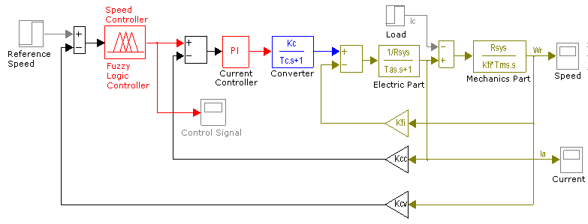
Fig. 15 Closed Loop Block Diagram using the FLC.

Figure 16 illustrate the FLC efficiency, it may be observed the improvements in the current and speed responses if they are compared with conventional PI controller in figure 9.

A set-point change, equal to the rated voltage, was applied with zero load current. At time instant t = 0.6 sec. the load current was increased with a step change to the rated value.

Time (Sec)
(a)
Time (Sec)
(b)

Fig. 16 Close Loop Responses with the FLC. (a) Current Response, (b) Speed Response

- Conclusions

A fuzzy logic controller for a DC servo drive system was presented. The fuzzy controller is synthesized using information from a previous modeling and simulation for the servo-drive system. The efficiency of the proposed fuzzy scheme was analyzed and compared with a conventional scheme using a PI controller tuned using symmetrical optimum and optimal module methods [3, 4], with saturation and anti-windup strategies.

The fuzzy control scheme provided better current and speed responses without overshoot, when load changes are applied. Additionally, with FLC, the current never take negative values, which would produce braking torques in the motor.

References:
- Cox, E. The Fuzzy System Handbook. AP, 1994.
- Dewan, S. B., G. R. Slemon and A. Straughen, Power Semiconductor Drives, Wiley, 1984.
- Leonhard, W, Control of Electrical Drives. Springer – Verlag, 3rd ed., 2001.
- Pardo G., A. and Díaz R., J. L. Fundamentos en Sistemas de Control Automático. Ed. Universidad de Pamplona, Colombia, 2004.
- Passino, M. K. and Yurkovich, S. Fuzzy Control. Addison – Wesley, 1998.
- Zadeh, L.A. Fuzzy Logic, Computer, Vol. 1, No. 4, pp. 83-93, 1988.
- R. R. Yager and D. P. Filev, Essential of Fuzzy Modelling and Control John Wiley and Sons, USA, 1994

