Processing of biosignals

using fractal and symbolic complexity methods

W.KLONOWSKI^{1*}, E.OLEJARCZYK¹, R.STEPIEN¹, P. JALOWIECKI ² , and R. RUDNER ²

¹ Institute of Biocybernetics and Biomedical Engineering,
Polish Academy of Sciences, 4 Trojdena St., 02-109 Warsaw, Poland,

² Chair and Department of Anaesthesiology, Intensive Therapy and Emergency Medicine, Silesian University of Medicine, Sosnowiec, Poland

Abstract: - We propose simple and effective methods of characterizing complexity of EEG-signals for monitoring the depth of anaesthesia. We demonstrate that the propose methods are competitive to the widely used BIS monitoring method.
Key-Words: - Complexity, Fractal Dimension, Symbolic Dynamics, EEG, Anaesthesia

1. Material and methods

Following approval from the Local Ethics Committee and informed consent patients under general anaesthesia were studied. Patients with known neurological disorders, as well as those who were receiving neuropsychiatric medication, were excluded from the study. Anaesthesia was induced with fentanyl, midazolam and propofol.
Brain electrical activity was measured continuously with an A-2000 BIS Monitor (software version: XP, Aspect Medical Systems, Newton, MA, USA). The bispectral index (BIS) is commonly accepted as a measure of hypnosis under anaesthesia [1], but the algorithms the BIS Monitor uses are not in public domain.
In addition, depth of anaesthesia was continuously tested and classified by a specialist-anaesthesiologist to six OAA/S (Observer's Assessment of Alertness and Sedation) levels [2]; patients were judged to be conscious if the OAA/S score was between 3 - 5 and unconscious if the OAA/S score was less then 3.
Recorded EEG-signals were analysed postoperatively using two methods we proposed – the first is based on Higuchi’s fractal dimension of the signal [3, 4] and the second is a symbolic method applied to signal’s derivative [5].

2. Results

We analysed EEG and demonstrated that the fractal dimension corresponds to the depth of anaesthesia

[4, 5, 6]. Our study demonstrates that changes of fractal dimension method were more significant and occurred earlier then changes of BIS. For 26 patients from group of 42 patients changes of fractal dimension in response to an anaesthetic are observed about 20-30 seconds earlier than changes in BIS parameter. This finding can be of great importance for anaesthesiologists since it may help to predict and so to avoid unwelcome situations of patient awakening during anaesthesia.

Fig. 1a shows the values of three variables (OAA/S, BIS and fractal dimension, (D_{f} -1) *100 , during a study in which the patient loses consciousness, remains unconscious during anaesthesia and subsequently wakes up after completion of the procedure. In addition, exact dosage and timing of administered drugs is illustrated. After the initial dose of propofol fractal dimension started to change about 25 seconds before BIS.

Fig. 1b shows another case where at 16th and 27th minutes of the study sedation was lightened to level 3 in OAA/S score. Record shows that at those moments fractal dimension roses rapidly to rich the highest value. BIS increases only at 27th minute while at 16th minute it remains unchanged.

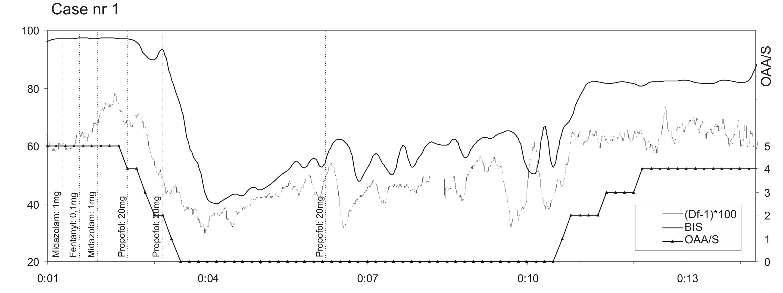
a.

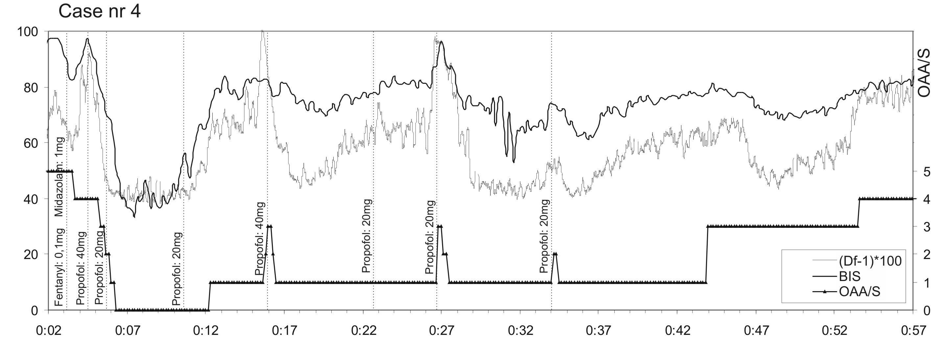
b.

Fig. 1. Comparing fractal dimension method for monitoring the depth of anaesthesia with BIS and OAS/S scale.

Figs. 2a and 2b. show normalized counts of the symbol 4x0 (binary sequence [0000]) in binary encoded derivative of the EEG signal (cf. [5]), calculated for the same two clinical cases. We observe that symbolic measure L_{4x0} is also more sensitive to anaesthetic induction than BIS.

Conclusions

The methods we propose may find several applications. They may be used for analysis of other biosignals, like EOG, ECG, etc. Because they are simple and quick to be applied in a real time they may be used with new nano-sensors. In general, application in biosignal analysis of the methods borrowed from Nonlinear Dynamics and Symbolic Dynamics seems to be very promising – the methods are efficient and user-friendly to be used for computer-assisted medical assessment and diagnosis.

Acknowledgements
This work was partially supported by IBBE PAS St/24/04 and by SENSATION Integrated Project (FP 6. IST 507231).

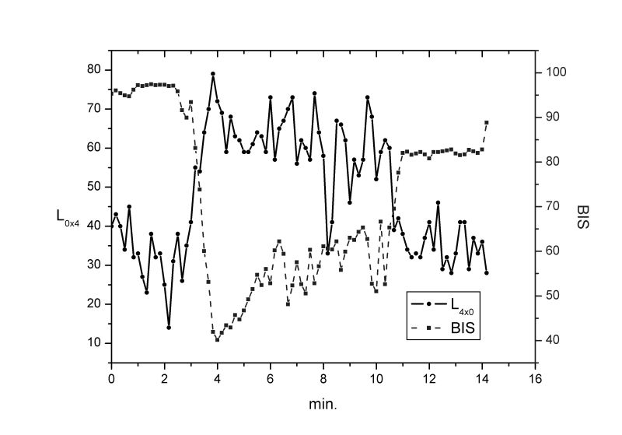

a.
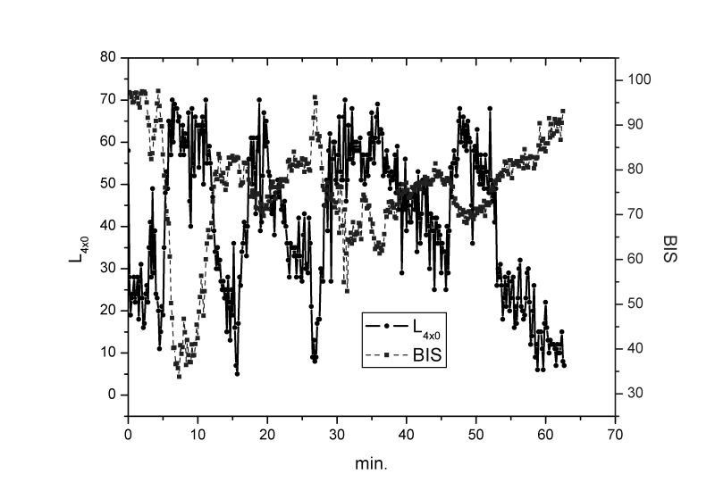
b.
Fig. 2. The same cases as in Fig. 1, . analysed using symbolic dynamics method.

References

1. Rampil JI: A Primer for EEG signal processing in anesthesia. Anesthesiology 1998, 89: 980-1002.
2. Chernik DA, Gillings D, Laine H: Validity and reliability of the observer's assessment of alertness/sedation scale: Study with intravenous midazolam. J. Clin. Psychopharm. 1990, 10: 244-245.
3. Higuchi T: Approach to an irregular time series on the basis of the fractal theory, Physica D, 1988, 31: 277-283.

4. Olejarczyk E: Analysis of EEG signals using fractal dimension. PhD Thesis, Institute of Biocybernetics and Biomedical Engineering, Polish Academy of Sciences, Warsaw, 2003.
5. Klonowski W, Olejarczyk E, Stepien R: Complexity of Polysomnogram Signals. WSEAS Transactions on Computers, 2004, 3(5): 1290-1294.
6. Klonowski W., Olejarczyk E. and Stepien R. (2003). New Methods of Nonlinear and Symbolic Dynamics in Sleep EEG-Signal Analysis, in: Modelling and Control in Biomedical Systems 2003 (Feng D.D. and Carson E.R., Eds.): 241-244, IFAC Publications, Elsevier, Oxford.

