Computationally efficient algorithmic structures for an all-digital switching amplifier

S. Apostolacos, I. Grammatikakis, A. Tavoularis
Department of Electrical and Computer Engineering
National Technical University of Athens
Heroon Polytechneiou 9, Zographou Campus, GR-15773, Athens
GREECE

D. Mexis
Department of Informatics and Telecommunications
National and Kapodistrian University of Athens
Panepistimiopolis, Ilissia, GR-15784, Athens
GREECE

Abstract: In order to implement a switching amplifier, it is necessary to employ DSP techniques such as oversampling, noise-shaping, quantization with dithering and PCM-to-PWM conversion so as to drive the output stage from a digital sound source. This paper presents the abovementioned building blocks as well as a comparison of the performance of their various implementations. Those are rated according to their impact on the signal and the necessary processing power when implemented on a fixed-point processor.

Key-Words: - Switching amplification, DSP implementation, PWM, noise shaping, oversampling, dithering

1 Introduction
It is well known that switching amplifiers are far more power efficient than conventional ones, since their output transistors operate either at cutoff or saturation, minimizing losses ([1]). When used with a digital sound source, all intermediate digital to analogue conversions except for the power conversion on the loudspeakers can be omitted, yielding better sound quality.
Such amplifiers employ Pulse Width Modulation (PWM) on their Pulse-Code Modulated (PCM) input and directly drive the loudspeaker with a series of discrete switching commands of 2 or more levels. If direct PCM-to-PWM conversion is pursued, a CD-audio input at 16 bits/44.1 KHz would result in a maximum switching frequency in the range of 3 GHz, rendering a practical implementation impossible to achieve.
The target of the designer of such systems is to reduce the maximum switching frequency without compromising performance in terms of signal quality. In order for such a stringent requirement to be met, state-of-the-art digital signal processing algorithms like oversampling, noise shaping, quantization with dithering and low-distortion PCM-to-PWM conversion must be employed (Figure 1).
In the ensuing, an integrated switching amplifier implemented by the authors, which operates on CD and DAT audio data, is analyzed in detail and performance metrics are provided for both its individual blocks and the overall system.
Fig 1. Switching amplifier block diagram
2 Sinusoidal Generator
Either a sine generator or a normal digital audio source (CD or DAT) can be used as input to the system. The sinusoidal signal is generated using Taylor series expansion implemented with double precision multiplications. The 32-bit wide output x(n) is then summed with a dither signal d(n), which has a triangular probability density function (PDF) with an amplitude that spans the 2 LSBs of the 16-bit output of the quantizer that follows, denoted as xdq(n). As shown in Figure 2, the spectrum of the quantized signal has no tonal content other than that of the basic tone. Moreover, the quantization noise is uncorrelated with the signal and white due to the added dither.

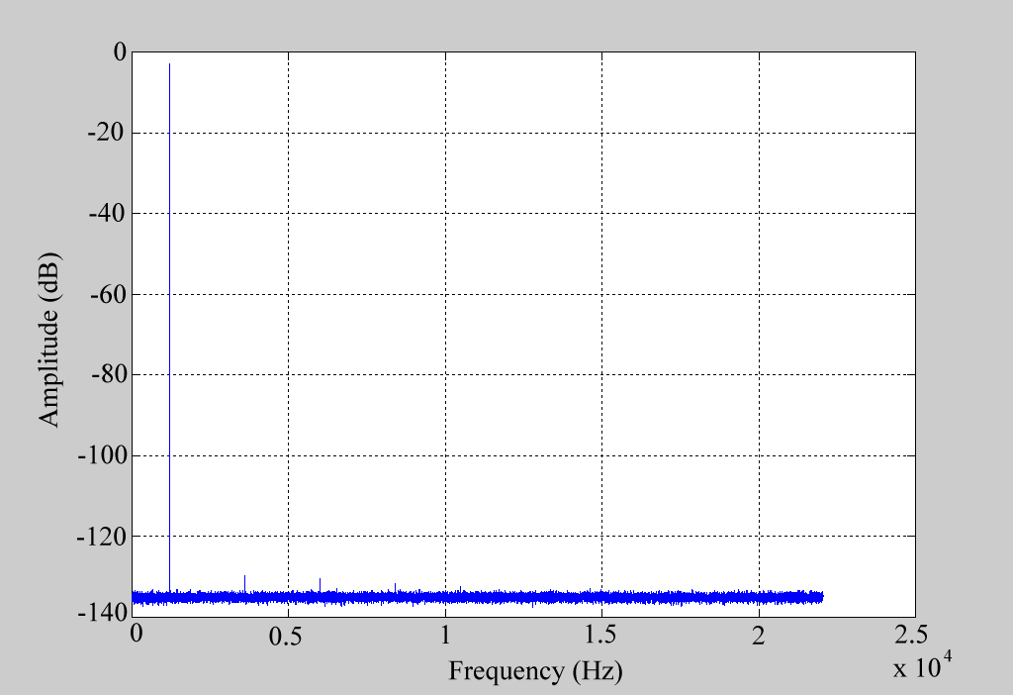
Fig.2. Spectrum of a sinus, produced using a Taylor series and rounded at 16 bits with added dither

3 Oversampling
Since oversampling places the signal bandwidth much lower than the Nyquist frequency, noise shaping can then be used to reduce the inband quantization noise at the expense of a higher noise floor at higher frequencies. A second advantage of oversampling is that intermodulation distortion of the PCM-to-PWM conversion is largely alleviated. Finally, as shown in [2], oversampling reduces the sample bit-width necessary to achieve a specific noise floor in a digital representation by 1 bit for every increase of the sampling rate by 4.
The oversampling process consists of 2 steps. Initially, I - 1 zeros, where I is the oversampling factor, are interleaved between consecutive samples of the input signal xdq(n). Then, low-pass filtering with a carefully selected cutoff frequency follows.
The implementation of this lowpass filter in direct form is very inefficient in the case of oversampling, since most FIR multiplications yield zero outputs due to zero interleaving. Moreover, calculations will have to be carried out at the increased sampling rate of I*Fx, where Fx is the sampling rate of the original signal (44.1 KHz for CD-Audio, 48 KHz for DAT). Both these drawbacks can be overcome through the use of a polyphase filter structure.
For the presented application, the lowpass filter was designed using the Parks-McClellan optimum equiripple FIR filter method. The oversampling factor was chosen to be equal to 8. The amplitude and phase characteristics of the resulting filter are depicted in Figure 3. The filter has 976 taps, yielding 8 polyphase filters of 122 taps each. The filter coefficients were quantized to 16 bits, in order for the output to be representable with 32 bits.

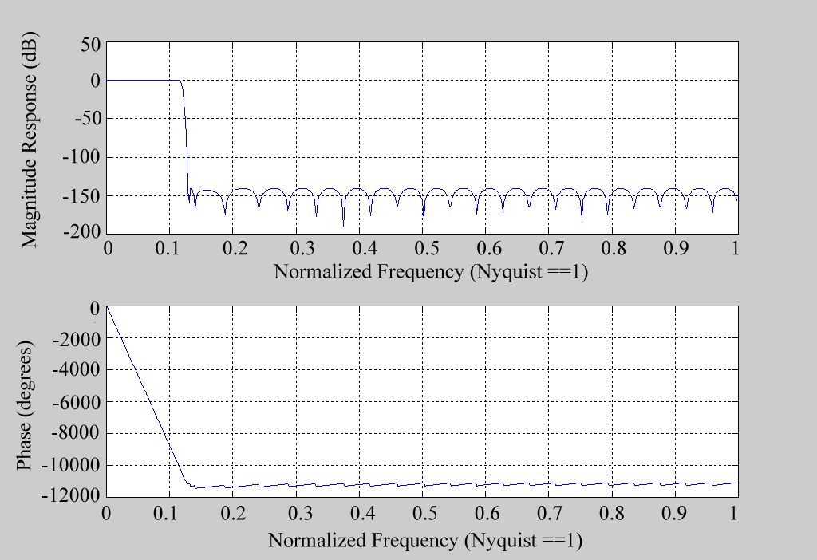
Fig. 3. Amplitude/phase characteristic of the low-pass FIR filter of the oversampling process (I = 8)

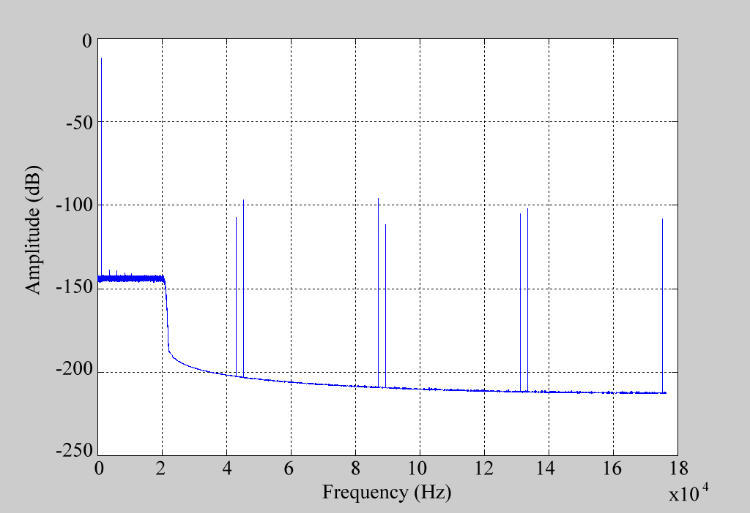
Fig. 4. Spectrum of the sinus shown in Figure 2 after oversampling

The spectrum of the oversampled signal is shown in Figure 4, where xdq(n) was used as input. It is apparent that the inband signal has not been impaired. Attenuated and aliased images of the input signal exist outside the acoustic band and around multiples of the sampling frequency (more specifically at frequencies k*f_{s} ± f_{sinus}). They are caused by zero interleaving and the limitations in stopband rejection of the lowpass filter. However, they reside outside the audible spectrum and are at least 90 dB below the input signal, so performance is not compromised.

4 Noise Shaper
The main objective of the noise shaper is to move the quantization noise, which is produced by the input signal resampling process, out of band. The FIR used in the feedback stage of noise shaper (see Figure 1) is selected to represent a high-pass Noise Transfer Function (NTF) given by:

NTF(z) = 1 + H(z) (1)

where H(z) is the transfer function of the feedback stage FIR. A widely used family of filters, which have been proven suitable for audio applications, have the following NTF(z), ([1]):

NTF(z) = 1 + H(z) = (1 – z⁻¹)^{N}, N=1, 2, 3,…. (2)

Figure 5 depicts the high-pass nature of NTF(z) for N = 5.
The coefficients of the feedback filter are quantized to 16 bits. The input signal eq(m) is produced through quantization of e(m) from 32 to 16 bits. The signal e(m) is the quantization error from the conversion of z(m) from 32-bits to q-bits. The output of the feedback filter u(m) is added to the input signal y(m), yielding z(m). The signal z(m) is then fed to the quantizer, where it is quantized to q bits and the output of the noise shaper zq(m) is produced.

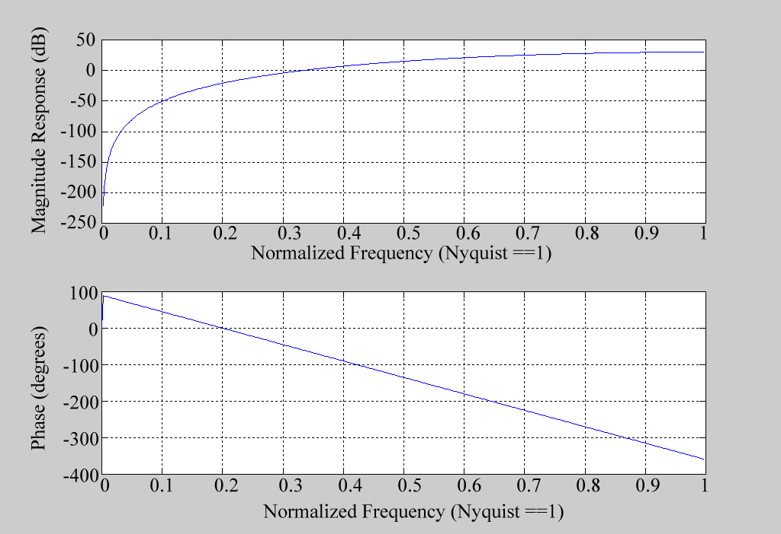
Fig. 5. Frequency response of the NTF = (1 – z⁻⁻¹)⁵

Using the signal of Figure 4 as input to the noise shaper, the output spectrum for various values of N is presented in Figure 6. The number of re-quantization bits equals 9 for all cases depicted. The advantageous effect of the noise shaper is evident, since most of the quantization noise has been removed from the audio band, inside of which, noise components are at least 120 dB below the useful signal for noise shapers of 5th order or higher. Moreover, use of a noise shaper with an order higher than 5th does not offer any significant improvement, in spite of the increase of the computational complexity. Since high-order noise shapers do not need dithered quantization, as shown in [3], a 5th order noise shaper will be used in the remainder of the paper.

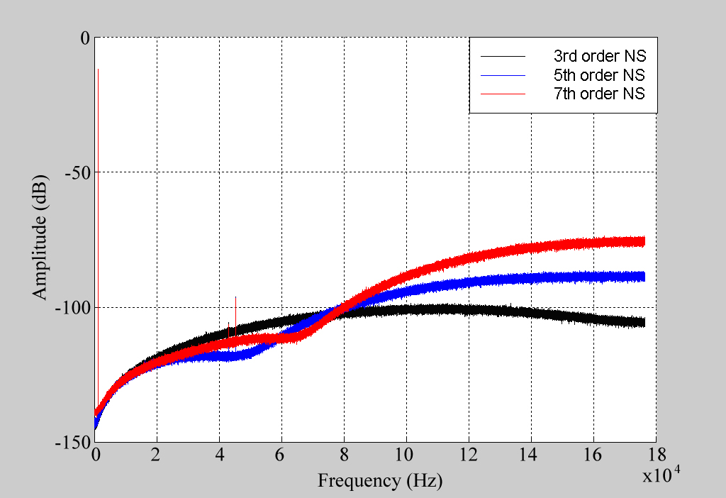
Fig. 6. Spectrum of the output of the noise shaper for various values of N

5 PCM-to-PWM conversion
The last processing stage involves the conversion of the q-bit output signal of the noise shaper zq(m) to a PWM waveform. This can be achieved by conversion of the amplitude of each sample of zq(m) to a respective pulse duration. Bipolar PWM is used, since it presents significantly milder non-linear behavior because of its differential nature, which results in the elimination of even sub-harmonics. The signal p(n), which is also the output of the system, can thus be represented with 2 bits (+1,0,-1).

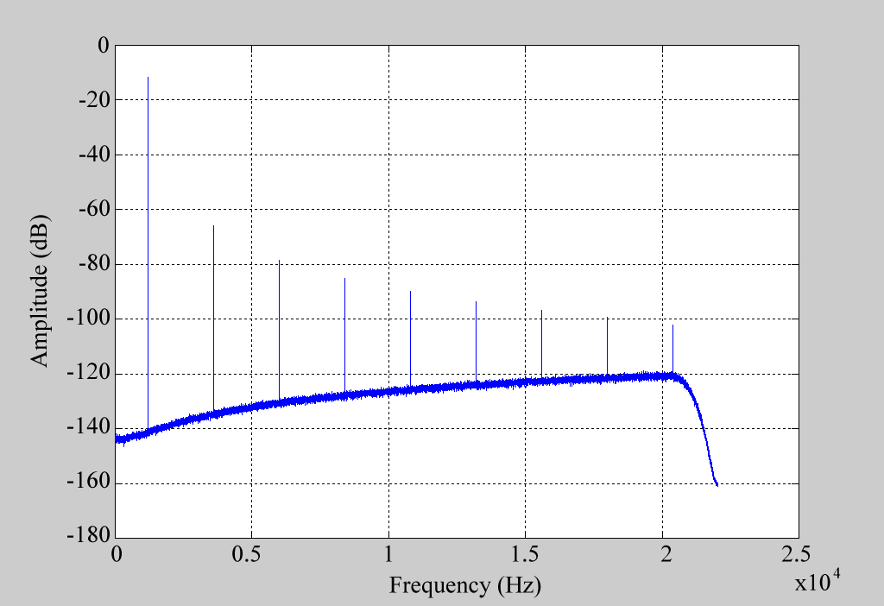
Fig. 7. Output spectrum of single-sided PWM

Figure 7 illustrates the output spectrum of the single-sided PWM, while Figure 8 demonstrates the respective spectra of the symmetric and quasi-symmetric double-sided PWM modulation schemes. Single-sided PWM presents strong non-linear artifacts, since it has created harmonics as high as 65 dB below the basic tone. On the other hand, the double-sided PWM scheme is obviously much more linear, as also shown in [1]. Comparing the symmetric with the quasi-symmetric case, the noise of the former is significantly higher. Hence, the best performance is achieved by using quasi-symmetric double-sided PWM. In that case, only the first odd harmonic is present, but its amplitude is 120 dB below the information signal, approaching the dynamic range of the 16-bit digital input. All other harmonic distortion is below the noise threshold.

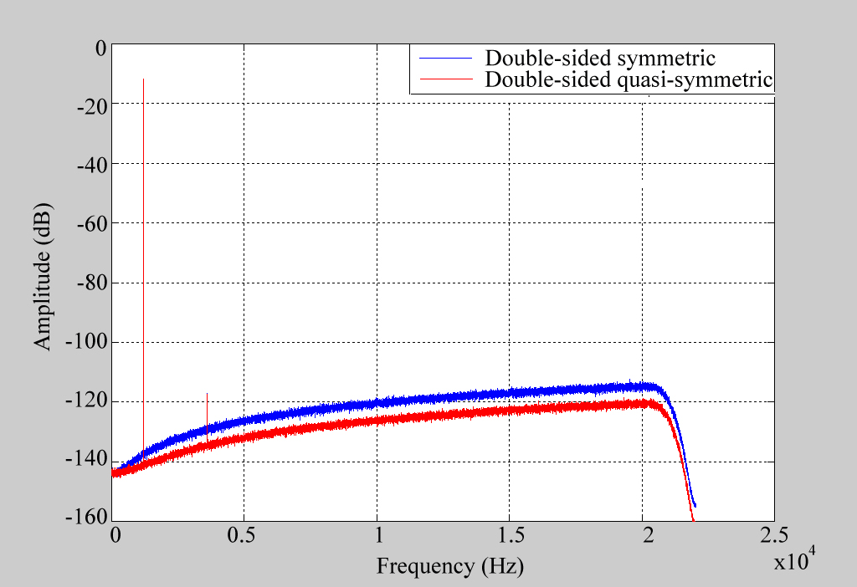
Fig. 8. Output spectrum of symmetric (blue) / quasi-symmetric (red) double-sided PWM

6 Implementation in a DSP
The algorithms presented above were implemented by the authors in a switching amplifier prototype consisting of a fixed-point Digital Signal Processor (Agere Systems dual-core DSP16410), an FPGA, an S/PDIF receiver capable of accepting either CD or DAT audio (44.1 or 48 kHz) and a clock multiplier to synchronize the operation of the amplifier to the audio source. The system was capable of providing either a low-power or a high-power output via a high-speed DAC and a pair of analogue 20 kHz lowpass filters or a hand-crafted amplification section comprising of a power supply, the driver circuitry, a MOSFET bridge and optionally, an output filter. The prototype architecture is shown in Figure 9.
All audio processing for a stereo audio source was carried out within the DSP chip and Table 1 summarizes the memory requirements and the CPU usage for each algorithm in the case of 8x oversampling factor, 5th order noise-shaping, quasi-symmetric PWM modulation and CD-audio input. The CPU usage is expressed in Mega Instructions per Second (MIPS). With the DSP internal clock running at 180 MHz, there are 180 MIPS available per core. Hence the whole of the processing does not require more than 27% of the available horsepower. As far as the memory requirements are concerned, all algorithms occupy 1192 + 1236 = 2428 words, amount that corresponds to ~2.5 % of the 96 Kwords per core internal memory.

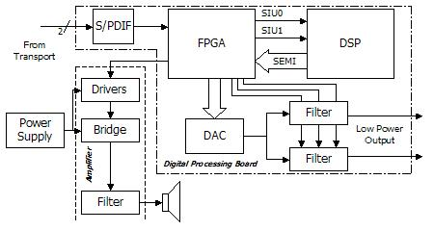
Fig. 9. Switching amplifier prototype architecture

Algorithm | CPU Usage (MIPS) | Program Memory (Words) | Data Memory (Words)
Tone generator | 6.72 | 190 | 17
Oversampling | 27 | 136 | 1111
Noise shaper | 9.73 | 203 | 32
PWM I/F | 2.92 | 65 | -
Scheduler | 0.87 | 598 | 76
SUM | 47.24 | 1192 | 1236
Table 1. DSP CPU usage and memory requirements

4 Conclusion
This paper has presented a study on the implementation of computationally efficient algorithmic structures for an all-digital switching amplifier using fixed-point arithmetic. It has been proven that it is possible to design such a system with an output dynamic range equivalent to that of its input. The noise floor increases at higher frequencies, but this occurs outside the audio band, so it does not affect human perception.

References:
[1] J. M. Goldberg and M. B. Sandler, “Noise Shaping and Pulse-Width Modulation for an All-Digital Audio Power Amplifier”, J. Audio Eng. Soc., Vol. 39, No. 6, 1991 June p. 449
[2] Max W. Hauser, “Principles of Oversampling A/D Conversion”, J. Audio Eng. Soc., Vol. 39, No.1/2, 1991 January/February
[3] A.J. Magrath et al., “Power Digital-to-Analogue Conversion Using Sigma-Delta Pulse Inversion Techniques”, 99th AES Convention New York. 1995, Preprint 4106

