Sampling-Reconstruction Procedure of Gaussian Processes with two Jitter Sources

VLADIMIR A. KAZAKOV AND DANIEL RODRIGUEZ S.
Department of Telecommunications of the School of Mechanical and Electrical Engineering
National Polytechnical Institute of Mexico
U. Zacatenco, C.P. 07738, Mexico City
MEXICO

Abstract: - The interest of this work is to consider the Sampling-Reconstruction Procedure of Gaussian processes with jitter. The jitter is analysed with different distribution functions taking into account two error sources. We analize the cases when the correlation exists between the jitter of each sample or between jitter sources. The investigation method is based on the conditional mean rule. The optimal error reconstruction functions are calculated in the domain of the time for some non trivial examples when the type of covariance function of the given process and jitter distribution are changed.

Key-Words: - Sampling, reconstruction, jitter and Gaussian process.

1 Introduction
The investigation of the sampling-reconstruction procedure (SRP) of the random processes with jitter began 40 years ago [1]−[2], but during the last years the interest about this problem has increased, see for example [3]−[5]. Some authors have also considered the case with two sources of jitter [2]-[4]. We notice some specific features of these investigation works: 1) the quantity of samples is equal to infinite; 2) the effect of the jitter is described with the same characteristics independently of the number of the samples; 3) the probability density function (pdf) of the stochastic processes is not defined; 4) the stochastic processes are only described by the covariance function or by its power spectrum, and in the most cases this spectrum is limited by a certain frequency; 5) the investigations have been carried out in the frequency domain and, hence, the reconstructions error is determined as average value.
In the present paper, the conditional mean rule is used to describe the Sampling-Reconstruction Procedure of Gaussian processes with jitter. This approach has been applied in the statistical description of the SRP of different types of stochastic processes, see for example [6]−[10]. The application of the conditional mean rule for the SRP of Gaussian processes with jitter allows us to investigate some new aspects of this problem. Namely, we investigate: 1) the case when the number of samples is arbitrary and limited; 2) the case when the jitter pdf can be the same or different for some samples; 3) the influence of two jitter sources, when the jitter is correlated or independent among the jitter sources or among the samples; 4) the error reconstruction function in the time domain; this approach provides the possibility to get this important characteristics in detail during any sampling interval; 5) the influence of the type of covariance function of the given process and the jitter pdf on the error reconstruction function.

2 The System with two sources of jitter
Usually the system with two jitter sources is described by the following manner: There is an input random process x(t). This process is passed through a sampler. The sampler is characterized by some instability. As a result the sample time T_{n} has a random time delay ε_{n}:

., (n=1, …, N) | (1)

where Ť_{n} - is the real sampling time, N-is the number of samples. The sequence of samples x(Ť₁), x(Ť₂),…, x(Ť_{N}) is stored in a memory device. The stored information is read out from the memory device by a special generator of impulses. This generator has its own instability. As a result, each sample suffers another random time delay ϕ_{n}. Finally, we observe that each sample is represented with two jitters in the definition of the sampling:

. | (2)

3 The Problem Formulation
Our investigation deals with Gaussian processes whose pdf of the dimension m is given by

(3)

where is the mathematical expectation, det |K(t_{i},t_{j})| is the determinant of the covariance matrix

(4)

and a_{ij} represents to each element of the inverse covariance matrix

. | (5)

After the sampling procedure of any realization x(t) we have the set of samples X,T={x(T₁), x(T₂),…, x(T_{N})}. On the basis of this set we have to find the reconstruction function and the error reconstruction function.
The main statistical characteristics of a Gaussian conditional process is known (see, for instance [11]). We write the expressions of the conditional mathematical mean and the conditional variance :

(6)

(7)

where σ²(t) is the unconditional variance of the initial process x(t).
The rule of the conditional mean provides the minimum mean square error of the estimation. Following this rule we take the reconstruction function as the conditional mean function (7), that is , and the reconstruction quality of the process is calculated by the conditional variance (7).
The expressions (6)-(7) and their multidimensional generalizations have been used in the statistical description of the SRP of different types of Gaussian processes, as well as in their transformations [6]−[10], when the set of samples X,T has a fixed position.
Knowing the distribution laws of the random variables ε_{n} and ϕ_{n} we can obtain the general expressions of the average error reconstruction function :

(8)

where the statistical average is fulfilled with regard to the random sampling instants and .
The operation of the statistical average is the most important in the calculations of the error reconstruction functions. In general case, this operation can be carried out on the basis of multidimensional pdf.
Now we choose the models of Gaussian processes. We take some processes into consideration with low pass power spectrum. It is convenient to use some models at the output of certain lineal filters driven by white noise. For example, at the output of the integrated RC circuit we have the Markov Gaussian process with the following normalized covariance function in the stationary regime:

(9)

where α is the RC circuit parameter.
The process obtained at the output of the two series integrated RC circuit driven by white noise has the following normalized covariance function:

(10)

and the normalized covariance function obtained at the output of the three series integrated RC circuit is:

(11)

In order to carry out the best comparison of the results, all these processes must have the same covariance time  τ_{c}=1. To make this, we have to consider that the parameter α has the values of 1, 2, and 8/3 for each covariance function, respectively.

4 Some Examples
The jitter of the sources are described by the corresponding pdf of the random variables (n=1; 2).
We consider the SRP with the number of samples N=2 for three types of Gaussian processes characterized by the covariance functions (10)-(12). The samples are located in the points T₁=0 and T₂=1. There are three variants of the jitter influence. 1) The jitters of both sources are independent. In this case we need to know the one-dimensional pdf: w(ε₁), w(ε₂), w(ϕ₁) and w(ϕ₂). 2) The jitter of the samples with the same index are statistically dependent, but the jitter samples with different index are independent. In this case is necessary to know the next two-dimensional pdf’s: w(ε₁, ϕ₁) and w(ε₂, ϕ₂). 3) The jitters of the samples with different index are statistically dependent, but the jitters between the same samples are independent. In this case, we need to know the two-dimensional pdf: w(ε₁, ε₂) and w(ϕ₁, ϕ₂).

4.1 The Independent Jitter
As first example, we take into account that the distribution of the jitter (of each sample) is uniform and independent. The distributions are represented by the following expressions:

(12)

(13)

In this example we study the following variants of jitters: w(ε₁)=w(ε₂) with the values a=-0.1, b=0.1; w(ϕ₁) with the values c=-0.3, d=0.3; w(ϕ₂) with three different ranges; 1) c=-0.1, d=0.5; 2) c=-0.3, d=0.3;. 3) c=-0.5, d=0.1. We notice that the last three distributions have the same interval between the values d and c, but they have different means with respect to the point T₂=1.
The results of the calculations with these parameters are presented in Fig. 1, 2 and 3 for three different types of covariance functions defined by (9), (10) and (11), respectively.

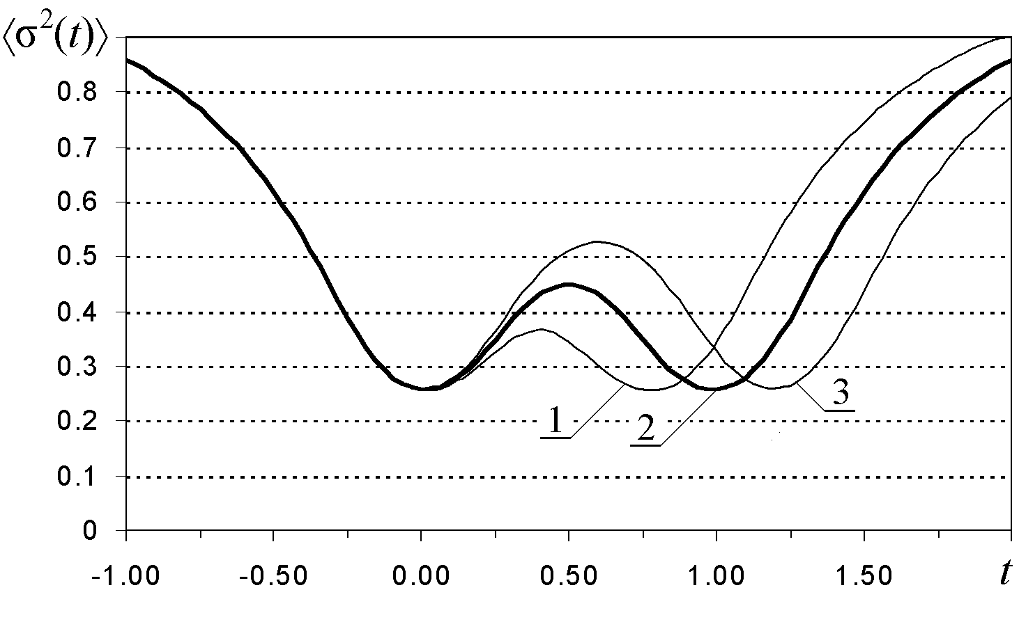
Fig. 1. Average error reconstruction function with jitter at the output of the RC circuit.

The average error reconstruction function has its minima in the position of each sample. The parameters of the first sample are fixed, hence the error reconstruction function around the first sample is the same for each curve (1, 2 and 3).
We observed that the distribution effects of w(ϕ₂) have influence only in the position of the second sample giving as a result a shift. However, we can notice that the minimum value of the error is practically the same on the second sample for the cases 1, 2 and 3.

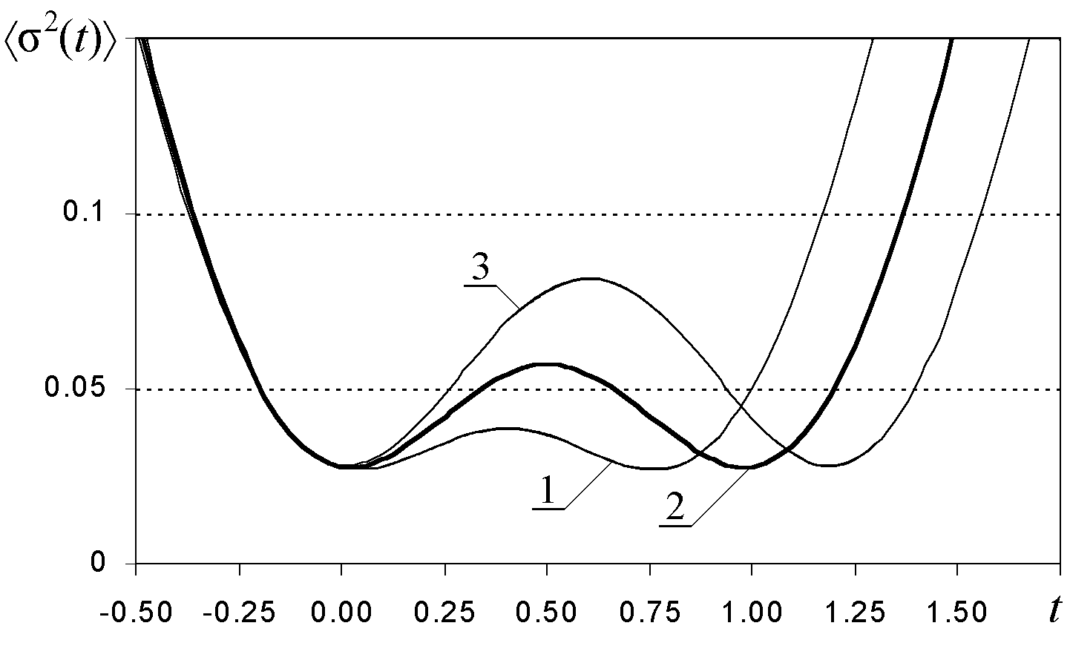
Fig. 2. Average error reconstruction function with jitter at the output of the two series integrated RC circuit.

As one can see, the values of the reconstruction error in Fig. 1, 2 and 3 are different. Here, we notice that the reconstruction error depends on the type of covariance function. The smoother process is characterized by the smaller reconstruction error.
Also, we observed that in the middle of the sampling interval formed by both samples, the error reconstruction function has a maximum.

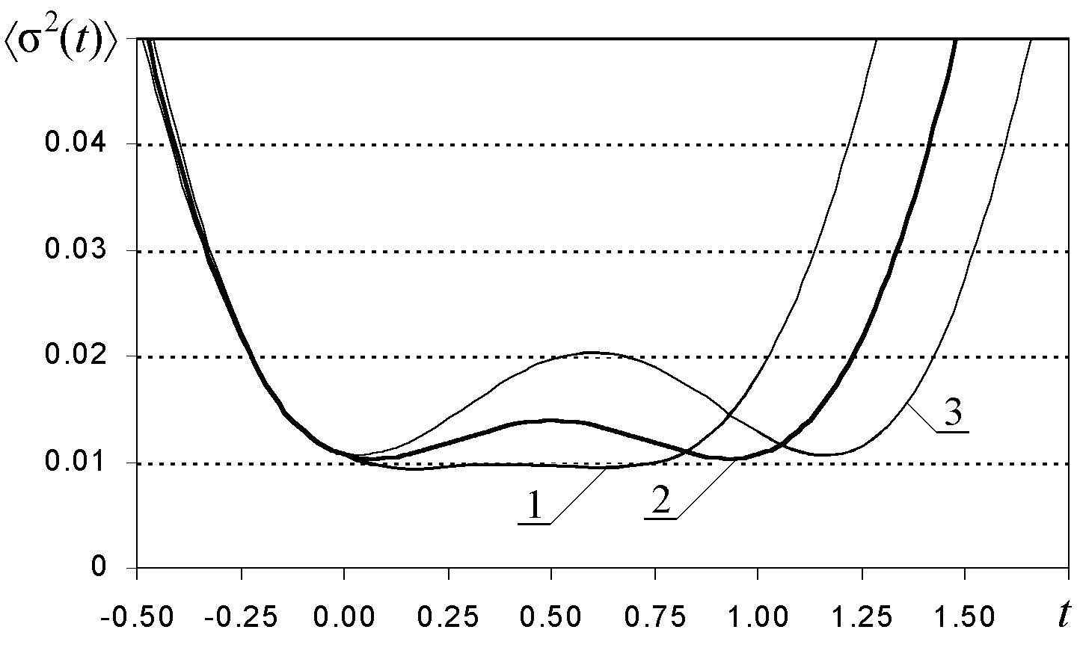
Fig. 3. Average error reconstruction function with jitter at the output of the three series integrated RC circuit

4.2 The Dependent Jitter of Samples with the same Index
We consider the case when the jitter between each source is correlated but it is independent between each sample. In this example, the jitter is represented by the bivariate Gaussian pdf. This distribution is given by the following expression:

(14)

i=1,2; for the correlated jitter of the i-th sample.

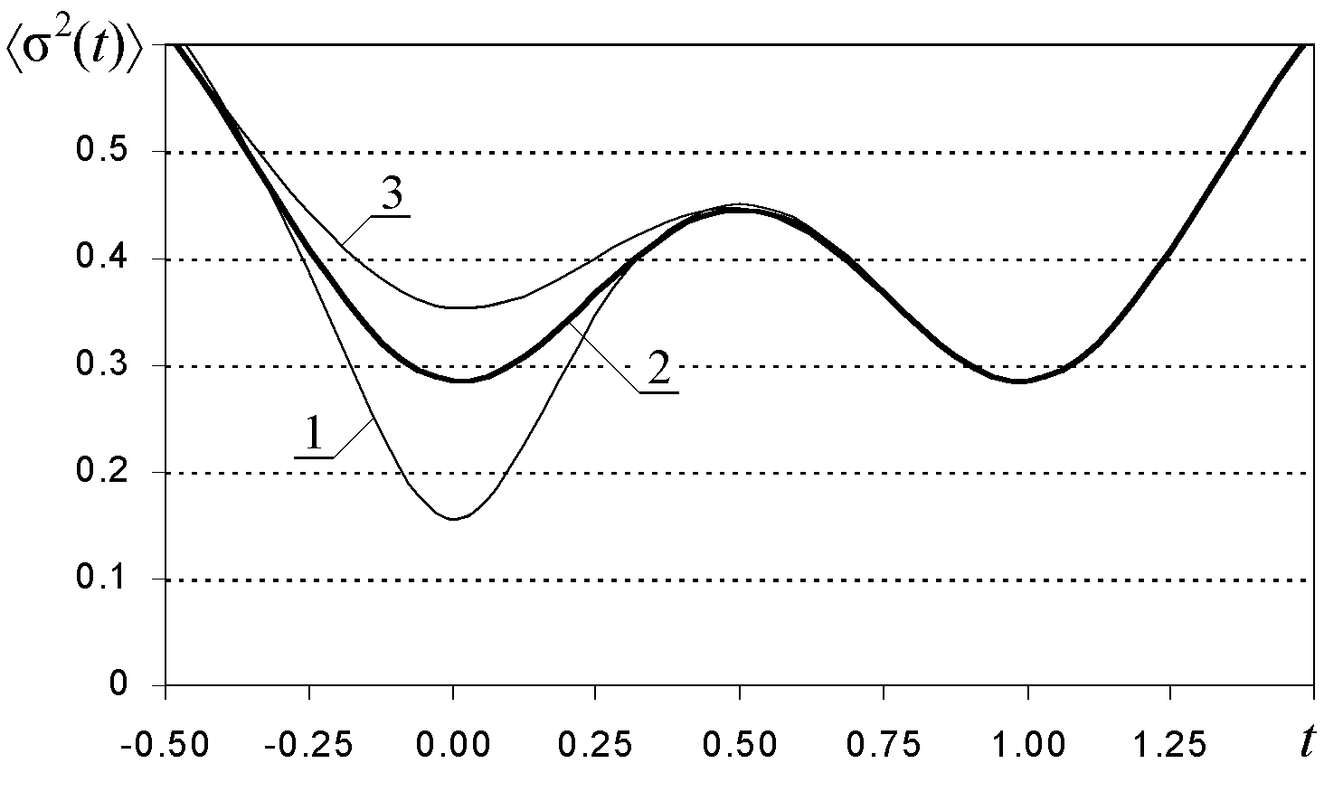
Fig. 4. Average error reconstruction function with jitter at the output of the RC circuit with correlation between two sources.

We have σ_{ε1} and σ_{ϕ1} like the variances of the jitter in the first sample generated by different sources and the correlation between ε₁ and ϕ₁ is ρ₁. In a similar way, σ_{ε2} and σ_{ϕ2} represent the variances of the jitter in the second sample caused by each source and the correlation between ε₂ and ϕ₂ is ρ₂.

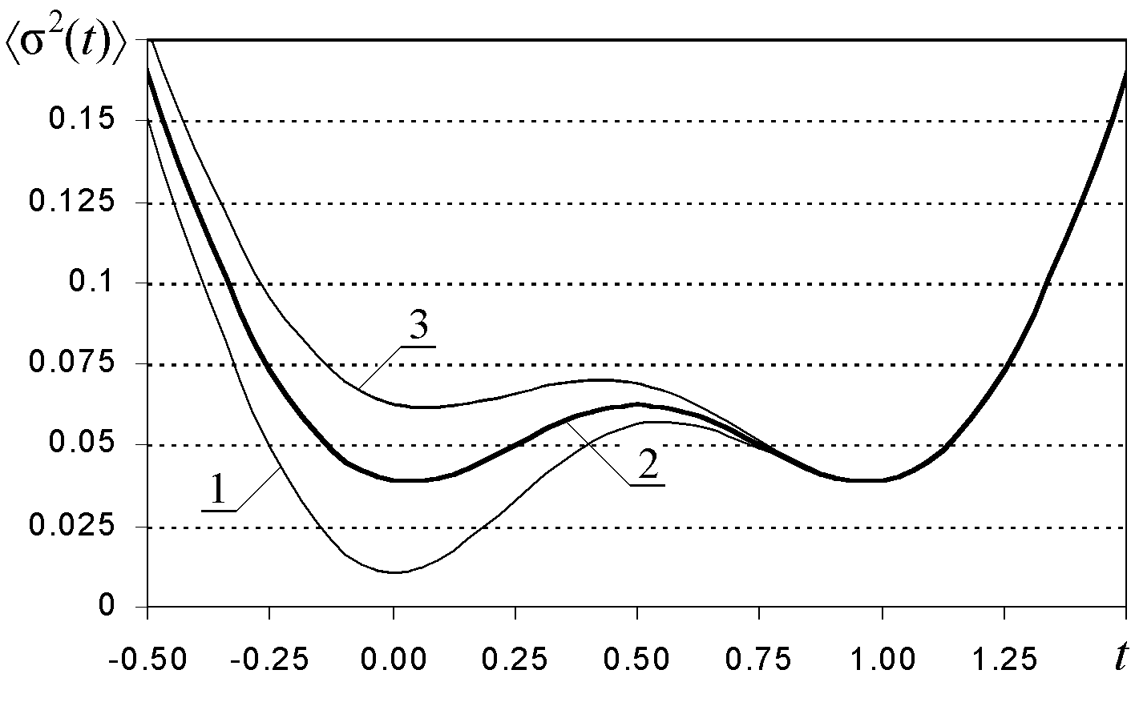
Fig. 5. Average error reconstruction function with jitter at the output of the two series integrated RC circuit with correlation between two sources.

In this case, we take into account the following values for each parameter: σ_{ε1}=σ_{ε2}=0.1, σ_{ϕ1}=σ_{ϕ2}= 0.2, ρ₂=0, and then we change ρ₁: 1) ρ₁ = -0.95, 2) ρ₁ = 0, and 3) ρ₁ = 0.95 of the calculations.

The results are shown in Fig. 4, 5 and 6 for each covariance function, respectively.

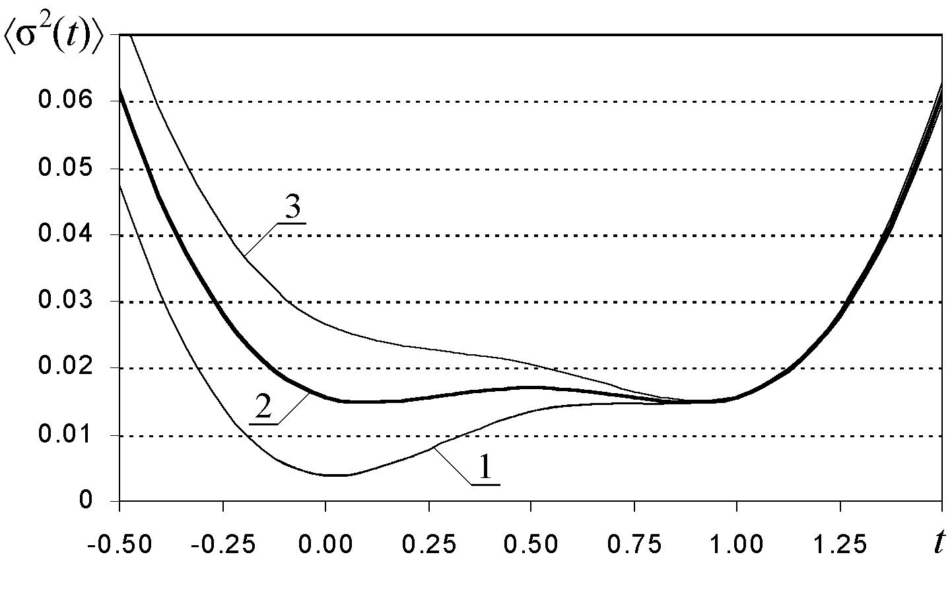
Fig. 6. Average error reconstruction function with jitter at the output of the three series integrated RC circuit with correlation between two sources.

In each figure, we can observe that the average error reconstruction function maintains mainly the same properties that we notice in the previous figures with regard to the existence of its minima and maxima. Here one can see that the reconstruction error in the proximities of the first sample varies when the value of ρ₁ is different. This is because the values of both variances, σ_{ε1} and σ_{ϕ1}, are related with the property of the sum of two random variables:

(15)

When ρ₁<0, the total jitter variance in the first sample diminishes. Therefore, the error in this sample decreases (curve 1). If ρ₁>0, the total value of the variance increases so that the error reconstruction is greater with regard to the curve 2, when ρ₁=0.

4.3 The Dependent Jitter of Samples with different Index
We consider the last example with the bivariate Gaussian fdp. Now, the correlation is given between the different samples of the process for one jitter source. Here we need to use the expression (14) with the changed arguments, namely pdf w(ε₁, ε₂) and w(ϕ₁, ϕ₂). It is convenient to apply the designation ρ_{ε} and ρ_{ϕ,} and for the normalized covariance factor between ε₁ and ε₂, and between ϕ₁ and ϕ₂, respectively. We put the values of the jitter variances are the same as in the previous subsection 4.2. We choose the one value for the covariance factor ρ_{ε}=0, and three values for the covariance factor ρ_{ϕ}: 1) ρ_{ϕ}=-0.9, 2) ρ_{ϕ}=0, 3) ρ_{ϕ}=0.9.

In this case, we consider the process with the covariance function (11). In Fig 7, we observe that the error is smaller when the correlation factor is negative and bigger when the correlation factor is positive. The correlation affects meanly in the middle of the interval, but in minor degree due to the separation between the two samples.

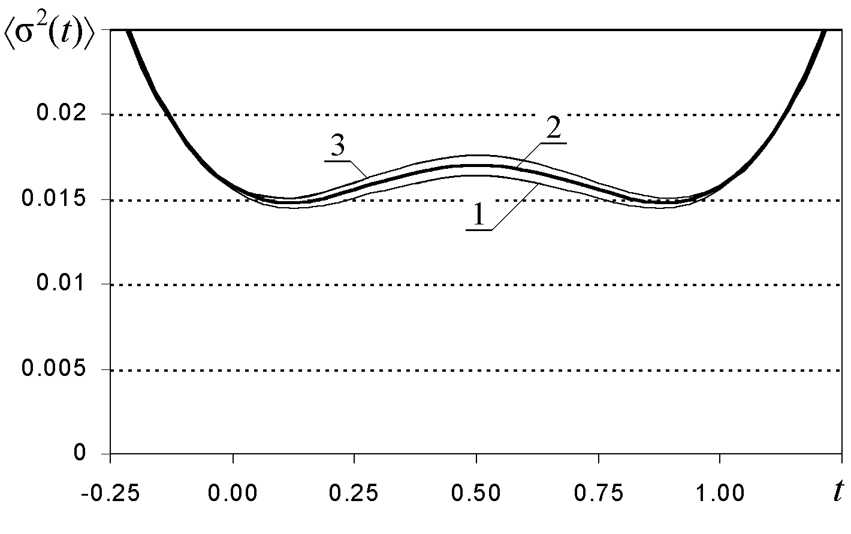
Fig. 7. Average error reconstruction function with jitter at the output of the three series integrated RC circuit with correlation between two sources.

5 Conclusion
The different variants of the SRP of Gaussian processes with two sources of jitter are investigated on the basis of the conditional mean rule. We demonstrate that this approach provides the possibility to investigate in details the effects of the two sources jitters. It is quite possible to carried out the calculations for the number of samples N>2.

References:
[1] A. V. Balakrishnan, On the Problem of Time Jitter in Sampling, IRE Transactions on Information Theory, Vol. 8, April 1962, pp. 226-236.
[2] B. Liu and T. P. Stanley, Error Bound for Jittered Sampling, IEEE Trans. on Automatic Control, Vol. AC-10, No. 4, 1965, pp. 449-454.
[3] J. Schoukens, R. Pintelon and G. Vandersteen, A Sinewave Fitting Procedure for Characterizing Data Acquisition Channels in the Presences of Time Base Distortion and Time Jitter, IEEE Trans. on Instrum. and Measurement, Vol. 46, No. 4, 1997, 1005-1010.
[4] G. Vandersteen and R. Pintelon, Maximun Likelihood Estimator for Jitter Noise Models, IEEE Trans. on Instrum. and Measurement, Vol. 49, No. 6, 2000, 1282-1284.
[5] T. Chalvatzis, E. Gagnon and J. S. Wight, Clock Jitter in Direct Sampling Systems, 4th International Symposium CSNDSP, 20-22 July 2004, Newcastle, UK., pp. 601-604.
[6] V. Kazakov, Regeneration of Samples of Random Processes following Nonlinear Inertialess Conversions, Telecommunications and Radio-engineering, Vol. 43, No. 10, 1988, pp. 94-96.
[7] V, Kazakov and M. Belyaev, Sampling Reconstruction Procedure for Non-Stationary Gaussian Processes Based on Conditional mean Rule, Sampling Theory in Signal and Image Processing, Vol. 1, No.2, May 2002, pp. 135-153.
[8] V. A. Kazakov and S. Sánchez, Sampling-Reconstruction Procedure of Random Processes at the Output of Exponential Non-Linear Converters, Electromagnetic Waves and Electronic Systems, Vol. 8, No. 7-8, 2003, pp. 77-82.
[9] V. Kazakov and D. Rodríguez, Sampling- Reconstruction Procedure of Gaussian Processes with an Arbitrary Number of Samples and Uniform Jitter, Electromagnetic Waves and Electronic Systems, Vol. 9, No. 3-4, 2004, pp. 108-114.
[10]D. Rodríguez and V. Kazakov, Sampling-Reconstruction Procedure of Gaussian Processes with a Finite Number of Samples with Jitter, 4th International Symposium CSNDSP, 20-22 July 2004, Newcastle, UK., pp. 557-560.
[11]R. L. Stratonovich, Topics in the Theory of Random Noise, Gordon and Breach, New York, 1963.

