Magnetomicropolar Transient Couette Flow: Impulsive Motion

A.chandra Sekhar
Associate Professor of Engineering Mathematics

College of Engineering

GITAM
VISAKHAPATNAM-45

India

Prof. B.Krishna Gandhi
Professor of Engineering Mathematics

College of Engineering

JNTU
Hyderabad

India

Abstract

The analysis of the effects of rotation and magnetic field in fluid flows has been an active area of research because of its geophysical and technological importance. The secondary flow generated by rotation finds applications in meteorology and oceanography, cooling turbine blades and MHD power generators with neutral fluid seedings in the form of rigid micro-inclusions. In this paper we extended the work for micro polar fluids.
Key words: Micro polar fluids, magnetic field, Reynolds number, Primary and Secondary flows, shear tension.

INTRODUCTION

The analysis of the effects of rotation and magnetic field in fluid flows has been an active area of research because of its geophysical and technological importance. The secondary flow generated by rotation finds applications in meteorology and oceanography, cooling turbine blades and MHD power generators with neutral fluid seedings in the form of rigid micro – inclusions given by Vidyanidhi and Chenchu Raju [1]. Eringen [2,3] has pointed out those liquid crystals, the mathematical model underlying micropolar fluids can represent certain polymer fluids or blood flows in small arteries.
Vidyanidhi and Chenchu Raju [1] discussed the steady laminar flow of an electrically conducting micropolar fluid between two parallel walls in the presence of a transverse magnetic filed. In view of the works on rotating system by Vidyanidhi and Nigam [4], Gupta [5] and Niimi [6], we extend the work of Singh et. al. [7] for micropolar fluids. Ahmadi and Shahinpoor [8] studied the universal stability of magneto micropolar fluids and Siddheswar and Pranesh [9] the Benard convection in these fluids.
In an ionized gas when the magnetic field is very strong one cannot neglect the effects of Hall currents as studied by Sato [10], Yaminishi [11] and Sutton & Sharman [12] for a viscous fluid. Keeping this in view and also the works on rotating system by Vidyanidhi and Nigam, Gupta & Niimi, Satyanarayana Murty & Ramana Rao [13] extended the work of Vidyanidhi & Chenchu Raju to include the effects of Hall Currents and rotation. The rotating channel has the following meaning: If we introduce a channel into a rotating flow (for example, rotating flow due to earth’s rotation) then the channel also rotates. This sets up the primary and secondary flows.
The usual assumptions of magneto – hydrodynamics are made i.e., the displacement current, Hall and relativistic effects and the body couple have been neglected. At the outset, the gravitational forces are neglected. FORMULATION OF THE PROBLEM
Consider the unsteady hydromagnetic flow of viscous incompressible and electrically conducting micropolar fluid bounded by two infinite parallel walls separated by a distance h. The fluid is assumed to flow in the x – direction between the two walls z = 0 and h. It is assumed that the walls are electrically non-conducting and an applied uniform magnetic field H₀ is acting parallel to z – axis. The entire system is rotated about z – axis with an angular velocity‾Ω . The governing equations of continuity and motion together with
Maxwell’s equation are,
(1)

(2)

(3)

$\bar{J}=σ\left(\bar{E} + \bar{V} x \bar{B}\right)$ (4)

$∇ x \bar{B} = μ_{m}\bar{J}$ (5)
$∇ x \bar{E} = −\frac{∂\bar{B}}{∂t}$ (6)
$∇\text{.}\bar{B} = 0$ (7)
Where,

‾V (u(z,t), v(z,t),0) is the velocity, ‾ζ(ζ₁(z,t), ζ₂(z,t),0) is the micro-rotation, E is the electric field, J' is the micro-inertia, ∇p is the pressure gradient, ρ is the density, μ_{m} is the magnetic permeability, σ is the electrical conductivity,‾B is the magnetic induction, ‾Ω(0,0,Ω) is the angular velocity and‾J(J_{x},J_{y},0) is the current density. μ, κ, α, β, γ and δ are the material constants of the micropolar fluid.
In addition, the following restrictions are imposed on the fluid constants due to Clausius inequality proposed by Eringen [3],
3λ + 2μ + κ≥0; μ ≥ 0, κ ≥ 0, γ ≥ 0; |B| ≤ γ; 3α + 2γ ≥ 0.
The magnetic Reynolds number is so small that the induced magnetic field can be neglected in comparison with the applied magnetic field as pointed by Pai [14] so that ‾B = (0,0,b₀), B₀ being a constant.
(1)
Initially (t ≤ 0), both the fluid and walls are at rests. And for t > 0, the lower wall starts moving with a velocity proportional to t^{n}, n being a positive integer.
It is assumed that no applied and polarization voltage exists. i.e., ‾E = 0. This corresponds to the energy invariance due to the electric field. From Eqn. (4) we obtain,
J_{x} = σB₀u'; Jy = -B₀v' (8)
Eqs. (2) and (3) in component form are given as,
$ρ\frac{∂u}{∂t}−2∂Ωv=\left(κ+μ\right)\frac{∂^{2}v}{∂z^{2}}+κ\frac{∂ζ}{∂z}−{σB}_{0}^{2}v$ (9)
$ρ\frac{∂v}{∂t}−2∂Ωu=\left(κ+μ\right)\frac{∂^{2}v}{∂z^{2}}+κ\frac{∂ζ}{∂z}−{σB}_{0}^{2}v$ (10)
$J'ρ\frac{∂ζ_{1}}{∂t}=−κ\frac{∂v}{∂z}−2{\text{κζ}}_{1}+γ\frac{∂^{2}ζ_{1}}{∂z^{2}}$ (11)
$J'ρ\frac{∂ζ_{2}}{∂t}=−κ\frac{∂v}{∂z}−2{\text{κζ}}_{2}+γ\frac{∂^{2}ζ_{2}}{∂z^{2}}$ (12)
The initial and boundary conditions on the velocity and micro-rotation are given by,
t ≤ 0: u = v = ζ₁ = ζ₂ = 0 in0 ≤ z ≤ h,
t > 0 : u = Ut^{n}, v = 0; ζ₁ = ζ₂ = 0 atz = 0, u = v = ζ₁ = ζ₂ = 0 at z = h (13)
Eqn. (9) is valid only when the magnetic lines of force are fixed relative to the fluid.
To include the case when the magnetic lines of force are fixed relative to the moving wall, following Raptis and Singh [15], Eqn. (9) becomes,

$ρ\frac{∂u}{∂t}−2∂Ωu=\left(κ+μ\right)\frac{∂^{2}u}{∂z^{2}}+κ\frac{∂ζ_{2}}{∂z}−{σB}_{0}^{2}\left(u−{\text{Ut}}^{n}\right)$ (14)

Writing, Eqs. (9) and (14) in a single equation,
$ρ\frac{∂u}{∂t}−2∂Ωv=\left(κ+μ\right)\frac{∂^{2}u}{∂z^{2}}+κ\frac{∂ζ_{2}}{∂z}−{\text{σB}}_{0}^{2}\left(u−K_{1}{\text{Ut}}^{n}\right)$ (15)

Where,
0 if B₀ is fixed relative to the fluid
K₁ =
1 if B₀ is fixed relative to the moving wall
Letting q = u + iv and s = ζ₁ = iζ₂, Eqs. (10) to (13) along with Eqn. (15) become,
$ρ\frac{∂q}{∂t}−2iρΩq=\left(κ+μ\right)\frac{∂^{2}q}{∂z^{2}}+iκ\frac{∂s}{∂z^{2}}−{σB}_{0}^{2}\left(q−K_{1}{\text{Ut}}^{n}\right)$ (16)
$ρJ'\frac{∂s}{∂t}=iκ\frac{∂q}{∂z}−2κs+γ\frac{∂^{2}s}{∂z^{2}}$ (17)
Together with initial and boundary conditions,
t ≤ 0 : q = 0; s = 0 in 0≤ z ≤ h
t > 0 : q = Ut^{n};s = 0 at z = 0,q = 0;
s= 0at z = h (18)
The non-vanishing components of the shearing stress due to primary and secondary flows are given by,
$$τ_{\text{xz}}=\left(μ−\frac{κ}{2}\right)\frac{∂u}{∂z}+{\text{κζ}}_{2};τ_{\text{zx}}=\left(μ−\frac{3κ}{2}\right)\frac{∂u}{∂z}−{κζ}_{2}$$
$τ_{\text{yz}}=\left(μ−\frac{κ}{2}\right)\frac{∂v}{∂z}−{\text{κζ}}_{1};τ_{\text{zy}}=\left(μ−\frac{3κ}{2}\right)\frac{∂v}{∂z}−{κζ}_{1}$ (19)

The non-vanishing components of the couple due to the primary and secondary flows are given by,
$m_{\text{xy}}=β\frac{∂ζ_{1}}{∂z}; m_{\text{yz}}=β\frac{∂ζ_{2}}{∂z}$ (20)

GOVERNING EQUATIONS AND SOLUTIONS

After substituting n = 0, Eqs. (16) to (18) in terms of the following non-dimensional quantities.

$$R=\frac{κ}{μ}; z^{}=\frac{z}{h}; q^{}=\frac{q}{U}; s^{}=\frac{\text{sh}}{U}; t^{}=\frac{\text{Ut}}{h}; E_{k}=\frac{2Ωh^{2}}{v};J=\frac{J'}{h^{2}}$$
$$M=B_{0}h\sqrt{\frac{σ}{μ}} ; R_{e}=\frac{\text{Uh}}{v}; λ=\sqrt{\frac{κ\left(2μ+κ\right)}{γ\left(κ+μ\right)}}h$$
Where M and E_{k} are Hartmann and Ekman numbers respectively and R_{e} being Reynolds number, become (dropping * for convenience),
$R_{e}\frac{∂q}{∂t}+{\text{iE}}_{k}q=\text{iR}\frac{∂s}{∂z}+\left(1+R\right)\frac{∂^{2}q}{∂z^{2}}−M^{2}\left(q+K_{t}\right)$ (21)

$R_{e}J\frac{∂s}{∂t}=\text{iR}\frac{∂q}{∂z}−2\text{Rs}+\frac{R\left(R+2\right)}{λ^{2}\left(1+R\right)}\frac{∂^{2}s}{∂z^{2}}$ (22)
Together with initial and boundary conditions,
t ≤ 0 : q = 0; s = 0 in 0≤ z ≤ 1,
t > 0: q = 1 s = 0 at z = 0,q = 0; s= 0 at z = 1 (23)
Solve Eqs. (21) to (23) by adopting the Crank-Nicholson method, by taking,
$$\frac{∂f_{i}^{n}}{∂t}=\frac{f_{i}^{n+1}−f_{i}^{n}}{Δt}, \frac{∂f_{i}^{n}}{∂z}=\frac{1}{2Δz}\left[f_{i+1}^{n+1}−f_{i−1}^{n+1}+f_{i+1}^{n}−f_{i−1}^{n}\right] \text{and}$$
$\frac{∂^{2}f_{i}^{n}}{∂z^{2}}=\frac{1}{2{\left(Δz\right)}^{2}}\left[f_{i+1}^{n+1}−2f_{i}^{n+1}+f_{i−1}^{n+1}+f_{i+1}^{n}−2f_{i}^{n}+f_{i−1}^{n}\right]$ Where f may be either q or s.
We take the mesh lengths along a perpendicular to z-direction as 0.01 so that the grid size of the computational domain be of the order 101 x 101. We allow the error of the order 10⁻¹⁰ in computing the velocity, the spin and the stress distributions

CONCLUSIONS
Following notation is adopted to distinguish various curves shown in Figs. 1 to 8 and Tables 1 to 4.
- K = 1, E_{k} = 1, λ = 1, J = 1, M = 1, R = 1
- K = 1, E_{k} = 1, λ = 1, J = 1, M = 1, R = 5
- K = 1, E_{k} = 1, λ = 1, J = 1, M = 1, R = 10
- K = 1, E_{k} = 1, λ = 1, J = 1, M = 3, R = 5
- K = 1, E_{k} = 1, λ = 1, J = 1, M = 5, R = 5
- K = 1, E_{k} = 1, λ = 1, J = 10⁻⁴, M = 3, R = 5
- K = 1, E_{k} = 1, λ = 1, J = 10⁴, M = 3, R = 5
- K = 1, E_{k} = 1, λ = 10⁻⁴, J = 1, M = 5, R = 5
- K = 1, E_{k} = 1, λ = 10⁴, J = 1, M = 5, R = 5
- K = 1, E_{k} = 5, λ = 1, J = 1, M = 1, R = 10
- K = 1, E_{k} = 10, λ = 1, J = 1, M = 1, R = 10
- K = 0, E_{k} = 1, λ = 1, J = 1, M = 5, R = 5
- K = 5, E_{k} = 1, λ = 1, J = 1, M = 5, R = 5

From figs. 1 and 2, it is observed that, when K₁ = 0, with an increase in Hartmann number M, the primary flow always decreases. For higher values of Reynolds number R_{e}, this effect is observed when the variation in M is high. For small variations in M this effect is negligibly small. When K₁ = 1, the usual effect of the Hartmann number M to flatten the velocity profile is observed. This is true for all time t. The primary velocity decreases with increase in E_{k} when R_{e} is small. For high values of R_{e}, as E_{k} increases the effect on the primary flow is negligible. This is true for both K_{t} = 0 and 1. This is also observed as time t increases.
For any R_{e}, the primary flow decreases as J increases up to a certain value of z and thereafter it increase for both K₁ = 0 and 1. However, for large values of time, and for K₁ = 0, the effect gets lost when R_{e} is small (R_{e}≤1) and is present for higher values of R_{e}. The parameters λ and J play opposite roles on the primary velocity for both K₁ = 0 and 1. With increase in R, the primary velocity increases for both K₁ = 0 and 1.
In all the above cases, the primary velocity decreases with increase in Reynolds number R_{e}. With increase in time t, the primary velocity increases, as it ought to be.
It is noted from Figs. 3 and 4, for K₁ = 0, with increase in M, the secondary velocity decreases in magnitude. For K₁ = 1, for large value of the Reynolds number R_{e}, as M increases the secondary velocity increases in magnitude and for small values of R_{e} (R_{e} ≤ 1), the secondary velocity decreases in magnitude. For large values of R_{e}, the effect of small values of M is negligible for K₁ = 1. In terms of magnitude, the secondary velocity of the fluid increase in magnitude with increase in Ekman number E_{k}. As J increases, the secondary flow decreases in magnitude up to certain z and it increases afterwards. Similar effects of opposite nature on J and λ have been exhibited on secondary flow distribution as in the primary flow.
For small time and low values of R_{e} (R_{e} ≤ 1) as R increases, the secondary flow decreases in magnitude whereas it increases for higher values of R_{e}. For large time t, with increase in R, the secondary velocity decreases in magnitude for every R_{e}. In all the above cases, as the Reynolds number increases the secondary velocity also increases. The secondary velocity increases in magnitude with time t. All the above cases are valid for both K₁ = 0 and 1. The primary spin is distributed over the positive and negative x-axis. With an increase in Hartmann number M, this spin component decreases in magnitude. An increase in Ekman number E_{k} increases the primary spin in magnitude. With increase in J, the primary spin decreases in magnitude. With increase in λ, the primary spin increases in magnitude.
Figs. 5 and 6 show that the primary spin increases in magnitude with increase in R for small values of R_{e}. For large values of R_{e} this spin decreases in magnitude with increase in R. However,, for K₁ = 0, for small values of time (t ≤ 0.2), this increases in magnitude along with R. With increase in R, the primary spin decreases with increase in time t. All the above results are true for both K₁ = 0 and 1.
Lastly from Figs. 7 and 8, it is concluded that increase in M decreases the secondary spin in magnitude when R_{e} is small. With increase in E_{k} the secondary spin increases in magnitude. For large R_{e}, with increase in E_{k} the secondary spin decreases in magnitude and the effect is feeble. As above, the parameters J and λ play opposite roles in the case of secondary spin also. With increase in J the secondary spin decreases in magnitude. With increase in R, the secondary spin increases in magnitude. With increase in time t, the secondary spin increases in magnitude for all the above cases, both when K₁ = 0 and 1.
In both the cases, when the magnetic lines of force are fixed relative to the fluid and the moving wall, it is observed that the shear stress difference due to primary flow decreases near the lower wall and increases at the upper wall. This is true with increase in time t. An opposite effect is observed in the case of shear stress difference due to secondary flow. It is also observed that the couple stresses M_{yz} and M_{sz} almost vanish at any point of the channel and play similar roles as in the case of shear stress difference.
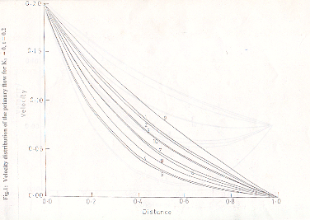
fig.1:velocity distribution of the primary flow for K₁=0,t=0.2
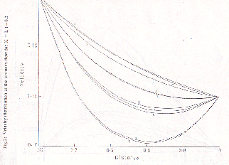

fig.2: velocity distribution of the primary flow for K₁=1.0,t=0.2

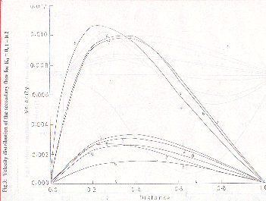
Fig.3:velocity distribution of the secondary flow for K₁=0,t=0.
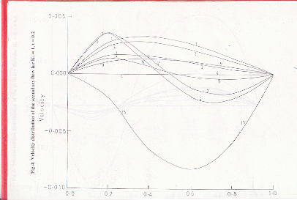
Fig.4:velocity distribution of the secondary flow for K₁=0,t=0.2
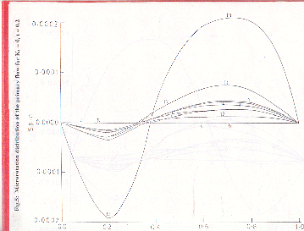
Fig.5:micro rotation distribution of primary flow for K₁=0,t=0.2
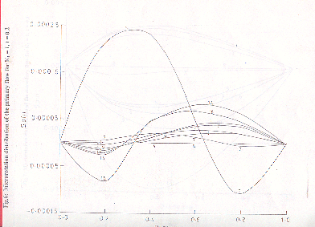
Fig.6:micro rotation distribution of primary flow for K₁=0.1,t=0.2
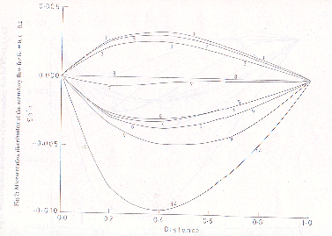
Fig.7:micro rotation distribution of secondary flow for K₁=0,t=0.2
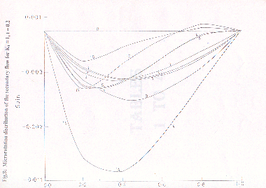
Fig.8:micro rotation distribution of secondary flow for K₁=0.1,t=0.2

References

[1] V.Vidyanidhi and Chenchu Raju, Hartmann problem for micropolar fluids,Acta Cienicia Indica 4, 1978,pp60
[2] A.C.Eringen, Simple micro fluid, International journal Engineering Science 2, 1964,pp 205
[3] A.C.Eringen, theory of micropolar fluid, International Journal of Mathematics,1966,pp1-9
[4] V.Vidyanidhi and S.D.Nigam, Journal of mathematics and Physical sciences,Vol1,1967,pp85
[5] A.S.gupta, Ekman layer on porous plate, Physics fluids,1972,pp930
[6]H.Nimmi,J.Phys.soc.jpn.31,1974, pp1567
[7] A.K.Singh,Nirmal C,Sacheti and Pallath Chandran, Transient effects on magnetohydrodynamic Coutte flow with rotation:Accelerated motion, International Journal Engg.Sci,1994,pp133
[8] G.Ahmadi and M.Shahnipoor,Universal stability of magnetomicropolar fluid motions, International Journal Engg.Sci,Vol12,1974 pp657
[9] P.G.Siddeswar and S.Pranesh, Magnetoconvection in a micropolar fluid, International Journal Engg.Sci
[10] H.Sato J.Phys.soc.jpn.vol 16,1901, pp1427
[11] T.Yaminishi,Preprint , 17 Annual meeting,Phys.soc.Japan,Osaka,Vol5, 1962,pp29
[12]G.W.Sutton and Sharman,Engineering Magneto Hydrodynamics,McGrawhill, NY ,1965,pp346
[13] A.S.N.Murthy and V.VramanaRao,Indian Jounal of Technology,Vol20,1982,pp168-174
[14] S.I.Pai,Magneto gas dynamics and plasma dynamics,Springer,Berlin 1962
[15] A.Rapits and A.K.singh, Acta.Phy.Hung.vol60,1986,pp221

