Time-dependent Source Model for EEG

DIANA RUBIO¹ and MARÍA INÉS TROPAREVSKY²
¹Instituto de Ciencias, Universidad Nacional de General Sarmiento
José M. Gutiérrez entre José L. Suárez y Verdi 1613 - Los Polvorines - Prov. de Bs. As.
¹Escuela de Ciencia y Tecnología, Universidad Nacional de General San Martín
Calle 91 Nº 3391, V. Ballester – Prov. de Bs. As.
² Departamento de Matemática, Facultad de Ingeniería

Universidad de Buenos Aires

ARGENTINA

Abstract: - The process underlying the generation of the Electroencephalogram (EEG) waves can be described as a set of current sources within the brain. The potential distribution produced by these sources can be measured on the scalp and inside the brain by means of an EEG recorder. In the case of epilepsy there are zones that give major contribution in the generation of the electric field and the electric source responsible of a seizure is usually modeled as a dipole. In this work, we propose a time-dependent model for the source that approximates a dipole and we simulate an EEG recording during a seizure. The approximated potential values are plotted on a 3D head model and as an EEG signal. Real data are plotted in the same way and the results are compared.
Key-Words: - Bioelectric Potentials, Source Model, Forward Problem , EEG, Spherical Head Model.

1 Introduction
The electric process underlying the generation of the EEG waves can be described as a set of current sources within the brain. In the case of epilepsy there are epileptogenic zones that give major contribution in the generation of the electric field. For decades, neurologists have been interested in solving the problem of determining the location and orientation of these current sources from the measured potential on the scalp. This problem is known as the Inverse Problem in EEG. In order to solve it, we must first face the Forward Problem (FP) in EEG that consists in calculating the superficial potential for a given source. A typical mathematical model that describes this process is a differential-boundary value problem of second order, based on the static approximation of Maxwell's Equations (see[1]). Then, integral equations are derived from the PDE model, which will be discretized to obtain an approximated solution. A simplified model of the human head is adopted and different approximation techniques are applied.
There are many works where reconstruction of spatially extended sources and different source models are presented. Different dipole source models and localization methods can be found in [2] and [3]. In [4] and [5] possible models for a stationary source are discussed and statistical selection methods are used to distinguish them. One dimensional source distribution to model the primary cortical response to nerve stimulation is theoretically analyzed in [6]. In [7] a spatiotemporal source analysis based on the spatiotemporal noise covariance matrix is developed. Estimation of stationary dipoles from MEG and EEG noisy data is discussed in [8]. Other references can be found in the cited papers.
In this work we propose a time-dependent model for the electric source that approximates a dipole. From real data obtained from the recordings of spontaneous activity during a seizure (provided by Centro Municipal de Epilepsia, Hospital Ramos Mejía, Buenos Aires, ARGENTINA), and based on clinical diagnosis, we made an assumption about the position and the strength of the source. Assuming the proposed time dependent model, we numerically solve the FP for different time instants around a spike on a 3D-spherical model of the head by means of a Boundary Element Technique. We simulate an EEG recording at 40 time instants uniformly distributed along 0.2 seconds around the spike. We plot the solution of the FP and the real measurements on a 3D head model and as a EEG signal. We compare the plots obtained and we observe a reasonable similarity between the real and the simulated data.
The paper is organized as follows: in Section 2 we present the Differential and Integral System of Equations that model the FP. In section 3 we present the Numerical Scheme chosen to find the approximated solution. The time dependent source model is introduced in Section 4. In Section 5 we present the simulated results. Finally, some conclusions are presented in Section 6.
2. The Differential and Integral Equations
The static approximation of the dynamical model underlying the EEG signals is standard in neurology and it is justified by the high speed of propagation of waves in the head. This approximation uncouples the equations for the magnetic and electric fields. In consequence the model for the electrical activity consists of the Poisson equation type with boundary conditions (see [1], [9]).
We model the head, G, by three concentric volumes denoted by -brain-, -skull- and -scalp-. The surfaces between them are , and the external one is . We assume that the radii and conductivity values of the different tissues are given (see [10]).
The current density J is decomposed into one due to the macroscopic electric field, and another one caused by synaptic activity as follows
(1)
where E is the electric field, J_{i} is the impressed current and σ(x) is a piecewise constant function containing the values of the electric conductivity of the different tissues. In our case we have
$$σ(x)=\left\{\begin{matrix}σ_{1} & x∈G_{1} \\ σ_{2} & x∈G_{2}\text{.} (2) \\ σ_{3} & x∈G_{3}\end{matrix}\right.$$
Under these assumptions the equation that describes the relationship between the measured potential u and the current density is
(3)
with boundary condition
(4)
where n represents the outward normal. The continuity conditions at the transition surfaces are
,
where [w]|_{S} denotes the difference w|_{S}⁺ - w|_{S}^{-.}
The differential equation (3) on the domain G is transformed into integral equations on the interface surfaces yielding to (see [11], [12]):
$\begin{aligned}\frac{σ_{k}+σ_{k+1}}{2}u(r)=v(r)− \\ −\sum_{j=1}^{3}{\frac{σ_{j}−σ_{j+1}}{4π}\int_{S_{j}}{u\left(r'\right)\frac{r−r'}{{\left|r−r'\right|}^{3}}\text{dS}'}}\end{aligned}$ (5)
for , k=1,2,3,
where
$v(r)=−\frac{1}{4π}\int_{G}{\frac{∇\text{.}J_{i}}{\left|r−r'\right|}\text{dr}'}\text{.}$ (6)
The numerical solution of (5)-(6) is an approximation of the electric potential u on the surfaces , and .

3 Numerical Scheme
We choose a Galerkin-BEM technique to numerically solve the integral equation (5) (see [13]).
We construct a grid of curved elements E_{j,k} that coincides exactly with each surface S_{j}, i.e. j=1,2,3.
We choose the nodal points to be the vertices of E_{j,k} and approximate u over the elements by an average of its values u_{j,k,i} at the nodal points. Hence, each surface integral
$I_{S_{j}}(r)=\int_{S_{j}}{u\left(r'\right)\frac{r−r'}{{\left|r−r'\right|}^{3}}\text{dS}'}$ (7)
is firstly approximated by
$I_{S_{j}}(r)≃\sum_{E_{j,k}}{\sum_{i=1}^{N_{k}}{\frac{u_{j,k,i}}{N_{k}}}}\int_{E_{j,k}}{\frac{r−r'}{{\left|r−r'\right|}^{3}}}\text{dS}\text{',}$ (8)
where N_{k} is the number of vertices of the element E_{j,k}.. Finally we numerically solve the resulting integrals (8) (see [14] ).
On the other hand, the approximation of the integral (6) depends on the model chosen for J_{i}.
The implementation of all these approximation schemes leads to a linear system of equations
(D -A) u=C (9)
where D is a block diagonal matrix containing information about physical properties of the problem, A is the matrix resulting from the discretization of the surface integrals I_{Sj} (7), C is the discretization of (6) and u is the vector containing the unknowns u_{j,k,i}. After solving (9) we can reconstruct the scalp potential by interpolation.

4 The Time Dependent Source Model
In this section we present a model that intends to reflect the electrical activity of the brain for a short period of time around the spike of a seizure.
As we mentioned in the Introduction, in the case of epilepsy there are small epileptogenic zones that give major contribution in the generation of the electric field. The primary current (see (1)) is then concentrated to a small area around a point, namely (dipole location), inside the epileptogenic zone.
Here, we consider a function to model the source that depends on time, t, and position, r. This function approximates a dipole, i.e., it is nearly zero outside a small area around r_{q};
$J_{i}(r,t)=q\text{.}\frac{M_{q}(r,t)}{{\left|r−r_{q}\right|}^{3}}$ (10)
where
$$\begin{aligned}M_{q}(r,t)=−α_{1}e^{−α_{2}t^{2}−α_{3}{\left|r−r_{q}\right|}^{2}}\text{cos}(α_{4}t)− \\ β_{1}e^{−β_{2}t^{2}−β_{3}{\left|r−r_{q}\right|}^{2}}\text{sen}(β_{4}(t+\frac{π}{2})),\end{aligned}$$
with
$$\begin{aligned}α_{1}=\text{100},α_{2}=\text{3000},α_{3}=\text{10000},α_{4}=0\text{.}5, \\ β_{1}=0\text{.}\text{001},β_{2}=\text{2500},β_{3}=\text{2000},β_{4}=\text{100},\end{aligned}$$
$q=(q_{1},q_{2},q_{3})$ a fixed direction and $r∈S_{j}$.

- Simulated Results
The Hospital Ramos Mejía (Buenos Aires, ARGENTINA) provided us with recorded scalp EEG during seizures.
We consider the EEG waves sampled at 200 Hz. shown in Figure 1. They correspond to a short time period around a spike marked by the neurologists.
Based on that real measurements, we made an initial guess about the location and strength of the source.
We considered a time period of 0.2 seconds centered in a spike (boxed in Figure 1) and we simulate the

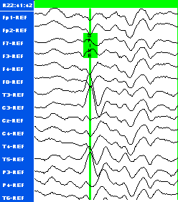
Fig. 1. EEG waves around a spike.

potential by solving the FP for 40 time steps in that period. Then we plot the potential distribution on the
scalp for both, the real and the simulated case. With the simulated values we generate EEG signals. We also plot the resulted values on a sphere for fixed time instants.

5.1 EEG Signal Plots
In this subsection we present the EEG signals, the real and the simulated one, as usual: the values of the potential u on each electrode channel varying in time (see Figure 2).

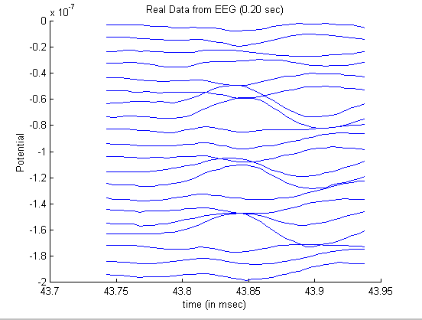
Fig. 2. EEG signal

We solve equation (9) considering the time-dependent source model defined in (10) for the chosen time period. We select the simulated values at the electrode positions and plot them in Figure 3.

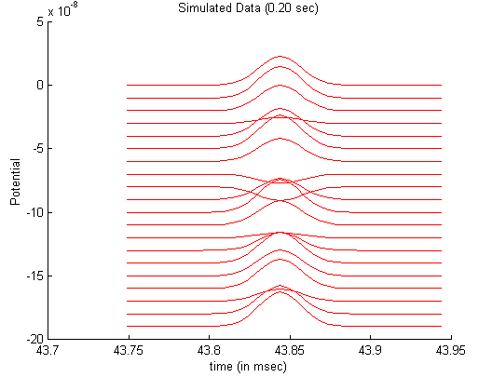
Fig. 3. The simulated EEG signal

Although there are some differences between the real and the simulated data, the shapes of the signals look similar.

5.2 3D Plots
Another way of comparing the real vs. the simulated data is plotting the scalp potential distribution on a sphere at any fixed time instant.
In Figure 4 we present the 3D plot of the real EEG data at the spike time marked in Figure 1.
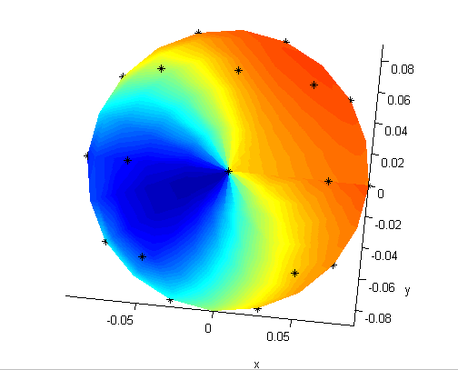
Fig. 4. Measured Potential at a Spike Instant.

The approximated potential values at that instant is plotted in Figure 5.
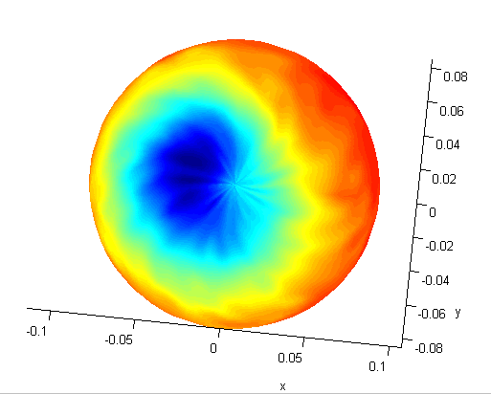
Fig. 5. Simulated Potential Distribution at a Spike Instant.

The color scheme refers to the intensity of the electric scalp potential, where the lowest values are plotted in blue and the highest ones in red.
We can observe a similar pattern between the real and the simulated values shown in the above figures. Moreover, the sense and direction of the gradient of the potential coincide.
Also, to compare the evolution of the scalp potentials, we plot the real and simulated data for the 40 time steps around the spike instant on a 3D sphere. Then a movie was generated and we could observe strong similarities along the whole time period.
In consequence, we will use the source model (10) with the location and strength of the electric source as an initial guess for the Inverse Problem in future works related to this patient.

6 Conclusions and Future Work
This work presents a time-dependent source model that turns out to be suitable for the real case presented in Section 5. This model can be adapted to different seizure process by adjusting the parameters q, rq,the constants α_{j,} β_{j} and by allowing rq to change in time.
In order to calculate the approximated potential distribution we use estimations of the position rq and the moment q of the source based on clinical information. We approximate the EEG signal and plot it on a spherical head model. Then we compare the real and simulated data as EEG waves and as 3D plots. The results obtained with this source model encourages us to use it in future works to estimate the parameters of the model by means of an Inverse Problem Technique.
We also want to point out that in the real case, base activity and noise are present, while they were omitted in the model. Their contribution to the signals are not quite significant in terms of the source location but modify the potential values. Therefore, the incorporation of both, base activity and noise, will be considered in future works to obtained more realistic simulations.

ACKNOWLEDGEMENTS
This work was partially supported by Fundación Antorchas under Grant 13900-2.
The authors also want to thank the Centro Municipal de Epilepsia of Hospital Ramos Mejía, Buenos Aires, Argentina, for their collaboration and encouragement.

References:

[1] Hamalainen M., Hari R., Ilmoniemi R. J., Knuutila, J. and Lounasmaa O., Magnetoencephalography, Theory, Instrumentation and Applications to Noninvasive Studies of the Working Human Brain, Reviews of modern Physics, Vol.65, No.2, 1993, pp.414-487.
[2] Schimpf, P. H., Ramon, C., and Haneisen, J., Dipole Models for EEG and MEG, IEEE Trans. Biomedical Engineering, Vol.49, No.5, 2002, pp.409-418.
[3] Lagerlund, T.D., EEG Source Localization (Model-Dependent and Model-Independent Methods), Electroencephalography: Basic Principles, Clinical Applications, and Related Fields, Chap. 46, 1999, pp 809-822.
[4]Yetik. I.S., Nehorai, A.,Lewinw, J. and Muravchik, C.H., Distinguishing Between Moving and Statiopnary Sources Using EEG/MEG Measurements with Application to Epilepsy, to appear IEEE Trans. Biomedical Engineering.
[5] Yetik. I.S., Nehorai, A., Muravchik, and Hauuesen, J., Line-Source Modeling and Estimation with Magnetoencephalography, to appear IEEE Trans. Biomedical Engineering .
[6] Nolte, G. and Curio,G, Current Multuipole Expansion to Estimate Lateral Extent of Neuronal Activity; A theoretical Analysis, IEEE Trans. Biomedical Engineering, Vol.47, No.10, 200, pp.1347-1355.
[7] Huizenga, H, de Munck, JC, Waldrop, L J and Grasman, RPPP, Spatiotemporal EEG/MEG Source Analysis Based on a Parametric Noise Covariance Model, IEEE Trans. Biomedical Engineering, Vol.49, No.6, 2002, pp.533-539.
[8] de Munck, JC, Huizenga, H, Waldrop, L J and Heethaar R.M., Estimating Stationary Dipoles from MEG/EEG Data Contaminated with Spatially and Temporal Correlated Background Noise, IEEE Trans. On Signal Processing, Vol. .50, No.7, 2002, pp.1565-1572.
[9] Lopes da Silva, F. and Van Rotterdam, A., Biophysical Aspects of EEG and Magnetoencephalogram Generation, Electroencephalography: Basic Principles, Clinical Applications, and Related Fields, Chap.5, 1999, pp 93-109.
[10]Geddes, L.A. and Baker, L.E:, The specific resistant of biological materials-
:a compedium of data for the biomedical engineering and physiologist, Med. Biol. Eng., 1967.
[11] Brebbia, C.A., Telles, J.C.F.,and Wrobel, L.C., Boundary Element Techniques: Theory and Applications in Engineeering, Springer Verlag, N.Y. 1984.
[12] Kythe, P.K., Fundamental Solutions for Differential Operators and Applications, Birkhauser, Boston, Basel, Berlin, 1996.
[13] Meijs, J. W. H., Weier, O. W.,, Peters, M. J., and Van Oosterom, A., On the Numerical Accuracy of the Boundary Element Method, IEEE Trans. Biomedical Engineering, Vol.36, No.10, 1989, pp.1038-1049.
[14] Rubio, D. and Troparevsky, M.I., On the Accuracy of an Approximated Solution of the EEG Forward Problem, Proceeding of the RPIC 2003, San Nicolás, ARGENTINA, Vol. 1, pp.19-23, 2003.

