Computer-Aided Design and Optimization of an

Aluminum Track Bracket

ARNEL RENOLAYAN, SYED TAQI and RAFIQ NOORANI
Department of Mechanical Engineering
Loyola Marymount University
One LMU Drive, MS 8145
UNITED STATES of AMERICA
http://www.lmu.edu

Abstract: - The project involves redesigning a track bracket used for a wall cutting saw assembly currently being manufactured by Cushion Cut Company based in Torrance, California. The purpose of the redesign was to facilitate the installation and removal of the track bracket. Each bracket was secured in place by four screws, installed at its bottom surface. The top surface of the bracket was in contact with the track assembly. When mounted in the horizontal or vertical configuration, the bracket’s sides do not allow easy access to install/remove the screws for mounting/dismounting the bracket. The geometry of each side provides a limited view and tool leverage to the installer. The manufacturer emphasized that the redesign should involve modifying the sides of the bracket. The brackets were to be made of 6061-T6 aluminum alloy. A safety factor of 5.5 or better was required for the final design.

Key-Words: - Computer Aided Design, Finite Element Analysis, Rapid Prototyping, Optimization

1 Introduction
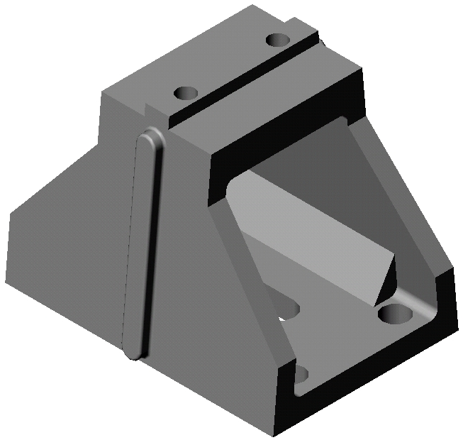
The project involved modifying a track bracket used to mount a tracking system. The tracking system was a part of a concrete wall cutting saw assembly, currently manufactured by Electrolux based in Torrance, California [1]. The track brackets were to be made of Aluminum 6061. The bottom surface of the track bracket, which was the immovable surface, had an anchor slot and four leveling screw holes. The existing configuration of the track bracket did not allow easy access for the installation and removal of the anchor bolt in the slot, and the four leveling screws.
Figure 1: Original Part
A 3D model of the track bracket was designed in SolidWorks shown in Figure 1. By using the given constraints, and the load conditions, the model was analyzed by performing Finite Element Analysis (FEA). The requirements, stipulated by the manufacturer, allowed for a safety factor of 5.5. However, the analysis performed on the existing design revealed a large safety factor. The bracket was modified to provide maximum tool accessibility. The modification consisted of a spline cut on each side of the bracket, beveling all the edges, and chamfering all the screw holes. The final design was prototyped using Fused Deposition Modeling (FDM-1650) rapid prototyping machine. Final analysis performed on the modified model showed that the model was well within the margin of safety factor.

2 Problem Formulation
The subject track bracket was a part of a tracking system, used to guide a concrete wall cutting saw assembly. The fixture was comprised of four track brackets, supporting two tracks. The remotely controlled saw assembly slid back and forth on the tracks. The combined weight of tracks and the saw assembly was approximately 360 lbs. The entire assembly could be installed in a vertical or a horizontal configuration. Each bracket's bottom surface had four threaded screw holes, and an anchor slot for a bolt and a washer. The tracks were installed on the bracket's top surface, which had two threaded screw holes. The top surface of each track bracket was subjected to normal force of 90 lbs. The two threaded screw holes were subjected to shear stress of 45 psi. each. The required safety margin was 5.5.
For the brackets to be lightweight and withstand the applied loads and stresses, aluminum alloy 6061 was selected as the suitable material for bracket construction [2,3]. The present geometry of the bracket's sides provides very limited access and leverage to the installer, requiring the redesigning of the bracket's sides. A 3D model of the bracket was created in a software package called SolidWorks [4]. Several options were looked at for the redesign of the bracket's sides. An optimum design would consist of having enough clearance for allowing the operator to use the installation tools, and would keep the stresses within the safety margins. To minimize stress and deformation, a circular spline was cut on one side of the bracket. All the edges were beveled; and the top and bottom screw holes were chamfered.
Finite Element Analysis (FEA) was performed on the modified model. A software package called COSMOS/Works [5] was used for performing FEA. The bottom surface of the bracket was selected as the immovable surface, and the four screw holes on the bottom surface were designated as part of the constraints. The distributed load on the bracket's top surface was taken as fixed load, and applied on all the faces of the top surface. The bracket's holes on the top surface were subjected to the design stress. The entire bracket was meshed, followed by performing the stress and deformation analysis. The analysis allowed for the visual inspection of the weak areas of the bracket, and simulated the deformation. After running the analysis, the bracket showed no areas where the stress was exceedingly high. Safety factor calculations were performed using von Mises stress analysis. The results revealed that the safety factor was very high, which provided more room for further modification and simplification of the bracket. For results, please refer to the discussion and conclusion of the results section of this report.
The bracket was further modified by creating a circular spline cut on both sides. The edges of each spline cut were beveled. The model was meshed; and stress and deformation analyses were performed. The stress results indicated no areas of extremely high stresses. Since the bracket was part of the assembly with fast moving saw blades and safety was of utmost concern, stress analysis were based on yield strength of the material. For the calculation of the safety factor, von Mises stress analysis was performed for maximum yield stress [6]. The results indicated that the bracket was still well above the stipulated safety factor. For results, please see the conclusion and discussion of results of this report.

3 Problem Solution
With the aid of Finite Element Analysis using COSMOS/Works, the bracket was optimized to meet its design requirements. The analysis calculated the response of the system by solving the set of simultaneous equations that represent the behavior of the structure under the applied loads [2,3]. The forces and moments were reduced into their component loads. A shear load of 45 lbs. was applied at the socket head cap screw locations (the two holes at the top of the track bracket) in shear, and normal to the plane, a load of 90 lbs. at the top of the track bracket. The fixed/immovable constraint was the base of the bracket. After the 6061 Aluminum alloy material was defined for the model, nodes were created. The mesh contained the material and structural properties that defined how the part would react to certain load conditions. There were roughly 16,000 nodes and 8,800 elements created for this model.
The analysis also identified the areas of high stress [2,3] and allowed modification of the indicated weak areas of our design to increase its strength. A failure analysis using maximum von Mises stress criteria of the initial design with one-side cutout produced a factor of safety (FOS) greater than 12, which was well above the design limitations. Figure 2 depicts a graphical representaion of von Mises stress analysis for the initial design.
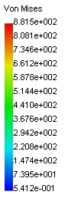
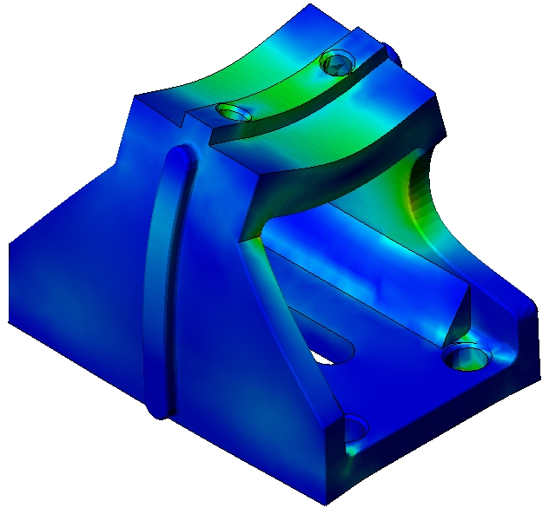
The result of the initial design indicated that further modification of the bracket was feasible. The high FOS allowed the cutting of both sides without greater risk. Upon completion of the design enhancement, the FEA process was re-evaluated by meshing the new model into finite elements, defining the material properties, and applying the loads and boundary conditions. The failure analysis using maximum von Mises stress criteria of the final design produced a peak von Mises stress of 834.8 psi. Figure 3 depicts a graphical representaion of von Mises stress analysis for the final design.
Units: psi
Figure 2: von Mises stress results

Von Mises stress criterion was one of the four failure criteria that COSMOS/Works software supports. The maximum von Mises stress criterion was based on the von Mises-Hencky theory, also known as the Shear-energy theory and the Maximum distortion energy theory. This theory stated that yielding in ductile material occurred when the distortion energy per unit volume of the material equaled or exceeded the distortion energy per unit volume of the same material when it was subjected to yielding in a tensile test. This theory took into account the energy associated with changes in the shape of the material.

- Maximum von Mises stress criterion was used mostly to analyze materials that would fail in a ductile manner.
- Both von Mises stress criterion and Maximum shear stress criterion give the same results at points. For any other state of stress, the maximum shear stress criterion was more conservative than the von Mises stress criterion since the hexagon representing the shear stress criterion was located within the ellipse representing the von Mises stress criterion.
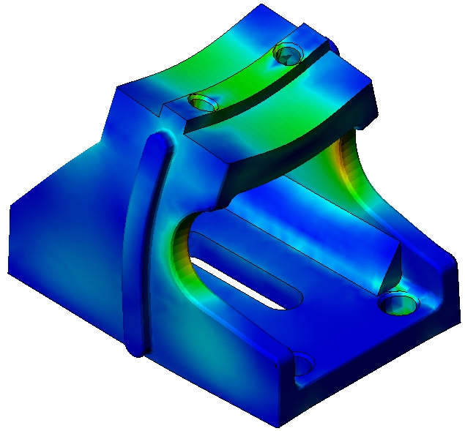
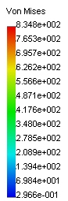
- For a condition of pure shear, von Mises stress criterion predicted failure to be at 0.577 * Yield strength whereas the shear stress at 0.5 * Yield strength. However, actual torsion tests used to develop pure shear have shown that the von Mises stress criterion gives more accurate results than the maximum shear stress theory.
Figure 3: Final Design, von Mises stress result
Units: psi

The factor of safety in the final design was 9.6, well above the stipulated safety factor. Table 1 shows structural analysis throughout the bracket’s design process. The factor of safety was calculated as follows:
$\text{Factor of safety}=\frac{σ_{\text{limit}}}{σ_{\text{vonMises}}}$
where the limit stress was expressed as a factor of yield strength of 6061 Aluminum material at 8,000 psi. The typical yield strength of alloy 6061 Aluminum with temper condition of: O, T4, and T6 were 8,000, 21,000 and 40,000 psi. respectively.
The various results of various structural analysis are shown in Table 1. Figure 4 shows the prototype of the final design. The prototype was created using stereolithography file (stl), obtained from the CAD file of the part and the FDM-1650 rapid prototyping machine.
Table 1 – Structural Analysis
at Various Stages of Development
Design Phase | Von Mises Stress (psi) | Strain | Maximum Displacement (in) | Factor of Safety
Original Phase | 383.8 | 4.00e-5 | 1.64e-5 | 20.8
One side-cutout | 661.2 | 6.35e-5 | 2.07e-4 | 12.1
Final | 834.8 | 5.60e-5 | 2.98e-4 | 9.59

Figure.4: Final Prototype Part

4 Conclusion
A solid model of the track bracket was designed in SolidWorks, and analyzed by performing Finite Element Analysis utilizing COSMOS/Works. The modified bracket provided maximum tool clearance/accessibility and surpassed the manufacturer’s required safety factor of 5.5 by 74.5%. The modification consisted of a spline cut on both sides of the bracket, beveling all the edges, and chamfering all the screw holes. The finite element analysis performed on the modified model showed that it was structurally sound using a bare 6061 aluminum alloy with a yield strength of 8 ksi. The manufacturer may select to use the T4 or T6 tempered and artificially aged 6061 aluminum with a much higher tensile strength that would raise FOS by a factor of ten. This is a judgment that they will make depending on the added value to the bracket.

References:
[1] Electrolux Catalog, 2000
[2] Hibbeler, R.C., Mechanics of Materials, Second Edition, Prentice Hall, 1994.
[3] Beer, F.P. and Russell Johnston, E., Mechanics of Materials, McGraw-Hill, 1981.
[4] SolidWorks Users Manual, 2000
[5] COSMOS/Works User’s Guide, 2000
[6] Shigley, J.E. and Mischke, C.R., Mechanical Engineering Design, Fifth Edition, McGraw-Hill, 1989.

