Web Based Portal for Capacity Building of Development Sector Enterprises in Pakistan

SHAFAY SHAMAIL, MIAN M. AWAIS, SHAHID MASUD, SADAF SHAMS
Center for Knowledge Engineering
Department of Computer Science
Lahore University of Management Sciences
DHA, Lahore, Pakistan

Abstract: - Civic organizations are becoming an important part of the development sector. These organizations bring people and communities together for economic development and social gain. With the devolution of the government to the grassroots, their role has become even more significant in Pakistan. As a result rapid capacity building is needed on the part of these social enterprises. This paper discusses the development of a web portal that provides information resource base to establish learning and development environment for capacity building.

Key Words: - Portal, Social Enterprise, Capacity Building, E-Learning, NGO, Development Sector.

1. Introduction
The social sector is emerging as an independent third sector in a developing economy after public and private sectors. The distribution of governance at the grassroots level has made it important that the social enterprises take an active part in socio-economic development of the country. As a result we see a rapid growth of the community-based organizations (CBO) most of which are non-governmental organizations (NGOs). In order that these organizations become effective in a short span, rapid capacity building is needed on their part [1]. In Pakistani scenario, this translates to utilizing the available scarce resources in the most efficient way.
We have seen an increased awareness regarding information technology as a tool for capacity building in recent years [2]. With initiatives like United Nations' Sustainable Development Networking Programme (SDNP), information and communication technology is being used to address issues of capacity building and national content development [3]. Asia Pacific Development Information Programme [4] and the Internet Initiative for Africa are just a few examples. The Development Gateway Portal by World Bank is another such initiative that aims to “create a common platform for shared material, dialogue, and problem-solving that is easier to access and navigate than the current wealth of information on the Internet. This will enable those in the development field to share information, easily communicate, and build communities of practice around significant development challenges from the grassroots up” [5].
A few projects have been initiated in Pakistan in recent years. NGO Resource Center provides management training and advice to citizen organizations [6]. The Pakistan Development Gateway is developed by SDNP Pakistan [7]. Net-NGO is a guide to Pakistani NGOs [8]. Another similar project is ProPoor [9], which is a portal for NGOs across South Asia. The British Council has also set up a portal in India called Indev to act as a web-database, hosting site and discussion forum [10]. These projects mostly focus on providing a common platform to NGOs and donors for information dissemination and exchange, discussion boards and posting facilities.
This paper outlines a web based training portal developed for the civic organizations in Pakistan. The portal provides not only information resource but also facilities to conduct online training activities, using text, audio and video. Before developing the portal a need assessment survey was conducted as explained in the next section.

1.1 Need Assessment
Research was conducted to determine the immediate needs of the organizations working in the social sector in Pakistan. Apart from the need to develop a social network we specifically focused on their need for training. Based on this survey three training needs for social organizations were established. These include general trainings needed by all, trainings specific to type of organization and area, and technical trainings [11]. All organizations wanted trainings on general management practices, project management, time management in the office environment, human resource management, human resource development, report writing, communication skills, negotiation skills along with business and technical communications. Whereas some specific training needs were identified in research methodology, field-surveying techniques, poverty alleviation, gender issues, health, and women empowerment [11].
Another survey was conducted to find out the IT infrastructure strengths of these organizations [11]. It was noted that Internet bandwidth was just about sufficient to conduct distant training without going into multimedia rich content. Only 20% of the surveyed organizations had plans for broadband Internet connections. More than 95 % of the social enterprises surveyed felt that IT facilities would help them in enhancing their output and building their capacity [12].
Here are the main components of the portal that were determined as a result of the surveys mentioned above [12].
- A one-stop information repository
- Communications facilities
  - Live text/audio/video chat
  - Video conferencing
  - Discussion forums
- E-Magazine
- E-Seminar
- Online survey tool
- Online event publishing tool
- E-learning tools
  - Distance learning
  - Virtual classroom
As a result a portal was built to act as an information resource. Fig.1 shows the main page of this portal. In the following sections the e-learning tools of the portal are explained.

1.2 Infrastructure Analysis
The surveys show that insufficient bandwidth is available to the organizations working in the social sector. The usual connection to the Internet is dialup connection with an average speed of 28kbps. It is expected that the target organizations will have faster connections [11]. Whereas the current infrastructure within these organizations can be utilized for the initial stages of distance learning by avoiding multimedia-rich content.

Fig.1: Main page of the e-platform

3. The SEDP Portal
The Social Enterprise Development Project (SEDP) portal is designed to serve as a one-stop information repository for any person or institution seeking information about a particular social enterprise in Pakistan. Other facilities include chat services, discussion forums, e-seminar, e-magazine, online survey tool, online event calendar, and e-learning tools.
The main part of the SEDP portal is build using open source software including PHP and mySQL. It is a two-tier application at present. Whereas the distance learning part incorporates macromedia tools.

2.1 Information Repository
The main focus of the SEDP portal is to provide a resource base to share and disseminate information that is useful for the organizations working in the social sector in Pakistan. The information repository contains the organizational information including contact information, publications, projects, future plans, thematic areas, operational area etc. In addition to this public documents such as reports, case studies, research papers and conference papers, etc are also available for intended audience.

2.2 Communication Facilities
It is very important for the social enterprises to build communities in order to be effective. One important factor in building such communities is a better and faster communication infrastructure. The SEDP portal provides email and chatting facilities along with a discussion forum to discuss issues and share information. This enhances output while at the same time cutting down travel and telephone expenses. The discussion forum can be used by the members when live synchronous presence is not possible. Members can make new forums and add new topics.

2.3 Online Surveys
This tool facilitates the process of creation of questionnaire and conduction of surveys. A questionnaire can be composed and made available online to the intended audience to fill in. Various options are available such as multiple choice, yes-no, single line, multilane, etc. Results of the survey are available online and trends can be monitored while the survey is in progress. This tool can help an enterprise save on reprographic, distribution, and data entry costs on top of saving a lot of time.

2.4 Online Event Calendar
This tool can be used to publicize the activities of a social enterprise such as seminars, workshops, and other events. It provides the options to add new events, edit current ones, or archive the ones that have been completed.

3. E-Learning Tool
Distance learning tools can be divided into three major categories viz. text, audio, and video. These three categories can be brought together through web technologies. The computer-based training has become interactive and rich in multimedia content. However, due to low bandwidth available to most of the members of the social enterprises in Pakistan, it is not possible to deliver an information rich content at reasonably good speed and quality through the web [11]. In this research we have experimented with combination of content delivery tools according to the needs of the end user. Fig.2 shows the title page of the distance learning part of the portal. The main facilities are shown in Table 1.
A classroom environment can be created using these tools. for example to deliver a lecture on Marketing Principles to the participants of a workshop The facilitator may proceed with the lecture from her office while the participants could be seated in a computer lab on their individual terminals. A similar classroom situation can also be simulated with the trainers in their own residence/offices and participants in their own.

Table 1: Main feature of the EDU-Portal
Chat: text and audio | Audio, video, text
Audio conference | White board
Video conference | White board with audio and video
E-seminar | Online lectures

Fig.2: The Portal display

The facilitator may use one option or multiple options. For instance, if the facilitator starts off with Audio Conferencing, she may end by requesting the users to shift to the Whiteboard module when diagrammatic explanation is required or to shift to the E-Seminar module when a slide show has to be displayed.

3.1 Text Facilities
Print materials may serve as the primary source of instruction or they may be used as supplementary. E-mail may then be used to establish contact between the instructor and the student. Text based chat systems provide synchronous mode of learning environment. The portal provides both email as well as text based chatting facilities, as shown in Fig.3. The users may create a chat room, delete a chat room or join an existing chat session. Also, a large number of users may chat simultaneously.
In our Marketing class, chat can be used by the facilitator to deliver the lecture and by the trainees to ask questions. Email may used by the trainees to submit their case study reports to the facilitator for review.

Fig.3: Text based chat

3.2 Audio Facilities
Voice technologies offer cost-effective ways to enhance distance-learning content. The simplest of these could be a telephone with voicemail or as complex as an audio-conference with microphones, telephone bridges, and speakers. Audio conferencing is the basic media of communication in our portal as shown in Fig.4. In the case of Marketing Principles class; all trainees can hear the instructor speak by using the audio facilities of the portal and contribute to the class discussion through this system.

Fig.4: Audio facility

3.3 Video Facilities
The ability to observe the instructor delivering a lecture establishes a two-way dialogue that enhances learning manifold. Fig.5 shows our Marketing Principles class case where the snapshots of an instructor and a trainee are visible. The instructor is currently conversing with this trainee. In Fig.5 chat facility is being used simultaneously with the video facility.

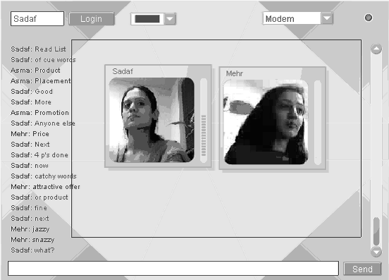

Fig.5: Video facility

3.4 E-Seminar
An online seminar can be conducted using this option as shown in Fig.6. A user may enter as a viewer or a speaker. The speaker requires a web camera since to be visible to all viewers. The speaker also requires a mike and all viewers would require headphones or speakers. The speaker may load any presentation slide show and control it through the options to move slides back and forth. The slide on the viewer side automatically changes when a speaker changes slide. Though previous slides may be reviewed by a viewer, it is not possible to see the slides that the speaker has not yet made visible. The speaker has the option to enable a question and answer session. Once a viewer posts a question, the question is visible to all other viewers and to the speaker as well. The speaker may either answer the question or delete it. These features allow an interactive classroom session or seminar to take place.

Fig.6: E-Seminar

3.5 Whiteboard
One very important aspect of a classroom is a board, which can be used to explain figures and drawings. This has been simulated into the portal as a Whiteboard. This whiteboard simulates the classroom board. Anything drawn by one user on this board is visible to all other users. Unidirectional as well as bi-directional manipulation of the board is possible. A user can either type something on the board or draw simple objects such as arrows, boxes and lines. Colour of the pen can also be changed. The Whiteboard may be used by a teacher to draw diagrams to the whole class or by two people to discuss diagrammatic information. It can also be used to write mathematical equations using freehand. Fig.7 shows how Whiteboard can be used in the class of Marketing Principles. The facilitator draws the basic structure and the trainees add the appropriate text to it.

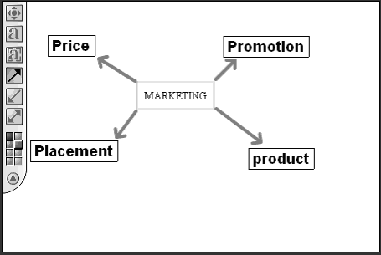

Fig.7: Whiteboard

3.6 Combinations
The utility of video conferencing, audio conferencing and text facilities increases manifolds when used together. Fig.8 shows a combination of whiteboard, audio, video and attendance facilities. The facilitator is visible in the top right window and all trainees present are visible in the bottom right window. The photographs of the trainees absent from the session do not appear. The left window has a Whiteboard that the facilitator uses to draw lecture related diagrams.
Similarly, various other combinations are also available. For instance, slide shows may be used in conjunction with video and audio conferencing.

3.7 Classes Based on Case-Based Teaching Methodology
A class room is proposed to be used in conjunction with case based teaching methodology. This approach relies on the class participation. The students shall be able to carry out discussions with the instructor. Any student who wants to take part in the class discussion raises hand and starts participating only when allowed. This has been displayed using the Icons of the “hand” and “speech” beside the students’ pictures in Fig.8.

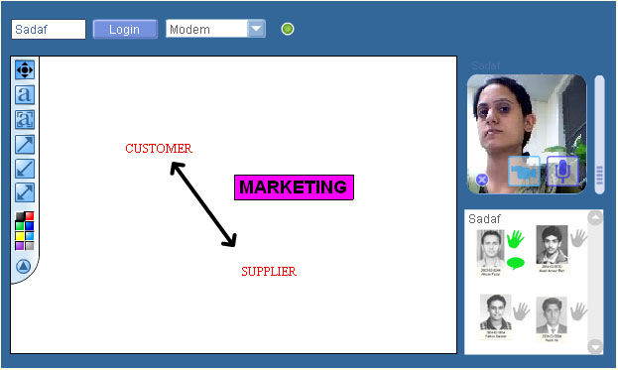
Fig.8: Case Based Class Room simulation using icons

Any student who wants to raise his/her hand to enter the discussion clicks on the icon right next to his/her picture and all connected users, including the instructor, see the icons light up in green. By permission from the teacher, the student is allowed to speak until the teacher or the student himself clicks on the speech icon to end the dialogue.

3.8 Lecture Schedule
The portal also provides the facility to view the lecture schedule online. The time and title of all future lectures are entered by the facilitator. Fig.9 shows the interface for checking out the lecture timings. The user may click on any date on the calendar at the left of the window and the lecture titles and lecture times for that day appear at the right.

Fig.9: Online lectures

4. Conclusion
Internet technologies offer a very promising future to developing countries like Pakistan. These offer a cheaper and more effective alternative to conventional methods of training and communication for capacity building. With its proper implementation and targeted use, social enterprises can definitely start to benefit. While its effectiveness is yet to be substantiated and debated upon, are ample opportunities in resource creation and capacity building where this portal can be of direct benefit.

5. Acknowledgement
The financial support from LUMS-MCGILL Social Enterprise Development Program is gratefully acknowledged.

References:

[1] Eileen Davenport. CID study of NGO capacity building issues for donors in the Pacific, The Development Studies Network Conference, Victoria University, Wellington, New Zealand, November 17, 2000.
[2] Alain Breuleus, Therese Laferriere, Mary Lamon, Capacity Building within and across Countries into the Effective uses of ICTs, Report prepared for 2002 Pan-Canadian Education Research Agenda Symposium, Motreal, Quebec, April 30-May 2, 2002.
[3] Driving Information and Communications Technology for Development, A UNDP Agenda for Action, 2000-2001, http://www.sdnp.undp.org/it4dev
[4] Asia Pacific Development Information Programme, UNDP, http://www.apdip.net/
[5] The Development Gateway Portal: Where worlds of knowledge meet, Concept Note, World Bank, March 7, 2001.
[6] NGO Resource Center, http://www.ngorc.org.pk/
[7] Pakistan Development Gateway, SDNP Pakistan, http://www.pdg.org.pk/
[8] About Net-NGO, http://net-ngo.com
[9] About ProPoor, http://www.propoor.com
[10] John Borgoyary, Indev- A Development Information Portal of India, The British Council, New Delhi, India, www.itcd.net/itcd-2001/papers/doc_pdf/doc_18.PDF
[11] Shafay Shamail, Mian M. Awais, Muhammad Asim Noor. IT support for distance learning to social enterprises in Pakistan, Proceedings of International Conference on Systems, Development and Self-Organization, Beijing, China, November 30-December 1, 2002.

[12] Arsalan Ijaz Anwer, Shafay Shamail, Mian M. Awais, An E-Platform for Capacity Building of Social Enterprises in Pakistan, Proceedings of IEEE International Multi Topic Conference, Karachi, Pakistan, December 27-28, 2002.

