Noise-induced synchronization and coherence resonance
of homoclinic chaos

C.S. Zhou♣, E. Allaria♦, F.T. Arecchi♠,♦, S. Boccaletti^{♦,+},
R. Meucci♦ and J. Kurths♣
♣Institute of Physics, University of Potsdam, PF 601553, 14415 Potsdam, Germany
♦Istituto Nazionale di Ottica Applicata, Largo E. Fermi 6, I50125 Florence, Italy
♠Dept. of Physics, University of Florence, Florence, Italy
http://www.inoa.it/~stefano

Abstract: - We present numerical and experimental evidence of noise-induced synchronization (NIS) and coherence resonance (CR) in homoclinic chaos. These two constructive effects of noise are realized in one experimental laser system, and for weak noise intensities that do not change the main geometrical features of the unperturbed dynamics. These nontrivial effects originating from the intrinsically strong nonuniform dynamics of homoclinic chaos are of great relevance to neuroscience.

Key-Words: - Synchronization, Noise, Homoclinic chaos

1 Introduction
Effects of noise in nonlinear systems are a subject of great interest in the context of stochastic resonance (SR) and coherence resonance (CR). With SR, noise can optimize a system's response to an external signal [1], while with CR pure noise can generate the most coherent motion, mainly observed in excitable systems [2].
On the other hand, two identical systems which are not coupled, but subjected to a common noise may synchronize, as has been reported both in the periodic [3] and in the chaotic [4] cases. For noise-induced synchronization (NIS) to occur, the largest Lyapunov exponent (LLE) (λ₁>0 in chaotic system) has to become negative[4]. However, whether noise can induce synchronization of chaotic systems has been a subject of intense controversy[5-7]. The debate mainly focuses on the effect of the mean value of noise [6,7]. It has been shown that a nonzero mean (biased) noise plays a decisive role by shifting the dynamics toward a stable regime (fixed point or periodic orbit smeared by noise) [6,7]. However, a general conclusion [7] that an unbiased noise cannot lead to synchronization has been disproved by recent examples [8]. This long-standing controversy have been clarified by showing that the key mechanism of NIS is the existence of a large contraction region in the phase space where all the eigenvalues of the Jacobian matrix have a negative real part and nearby trajectories converge to each other [9]. The effect of the noise is to change the competition between contraction and expansion, and synchronization (λ₁<0) occurs if the contraction becomes dominant. However, in the systems of Refs. [8,9], the dynamical structure has been significantly deformed when NIS occurs at large enough noise intensity.
The study of common noise is of great relevance in several disciplines, especially in neuroscience. Neurons connected to another group of neurons, receive a common input signal that often approaches a Gaussian distribution as a result of integration of many independent synaptic currents. A common external noise can generate stochastic phase synchronization of bursts induced by internal noise in non-coupled sensory neurons [10]. Experiments on rat neocortical neurons have demonstrated a remarkable reliability of spike timing in response to a fluctuating stimulus [11]. When the input is a constant current, a neuron generates independent spike trains in repeated experiments, which is an evidence that the constant input has moved the neuron from a quiescent state into a chaotic spiking regime. Remarkably, when a strong enough Gaussian noise is input in addition to the constant current, the neuron generates repetitive spike trains in repeated experiments with the same fluctuating stimulus. The dynamical mechanism underlying such remarkable NIS of chaotic neurons, however, has not been clearly explained. It should be noted that the shape of neuronal spike is preserved in the presence of a noisy input, which is important for biological information processing. So far, it is not known in what type of systems a significant contraction region can exist and NIS occurs while the basic dynamical structure is preserved in the presence of noise. Clearly, studying NIS of chaotic dynamical systems, especially in those displaying similar chaotic spiking behavior neurons, is of great relevance to this important problem in neuroscience.
An important characteristic of many biological [12], chemical [13] and laser [14] systems displaying spiking behavior is the existence of a saddle point S in the phase space. We study this general class of chaotic systems possessing the structure of a saddle point S embedded in the chaotic attractor, i.e. homoclinic chaos [15]. Chaotic trajectories starting from a neighborhood of the saddle point will have very close recurrence to S. There exists generically an expansion region close to the unstable manifold of S, which is the origin of the chaoticity (λ₁ > 0), and a wide contraction region close to the stable manifold of S so that expanded trajectories converge again toward the neighborhood of S. The dynamics is characterized by rather regular orbits in the phase space and widely fluctuating time intervals T between successive returns, because the trajectory slows down considerably and T depends on how close the orbit approaches S. It is important to note that this type of systems has intrinsically highly nonuniform dynamics and the sensitivity to small perturbations is high only in the vicinity of S. Hence, the basic geometrical structure of the orbits is preserved, while T may be changed significantly, so that information of a fluctuating input may be encoded by the spike timing, which is of special importance for biological information processing. Moreover, noise may reduce the fluctuation of T and enhance the coherence of spike trains.
In this work, we demonstrate that both constructive effects of noise, NIS and CR, occur in homoclinic chaos. These effects have been realized in a single mode CO₂ laser with a feedback proportional to the output intensity, both numerically and experimentally. Previous studies on synchronization of CO₂ lasers [16] have not considered effects of noise.

The simulations
We first present numerical simulation of the laser model recently introduced [17]:
$\begin{aligned}{\overset{˙}{x}}_{1}=k_{0}x_{1}(x_{2}−1−k_{1}{\text{sin}}^{2}x_{6}), \\ {\overset{˙}{x}}_{2}=−γ_{1}x_{2}+{\text{gx}}_{3}−2k_{0}x_{1}x_{2}+p_{0}, \\ {\overset{˙}{x}}_{3}=−γ_{1}x_{3}+{\text{gx}}_{2}+x_{5}+p_{0}, \\ {\overset{˙}{x}}_{4}=−γ_{2}x_{4}+{\text{gx}}_{5}+{\text{zx}}_{2}+{\text{zp}}_{0}, \\ {\overset{˙}{x}}_{5}=−γ_{2}x_{5}+{\text{gx}}_{4}+{\text{zx}}_{3}+{\text{zp}}_{0}, \\ {\overset{˙}{x}}_{6}=β\left(−x_{6}+b_{0}−R⋅X_{1}\right)\text{.}\end{aligned}$ (1)

Here, x₁ represents the laser output intensity, x₂ the population inversion between the two resonant levels, x₆ the feedback voltage signal which controls the cavity losses, while x₃, x₄ and x₅ account for molecular exchanges between the two levels resonant with the radiation field and the other rotational levels of the same vibrational band. Furthermore, k₀ is the unperturbed cavity loss parameter, k₁ determines the modulation strength, g is a coupling constant, γ₁, γ₂ are population relaxation rates, p₀ is the pump parameter, z accounts for the number of rotational levels, and β, r, α are respectively the bandwidth, the amplification and the saturation factors of the feedback loop. In order to compare with the experimental system, in the following we set k₀=28.5714, k₁=4.5556, γ₁=10.0643, γ₂=1.0643, g=0.05, p₀=0.016, z=10, β=0.4286, α=32.8767, r=160. b₀ is a constant input bias current. The system stays at a quiescent state for b₀=0 and it moves into a chaotic spiking regime (homoclinic chaos) with a large enough b₀, as is similar to the response of neurons to a constant input [11]. At b₀=0.1031, the model describes very accurately the regime of homoclinic chaos observed experimentally [17]. A Gaussian noise term ξ(t) with zero mean, δ-correlation in time and intensity D is added to the feedback loop. The equations are integrated using a Heun algorithm [18] with a very small time step Δt=5*10^{–5} ms (note T ≈ 0.5 ms).

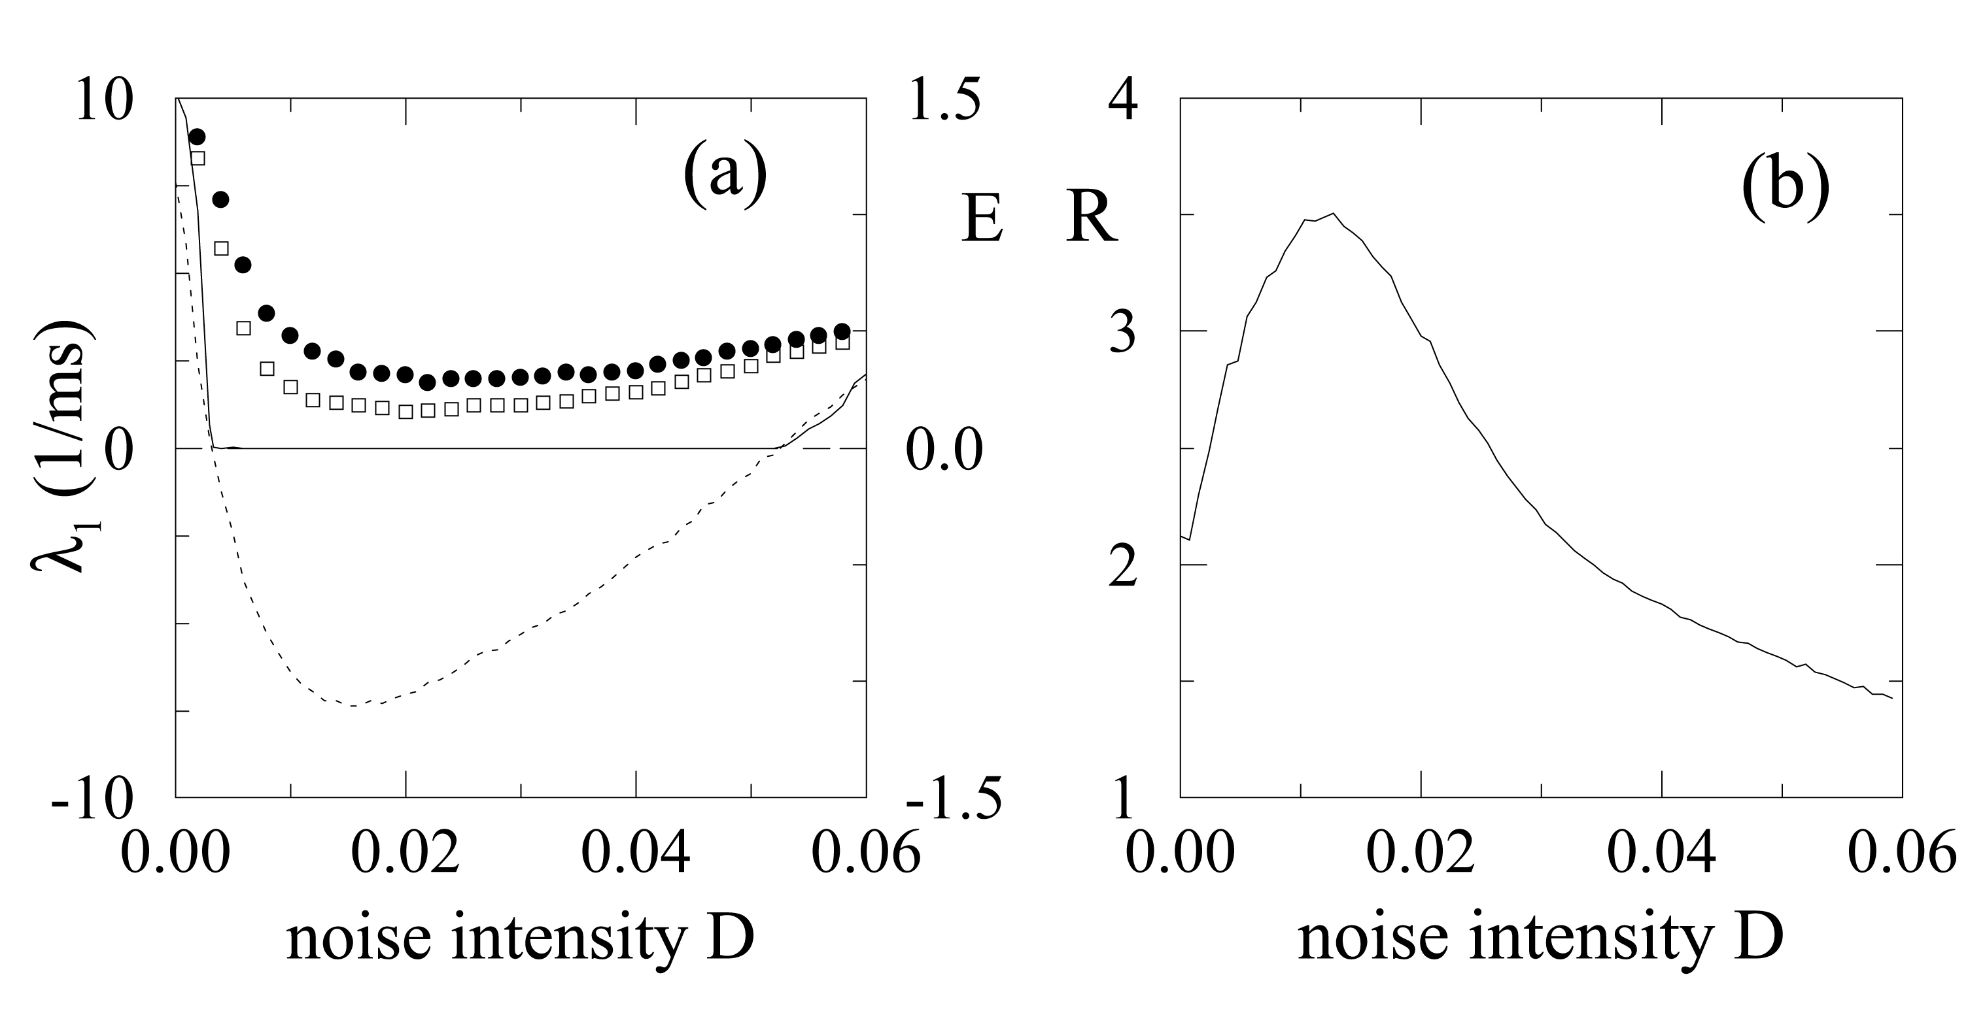
Fig.1: Noise-induced synchronization (NIS) and coherence resonance (CR) in the noisy laser model.
- Dotted line: the LLE λ₁, solid line: normalized synchronization error E between two fully identical lasers x and y, filled cycles: E between two lasers with a small amount of independent noise (intensity D₁=0.0005) and squares: E between two nonidentical lasers with b₀=0.1031 and b₀=0.1032, vs. intensity D of the common noise. (b) Coherence factor R vs. D.

We calculate the LLE λ₁ as a function of the noise intensity D (Fig.1a, dotted line). λ₁ undergoes a transition from a positive to a negative value at D_{c} ≈ 0.0031. Beyond D_{c}, two identical lasers x and y with different initial conditions but the same noisy driving force achieve complete synchronization after a transient, as shown by the vanishing normalized synchronization error $E=\frac{\left\langle \left|x_{1}−y_{1}\right|\right\rangle }{\left\langle \left|x_{1}−\left\langle x_{1}\right\rangle \right|\right\rangle }$ (Fig.1a, solid line). Shortly before D_{c}, the behavior is characterized by on-off intermittency where synchronization is interrupted by short bursts of desynchronized spikes.
The synchronization behavior in this system is determined by a competition between contraction and expansion in the phase space. Without noise, the laser intensity displays large spikes, followed by a fast damped train of a few oscillations and a successive longer train of chaotic bursts which on average appears as a growing oscillation, as seen by the time series of the laser output (Fig.3a,b). The damped oscillation manifests the contraction in the phase space, while the growing one manifests the expansion, which can be described approximately as
$X\left(t\right)≈X_{0}\text{exp}\left[λ_{u}\left(t−t_{0}\right)\right]\text{cos}\left[ω\left(t−t_{0}\right)\right]$ (2)
where $λ_{u},±iω$ are the eigenvalues of the unstable manifold of S and X₀ is the distance from S at any reinjection time t₀. Thus, the smaller is X₀, the longer is the time taken to spiral out. In the presence of noise, the trajectory on average cannot come closer to S than the noise level. With a larger X₀, the system spends a shorter time following the guidance of the unstable manifold so that the degree of expansion is reduced. When contraction becomes dominant, the LLE takes a negative value, and identical systems synchronize. At larger noise intensities, expansion becomes again significant, and the LLE increases and synchronization is lost when λ₁ becomes positive for D > 0.052. Notice that even when λ₁ < 0, the trajectories still have access to the expansion region where the largest local Lyapunov exponent is positive so that small distances between them grow temporally. As a result, when the systems are subjected to additional perturbations, synchronization is lost intermittently, especially for D close to the critical values. Actually, in the experimental laser system, there exists an intrinsic noise source which is estimated to be about 0.15% perturbation to the feedback loop. Therefore the transition to synchronization should be smeared out in real systems. To take into account this intrinsic noise in real systems, we introduce into the equations x₆ and y₆ an equivalent amount of independent noise (with intensity D₁ = 0.0005) in addition to the common one Dξ(t), and calculate the synchronization error E again. By comparison, it is evident that the sharp transition to a synchronized regime in fully identical model systems (Fig.1a, solid line) is smeared out (Fig.1a, filled cycles), as observed in the experimental data that will be presented below.
Parameter mismatch has similar desynchronizing effects, as shown by E between two lasers in the homoclinic regime, with b₀=0.1031 and b₀=0.1032, but the same random forcing (Fig.1a, squares).
It is important to emphasis that NIS is obtained already for a very low noise intensity D. Compared to the peak amplitude of the spikes in x₁ (multiplied by r and β), the critical intensity D_{c} ≈ 0.0031 represents only about 1% perturbation to the feedback loop. In the presence of nonidentity, the onset of synchronization occurs at about 3% perturbation to the feedback loop. This tiny amount of noise only affects the system's behavior close to the saddle S, while it does not change the main geometrical feature of the orbit. This is in contrast with other systems [8,9] where the dynamical structure has been distorted significantly when NIS occurs at large noise intensities.
Based on the above considerations, we expect also noise-enhanced coherence of spike sequences. The interspike interval T becomes shorter on average due to larger X₀ for increasing noise intensity. It is also noted from Eq.2 that, when X₀ is larger, a variation ΔX₀ of it may result in a smaller difference in ΔT, because they are related approximately by ΔT ≈ ΔX₀/X₀, so that the fluctuation of T becomes smaller. When the noise is rather large, it affects the dynamics not only close to S but also during the spiking, so that the spike sequence becomes fairly noisy. We observe the most coherent spike sequences at a certain intermediate noise intensity. We quantify the coherence by
$R=\left\langle T\right\rangle /\sqrt{\text{var}\left(T\right),}$ (3)
as a function of noise intensity D (Fig.1b). When D increases, R reaches a maximal value and decreases again, exhibiting coherence resonance (CR), similar to that of excitable systems [2], but with a different mechanism. At variance with excitable systems [2], where noise induces spiking by kicking the system over an energy barrier, in the homoclinic chaos the spike sequence is generated by chaotic recurrence to the saddle S, and CR occurs as a consequence of a small noise that changes the time spent in the neighborhood of S. Our mechanism is also different from noise-induced coherent jumping among coexisting attractors [19].
In our model NIS and CR persist over a large region of the parameters space.

The experimental measurements
We next demonstrate these effects in a real laser experiment. The numerical parameters considered above refer to a regime of homoclinic chaos in a CO₂ laser with electro-optic feedback as recently reported in Ref. [20]. We use the same experimental setup, consisting of a CO₂ laser with an intracavity loss modulator, driven by a feedback signal which is a function of the laser output intensity. In order to investigate the role of external noise and its capability to induce NIS and CR, we use a random noise generator with a 50 kHz Gaussian distribution. Precisely, a noise signal, recorded by means of a real time Input-Output PC board with a sampling time of 2 μs, is added to the feedback loop for a finite duration of 400 ms. This long time is well beyond the correlation time of the unperturbed homoclinic dynamics [20].

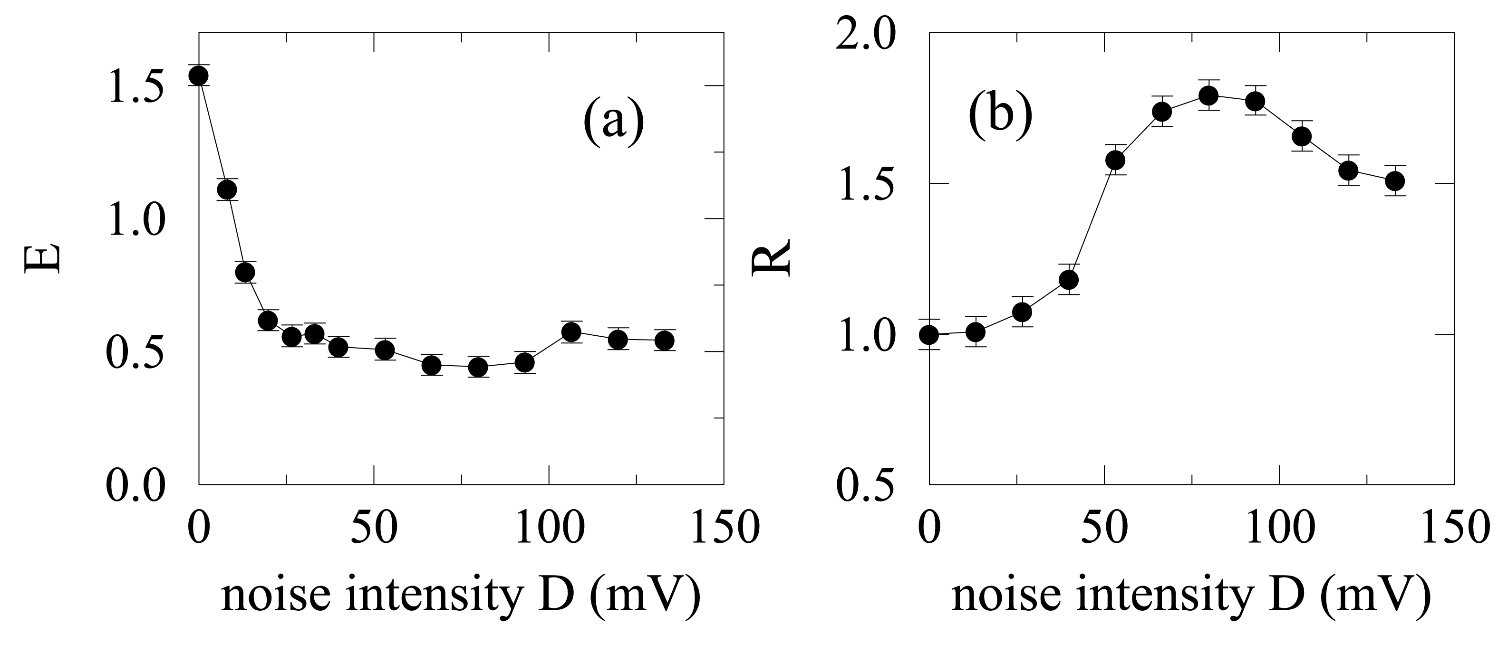
Fig.2: Experimental observation of NIS and CR. The normalized synchronization error E a and coherence factor R b vs. noise intensity D.

To study NIS experimentally for each noise intensity D, we repeat the experiment twice with the same noise. The normalized synchronization error E between the laser output intensities x₁ and y₁ of the two experimental runs is then calculated and reported in Fig.2a as a function of the noise intensity D. Because in repeated experiments the systems are subjected to a small inevitable intrinsic noise in addition to the common external one, and thus are not fully identical, E does not reach zero exactly, and it increases slightly at large D, as is consistent with the numerical results (Fig.1a, filled cycles).
The experimental coherence factor R (Fig.2b) again resembles numerical results. It is important to emphasize that NIS and CR are obtained for rather small noise intensities. In particular, the onset of NIS occurs at an experimental noise (D ≈ 20 mV) of about 3% of the feedback driving signal, whereas the maximal coherence is obtained for a noise (D ≈ 66 mV) of about 10% of the feedback signal.
To present a more descriptive view of NIS and CR, we report in Fig.3 some portions of the numerical (a,c,e) and experimental (b,d,f) laser intensity data for three noise intensities. Precisely, Fig.3a,b are obtained without a common noise, Fig.3c,d for the noise value D_{max} at which the coherence factor R is maximal, and Fig.3e,f are obtained for a noise intensity D ≈ 2D_{max}. In the absence of a common noise, the two signals are unsynchronized, the spike intervals T are large on average and fluctuate strongly. For D ≈ D_{max}, both experimental and numerical results demonstrate the existence of almost complete synchronization induced by the external noise, and in parallel the spike sequences are most coherent with a smaller average T, because the escaping time from the vicinity of the saddle S has been reduced; yet, the main geometry of spikes is preserved. Finally, at a larger noise, synchronization is intermingled with short epochs of desynchronization. All features of NIS and CR in the model and in the experimental system are in good agreement.

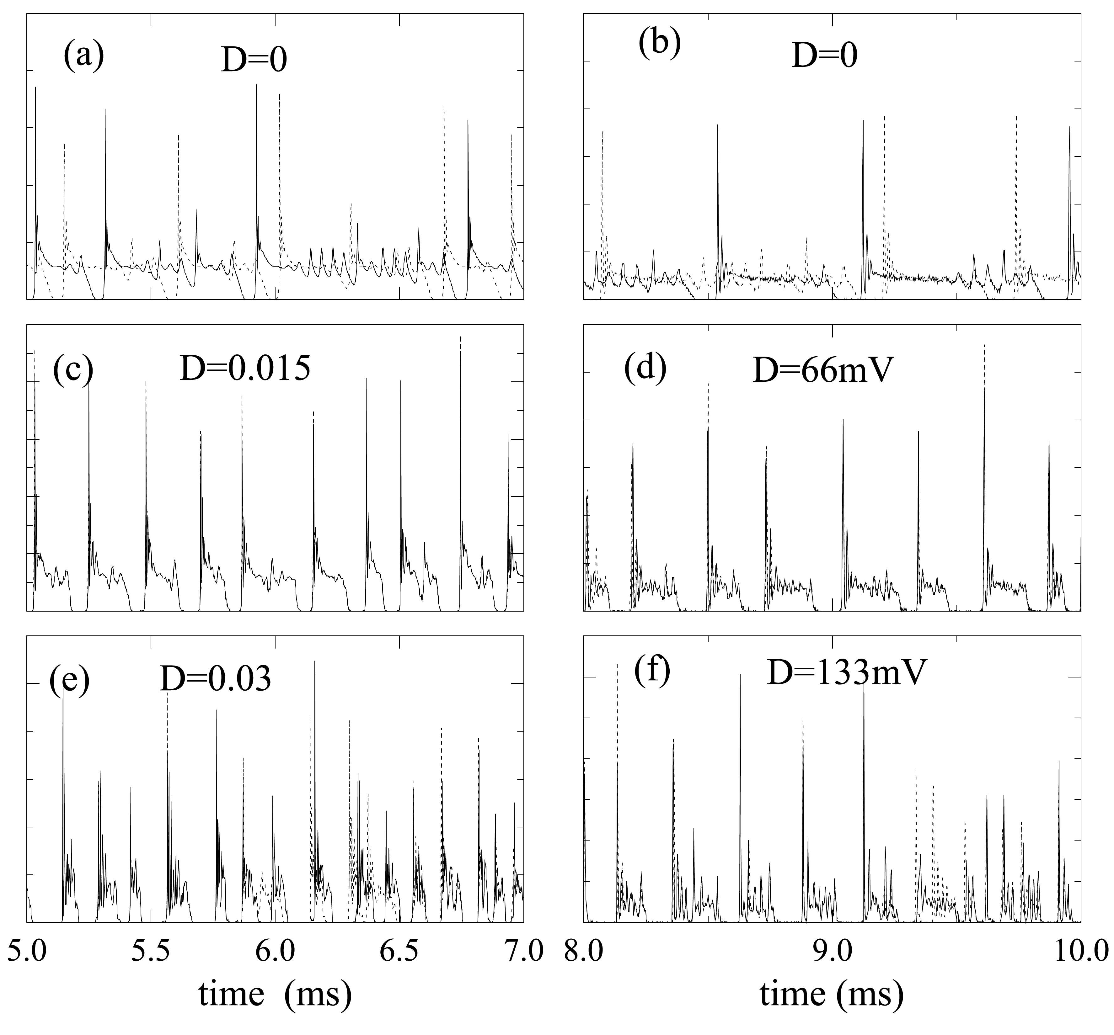Fig.3: Time series of the laser output intensities (arbitrary units) x₁ (solid lines) and y₁ (dotted lines) with a common noise at various intensities. Left panel (a, c, e): models including independent noise (with intensity D₁=0.0005). Right panel (b, d, f): experimental systems.

Conclusions
The two effects NIS and CR have been also numerically investigated in other homoclinic chaotic models, such as a chaotic Hodgkin-Huxley model of thermally sensitive neurons. This model mimics various types of spike train patterns in electroreceptors from dogfish and catfish, and from facial cold receptors and hypothalamic neurons of the rat [21], and display homoclinic bifurcation when the control parameter temperature is varied [22]. Also in this case we find NIS at rather small noise intensity and maximal coherence at a stronger intensity in a wide parameter range.
In summary, we have shown that two constructive effects of noise, NIS and CR which have attracted great recent interest, can occur in a general class of systems displaying chaotic spiking behavior. These effects have been demonstrated numerically and verified experimentally in a CO₂ laser system. Importantly, we have shown that unbiased noise is sufficient to induce NIS. Moreover, NIS is not necessarily associated with large noise intensities, but in the case of homoclinic chaos it can be induced by weak noise which does not significantly alter the geometry of the dynamics. The mechanism presented is of great relevance to experimental observations of repetitive spiking in neurons [21] and brings new understanding of neuron encoding and biological information processing.
This work is supported by SFB555 (Germany), Humboldt-Foundation (Germany), and EC Network HPRN CT 2000 00158.

References:
- R. Benzi, A. Sutera, and A. Vulpiani, J. Phys. A 14, L453 (1981); L. Gammaitoni, P. Hänggi, P. Jung, and F. Marchesoni, Rev. Mod. Phys. 70, 223 (1998).
- A.S. Pikovsky and J. Kurths, , Phys. Rev. Lett. 78, 775 (1997); B. Hu and C. Zhou, Phys. Rev. E 61, R1001 (2000); C. Zhou, J. Kurths and B. Hu, Phys. Rev. Lett. 87, 098101 (2001); G. Giacomelli, M. Giudici, S. Balle, and J.R. Tredicce, ibid., 84, 3298 (2000); J. L. A. Dubbeldam, B. Krauskopf, and D. Lenstra, Phys. Rev. E 60, 6580 (1999).
- A.S. Pikovsky, Radiophys. Quantum Electron. 27, 576 (1984); R.V. Jensen, Phys. Rev. E 58, R6907 (1998).
- K. Matsumoto and I. Tsuda, J. Stat. Phys. 31, 87 (1983); A.S. Pikovsky, Phys. Lett. A 165, 33 (1992); L. Yu, E. Ott and Q. Chen, Phys. Rev. Lett. 65, 2935 (1990).
- A. Mritan and J.R. Banavar, Phys. Rev. Lett. 72, 1451 (1994).
- H. Herzel and J. Freund, Phys Rev. E 52, 3238 (1995); G. Malescio, ibid. 53, 6551 (1996); P.M. Gade, and C. Basu, Phys. Lett. A 217, 21 (1996).
- E. Sanchez, M.A. Matias and V. Perez-Munuzuri, Phys. Rev. E 56, 4068 (1997).
- C.H. Lai, and C. Zhou, Europhys. Lett. 43, 376 (1998); R. Toral, C.R. Mirasso, E. Hernandez-Garcia, and O. Piro, Chaos 11, 665 (2001); L. Baroni, R. Livi and A. Torcini, Phys. Rev. E, 63, 036226 (2001).
- C. Zhou and J. Kurths, Phys. Rev. Lett. (submitted).
- A.B. Neiman and D.F. Russell, Phys. Rev. Lett. 88, 138103 (2002).
- Z.F. Mainen and T.J. Sejnowski, Science 268, 1503 (1995); A.C. Tang, A.M. Bartels, and T. Sejnowski, Cerebral Cortex 7, 502 (1997).
- A. L. Hodgkin and A. F. Huxley, J. Physiol. 117, 500 (1952).
- F. Argoul, A. Arnéodo, and P. Richetti, J. Chem. Phys. 84, 1367 (1987).
- F. T. Arecchi, R. Meucci, and W. Gadomski, Phys. Rev. Lett. 58, 2205 (1987).
- L. P. Shilnikov, Math. USSR Sb. 10, 91 (1970).
- T. Sugawara et al., Phys. Rev. Lett. 72, 3502 (1994); T. Tsukamoto et al., Phys. Rev. E 56, 6564 (1997).
- A.N. Pisarchik, R. Meucci and F.T. Arecchi, Eur. Phys. J. D 13, 385 (2001).
- J. Garcia-Ojalvo and J.M. Sancho, Noise in Spatially Extended Systems (Springer, New York).
- C. Palenzuela et al., Europhys. Lett. 56, 347 (2001); C. Masoller, Phys. Rev. Lett. 88, 034102 (2002).
- E. Allaria, F.T. Arecchi, A. di Garbo and R. Meucci, Phys. Rev. Lett. 86, 791 (2001).
- H.A. Braun et al., Int. J. Bifurcation Chaos, 8, 881 (1998).
- U. Feudel et al., Chaos 10, 231 (2000).

