Robust Underwater Imaging with Fast Broadband Incoherent Synthetic Aperture Sonar

K.Y. FOO, P. R. ATKINS, T. COLLINS
School of Electronic and Electrical Engineering
University of Birmingham
Edgbaston, Birmingham, B15 2TT
United Kingdom
fooky@eee.bham.ac.uk http://www.eee.bham.ac.uk/acs_gr/asproj.htm

Abstract: - Synthetic aperture techniques have been of interest to the sonar imaging community, but suffer from the problems of maintaining phase coherence and a slow mapping rate. The need for rigorous and accurate platform trajectory monitoring often increases the design and implementation costs as well as the hardware complexity. This paper examines incoherent processing techniques and shows their potential for use in designing a robust and practical underwater imaging system. A novel, fast, incoherent, time-domain processing technique is presented. Advantages of using incoherent processing for 3-dimensional imaging are discussed. Broadband signals are used for achieving high range-resolution. Results from simulations and processing of sea-survey data are included.

Keywords: - Incoherent Synthetic Aperture Sonar, Robust Acoustic Imaging, Array Signal Processing.

1. Introduction
Synthetic aperture techniques, successfully used in radar applications, have also been the subject of research within the sonar community over the past two decades [1]-[3]. However, the relatively slow speed of sound and the nature of the propagation medium have made the task of adopting these techniques problematic.
The main problem with coherent processing in synthetic aperture sonar systems has been maintaining phase coherence throughout the whole aperture or integration time. The fluctuating platform trajectory calls for the need for accurate platform monitoring and motion compensation. This results in a much more complex system and imposes operating constraints in realistic applications. In addition to this, a slow mapping rate also results from the classical constraint of array spacing in aperture synthesis.
This paper presents an incoherent approach to synthetic aperture processing that does not make use of phase information. This removes the need for complex motion compensation and offers a robust and easily deployable system. Also, the physical array geometry and the arrangements for aperture synthesis are now flexible. An optimal method for fast incoherent processing is then presented which significantly reduces processing time and resources. Broadband signals are used for achieving fine range-resolution by pulse compression. Simulation results and results from the processing of sea-survey data will be presented.
Finally, the foundations for the implementation of fast incoherent synthetic aperture processing in 3-D underwater imaging will be laid.

2. Incoherent Synthetic Aperture (SA) Processing

2.1 Differences in Principle
In coherent synthetic aperture (SA) processing, phase differences between consecutive echoes are exploited to produce images with very fine azimuth resolution. The echoes are accurately time-aligned given a precise knowledge of the sonar platform position as a function of time, and then summed coherently. Thus, the coherent summation of echoes with both magnitude and phase information leads to an optimal processing strategy. However, in incoherent processing, the phase information is removed before the echoes are summed. Thus, the relationship for azimuth resolution and the classical constraint on transducer spacing no longer applies. These differences become the basis of the potential robustness and practicality of this approach.

2.1.1 Azimuth Resolution
The azimuth resolution of an incoherent processing scheme can be derived from the geometry as shown in Fig. 1. R_{a} and R_{b} are two receiver positions with -3dB half-beam angle θ_{b}. The dotted lines are range-ambiguity curvatures with respect to the receiver positions, and they correspond to the matched-filtered responses from a point target marked ‘x’. The point target matched-filtered responses range from -Δr to Δr.
r_{o} + Δr
y
r_{o} - Δr
r_{o}
(x_{b} , y_{b})
(x_{a} , y_{a})
x

r_{o}
r_{o}
θ_{b}
θ_{b}
x

R_{a}

R_{b}

Fig.1: Geometry of matched-filtered responses from target ‘x’ resolved by two receiver positions, R_{a} and R_{b}.

The azimuth resolution of the system is defined in terms of the correlation of the overlapping responses. This resolution is taken to be twice the azimuth increment that causes the correlation to drop to one-half of its peak value, considering only a cut along the azimuth dimension of the azimuth-range ambiguity function [4]. Thus, the azimuth resolution, P_{z}, can be expressed as

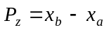 (1)

By trigonometric relationships and assuming r_{o}>>Δr, one can derive that, at the -3dB level,

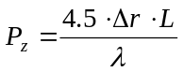 (2)

where L is the physical dimension of the receiver, λ is the wavelength of the signal and 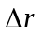 is related to the range resolution. Unlike the expression of azimuth resolution for classical coherent SA [5], the azimuth resolution here is also proportional to the range resolution of the signal. Thus, the use of broadband (i.e. linear frequency modulated (chirp) or linear period modulated) signals and pulse compression is essential for improving both the range and azimuth resolution in incoherent processing [6].

2.1.2 Array configuration
Unlike coherent SA processing, the transducer spacing for incoherent processing can be greater than λ/2. There is a complete absence of grating lobes regardless of the spacing between transducers (Fig.2), thus allowing the use of flexible synthetic array configurations. This means that sparse-array geometries can be used to synthesize the aperture, and a higher mapping rate can be achieved.

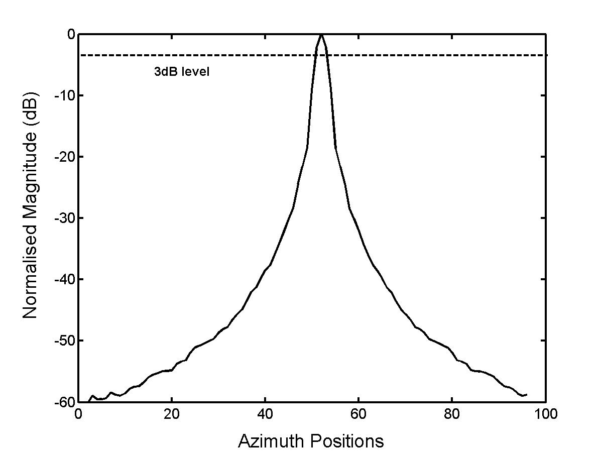 | 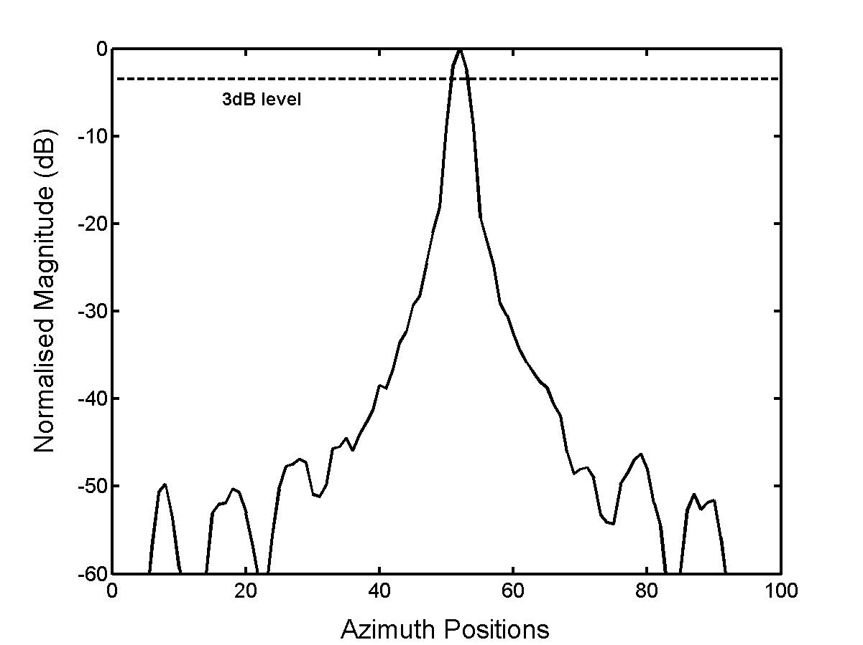
(a)
(b)

Fig.2: Azimuth cross-section of a point target, incoherently processed with (a) normal spatial sampling and (b) 5-times spatial under-sampling.

2.2 The Algorithm
Consider a broadband signal, s(t), being transmitted. Assuming a propagation model with no Doppler scaling and no phase errors, the received signal from a point target, r(t), will be a delayed and attenuated version of the transmitted pulse;

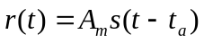 (3)

where A_{m} is the attenuation factor (which accounts also for target reflectivity) and t_{a} is the time delay for the two-way propagation of s(t). Defining R(f) and S(f) to be the transmitted and received signal in the frequency domain respectively, matched filtering is performed by multiplication with the conjugate of the replica. This is then converted into the time domain (via inverse Fourier Transform) to give

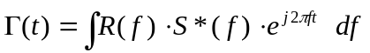 (4)

Next, the matched-filtered signals are envelope detected to remove the phase information and then delayed-and-summed for image reconstruction, giving

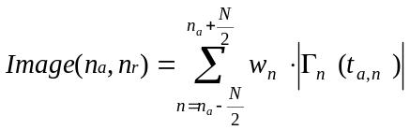 (5)

where Image(n_{a},n_{r}) is the specific pixel of concern on the image to be reconstructed, n_{a} and n_{r} are the coordinates for the pixel concerned, in the azimuth and range direction respectively, and w_{n} accounts for the amplitude shading and windowing in the azimuth direction. N is determined by the necessary synthetic aperture length. To ensure that the azimuth resolution is independent of range, it is proportional to n_{r}. The time delay t_{a,n} is the echo return time corresponding to each point on the synthesized aperture and is given by [7]:

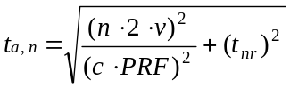 (6)

where v is the platform tow speed, PRF is the pulse repetition frequency, c the speed of sound in water, and t_{nr} is the minimum time delay corresponding to pixels at n_{r}. To reconstruct the whole image, the processes in (5) and (6) are repeated for all pixels in Image(n_{a},n_{r}), in the discrete-time domain.

Azimuth

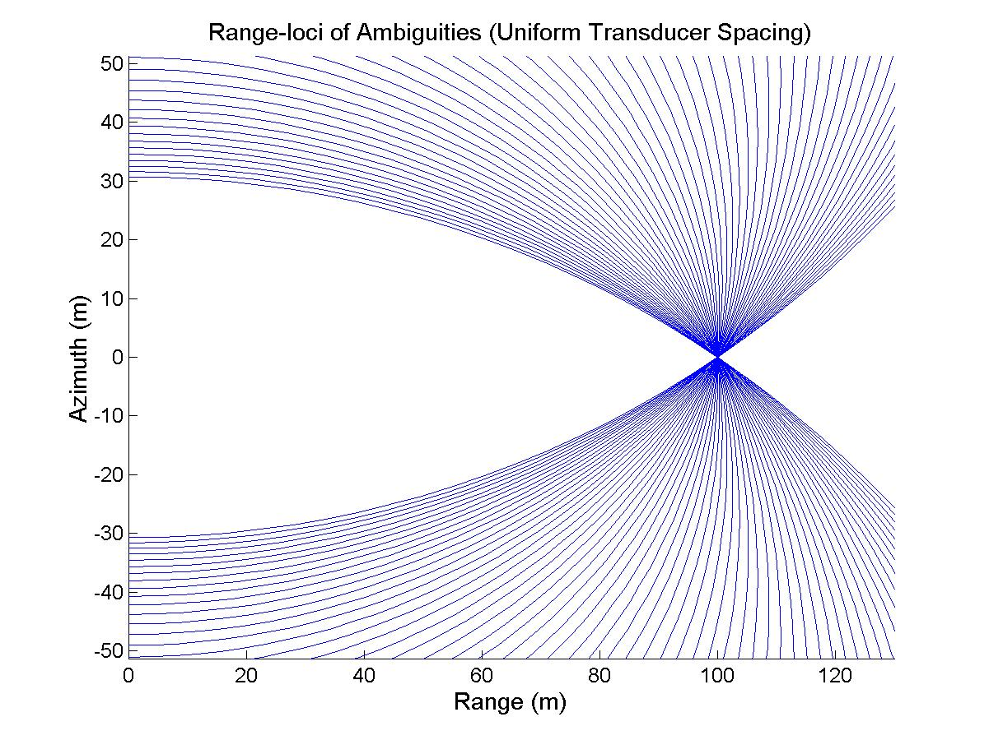
Range

(a)
Azimuth

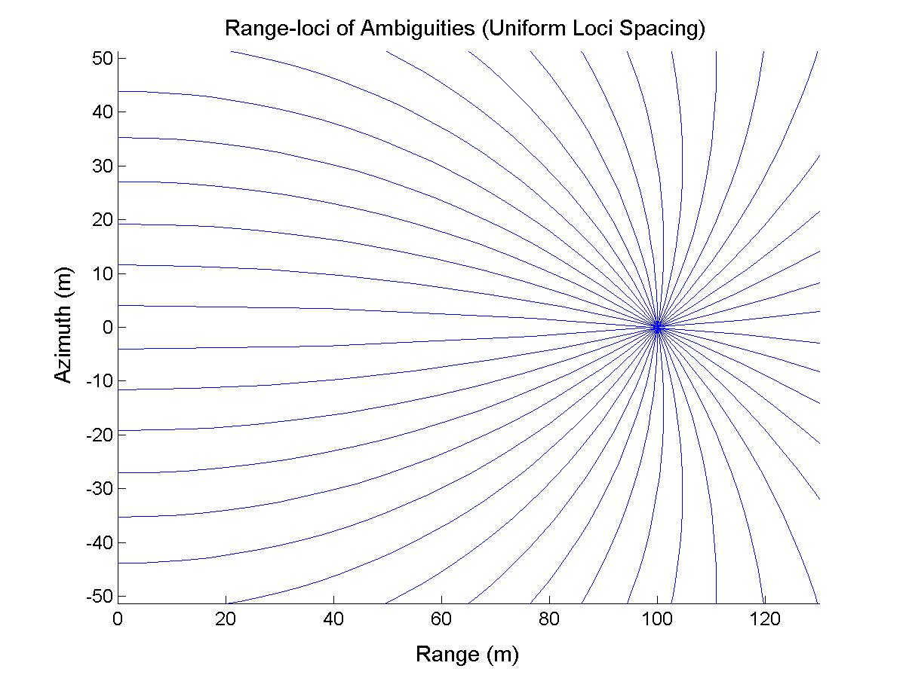

Range

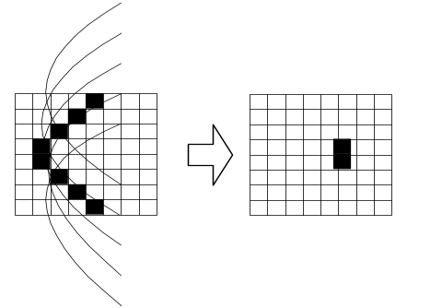
(b)

Fig.3: Illustration of the delay-and-sum process in which the received signals are arranged into a spatial matrix, matched-filtered, and envelope detected. Delay-and-sum is repeated for each pixel to reconstruct entire image.

3. Fast Incoherent Synthetic Aperture Processing Method
Synthetic aperture sonar systems effectively work in the near-field of the array, thus the traditional performance indicators based on far-field beam-patterns are inapplicable. Rather, what is of interest in the case of incoherent processing is the energy pattern on and around a target. Thus, to achieve an equivalent of a point spread function to analyze the response of different array configurations, the loci of range ambiguities corresponding to each transducer position is plotted (Fig. 4(a)).
Since incoherent processing allows flexible transducer spacing, this can be turned into an advantage for improving the distribution of energy around the target, and reducing processing time. The concept is, by constraining the constant range-loci to cross on the point target with equal angular spacing to one another, the signal to self-noise ratio is maximized, and the energy around the target is more uniformly smeared (Fig.4(b)).

Fig.4: Range-loci plots showing energy distribution on a point target after incoherent SA processing, with (a) uniform transducer spacing and (b) uniform range-loci spacing.

By the geometry of target range from a set of transducers (Fig.5), one would expect that to have uniform range-loci spacing, the transducer spacing will increase as the range from the target increases. Define D to be the distance of a transducer from the azimuth position where the range to the target is shortest, and θ_{l} to be the angle between two tangents of range-loci at the point of crossing, then it can be shown that:
(a)
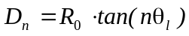 (7)

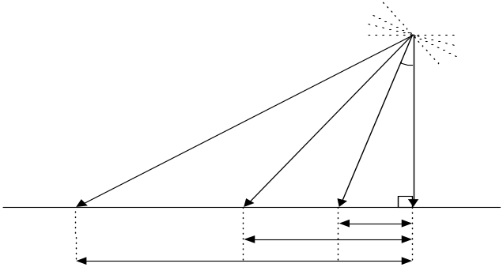
θ_{l}
D₁
D₂
D₃
R₂
R₃
R₁
R₀
Fig.6: A point target processed in simulation with (a) uniform elements’ spacing and (b) fast uniform loci processing.
(b)
Fig.5: Geometry of transducers’ spacing to achieve uniform loci spacing on target.

It is worth noting that, for obvious reasons, uniform transducer spacing is often used in data acquisition. Thus, the increasing spacing will actually be implemented during the delay-and-sum process by deciding which elements are used in the summation and which are not. Also, uniform smearing of energy around the target, as in Fig.4(b), would require a synthetic aperture that is too large to be practical. However, simulation shows a shorter aperture is adequate to provide an improvement in the energy pattern. Fig.6 shows images of a point target processed incoherently with uniform elements’ spacing and uniform loci spacing. It can be seen that there are streaks of far-reaching energy in Fig.6(a), but in Fig.6(b), the energy is more uniformly distributed around the target and there are no persistent streaks of energy escaping the target.
Measurements of processing time showed that the latter is at least twice as fast (82.3s versus 188.6s), due to the lesser number of elements used, and it varies slightly depending on the chosen value of θ₁. Using this method, processing time can be further reduced by increasing θ_{1.} Although using a lesser number of elements reduces processing gain, this effect, however, is minimal in incoherent processing since array processing gain (in dB) is 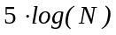 as compared to 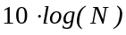 for coherent processing, where N is the number of elements used to produce each pixel. The factor of reduction in processing time will be even more prominent when dealing with large 3-D matrices in 3-D imaging.
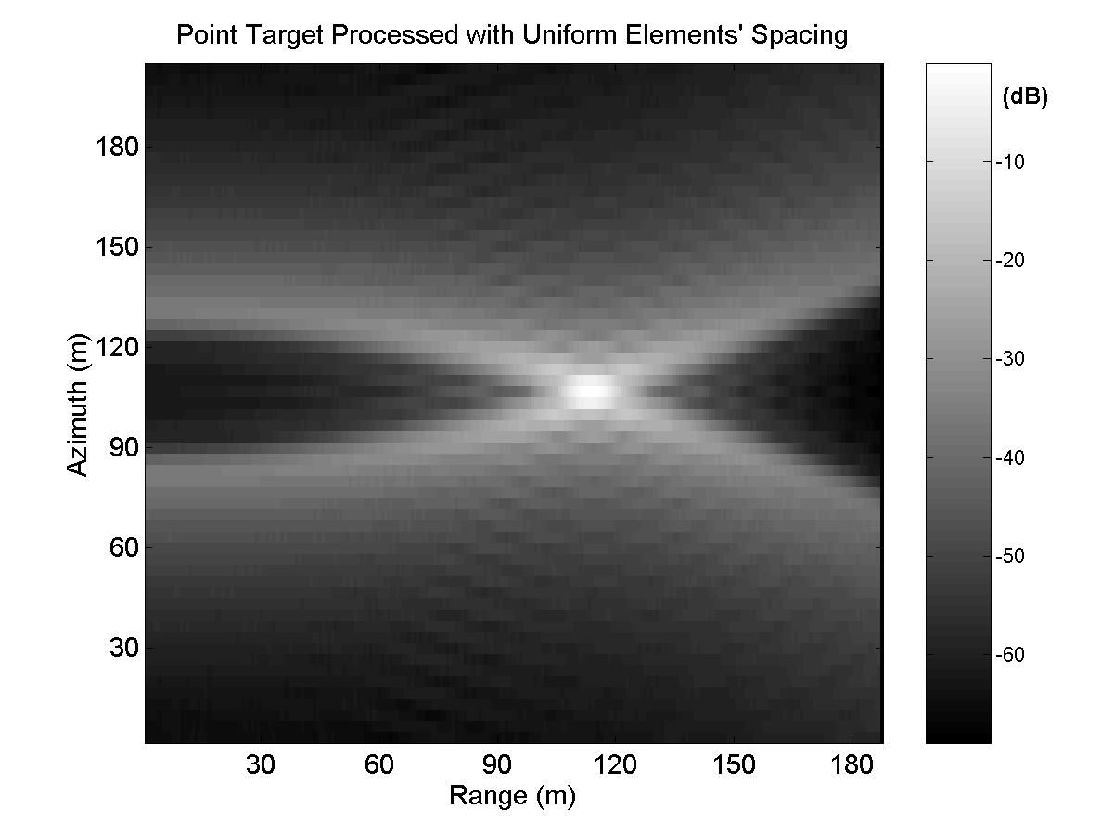
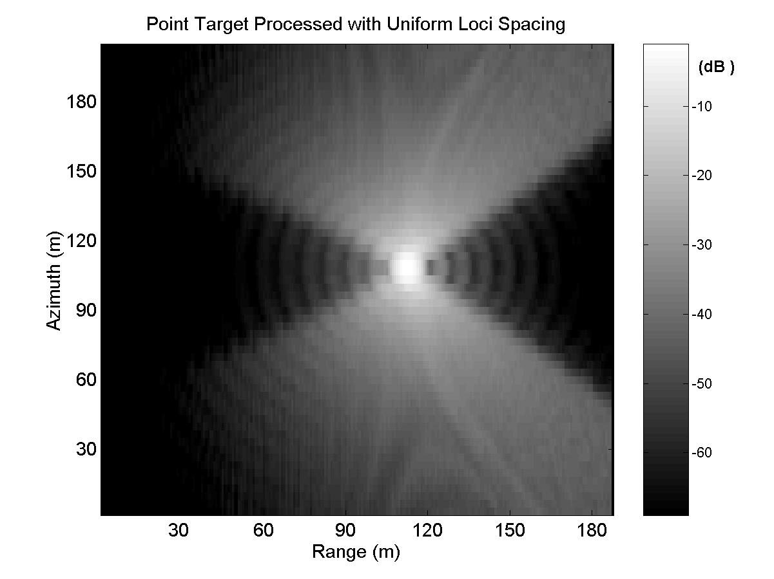
It is generally difficult to give a meaningful measurement of the quality of an image produced, as it largely depends on the application (e.g. target detection, surface mapping or sub-bottom profiling). The general aims in acoustic imaging, however, are to reduce speckle; processing time; and to improve signal-to-noise ratio, resolution and contrast. In practice, many of these goals conflict with one another and a compromise must be sought.

4. Processing of Aeolian Sky Wreck Survey Data
The Aeolian Sky, now lying on its portside, spans a size of 149m x 22m on the seabed in waters of 30m maximum depth. Its location, derived from GPS (Global Positioning System), is 50⁰ 30.55N, 02⁰ 08.33W.
The survey was carried out in early Jan 2002, by a ship towing a 32-channel linear array with inter-elements spacing of 0.75m. The average vessel speed was 3.35ms⁻¹ and the ping rate was 0.6Hz. The transmitted signal was produced from a GeoPulse boomer system, which produces relatively low-frequency, broadband pulses. The receive window duration was 200ms and the received signals were sampled at 51.2kHz. The arrow and the thicker line in Fig.7(b) show the path taken by the survey vessel with respect to the wreck’s location and orientation, based upon the vessel’s navigational readings.
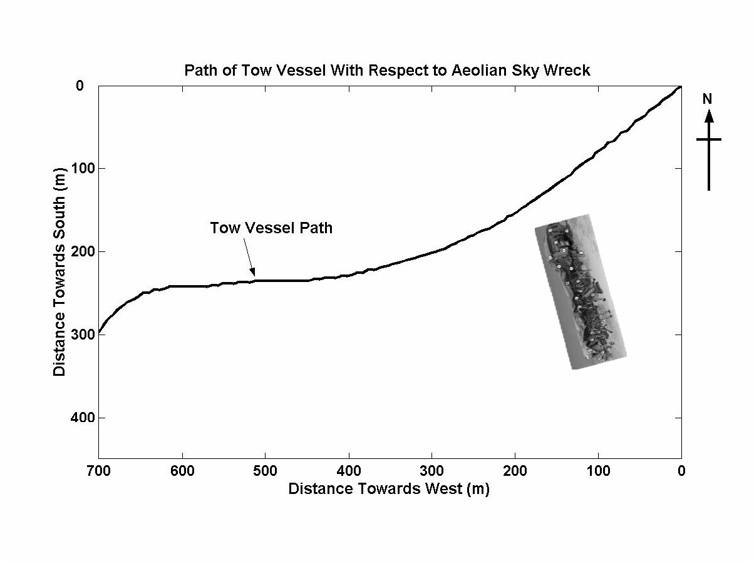
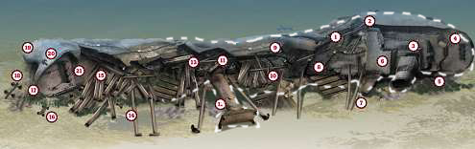
Fig.7: (a) Graphical sketch of Aeolian Sky Wreck’s orientation on the seabed, and (b) the path traveled by the survey ship with respect to the wreck’s location and orientation.
The processing methods used for analysing this data are conventional incoherent processing, fast incoherent processing and coherent processing. Neither motion compensation nor auto-focusing algorithms were used in the processing to give better comparison of the resilience to path deviations between incoherent and coherent processing. Due to the short data capture window, the displayed images only cover approximately half the length of this huge structure, as shown by the dotted box in Fig.7(a).
The results from the three processing schemes are shown in Fig.8. With conventional incoherent SA processing that took 2823 seconds of processing time, the smearing of energy is more spread out around the target, causing a stronger blurring effect in the image. The image produced with the fast incoherent processing method, on the other hand, is sharper, and took 1279 seconds of processing time. Both the images suffer little tarnish from speckle and ‘ghost’ targets that are quite a common phenomenon in coherent SA processing.
The coherently processed image is shown in Fig.8(c). The processing gain is significantly lower due to the lack of coherence over the whole synthetic aperture. The image as a whole is grainy and has a “noisy” appearance, thus lacking contrast. Also, it took a processing time of 5382 seconds.
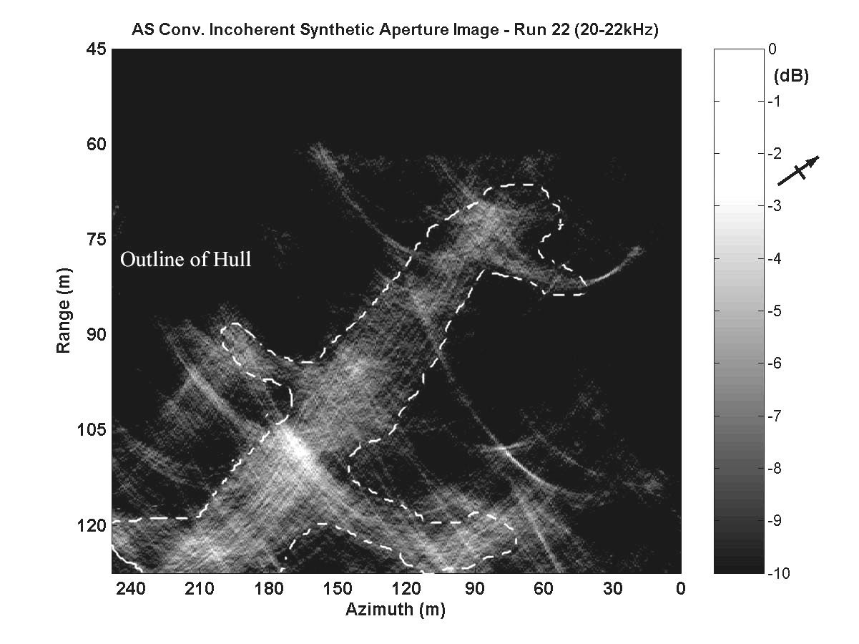 (a) 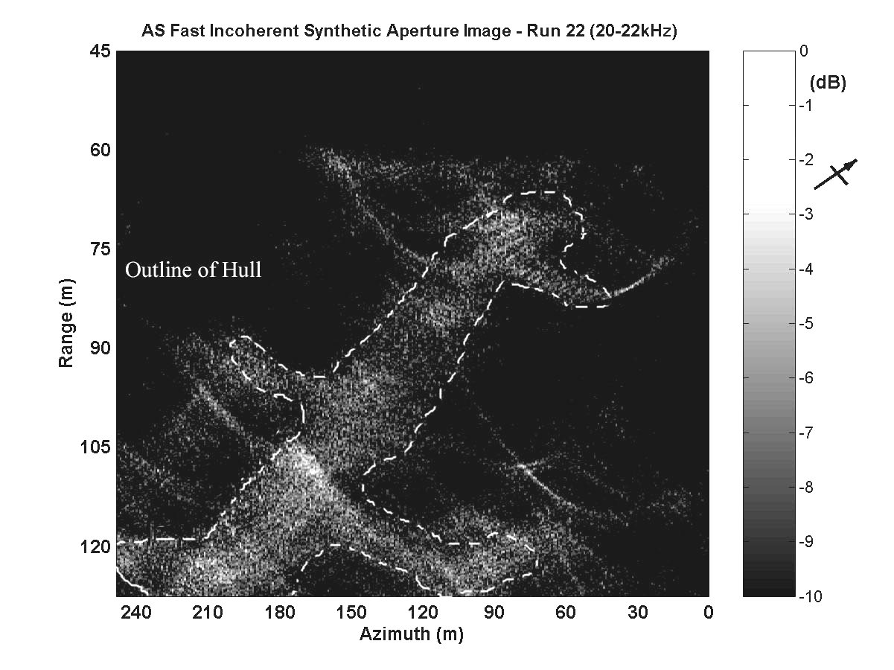
N
(a)
(b)
Thanks to http://www.divernet.com/wrecks/wtour270501.htm.
(b) 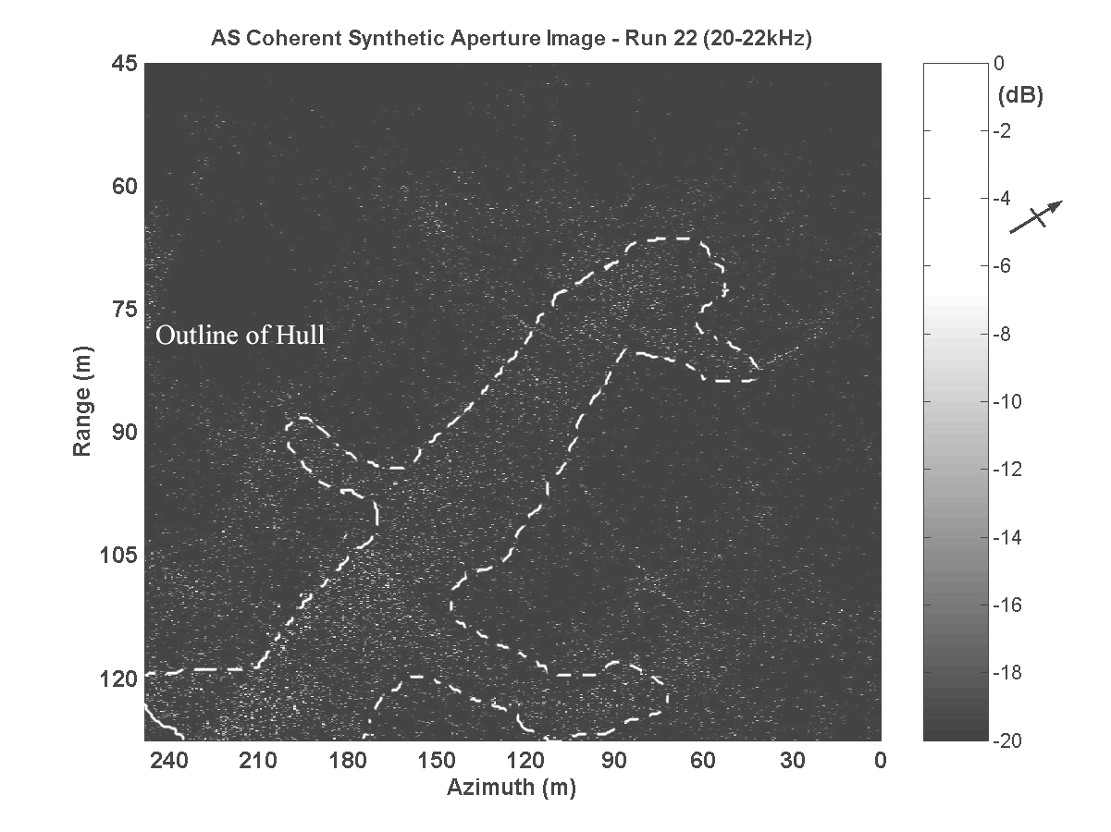
(c)
Fig.8: Aeolian Sky wreck images from (a) conventional incoherent SA processing, (b) fast incoherent SA processing, and (c) coherent SA processing.

5. 3-D Imaging with Fast Incoherent Synthetic Aperture Imaging
In 3-D underwater imaging, one of the problems being faced currently is the slow mapping rate achievable with practical systems [8]. Due to the use of 2-D array [9], the area that can be imaged is confined to the array’s physical dimension. This makes imaging of large areas extremely slow, and building a much larger 2-D array would be too costly and the data obtained would require much more processing power. If a 2-D array is synthesized coherently, there is the additional requirement for high precision motion compensation to achieve coherence in a 2-D synthetic aperture.
But with fast incoherent synthetic aperture processing techniques, one can increase the physical spacing between the transducers during data acquisition as much as the signal-to-noise ratio can allow, thus enabling a significant increase in mapping rate. In fact, there is no requirement for precise and uniform spacing among the elements in the 2-D synthetic aperture, as long as their relative position to one another is known. The shorter computational time involved using this technique makes it possible to build near real-time 3-D synthetic aperture imaging systems when the necessary computing power is available.

6. Conclusion
Incoherent synthetic aperture processing has been shown to be a clearly applicable method in underwater imaging. Its resilience to path deviations and spatial under-sampling is the key to its flexibility in array configuration and design of a robust imaging system. The use of broadband signals is necessary to achieve fine range resolution, and thus a finer azimuth resolution.
By representing the energy pattern of an incoherent synthetic aperture with the range-loci crossing concept, it was found that achieving equal angles between crossings gives a better confinement and distribution of energy on and around the target, improving overall image contrast and sharpness. Another significant gain with this technique is the reduction of processing time by at least a factor of 2 against conventional incoherent processing and a factor of 4 against coherent processing.
A direct comparison of the processing techniques using data from sea-survey of the Aeolian Sky wreck has shown that the benefits and advantages offered by fast incoherent processing technique are not merely a theoretical possibility, but are implementable and achievable in practice.
Incoherent processing strategies are suboptimal resulting in inferior azimuth resolution and processing gain. For applications where that extra resolution is not needed, incoherent processing offers a whole range of new options and possibilities, offering robustness in the synthetic array configuration, higher mapping rates, speckle free and higher contrast images and requires shorter computational times.
Finally, this technique is seen to be very promising in achieving high mapping rates in 3-D imaging after running initial simulations. Using fast incoherent synthetic aperture processing techniques for high rate 3-D underwater imaging will be our next line of research.

Acknowledgements:
The authors wish to thank D. Prowse of UPS, QinetiQ (Winfrith), UK, for undertaking the sea trials and for providing the data for this paper.

References:
[1] P.T. Gough, D.W. Hawkins, “Short history of synthetic aperture sonar”, 1998 International Geoscience and Remote Sensing Symposium (IGARSS 98) on Sensing and Managing the Environment, JUL 06-10, 1998, pp. 618-620.
[2] H.E. Lee, “Extension of Synthetic Aperture Radar (SAR) Technique to Undersea Application”, IEEE Journal of Oceanic Engineering, Vol.OE-4, No.2, 1979, pp. 60-63.
[3] M.P. Bruce, “A Processing Requirement and Resolution Capability Comparison of Side-Scan and Synthetic Aperture Sonars”, IEEE Journal of Oceanic Engineering, Vol. 17, No.1, 1992, pp. 106-117.
[4] P.D.Heering, “Alternate Schemes in Synthetic Aperture Sonar Processing”, IEEE Journal of Oceanic Engineering, Vol.OE-9, No.4, 1984, pp. 277-280.
[5] K. Tomiyasu, “Tutorial Review of Synthetic-Aperture Radar (SAR) with Applications to Imaging of the Ocean Surface” Proceedings of the IEEE, Vol.66, No. 5, 1978, pp.563-583.
[6] M.P. Hayes, P.T. Gough, “Broad-band Synthetic Aperture Sonar”, IEEE Journal of Oceanic Engineering, Vol.17, No.1, 1992, pp.80-94.
[7] J.Chatillon, M.E. Bouhier, M.E. Zakharia, “Synthetic Aperture Sonar for Seabed Imaging: Relative Merits of Narrow-Band and Wide-Band Approaches”, IEEE Journal of Oceanic Engineering, Vol.17, No.1, 1992, pp.95-105.
[8] V. Murino, A. Trucco, “Three-Dimensional Image Generation and Processing in Underwater Acoustic Vision”, Proceedings of the IEEE, Vol.88, No.12, 2000, pp.1903-1946.
[9] V. Murino, C.S. Regazzoni, A. Trucco, G. Vernazza, “A Noncoherent Correlation Technique and Focused Beamforming for Ultrasonic Underwater Imaging: A Comparative Analysis”, IEEE Transactions on Ultrasonics, Ferroelectrics, and Frequency Control, Vol.41, No.5, 1994, pp. 621-631.

