A SECOND LAW THERMOECONOMIC OPTIMIZATION OF A GAS TURBINE POWER PLANT AND FLUE GAS EMISSIONS EVALUATION

J.M. Rodríguez Lelis
Sosimo E. Díaz M.

Centro Nacional de Investigación y Desarrollo Tecnológico
Departamento de Ingeniería Mecánica
Interior Internado Palmira S/N
Apdo. Postal. 5-164, Cuernavaca, Mor., 62490
México

Abstratct:- A computer program for the exegetic optimization of a gas turbine power plant has been developed. This program is based on the thermoeconomic functional analysis, and uses the first and second laws of thermodynamics. The optimization process is carried out using Lagrange Multipliers. With this program optimal performance of the cycle and cost conditions are obtained, as well as the flue gas emissions for the economic optimum point.

Key-words:- optimization, exergy, gas turbine, energy

Nomenclature
Y = availability (kJ/kg.)
l_{r} = number of outputs of the unit r (r = 0 at environment conditions).
m_{r} = number of inputs of unit r.
w = number of units
Z_{r} = amortized capital cost rate of unit r including fixed charge and maintenance (USCD).
Γ_{0.k} = cost rate associated with Y_{0.k} (USCD)

Subindex
o = related to atmospheric conditions

1 Introduction
Optimization techniques have a wide potential in engineering sciences. In recent years, with the increasing power of computers, many numerical procedures have been developed to apply optimization techniques to different problems, among them to the analysis of thermal systems. In the optimization process the modeling of the system is carried out through a mathematical function called the objective function, which depends of capital and operation costs as well as the energy flows. The later may be determined using the first or second law of thermodynamics. The optimization process then consists on locating a extremum, either a maxima or minima of the objective function. For this purpose, according with Garceau [1], Lagrange Multipliers are recommended which can then be applied through functional analysis, Frangopolus [2]. The program developed was initially applied a Cogeneration Plant as described by Garceau [1] and then extended to a Gas Turbine Power Plant. Here the objective of the present work, was besides determining the optimum thermo economic condition, determine as well, the amount of flue gas emissions that correspond to that optimum condition. In operational practice, the optimal thermo economic parameters are difficult to evaluate, this represents an opportunity for this type of programs as a mean of evaluating, quick and reliable, the optimal operation conditions of a system, which will allow for minimum cost and enhance the use of energy.

2 Thermo-economic Functional Analysis
Thermal systems consist of a set of interrelated-units mutually dependent thermodynamically and economically. Because of this relationship, the optimization of individual components can not be easy oriented to the optimum design of the system. The method then used is Functional Analysis, which basically consists on dividing the system in a number of blocks, that is, simpler systems, each of which having a particular function (purpose or product) and a network of lines representing the distributions of blocks function. Optimization is carried out by applying Lagrange multipliers local objective function or subsystems [3]. Other works related to this method are those of Hendrix [4] and Frangopoulos [5] where is shown that the measure of the function of each block is exergy, where an isolated model is used

2.1 Optimization
The aim in an optimization process is to use the maximum available energy at a minimum cost, from where performance conditions that satisfy this statement may be found. As stated by Frangopulus [5], the objective function is
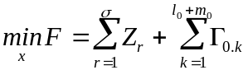 (1)
The costs are function of the decision variables and quantities purchased or sold as follow:
Z_{r} = Z_{r} (x_{r} ,Y_{r.1} ) (2)

Γ_{0.k} = Γ_{0.k} ( Y_{0.k} ) (3)
From substitution of equations (2) and (3) in (1), the objective function takes the form:
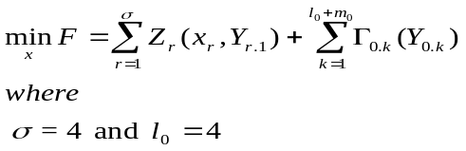 (4)
The equality constraints for the system shown in Figure 1 are:
Y_{r,j} = Y_{r,j} (x_{r}, Y_{r.}) (5)
in which
r = 0,1,..., w
j = 1,2,..., m_{r}
Y_{0.k} = Y_{0.j} (6)
where
k = l₀ + j
j = 1,2,..., m₀

The constraints (5) are the energy flow at the inlet of block r and are function of the availability Y_{r}. The constraints (6) represent the interconnections between the blocks of the system. For the solution of the optimization problem the method of Lagrange Multipliers is used, which leads to the special cases of decomposition and thermo-economic isolation [6,2]. The Lagrangian then is:

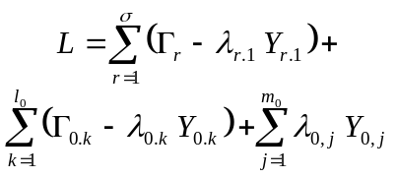 (7)
The necessary conditions for an optimum are:

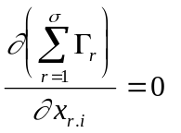 (8)

and
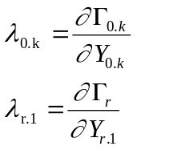 (9)

The concept of internal economy introduced by El-Sayed [7], and the corresponding interpretation of Lagrange Multipliers as economy indicators of prices are maintained here.

3 Exergy and Cost Equations for the Optimization Process

As may be seen from equations (1) to (4) a number of equations for the costs of each equipment and exergy flows bought and sold have to be determined to define the objective function and Lagrange multipliers. With reference to Figure 1, the exergy flows may be calculated by using the Darrieuz function, for example for the compressor inlet:

E₁ = m_{c} [( h₁ - h₀ )-T₀ (s₁ - s₀) (5)

where T is the temperature and the subindex c refers to the compressor and 0 to reference state.

The cost equations are formed in such a way that they reflect the capital invested, maintenance costs, etc.; as a function of the thermodynamic parameters of the system under analysis. These were developed as described by Garceau (1988).

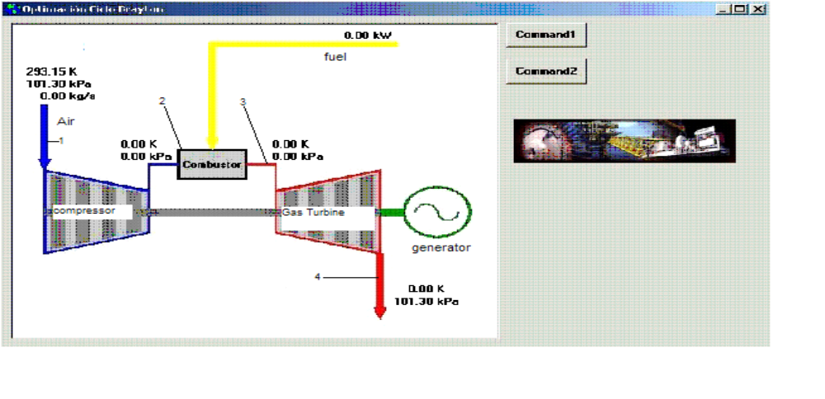
Fig. 1 A Gas Turbine Power Cycle.

4 Results
The results of the optimization process for the Gas Turbine are shown in Figures 2 and 3. A first law optimization is shown in Fig. 2 and the exergy optimization in Fig. 3. For the first law optimization, are shown the variation of the termal efficiency η_{I} (NTH) and total cost of the power plant Z_{TOT} as a function of the net power. It can be seen that η_{I} and Z_{TOT} describe parabolas, one open downwards and the other upwards respectively. It is also shown that Z_{TOT} reaches a minimum which is the optimum reference point. Thus any increment or decrement of the efficiency will cause an increment on the total costs of the plant. The optimal values obtained for the energy optimization are η_{I} = 36.13% y Z_{TOT} =0.3987 $/s for a net power of 69044 Kw, and for the exergy optimization are η_{II} = 36.06% y Z_{TOT} =0.3986 $/s for a net power of 69113 Kw. This shoes that higher power at a lower cost may be obtained using an optimum exergy design.

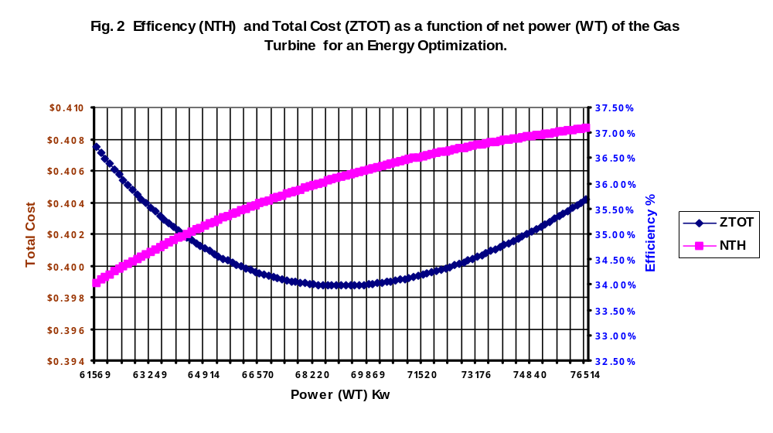

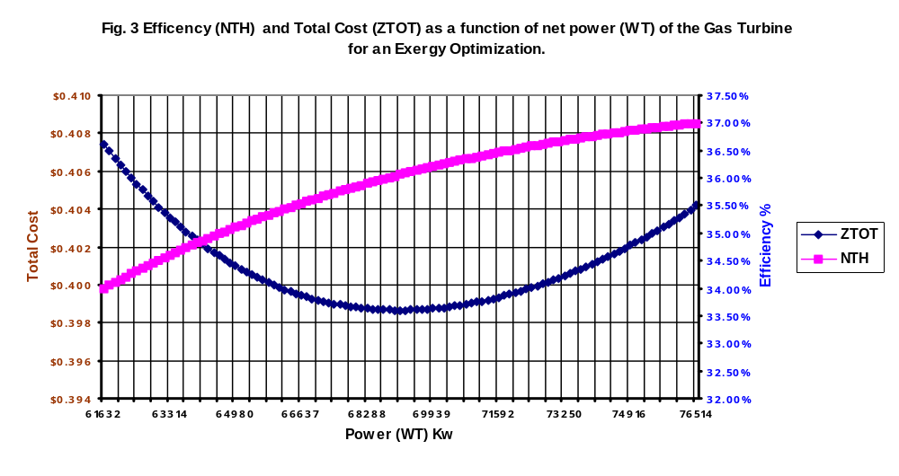
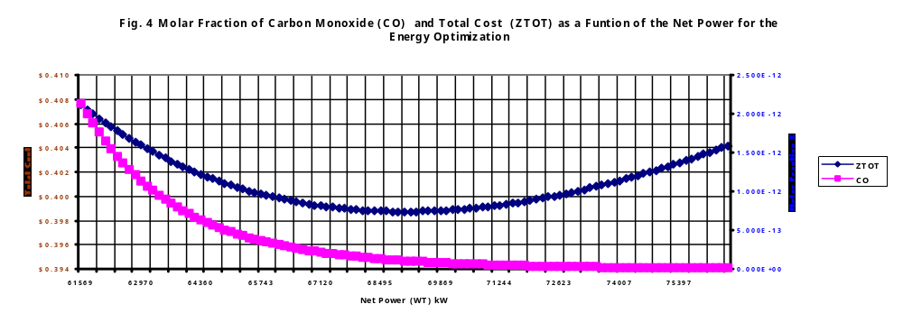
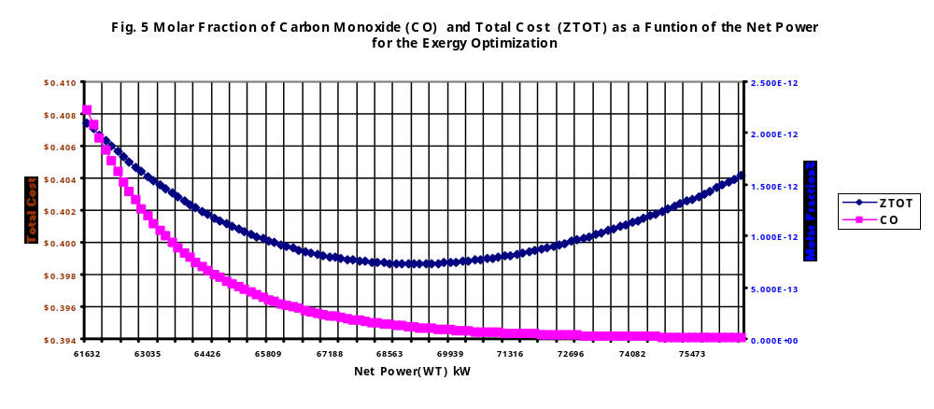

Once the optimum post for minimum cost is known, the remaining variables can be determined. Bearing in mind that actual environmental regulations require specific emission values, the optimum emissions values obtained to those specified on the environmental regulations can be compared. As an example, the behavior of the carbon monoxide CO and nitrogen oxide NO as a funcyion of net power are shown in figures 4,5, 6 and 7, for the energy and exergy analysis. It may be noted in all graphs that as the efficiency and power increase the gas emissions decrease, however for the minimum costs there is an specific value of emissions, which as already mentioned may be compared to those of the environmental regulations. The optimum molar fractions obtained for the energy analysis are CO=1.07E-13 y NO=4.495E-08 and for the exergy analysis CO=1.1388E-13 y NO=4.5809E-08.

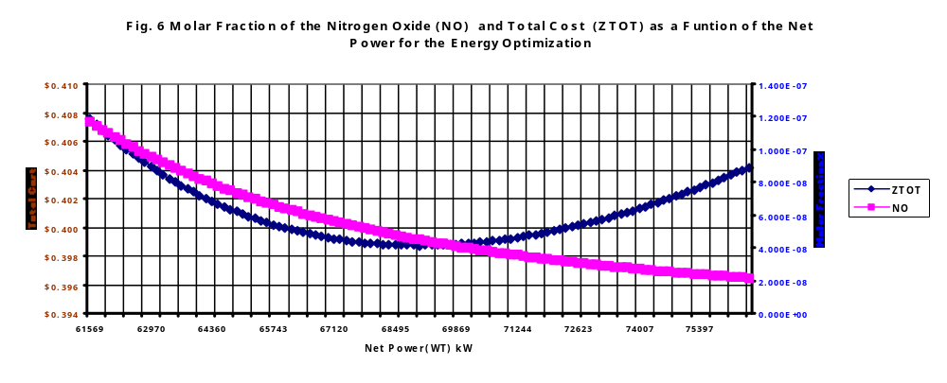

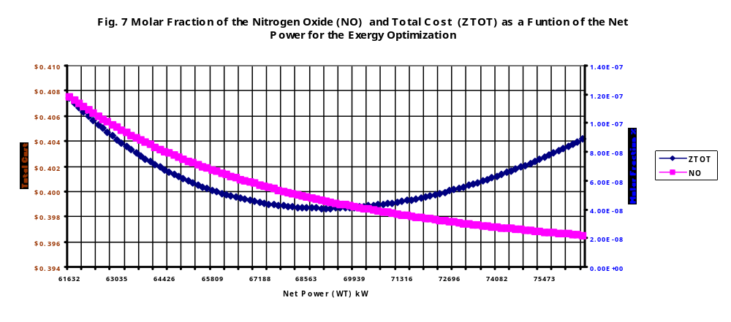

On the other hand it should be noted that the exergy analysis allows higher power conditions for lower gas emissions. It may also be considered, bearing in mind Gouy-Stodola Theorem, that the when the gass emission leave the gas turbine, still contain an amount of available energy or exergy. Thus, the performance conditions should be those that could guaranty the lower gas emissions to the athmosphere, with the lower exergy content and at the lower cost.

5 Conclusions
A computer program has been code to perform a thermo economic analysis of a Gas Turbine Power Plant. This program besides obtaining the optimum performance conditions, it may also evaluate the flue gas emissions.
Three main results were obtained from the optimization program: The first is related with the cost of the plant, where it is shown that the costs estimated by energy analysis are higher than those of the exergy analysis.. The second, which refers to the thermodynamic operation parameters, where it was found that the plant is operating at higher flows and pressures with the consequent waste of available energy. The last related to the gas emissions where its was shown that lower emissions may be obtained by exergy analysis.

References
[1] Garceau, R. M., “Thermoeconomic Optimization of a Rankine Cycle Cogeneration System”. M.S. Thesis, Georgia Institute of Technology, 1982.
[2] Frangopoulos C. A., “ Thermoeconomic Functional Optimization of a Cogeneration Systems”, ASME, COGEN-TURBO International Symposium of Turbomachinery, Combined Cycle Technologies and Cogeneration. IGTI Vol. 1. Montreux, Switzerland, Sept. 2-4, 1987, pp. 323-329.
[3] Evans R. B., “Thermoeconomic Isolation and Essergy analysis”, Second Law of Thermodynamics Workshop, U:S. Dept. Energy, George Washington Univ, 1979.
[4] Hendrix W. A., “Essergy Optimization of Regenerative Feedwater Heaters”, M. S. Thesis, Georgia Istitute of Technology, Atlanta, 1978.
[5] Frangopoulos C. A., “Thermoeconomics Functional Analysis: A Method for Optimal Design of Complex Thermal Systems”, Energy, Vol. 13, Nº 3, 1988, pp. 239-244.
[6] Olea G. U., “Programa de Cómputo para la Optimización Exergética de una Planta Geotermoeléctrica”, M.C. Tesis, Centro Nacional de Investigación y Desarrollo Tecnológico, Cuernavaca, Morelos, 1996.
[7] El-Sayed Y. M. y Evans R. B., “Thermoeconomics and Design of Heat Systems”, Journal of Engineering for Power,ASME, Vol . 92, 1970, pp. 27-35.

