Parameter Estimation for a Neurobiologically Realistic Computational Model of Auditory Pattern Recognition

FATIMA T. HUSAIN, MICHAEL C. CHEN, BARRY HORWITZ
Brain Imaging and Modeling Section, National Institute of Deafness and Communications Disorders National Institutes of Health
Building 10, Room 6C420, MSC 1591, 9000 Rockville Pike, Bethesda, MD
USA

Abstract:- A large-scale, neurobiologically realistic computational model of the human auditory system has been developed based on both hemodynamic-metabolic neuroimaging data and neuronal electrophysiological data. This model, which is capable of performing a delayed-match-to-sample task, provides a better understanding and interpretation of human brain imaging data and allows us to make predictions about the neural and synaptic behavior of the auditory system in the brain. In this paper, we detail the manner in which parameters were chosen to yield electrophysiological responses within each region of the model that resembled those recorded from experimental electrophysiological studies. The electrophysiological aspects of the model were refined through an exploration of the parameter space of the sigmoidal equations governing the activations of the basic units contained in the model.

Keywords:- Brain, Human, Primate, Neural Network, Auditory Cortex, fMRI, PET, Working Memory.

1 Introduction

The advent of functional neuroimaging, such as Functional Magnetic Resonance Imaging (fMRI) and Positron Emission Tomography (PET), has led to a greater understanding of the cognitive systems within the human brain. The advantages of such non-invasive methods far outweigh their somewhat-limited temporal and spatial imaging abilities. However, the neurobiological bases of the brain activations seen in such studies are poorly understood. Moreover, the relationship between hemodynamic activity, seen in PET and fMRI studies, and the underlying cellular-level activity is complicated. While the latter data usually represent action potentials, the hemodynamic measurements most likely reflect synaptic activity to a greater extent than spike activity [1, 2]. Further, both excitatory and inhibitory synaptic activity probably leads to increased PET or fMRI activity.
We and others [3-5] have argued that the way to deal with such issues is to use large-scale neural network modeling. To this end, w have developed a large-scale auditory model [6] that relates functional brain imaging data, specifically data obtained using fMRI, to the neuronal dynamics of cortical auditory processing. This model represents the brain cortical system for processing auditory objects – acoustic events that are perceived as units [7], in our case, the objects are tonal contours, composed of frequency modulated (FM) upward and downward sweeps.
The challenge addressed in our auditory model paper was in developing a model that not only simulated the neural and synaptic behavior taking place within the auditory system of the brain, but also integrated the electrophysiological and neuroimaging data sets into a coherent picture of auditory processing. This model, when performing a delayed-match-to-sample (DMS) task similar to those performed by research subjects in real experiments, was able to simulate in each region electrical activity similar to that observed in monkey electrophysiological studies, as well as simulate fMRI data comparable to that observed in experiments in humans. The model was validated by comparing the simulated BOLD-fMRI activity of its regions with those of selected brain sites from an experimental fMRI study and is reported in [6]. This combined experimental-theoretical framework thus allowed us to identify the regions involved in mediating an auditory short-term memory task that corresponded to the modules in the model. At the same time, it provided a means by which we can quantitatively compare simulated fMRI BOLD data with experimentally observed values in these regions, and consequently, test the neurobiological assumptions used in formulating the model.

2 Methods: Problem Formulation
In the present paper we detail how we determined the parameters of the auditory network model such that the electrical responses of the units of the model matched known electrophysiological and hemodynamic studies. The network consisted of a series of modules based on brain regions connected by feedforward and feedback weighted excitatory and inhibitory connections (Fig. 1). The, following is a description of each region of the model. The input to the model is via the medial geniculate nucleus (MGN) module.
up
selective
units
up
selective
units

ST
contour
selective
units
MGN
down
selective
units

Ai
Attention
down
selective
units

Aii

60%
E
Afferent inputs from other regions
15%
10%
15%

I
(b) Basic Unit

Figure 1. Network diagram of the model.

Ai
The early auditory processing areas are combined in Ai. The units of Ai respond to a particular frequency and exhibit one of two types of behaviors: upward (or up)-sweep selective and downward (or down)-sweep selective.
Aii
Similar to the Ai region, the Aii region of the model also contains up- and down-sweep selective units. However, Aii units have a longer temporal window of integration. In addition, Aii contains a third type of units, called contour selective units, that are activated when both an up-sweep and a down-sweep occur in close temporal proximity as when the FM signal changes direction. Although the existence of these units anatomically has not been established, unpublished evidence suggests that this type of units exists. Both Ai and Aii units are arranged in a tonotopical manner. For more details see [6].

C

D1
R

D2
Prefrontal Cortex

(a) Network model

Excitatory E → E

Inhibitory E → I

ST
The ST (similar to the superior temporal gyrus and superior temporal sulcal areas) receives inputs from all three types of Aii units and integrates these inputs into an abstract representation of a ‘percept’. The temporal window of integration in the ST region is wider than the temporal window of integration in the Aii region and ST units are not arranged in a tonotopical fashion.
PFC
The percept formed in the ST region is transferred to the PFC (prefrontal cortex) region, which serves as part of the short-term working memory module. The PFC consists of four different types of neuronal units (see Fig. 1a): cue-sensitive units (marked as ‘C’ in the figure) that respond when an external stimulus is present, two types of delay units (‘D1’ and ‘D2’ in the figure) that are active during the delay period of a DMS task, and response units (‘R’ in the figure) whose activities increase when the second stimulus matches the first. One type of delay unit (D2) is active during stimulus presentation and subsequent delay before presentation of the following stimulus. The second type of delay unit (D1) is only active during the delay between presentations of stimuli. The R units compare the first and second stimulus of the DMS task and respond more when there is a match (more units active above threshold) and less (few units active above threshold) when the two stimuli do not match.
2.1 The Basic Unit of the Model
Each module of the network shown in Fig. 1a is composed of 81 interconnected basic units (Fig. 1b). The basic unit, modeled after a cortical column, or as a modified Wilson-Cowan unit [4], consists of an excitatory element connected to an inhibitory element. The percentages shown in the connections depict the proportions of the different types of synaptic connections (excitatory-to-excitatory, excitatory-to-inhibitory, or inhibitory-to-excitatory) made to the basic unit, which are approximations based on anatomical data [8]. The excitatory element corresponds to the pyramidal neuronal population in a column, and the inhibitory element corresponds to the population of inhibitory interneurons. The most salient part of the dynamic range of the human auditory spectrum, 20 Hz to 5 KHz, is assumed to be represented by the 81 neuronal units, with the frequency bands changing in a step-wise logarithmic fashion. The activity of these units over time can be represented by a spectrogram – a graph of frequency versus time.
The Sigmoidal Activation Rule
The activities of the excitatory and inhibitory elements of each basic unit are governed by the sigmoidal activation rule:

$\frac{{\text{dE}}_{i}(t)}{\text{dt}}=Δ\left(\frac{1}{1+e^{−K_{E}\left[w_{\text{EE}}E_{i}(t)+w_{\text{IE}}I_{i}(t)+{\text{in}}_{\text{iE}}(t)−τ_{E}+N(t)\right]}}\right)−{δE}_{i}(t)$ (1)
$\frac{{\text{dI}}_{i}(t)}{\text{dt}}=Δ\left(\frac{1}{1+e^{−K_{I}\left[w_{\text{EI}}E_{i}(t)+{\text{in}}_{\text{iI}}(t)−τ_{I}+N(t)\right]}}\right)−{δI}_{i}(t)$ (2)
where $E_{i}(t)$ and $I_{i}(t)$ represent the electrical activities of the ith excitatory and inhibitory elements at time t respectively. K_{E} and K_{I} are the gains, or steepnesses, of the sigmoid functions for excitatory and inhibitory units, respectively, τ_{E} and τ_{I} are the input thresholds of excitatory and inhibitory units, Δ is the rate of change, δ is the decay rate, and N(t) is a term that contributes low-level, random, spontaneous activity to each neural element at all times. w_{EE}, w_{IE} and w_{EI} are the weights within a unit: excitatory to excitatory (value = 0.6), inhibitory-to-excitatory (value = -0.15), and excitatory-to-inhibitory (value = 0.15), respectively. in_{iE}(t) and in_{iE}(t) are the total inputs coming from other areas into the excitatory and inhibitory units at time t:
${\text{in}}_{\text{iE}}(t)=\sum_{j}{w_{\text{ji}}^{E}E_{j}(t)+}\sum_{j}{w_{\text{ji}}^{I}I_{j}(t)}$ (3)
${\text{in}}_{\text{iI}}(t)=\sum_{k}{w_{\text{ki}}^{E}E_{k}(t)+}\sum_{k}{w_{\text{ki}}^{I}I_{k}(t)}$ (4)
w^{E}_{ji} and w^{I}_{ji} represent the weights of synaptic connections coming from excitatory and inhibitory elements j in another basic unit into the ith excitatory and inhibitory elements the basic unit of interest, respectively. The electrical activations of the basic unit range between 0 and 1, and can be thought of as representing the proportion of neurons that are active within a cortical column.
The problem addressed in the current paper is to find reasonable values for the parameters of the sigmoidal equations, especially the timing parameters Δ and δ, in different regions of the network. The choice of the parameters was governed by determining the pattern of activations in the different interconnected modules as they collectively processed the FM-sweep input. Separately, we also refined the parameter choice and weights by comparing the simulated fMRI-BOLD values of the model with that obtained from an experimental study using similar inputs and experimental paradigm. However, the latter process is not reported in this paper but is detailed in [6].

3 Results: Problem Solution
To test the model under a chosen set of parameters, we simulated two types of DMS tasks, one consisting of a pair of identical, matching stimuli (in both sweep pattern and frequency space) and the second type consisting of a pair of nonmatching stimuli (in both sweep pattern and frequency space). We varied the parameters until each module of the model produced qualitatively appropriate responses to the tasks, in terms of electrical activity of the individual modules and in terms of the model’s performance. For instance, we verified that the electrical activity in the sweep-selective regions of Ai and Aii region matched that from experimental data [9-12]. Similarly the activation values of the PFC modules were similar to those obtained in experimental studies [13-14]. The values of the chosen parameters for each module are displayed in Table 1.

3.1 Timing Parameters
Choosing parameters so as to obtain appropriate temporal windows of integration for the different modules was important because the acoustic signal is inherently a temporal waveform. The main timing parameters were Δ and δ, the rate of increase and the rate of decay, respectively. In a series of simulated DMS tasks, values of parameters Δ and δ were varied from 0.2 to 2.0 using a looping algorithm in MATLAB (Mathworks, Natick, Mass, USA). Varying these two parameters in relation to one another resulted in changes in the temporal window of integration of the electrical activations (Fig. 2). The final choice of parameters led to the increased width the temporal window of integration from Ai to Aii to ST regions. This is similar to the results of [15] wherein the hemodynamic changes in primary and adjacent auditory cortex, during and after sound stimulation, were measured by optical imaging (see Fig. 2 (bottom) of [15]). The authors found that the hemodynamic response of the primary auditory cortex (AI) responded most rapidly both to the presence and absence of the acoustic stimulus, the response associated with the anterior auditory field (AAF) was slower than that of AI, and the optical changes of the secondary auditory cortex (AII) were the slowest compared to AI and AAF, and had the longest temporal window of integration. For further details see [6].
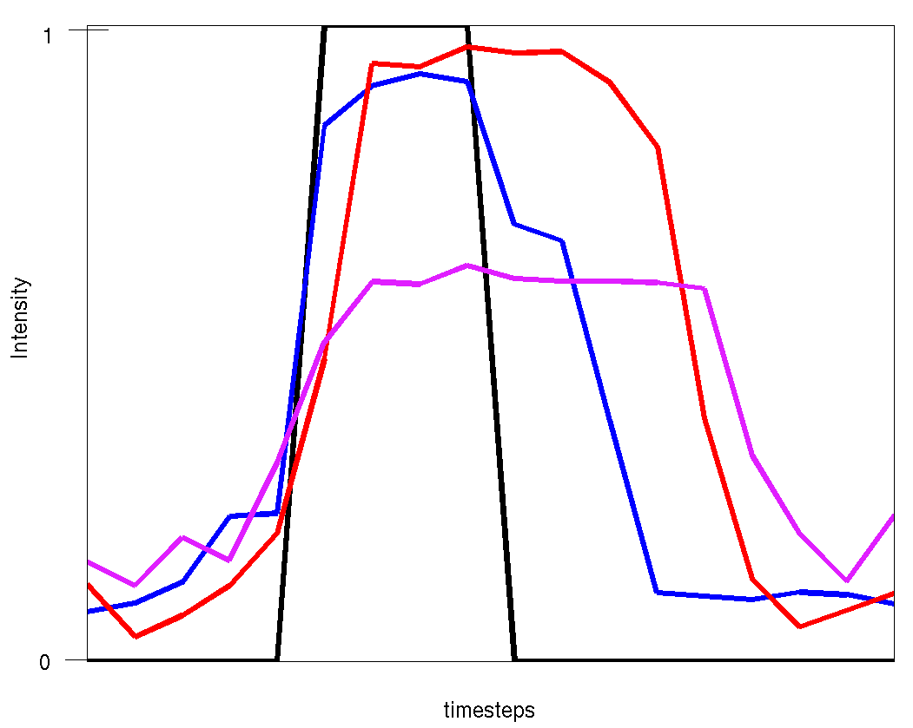
All the PFC modules shared the same time window with the cue-selective units, becoming active when a percept is registered at the ST stage. The PFC units were not in lock step with the ST units, but had a time window roughly between the time windows of Aii and ST (this was necessary because the PFC units have feedback connections to both Aii and ST modules).
Figure 2: Temporal Window of Integration of a unit from each stage. Black=MGN, Blue=Ai, Red=Aii, Purple=STG/STS.

3.2 Other Parameters

Some general observations concerning the choice of parameter values for the model are:
- For all of the excitatory elements except those of the ST and R elements, the values of timing parameters, Δ and δ, needed to be of equal value for the units to display the maximum magnitude of excitation. This is necessary in the initial regions of the model to transfer activity to the later stages.
- For all nodes except those of inhibitory Ai up/down selective elements, the value of δ needed to be greater than or equal to Δ. If δ (decay rate parameter) is less than Δ (activation rate parameter) the units either become unstable or saturated, and in both cases do not return to the baseline resting value.
- The value of the excitatory K (gain of the sigmoidal equation) was generally less than or equal to half the value of the inhibitory K.
Some specific observations concerning particular nodes are:
- Excitatory Ai up/down selective elements: As Δ and δ increased in value, the unit activations decreased in magnitude and the temporal window of integration became narrower.
- Inhibitory Aii up/down selective elements: If δ equaled 2.0, every unit in the node became unstable. Unit activations began showing a widening of the temporal window of integration when Δ became just less than half the value of δ. However, the widest temporal window of integration occurred when Δ was small and δ was large.
- Excitatory Aii contour selective elements: This node was extremely sensitive to a change in the value of threshold τ. For example, if Δ=2, δ=2, and τ=0.35, only the unit corresponding to the precise contour (junction of upward and downward sweep) of the stimulus was activated. Because we needed a larger temporal window of integration that would allow the units to respond to slightly separated upward and downward sweeps, τ was decreased to 0.34.
- Inhibitory Aii contour selective elements, inhibitory ST elements: Varying the values of Δ and δ resulted in very minor changes in unit activation responses.
- Excitatory ST elements: The appropriate units showed optimum responses when Δ was equal to two-thirds the value of δ. As the values of Δ and δ increased, the units displayed more noise.
- Excitatory C elements: The optimum unit activations at this node only required that Δ=δ, but to yield the correct match/non-match response from the Excitatory R elements, Δ and δ needed to be 0.5 (the other value that was tested was 1.0).
- Excitatory R elements: This node was extremely sensitive to the ratio of Δ to δ and to the value of τ. Appropriate activations occurred when the value of Δ was eighty to ninety percent of the value of δ. A change in the value of τ by 0.01 resulted in significant changes in unit activation responses.

4 Conclusion
In summary, the parameter space governing the electrophysiological aspects of an auditory model was explored and optimized to produce electrophysiological responses in each region of the model that resembled those recorded in experimental electrophysiological studies. Varying the parameter values of the sigmoidal activation equations affected the temporal window of integration of the basic unit activations in each region of the model, which in turn determined the electrophysiological response of each region of the model. Under the current set of parameter values, the model shows an appropriate widening in the temporal window of integration as activity progresses through to higher stages. We found that the model was sensitive to variations in some parameters, while it was relatively insensitive to other parameter choices. This sensitivity for certain parameter choices reflects the specificity evolution has imposed upon human cognitive processes. In a separate paper [6] we detail how we verified the simulated hemodynamic-metabolic aspects of the model against experimental data. This auditory model provides a way to better understand and interpret human brain imaging data as well as make predictions about the neural and synaptic behavior of the auditory system in the brain.

Acknowledgements:-Supported by the NIH-NIDCD Intramural Program.

Table 1: Parameter Values
 | Units | Δ | δ | K | τ | N(t)
Excitatory Elements | Ai up/down | 0.7 | 0.7 | 8.0 | 0.30 | 0.05
Excitatory Elements | Aii up/down | 1.7 | 1.7 | 9.0 | 0.35 | 0.10
Excitatory Elements | Aii contour | 1.3 | 1.3 | 8.0 | 0.34 | 0.10
Excitatory Elements | ST | 0.8 | 1.2 | 7.5 | 0.35 | 0.10
Excitatory Elements | C | 0.5 | 0.5 | 9.0 | 0.30 | 0.05
Excitatory Elements | D1 | 0.5 | 0.5 | 9.0 | 0.30 | 0.05
Excitatory Elements | D2 | 0.5 | 0.5 | 9.0 | 0.30 | 0.05
Excitatory Elements | R | 0.89 | 1.0 | 9.0 | 0.30 | 0.05
Inhibitory Elements | Ai up/down | 2.0 | 1.0 | 17.0 | 0.20 | 0.05
Inhibitory Elements | Aii up/down | 0.2 | 1.6 | 18.0 | 0.35 | 0.10
Inhibitory Elements | Aii contour | 0.2 | 0.8 | 17.0 | 0.30 | 0.10
Inhibitory Elements | ST | 1.0 | 1.0 | 19.0 | 0.30 | 0.10
Inhibitory Elements | C | 0.5 | 0.5 | 20.0 | 0.10 | 0.05
Inhibitory Elements | D1 | 0.5 | 0.5 | 20.0 | 0.10 | 0.05
Inhibitory Elements | D2 | 0.5 | 0.5 | 20.0 | 0.10 | 0.05
Inhibitory Elements | R | 0.5 | 0.5 | 20.0 | 0.10 | 0.05

Reference:-
1. Jueptner, M. and C. Weiller, Does measurement of regional cerebral blood flow reflect synaptic activity? -- Implications for PET and fMRI. NeuroImage, 1995. 2: pp. 148-156.
2. Logothetis, N.K., et al., Neurophysiological investigation of the basis of the fMRI signal. Nature, 2001. 412(6843): pp. 150-7.
3. Arbib, M.A., et al., Synthetic PET: Analyzing large-scale properties of neural networks. Human Brain Mapp., 1995. 2: pp. 225-233.
4. Tagamets, M.A. and B. Horwitz, Integrating electrophysiological and anatomical experimental data to create a large-scale model that simulates a delayed match-to-sample human brain imaging study. Cereb Cortex, 1998. 8(4): pp. 310-20.
5. Horwitz, B., M.A. Tagamets, and A.R. McIntosh, Neural modeling, functional brain imaging, and cognition. Trends Cogn Sci, 1999. 3(3): pp. 91-98.
6. Husain, F.T., et al., Relating neuronal dynamics for auditory object processing to neuroimaging activity: a computational modeling and an fMRI study. Neuroimage, 2004. 21(4): pp. 1701-20.
7. Kubovy, M. and D. Van Valkenburg, Auditory and visual objects. Cognition, 2001. 80(1-2): pp. 97-126.
8. Douglas, R.J., et al., Recurrent excitation in neocortical circuits. Science, 1995. 269(5226): pp. 981-5.
9. Shamma, S.A., et al., Organization of response areas in ferret primary auditory cortex. J Neurophysiol, 1993. 69(2): pp. 367-83.
10. Rauschecker, J.P., Processing of complex sounds in the auditory cortex of cat, monkey, and man. Acta Otolaryngol Suppl, 1997. 532: pp. 34-8.
11. Rauschecker, J.P., Parallel processing in the auditory cortex of primates. Audiol Neurootol, 1998. 3(2-3): pp. 86-103.
12. Bieser, A., Processing of twitter-call fundamental frequencies in insula and auditory cortex of squirrel monkeys. Exp Brain Res, 1998. 122(2): pp. 139-48.
13. Funahashi, S., C.J. Bruce, and P.S. Goldman-Rakic, Visuospatial coding in primate prefrontal neurons revealed by oculomotor paradigms. J Neurophysiol, 1990. 63(4): pp. 814-31.
14. Romanski, L.M. and P.S. Goldman-Rakic, An auditory domain in primate prefrontal cortex. Nat Neurosci, 2002. 5(1): pp. 15-6.
15. Harrison, R.V., et al., Local haemodynamic changes associated with neural activity in auditory cortex. Acta Otolaryngol, 2000. 120(2): pp. 255-8.

