Commercialising Reading Materials using Internet and Mobile Technology in Malaysia Environment

SITI HAFIZAH AB HAMID & YANG MEI LIN
Department of Software Engineering
University of Malaya
50630 Kuala Lumpur
MALAYSIA

Abstract: The number of Malaysia Internet user and mobile telecommunication is increasing every year. This gives a big impact to any organization either in government or private sector in their daily activities and businesses. This scenario effects to e-commerce in Malaysia as well. Besides web-based technology, dot com company can incorporate WAP technology to their business.

Key-Words: e-commerce, m-commerce, reading materials

Introduction
With the tremendous growth of the Internet, businesses are beginning to find new ways to expand their opportunities. Approximately 300 million people worldwide have now access to the Internet. The astonishing growth of the Internet, has led to a critical mass of consumers and companies participating in a global on-line marketplace. Business owners around the world are increasingly turning to the Internet to increase their efficiency and profitability. A large number of companies have come to the Net to maintain an electronic presence, market products, generate sales leads, provide customer support and open up electronic stores that can be accessed by the Internet users.
The number of Malaysian Internet users [19] is increasing from 4.8 in 2002 to 5.7 in 2003. By 2006, the percentage of Internet users is expected to increase up to 27 percent. This is because of the government target that by year 2020 at least 70% of Malaysians are computer literate (including Internet). Many things have done to encourage the usage; for example, purchasing items, paying bills and summons, and checking tax through Internet. In fact, more and more local banks are introducing electronic banking. All of these give a major impact to the growth of e-commerce in the country. People find it very convenient and save a lot of time.
In Malaysia [18] the mobile telecommunication was introduced in 1986. The growth of cellular service was tremendous and it reached the level of 3.2 million customers within this 14-year period. By the introduction of WAP technology in Malaysia by Celcom, Maxis, and Time it has opened another marketing channel to deliver product and services to the customers.

Objectives
The system is a combination of e-commerce and m-commerce applications. It provides the opportunities for the marketing of reading materials such as books, magazines and newspapers. It enables everyone to browse through the catalogues. However, only those who have registered as members (owns user names and passwords) are able to make purchase orders or view order status. The objectives of ECMC project are:
1. To provide easy and wide accessibility to the system through Internet accessed devices such as computer, PDA or hand phone user.
2. To increase convenience of using the system without being restricted by time and location.
3. To increase the efficiency by minimizing the time needed to perform a transaction such as making a purchase order and checking an order status.
4. To provide appropriate access control for users and the system administrator and enable them to update personal information and change passwords.
5. To enhance the management of the system administrator by providing the functions such as generating reports which shows the statistics of the purchase orders within a period as well as updating the catalogue information displayed on the interface by making changes on the database. Any knowledge in programming languages or changes on the source code is not required from the system administrator.

Scope
This project is a B2C development of a client/server system. It is divided into 2 categories, the normal user module and system administrator module with appropriate access control for different types of users. The normal users are restricted from entering into the system administrator's module. It is developed for commerce marketing within west Malaysia.
Both normal user module and system administrator module will be developed in e-commerce application. However, the m-commerce application will only contains some parts of the user module, which enables users to make purchase orders, check order status, change personal information and passwords. The new user registration will not be included in the m-commerce application development due to the limitation of screen seize and difficulties entering too much information by using PDA or hand phone.
The normal user module is accessible by an individual who has registered to become a member. This module enables users to browse through the product catalogue, register as members, check order status, change personal information and passwords as well as search for help.
While the administrator module is a complete module in which only the system administrator with an appropriate password is able to access the system. It includes all functions in user side menu. In additional, it also allows the system administrator to update or delete books, magazines, catalogue information and purchase status. It also enables the system to generate reports, insert new catalogue item and to access database.
The payment information and security features will not be included in the development. Besides, the system only allows one system administration to monitor the information. Any registration for other administrator is not available.
The product category is divided into three main parts: books, magazines and newspapers. Emphasis will be given to books and newspapers produced in foreign countries while only the local newspaper will be sold.

Overview of E-Commerce
According to Trepper, e-commerce is simply any business transaction that takes place via digital processes over a network. It is important in transforming the way products, services, and even information are bought, sold, and exchanged. E-commerce also changes the way organizations interact with customers and business partners. While according to Rajput, W. E , besides normal business transactions, e-commerce is also to establish the means to sell, establish incentives to sell, and collaborate with staff, partners, and customers through electronic channels in an interactive and non-interactive fashion.
Since the business transaction is using internet all the time, some people [8] prefer i-commerce that suits the main channel of the transaction. In its broadest sense, e-commerce refers to the use of electronic means and technologies to conduct commerce between following interactions:
- Business-to-Business (B2B)
- Business-to-Consumer (B2C)
- Business-within-Business (Intra-Company)

Business-to-Business (B2B)
The Internet can connect all businesses to each other, regardless of their location or position in the supply chain. This ability presents a huge threat to traditional intermediaries like wholesalers and brokers. Internet connections facilitate businesses to bargain directly with a range of suppliers, thereby eliminating the need for such intermediaries. An example in this category would be a company that uses a network for ordering from its suppliers, receiving invoices and making payments. This category of e-commerce has been well established for several years, over private or Value-Added Networks (VANs).
Business-to-business (B2B) e-commerce is the catalyst behind the rise of the extranet, an intranet whose boundaries extend beyond internal corporate users to include external business partners, such as customers and vendors.

Business-to-Consumer (B2C)
The business-to-consumer (B2C) e-commerce is focused on the use of a virtual storefront on the World Wide Web that allows an Internet user to browse and order goods or services from the storefront's online catalogue. This category largely equates to electronic retailing. It is clearly modeled on the real-world shopping experience, with "carts" (order forms) to drop your goods into and "checkouts" (payment processing) to settle your bill with a credit card. There are now shopping malls all over the Internet offering all kinds of consumer goods, from sweets and cakes to computers and cars.
An example of a company that has leveraged the power of Internet interactivity to revolutionize customer relationships is Firefly. Firefly is creating a custom product for each of its customers, based on the customer's profile and buying behavior.

Business-within-Business (Intra- Company)
Companies worldwide are embracing the application of web-based technology to improve and transform internal business communications and processes. The business-within-business e-commerce takes the intranet beyond its popular role as a corporate and product information center. Here, the e-commerce is strictly intra-company and payment processing is not an issue. The transfer of funds is purely an accounting transaction via a charge back or an inter-company billing, rather than a true payment where details of a credit card or bank account are being passed over the Internet.
In this scenario the intranet becomes a service center for the exchange of goods and services among the subsidiaries of a large company. This is a significant new market opportunity for existing and startup e-commerce application vendors to exploit.

Overview of M-Commerce
The m-Commerce unit produces value-added services for mobile phones. In Finland, Jippii Group [11] began offering value added services for mobile phones in October 1999. The first products to be launched were logos and ring tones that can be ordered with a mobile phone using SMS, and that are used to personalize your phone. This was immediately successful and so the product range was expanded to provide other SMS based information and entertainment services. The m-Commerce unit was formed in August 2000 to support the internationalization of Jippii and constantly provide customers with new information and entertainment services based on current and future phone technology.
M-Commerce [12] has been defined as the use of mobile handheld devices to communicate text and data via connection to public or private networks. Organizations across the world are realizing the compelling advantages created by emerging mobile technologies. Typical uses for mobile devices include stock quotes, instant driving directions (GPS), wireless financial transactions, and access to mobile enabled web sites. These are some of the everyday activities that will be forever changed by mobile technology. Many more applications are in the works as well. Literally, there are millions of tasks, operations, and applications where the influence and use of mobile technology make practical sense. These tasks are as simple a time clock applications or as complex as delivery logistics.
These technologies hold great promise for businesses and consumers alike. Some consumers are already doing mobile window-shopping. For example, lets say you are in the retail business and sell clothing. If you have an m-Commerce enabled site, a potential customer can be shopping at the mall, see an item they are interested in buying, submit a query to your site and compare prices. If you have the better price, the consumer may even purchase the article from you on the spot. M-Commerce will be a major revenue stream for many companies in the near future. The technology is still evolving, bandwidth is limited, screen size is limited, and security is still issues that have yet to be completely worked out [9].

Online Reading Material
Currently, amazon.com is one of the most popular online stores in Malaysia. Even though the dot com company is from United States, the service it has given to Malaysian in under satisfactory. However, most of the customers are who earned more than MYR3000 per month. This is because of the highly currency rate between USD and MYR. Because of that reason, a lot of dot com companies develop an e-commerce system to facilitate Malaysian consumers in purchasing items. However, most of these companies developed an online bookstore, which they not sell other reading materials except book. Arthurs.com is one of the most popular online bookstores and the first one in Malaysia. It has a good purchasing process. However, it does not recommend any current popular books or the bestseller ones.
Since, Malaysian is very aware of using credit card over Internet, some of the online bookstores use other method in payment such as cheque, postal order, telegraphic transfer, and demand draft [13][15]. Even though, these methods means secure (for some people), credit card still the best way of doing payment in e-commerce. In fact, a lot of improvements have been done in e-commerce security. Even so, the developer of the online bookstore has to consider about the verification and validation of the purchasing process. If not, they will face with invalid data [17].
Some of the online bookstores provide a lot of and good information of the books they are selling [13][14][16][17]. Yet, the online bookstore limited to certain publishers [15]. This gives a very limited option to consumer, unless the consumer is really looking at the particular publisher.

Database Design
An entity relationship diagram is used to model the logical aspect of the system. The E-R diagram shows all the entities and the relationship among them. Figure 1 is the database design.

Implementation
The user interfaces are design to improve the efficiency and effectiveness of users when using the entire system. Thus, the interface will be designed as attractive as possible in order to convince the customers to visit it and purchase the product of the catalogue. The interface is divided into two, which are for Internet user and for mobile user. The Internet-based has two types of end-user, which are customer and administrator. The customer can buy the product by registering the system first and the administrator can update the product. However, the WAP-based only has one end-user, which is customer. This is due to ensuring of database security. Figure 2 is the main page of Internet system and Figure 3 is the main page of mobile system.
The hardware development requirements used in developing the system are Intel Pentium 4 CPU, 120Mb RAM, D-Link DWL-650 11 Mbps WLAN Adapter, and 13 Gb of hard drive capacity. While software development tools are PHP (server side scripting), JavaScript (client side scripting), MySQL (web database), Apache web server, HTML for web front end development, WML (WAP development script), M3 Gate (WAP Browser), SWiSH (animation generator), and Microsoft Front Page as the design interface tool.
Basic testing has been done to ensure the system works as stated in requirements. The testing strategies that have been used are unit testing, integrated testing, and system testing. All these are concentrated on implementation part of both web-based and WAP-based system. Any errors or problems faced during testing level can be solved easily by using those advanced tools and software.
Acceptance testing also has been conducted to look at the end-users’ response over the technology especially WAP. The respondents are divided into three, which are public customers who prefer e-commerce facility, newspaper vendors, and administrators who work as technical staff. Most of public customers age between 25 until 35. They use Internet everyday whether for work or leisure purposes. Most of them (90%) feel e-commerce is very convenient and had used it more than twice. Majority of them think the system is very good since they are no such service in Malaysia. It cut a lot of time in purchasing the material and they can get overview of the material before buying it. However, these end-users mostly come from the capital city. About 61% of public customers who come from rural area still not prefer the service due to security issue. But, the other 39% of them have a very good reason to like the service which is they do not have to go to town to buy the material and they do not have to worry to miss any issue. The second end-user is vendor. This busy end-user can use PDA or mobile phone to check their status order, especially. They are two types of vendor, which are small-scale vendor and medium/large scale vendor. Obviously, medium/large scale vendor likes this service to ease their daily business routine, but for small-scale vendor, they think it is quite expensive to buy the device. However, most of them like the system. 95% of administrators find the admin module is good in maintaining the system.

Fig.1: Database Design
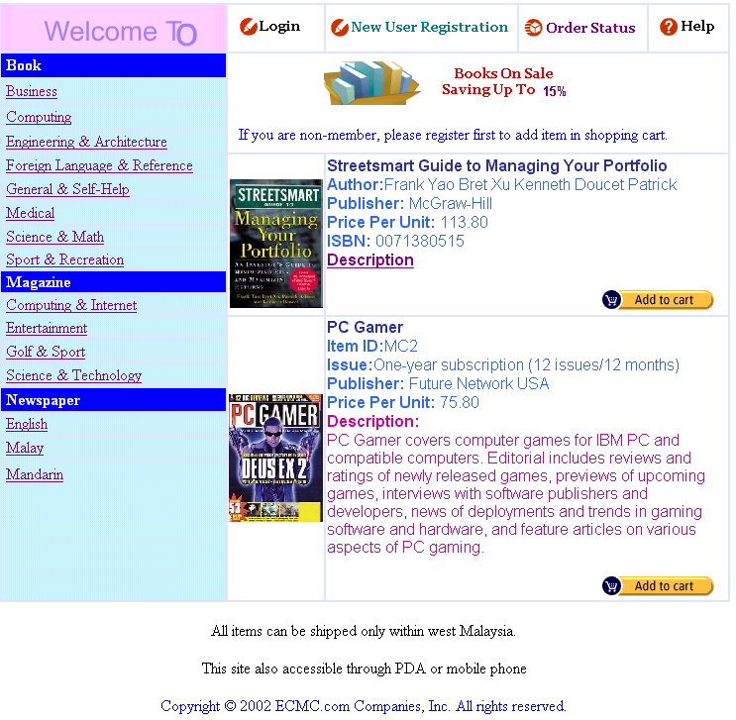

Fig.2 : Web-Based Homepage

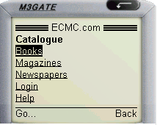

Fig.3 : Mobile Homepage

Future Enhancement & Conclusion
This paper proposed an integrated technology of e-commerce system by using web-based and WAP-based technology. The system gives option of methods to end-user in purchasing reading materials since the number of technology users is increasing rapidly every year. This system can be enhanced by adding searching function where it can help users to find the reading material they need in a better and faster way. At this moment, the number and variety of reading material is limited and displayed through hyperlink linking. The searching function may be useful to the system when the number and variety of reading material are increasing. Besides, at the moment, ECMC system does not implementing any payment system. In real environment, the credit card payment system is the most complicated part of the system. A greater amount of security can be implemented in ECMC system by enforcing SET and SSL technologies. By employing these technologies, customer identification can be recognized by the banking system and therefore online payment can be made. Hence, reduce the possibility of fraud. Besides, customer payment information can be guaranteed safe and will not be intercepted by other unauthorized party since encryption technique is provided by SSL and SET technologies. And, it is recommended to the system to perform encryption of passwords in the database to enhance the data confidentiality. Moreover, a function should be set up to retrieve the password if any user forgets it.

References:
- The McGrawHill Company. (2002). “McGrawHill Education About Us”. http:// www. asia- mcgraw- hill.com. sg/ about/ history.html.
- Popular Holdings Limited. (2001). “Scaling Our Brand Extending Our Reach”. http://www.popularworld.com/.
- New Straits Time Press(Malaysia) Bhd. (2002). “About Us”. http://adtimes. nstp. com. my/ aboutus.htm.
- Nanyang Press Holdings Berhad. (2003). “Nanyang Press Holdings Berhad”. http://www.klse.com.my/website/listing/lc/nanyang.htm.
- Kumpulan Karangkraf Sdn. Bhd. (2002). “Informasi”. http://www.karangkraf.com. my/ Informasi/.
- Chip Computer Comunication (2002). “About us”. http://www.chipmagazines. com/ aboutus.html#magazine.
- Rajput, W.E. (2000). “E-Commerce Systems Architecture and Applications”. Artech House. ISBN:1580530850.
- Straight-On Internet Consulting LLC. (2001). “E-commerce Definition”. http://www.straight-on.com/.
- Khalil Ahmed. (2000). “E-Commerce: Concepts, Benefits And Technologies”. http://www.iepsac.org/papers/p07a.htm.
- Treper, C. (2000). “E-Commerce Strategies”. Microsoft Press Copyright.
- Jippii Group Oyj. (2002). “M-Commerce”. http://www.jippiigroup. com/m-com.shtml.
- Sadeh, Normah. (2002). “ M-Commerce: Technologies, Services, and Business Models”. John Wiley & Sons.
- www.jahabersa.com.my
- www.arthurs.com
- www.pelangi.com
- www.vis.com.my
- www.buku.freeservers.com
- Khatibi, A & Thyagarajan, V. (2001). “WAP as marketing strategy in Malaysia-an assessment”. IEEE Proceedings of International Conference on Management of Engineering and Technology. Volume I, pp. 508.
- Berita Harian. “Bilangan pengguna internet Malaysia 5.7 juta”. Newspaper: Berita Harian. 12 May, 2003.

