Passive Navigation System Using Fixed Position Beacons for Domestic Applications

M.H. POLATOGLOU and O.R. HINTON
Department of Electrical Electronic and Computing Engineering
University of Newcastle upon Tyne
NE1 7RU Newcastle upon Tyne
UNITED KINGDOM

Abstract: Mobile robots are very interesting in a host of applications, including domestic and industrial ones. One of the key issues is the determination of their position in a complex and noisy environment. In the present work we deal with the design and prototype construction of an efficient fixed-position beacon positioning system. This system is capable of calculating its position using ultrasonic sound-waves, and has a very good accuracy for domestic home and office applications. The power consumption and computational power requirements are minimal due to the use of appropriate electronics and algorithms, thus our solution is also an energy efficient one.

Key-Words: robotics, positioning system, triangulation – trilateration, path finding.

1 Introduction
Robot positioning, or the process of a robot finding its position in the environment, is a major concern in mobile robot navigation. This process is furthermore crucial in domestic or industrial robots since most of the robot’s operations are related to its position. This position must be acquired easily and repeatedly.
Over the past years many methods of positioning and navigation were formed and applied based every time on the kind of the application. However two are the basic ways of positioning: relative and absolute positioning. Relative positioning is usually based on dead reckoning i.e. monitoring wheel revolutions to compute the offset from a known starting position. Absolute positioning relies on navigation beacons, active or passive, landmarks, map matching, or satellite based navigation signals [1].
Absolute positioning is also divided in triangulation and trilateration. In triangulation, position is calculated by measuring the angles at witch the robot ‘sees’ the fixed position beacons [2]. In trilateration position is calculated by measuring the distances from the fixed position beacons to the robot [3].
Relative positioning, while being the easiest and fastest to complete, has a serious problem of accumulation of errors. This means that errors are summed up and after several measurements position diverges considerably. Also whereas absolute positioning is applied and the robot is active, problems occur when considering multiple robots acquiring their position from the same beacons.
Positioning within small areas, such as a house room or an industrial place is a very important issue of robotics as well as a brand new dimension of what we consider positioning nowadays. The interesting part in this case is that in small distances, RF signals travel instantaneously (compared to the accuracy that a small microcontroller can achieve), so the solution of systems such as the GPS is impossible. The most common solution to that problem is to utilize ultrasonic sound waves, since the speed of the sound is much smaller compared to electromagnetic radiation.
Our initial goal was to design and construct a prototype passive positioning and navigation system together with its protocol such as to be mounted on domestic robots, and moreover our case was focused on autonomous mobile electric appliances, able to monitor their course and calculate repeatedly and accurately their position.
2 Method
The solution we developed consists of four different stages. First we had to decide the mathematical approach to the objective: absolute or relative positioning. Then we had to develop a protocol, which the hardware and software would follow in order to achieve positioning, then the hardware had to be designed, according to the necessities of the mathematical approach and the protocol. Last but not least, we had to design and implement the relevant software, able to use the hardware built according to the protocol, in order to calculate and output the position to the user or robot.
As for the mathematic approach of solving the problem we decided to use an absolute positioning algorithm, since it may be more complex than relative positioning but certainly can achieve better accuracy. As for trilateration or triangulation, trilateration is easier to implement in a small microcontroller that does not support trigonometric functions (a simple layout of the system is shown in Figure 1).
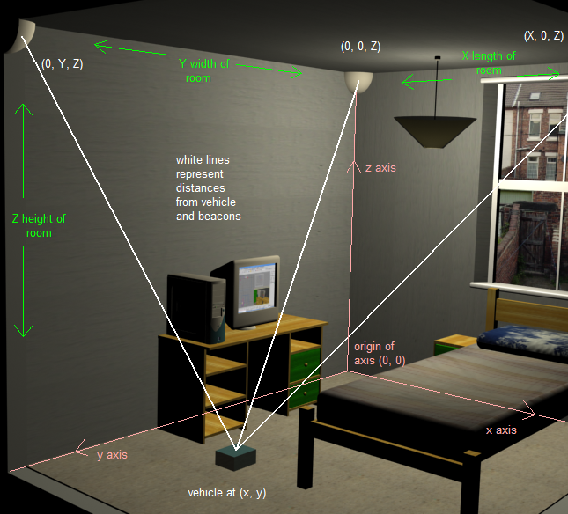
The protocol is probably the most crucial stage of the solution because all the definitions of how the system works and how beacons and the positioning unit should interact are decided here. Moreover the protocol provides a basic kind of error prevention system.
The system consists of three stationary fixed-position active navigation beacons placed in three out of four corners of a room. The first one will be placed at the start of the two axis (0, 0), the other one at (X, 0) and the last one at (0, Y) where X and Y represent the two dimensions of the room in a 2D plane (height is not considered at this time). One of the three beacons is called the ‘master’ beacon and it will undertake the task to synchronise the other two beacons, which will act as ‘slaves’. At this point only the ‘master’ beacon has the ability to transmit while the other two ‘slaves’ need permission from the ‘master’. The master beacon is equipped with an AM together with the ultrasonic transmitter array, while the two slaves have an AM receiver both (and the ultrasonic transmitter array). An AM receiver is also placed in the vehicle. The vehicle has an array of ultrasonic receivers, which is directly connected on an amplifier and a detector that can detect the ultrasonic signal after it is being amplified. When every circuit is switched on and has executed its initialization sequence, all of them await for the master beacon to transmit. The master beacon is the one to signal the beginning of each measurement circle. By the term measurement circle, a complete set of measuring the distances from all three beacons from the vehicle is meant. When the master beacon transmits its first burst of ultrasonic, along it transmits an AM signal, which lasts for the whole measurement circle. When this AM signal is picked up by the vehicle, a timer is activated and counts up until the ultrasonic signal from the first beacon is received. Also the two other beacons receive the AM signal, and they wait for one third of the measurement circle and two thirds of the measurement circle duration respectively to transmit their burst. The vehicle then records the time that it took for each ultrasonic burst to travel from each beacon to the vehicle and that way it is able to determine its distance from each beacon. Using then appropriate algorithm, it can calculate its position.
Figure 1: General layout of the positioning system
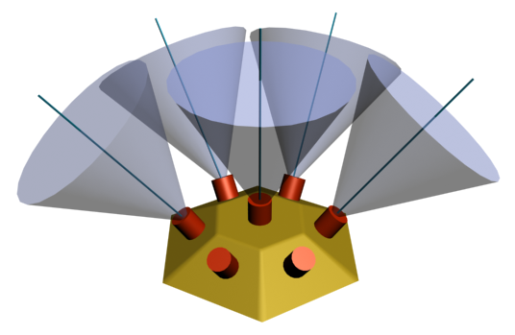
2.1 The hardware
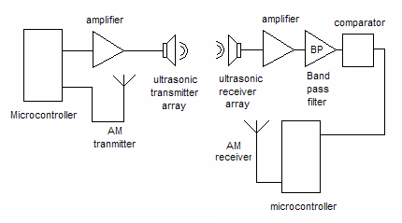
The hardware consists of two basic units: the beacons (which are fixed position), and the receiver which is mobile. The main part of the beacon is an 8bit low power microcontroller from ATMEL, the AT90LS2323 [4]. The microcontroller undertakes the task to produce the burst of ultrasonic pulses (10 pulses of 40 kHz) and send them for amplification. The amplifier boosts the peek to peek voltage of the pulse from 5 V_{P-P} to 24 V_{P-P} so it will be able to sustain the attenuation of the air and still be detectable from the receiver.
Figure 3: Ultrasonic receiver array
The ultrasonic signal, received with the reception sensor array is amplified by a cascaded amplifier which consists of two operational amplifiers (total practical gain of 200). The output is then fed to the comparator. This part consists of the circuit, which detects the ultrasonic waves returned from the measurement object. The output of the detection circuit is detected using the comparator. Using suitable resistor values we set the comparator to detect signals of more than 0.11 V.

2.2 Transmission and reception ultrasonic array
One of the most difficult parts of the project was to design the ultrasonic receiving and transmitting unit. Due to the fact that a single ultrasonic transducer had less than 60 degrees transmitting / receiving envelope, it was necessary to design an array of these transducers in order to achieve 180 degrees for the receiver – since it practically needed to scan everything above the surface where it was located – and 90 degrees for the transmitter. The solution we developed was to distribute the signal in 5 transmitters for the transmitter and 7 receivers for the receiver module. Since ultrasonic transducers are resonators and use crystals, they only require high voltage to operate so the configuration in parallel of the transducers had no effect on the performance of the system, while increasing the transmission and reception envelope to the desired values. Figure 3 shows the configuration of the ultrasonic transducers in the reception array.
Figure 2: Transmitter / Receiver block diagram
The blue transparent cones represent the reception area of each transducer (missing in the front 2 transducers for clarity). It is obvious that using this configuration we can achieve a reception angle of 180 degrees using 7 transducers of 60 degrees reception angle each.

2.3 Software
The final link between the hardware and protocol described above is the software of the system. The ATMEL AT90S8515 microcontroller was chosen as the CPU of the prototype. This is a powerful RISC 8-bit, 32 pins I/O microcontroller capable of running

at frequencies up to 10 MHz normal and 25 MHz over-clocked and deliver a processing power of 10 MIPS at 10 MHz. Its use in the circuit will be to measure the time delays from the three active beacons, then calculate the distance from the three beacons with the method described above, and calculate its position using an algorithm that will be described below.
Since our microcontroller is not so powerful to solve directly the positioning problem using analytic geometry on the Cartesian plane, it is necessary to simplify the load on the CPU while keeping high accuracy for the calculations. Normally to calculate the position we needed to calculate the intersection point of the tree circles that use as their centre each of beacons and radius the distance between the beacon and the system respectively. To simplify that, we consider the circles to consist only on few points instead of infinite (refer to Figure 4 for the general idea).
There are two ways to express a circle equation on a plane:

x² + y² = r² (1)
or
x = r cos θ and y = r sin θ (2)

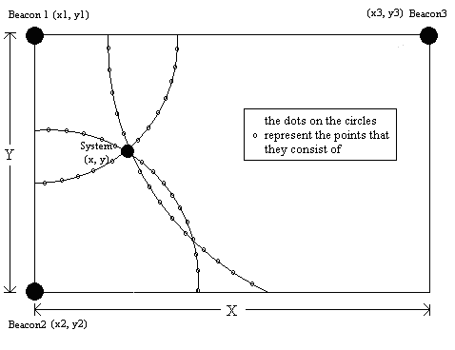
where r is the radius of the circle and θ is an angle between 0 and 360 deg.
The number of points that define the circle is proportion to the accuracy that we need to achieve, but since there is also the hardware limitation in the accuracy of the system (produced mostly by lack of accuracy of measurements of distances); we have to choose a number of points close to the hardware accuracy. Solving the trilateration algorithm now is now done using the simplified circles, consisting of only 40 points per quadrant, which proved to be effective in the areas of accuracy and simplicity.
The practical solution for the position would be to get all three circle equations, where r₁, r₂, r₃ are the distances from the three beacons respectively, and solve the three equations:
x₁² + y₁² = r₁² (3)
x₂² + y₂² = r₂² (4)
x₃² + y₃² = r₃² (5)

and since we know from the definition of the system in Figure 1 and Figure 2, x₁ = 0, y₁ = 0, x₂ = 0, y₂ = Y, x₃ = X, y₃ = 0, where X, Y are the length and width of the room, we can find the cross-point of the three circles which would be the position of the robot.
Figure 4: Schematic representation of the algorithmic solution
In the simplified version that we implemented into the microcontroller, we consider the trigonometric equation of the circle (equation 2). To define the circle using this trigonometric functions we need the values of either sin θ or cos θ for θ between 0 and 90 degrees. And considering 40 points per quadrant, we needed to store a table of 40 cosines of angles in the microcontroller, and then calculate the closest angle at which each beacon registers the robot, in order to calculate the position. The algorithm compares and finds the closest cross-point of the three beacons two by two so there are three total comparisons per measurement circle. If one of the distance measurements fails (due to lost signal, wrong reading) the system has the ability to neglect it and still calculate the correct position if it has any two correct readings.
3 Results
The prototype was tested in two ways. First we simulated the distance measurements fed into the main CPU to actually determine the algorithm’s accuracy, and then we tested the system in a realistic environment, using the normal readings of distance produced by the real sensors. The error margin of the system was always less than 2.5 cm. The only drawback we encountered was the inability of the system to calculate the position accurately when it was too close to the walls because of the limitation of the software in accuracy when the angle of the beacon to the system is really small.

4 Conclusions
We have developed a domestic robot positioning system, which uses ultrasonic and RF signals simultaneously to calculate the position of the robot. With a simple protocol, suitable receiver and transmitter array antenna design, and an appropriate algorithm an energy efficient and accurate prototype is constructed and tested in a realistic environment. However further capabilities can be added to the system, such as using interior maps stored in the vehicle’s memory in order to avoid walls, or recording the raw data of position of robot in an internal memory of the vehicle and then export them to be used for statistical analysis.

References:
[1] A new Home Robot Positioning System (HRPS) using IR switched multi ultrasonic sensors by Saeed Shiry Ghidary, Takahiro Tani, Toshi Takamori, Motofumi Hattori Dept. of computer and systems engineering, Faculty of Engineering, Kobe University, 657-8501, Japan, 1999.
[2] A Beacon System for the Localization of Distributed Robotic Teams Luis E. Navarro-Serment, Christiaan J.J. Paredis, and Pradeep K. Khosla The Institute for Complex Engineered Systems, The Robotics Institute, and Department of Electrical and Computer Engineering Carnegie Mellon University Pittsburgh, Pennsylvania 15213-3890.
[3] Where am I? Sensors and Methods for Mobile Robot Positioning by J. Borenstein, H. R. Everett , and L. Feng Contributing authors: S. W. Lee and R. H. Byrne by the University of Michigan, 1996.
[4] Programming and Customizing the AVR microcontroller Dhananjay V. Gadre, McGraw – Hill/TAB Electronics, 2001
[5] Mobile robot localization using a single rotating sonar and two passive cylindrical beacons - H.R. Beom and H.S.Cho, Robotica, 1995, volume 13, pp. 243-252, Cambridge university press.
[6] Navigating Mobile Robots: Sensors and Techniques, Borenstein, J., Everett, H. R., and Feng, L., Wellesley, MA: A. K. Peters, Ltd., 1996.

