A Modified Theory for Rectangular Vertical Drop Structures

MEHDI AZHDARY MOGHADDAM
Civil Engineering. Department
University of Sistan & Baluchestan
Nikbakht Faculty of Engineering, Zahedan
IRAN

Abstract: Vertical drop structures, or free-overfalls, are a simple form of energy dissipator commonly employed in urban stormwater drainage channels and irrigation schemes where the local topography is steeply-sloping. Free-overfalls can also develop naturally in degrading alluvial channels at rock outcrops in the channel bed. Several theories described the hydraulics of rectangular vertical drop structures. These theories may be applied to estimate spillway energy loss when the flow on a stepped spillway conforms to a nappe-type flow regime. A modified theory is proposed which addresses certain limitations associated with some earlier theories. The modified relationships are verified based on experimental data.

Key-words: Vertical Drop Structures, Energy loss, stepped spillways, momentum

1 Introduction
Vertical drop structures, or free-overfalls, are a simple form of energy dissipator commonly employed in urban stormwater drainage channels and irrigation schemes where the local topography is steeply-sloping. Free-overfalls can also develop naturally in degrading alluvial channels at rock outcrops in the channel bed. The hydraulics of vertical drop structures has been studied by, among others: Moore (1943), White(1943), Rand (1955), Gill (1979), Chanson (1994), and Rajaratnam and Chamani (1995). The various theories developed by these researchers reflect the different assumptions made regarding the hydraulics of the system. Two types of flow regime can occur on a stepped spillway, namely: nappe-flow and skimming-flow regimes (Fig. 1).
For a nappe-type regime, the flow across a single spillway step can be considered as being equivalent to that for a freely-discharging vertical drop structure, (Fig. 2). Accordingly, in these circumstances stepped-spillway energy losses may be estimated using expressions developed for vertical drops. However, certain assumptions made in the development of earlier design relationships for vertical drop structures are considered suspect. Previous studies on the hydraulics of vertical drop structures include, among others, those of Moore (1943), White (1943), Rand (1955), Gill (1979), Chanson (1994), and Rajaratnam and Chamani (1995). Moore's (1943) laboratory study investigated the energy loss produced at the base of vertical drops, using two model structures of 0.15m- and 0.45m-height respectively. He established that energy loss was a function of the relative fall h/y_{c} , where h = height of drop, and y_{c} = critical depth. Moreover he observed that, under free-discharge conditions, the depth of water standing behind the falling jet, (i.e. the pool depth), yp was greater than the depth of water shooting from the base of the fall into the downstream channel, y₁ (Fig. 2).

Moore's expression for pool depth takes the form:

where
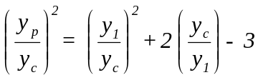 (1)
y_{p} = pool depth; and
y₁ = depth at section 1-1 (see Fig. 2).

In commenting on Moore's study, White (1943) made the following assumptions regarding the hydraulics of the system:
(i) the recirculating flow in the pool at the bottom of the drop was the same as the backwater flow;
(ii) the velocity of the supercritical stream immediately downstream of the drop was the same as the uniform velocity in the thicker stream at the side of the pool;
(iii) the angle of the falling jet was not affected by the presence of the pool;
- the energy loss at the drop was due to mixing between the jet and the pool; and
- the effect of the pool in calculating the velocity of jet, V, was neglected.

These assumptions were questioned by Moore and others, particularly in regards to items (ii) and (v). White's (1943) expression for energy at section 1-1 is:
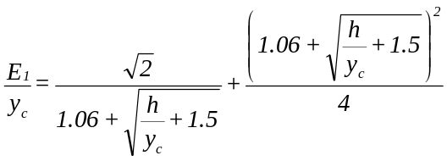
(2)
where
E₁ = energy at section 1-1.
Based on Moore's and his own experimental data, Rand (1955) developed the following relationships for vertical drops:

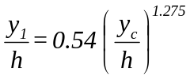 (3)
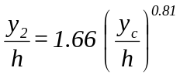 (4)
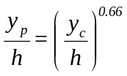 (5)
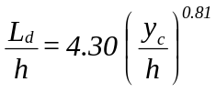 (6)
where
y₂ = conjugate depth (of y₁); and
L_{d} = distance from the wall to position y₁ , (Fig. 2).
Gill (1979) modified White's (1943) assumptions. He assumed that:
(i) uniform velocity occurs in the thinner layer below the pool;
(ii) velocity is not constant in the mixing zone;
(iii) the effect of the pool in the calculation of velocity is expressed as:
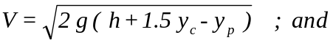
(iv) the effect of the pool in regards to energy loss is neglected.

Gill's relationships are:
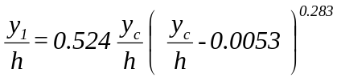 (7)

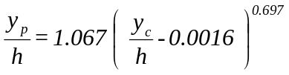 (8)
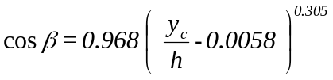 (9)
β = angle of jet where it impacts the bed.

While Gill addressed certain weaknesses in White's assumptions, assuming the pool immediately downstream of the drop would not affect energy loss was incorrect.
Chanson (1994), rather than using a momentum approach, used the trajectory equations of the nappe centreline to develop the following expressions:
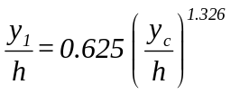 (10)
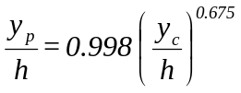 (11)
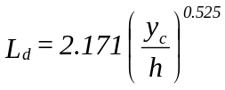 (12)
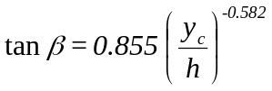 (13)
Rajaratnam and Chamani (1995) examined experimentally the energy loss produced at the base of a vertical drop structure. Their relationships take the form:
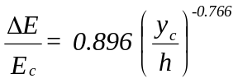 (14)
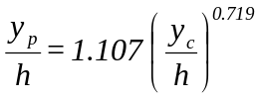 (15)
where
ΔE = energy loss across the drop (= E_{c}- E₁); where
E_{c} = ( h + 1.5 y_{c} ); and
E₁ = ( y₁ + V₁²/2g ).

2 Modified Theory
The following conditions are assumed regarding the vertical drop shown in Fig. 2:
(i) fluid shear on the downstream channel bed is negligible; and
(ii) the angles of the jet, where it impacts the pool and the channel bed, are the same.

Applying the momentum principle between sections 0-0 and 1-1 gives:
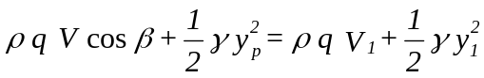 (16)
where
q = unit-width discharge;
γ = specific weight of water; and
ρ = mass density of water.

Critical depth, y_{c}, occurs a short distance upstream from the brink. Once again, applying the momentum principle between sections c-c and 0-0 gives:
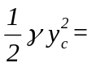 (17)
Assuming no energy loss occurs between sections c-c and 0-0, then
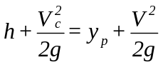 (18)
Now, critical velocity 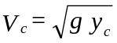18 therefore eq. (18) becomes:
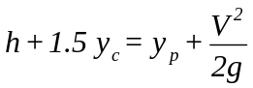 (19)
Applying the grid-search method to Moore's (1943), Rand's (1955), and Rajaratnam and Chamani's (1995) data produces the following relationship:
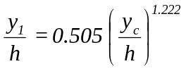 (20)
Solving eqs. (16), (17), (19), and (20) gives:
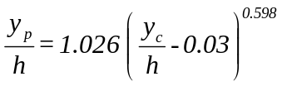 (21)

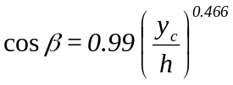 (22)
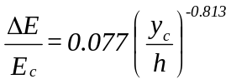 (23)
Figs. 3, 4, 5, and 6 compare the above equations with the experimental data and the data of others. Fig. 4 shows that, with increasing discharge the pool depth formed at the foot of the drop structure will also increase. When y_{c} = h, then eq. (21) indicates that the pool depth y_{p} = h, i.e. the air cavity below the lower nappe is filled entirely. Fig. 5 shows the relationship between y_{c}/h and cos β, which indicates that β decreases with increasing discharge. Fig. 6 presents the energy loss across a vertical drop structure, as described in eq. (23). It can be seen that as discharge increases the energy loss decreases. When y_{c} = h, the energy loss ratio (ΔE/E_{c}) would be the least (0.1). As noted in Figs. 3through 6, generally good agreement was observed between eqs. (20), (21), (22), (23) and Moore's (1943), Rand's (1955), and Rajaratnam and Chamani's (1995) data.

3 Conclusion
In this research a modified theory is proposed which addresses certain limitations associated with earlier theories for the hydraulics of rectangular vertical drop structures. The modified theory establishes the hydraulic parameters of vertical rectangular drop structures through eqs. (20), (21), (22), and (23). As indicated in Figs. 3 through 6, a generally good agreement was obtained between these equations and the experimental data of others.

References:
[1] Chanson, H., (1996): Discussion appearing in Rajaratnam, N., Chamani, M.R., (1995)
[2] Chanson, H., (1994), "Comparison of Energy Dissipation between Nappe and Skimming Flow Regimes on Stepped Chutes," J. Hydr. Res., 32(2), 213-218.
[3] Chow, V.T., (1959), "Open Channel Hydraulics," McGraw- Hill, New York, N.Y.
[4] Gill, M.A., (1979), "Hydraulics of Rectangular Vertical Drop Structures," J. Hydr. Res., 17(4), 289-302
[5] Moore, W.L., (1943), "Energy Loss at the Base of a free Overfall," Trans. ASCE, 108, 1343-1360.
[6] Rajaratnam, N., Chamani, M.R., (1995), "Energy Loss at Drops," J. Hydr. Res., 33(3), 373-384. Discussions: (1) Chanson, H., (1996), J. Hydr. Res., 34(2), 273-278.
[7] Rand, W., (1955), "Flow Geometry at Straight Drop Spillways," Proceedings, ASCE, 81E, Paper 791, 1-13.
[8] White, M.P., (1943): Discussion appearing in Moore, W.L., (1943)

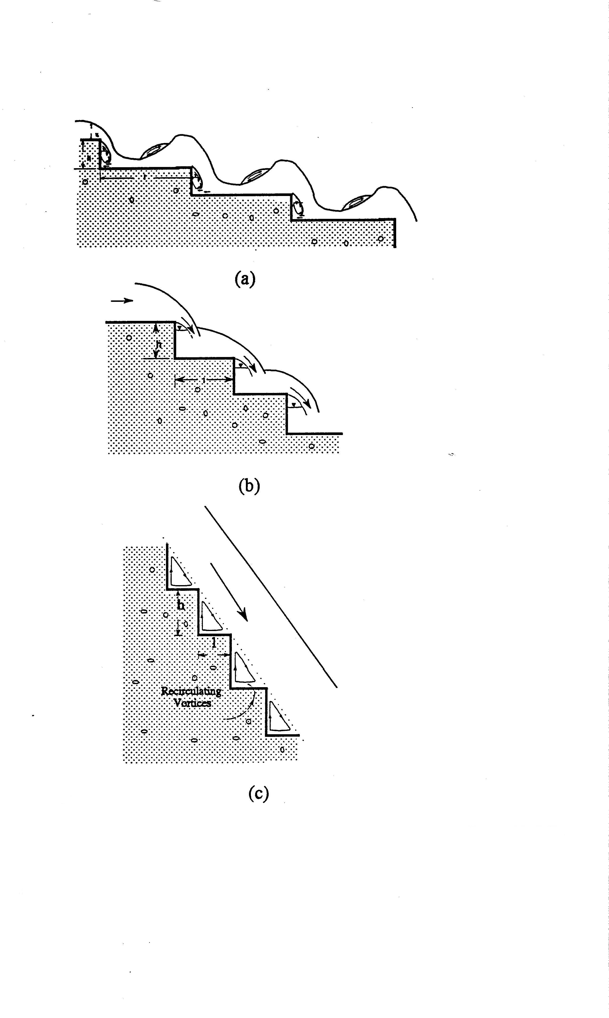
Fig. 1. Characteristic flows over a stepped spillway:
- nappe flow with fully developed hydraulic jump
- nappe flow with partially developed hydraulic jump
- skimming flow

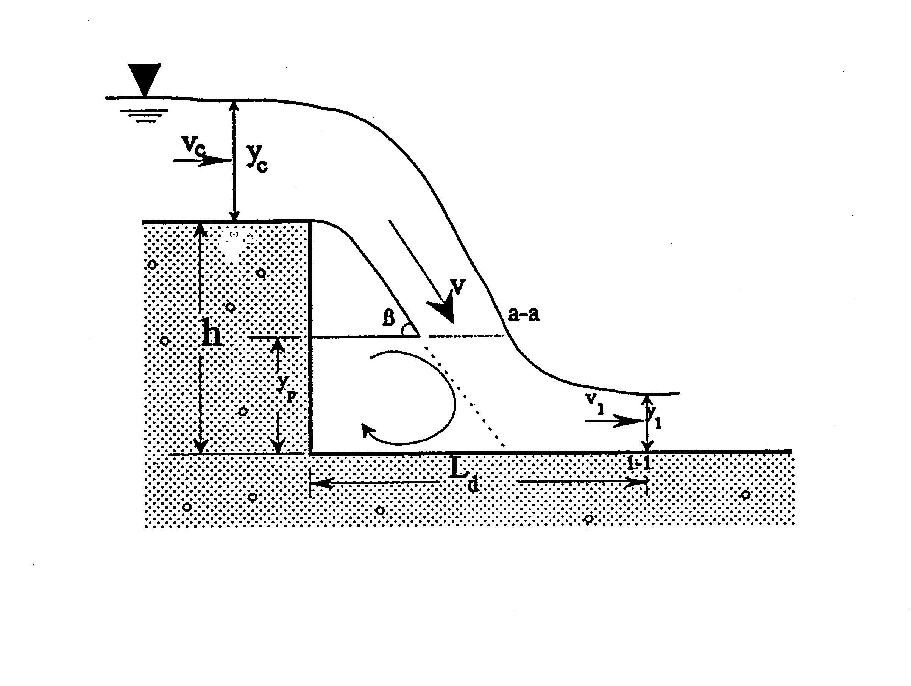
Fig. 2. Simple vertical drop structure

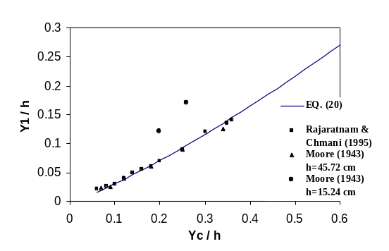

Fig.3 Comparison of eq. (20) with experimental data

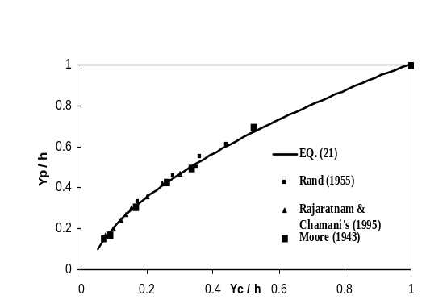

Fig. 4. Comparison of eq. (21) with experimental data

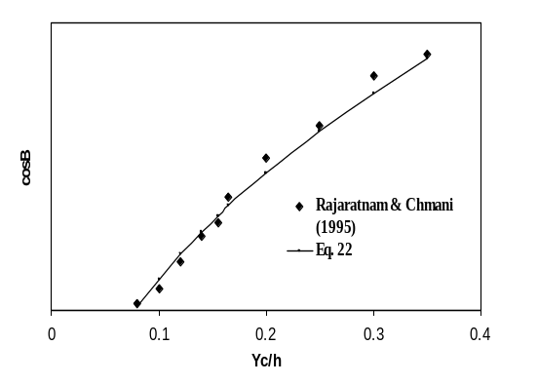

Fig.5. Comparison of eq. (22) with experimental data

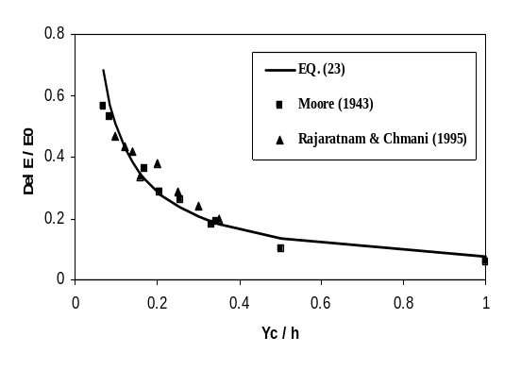

Fig.6. Comparison of eq. (23) with experimental data

