Modeling and Visualization of Emergent Behavior in Complex Geophysical Systems for Research and Education

NATALIA A. SMIRNOVA, VADIM M. URITSKY
Earth Physics Department
St.Petersburg State University
Ulyanovskaya Str. 1, Petrodvoretz, St.Petersburg 198504

RUSSIA

ANDREAS TZANIS
Department of Geophysics,
University of Athens

Athens, Panepistimiopoli, CR-15784

GREECE

FILIPPOS VALLIANATOS
Department of Natural Resources and Environment
Technological Educational Institute of Crete

Romanou Str. 3, Chalepa, 73133, Chania, Crete I.

GREECE

Abstract: - The theory of self-organized criticality (SOC) is now actively used for modeling complex processes in various multiscale dissipative dynamical systems. Applications include geophysical and environmental systems related to Earth's lithosphere, atmosphere, ionosphere, and magnetosphere. It has been shown that SOC methods can be successfully applied for explaining a number of stochastic and critical phenomena in such systems: interaction between small and large earthquakes, multiscale magnetospheric and ionospheric disturbances, atmospheric turbulence and cyclones, etc. Here, we discuss a novel teaching approach to modeling and visualization of self-organized critical processes in geophysical systems based on several classes of numerical SOC models. As an educational tool, these models represent basic physical scenarios of self-organization and catastrophes in complex geophysical systems in an easy-to-understand and illustrative way. Working with these models gives students of research and engineering departments an excellent opportunity to obtain further insight into most complicated aspects of the investigated phenomena. As particular examples, we show how a non-Abelian SOC model can be used for explaining critical spatiotemporal dynamics of complex geophysical systems such as fractal tectonic systems exhibiting Guttenberg-Richter earthquake statistics and magnetospheric disturbances.

Key-Words: - Self-organized criticality, teaching approaches, numerical models, complex geophysical systems

1 Introduction
The quality of research and engineering education depends essentially on the level of knowledge of the physical properties of the investigated objects. In geophysics, the objects under consideration are usually complex dynamical systems such as the Earth’s lithosphere, atmosphere, ionosphere, and magnetosphere. One of the methods to study complex dynamical systems is their numerical modeling. It is now widely recognized that many instabilities developing in the Earth’s interior and environment, such as earthquakes, volcano eruptions, magnetospheric storms, ionospheric disturbances, atmospheric cyclones etc. belong to the class of nonequilibrium critical phenomena. Their cooperative nature contrasts essentially with traditional concepts based on low-dimensional models, and requires development of adequate modeling methods and corresponding teaching approaches. One of the most promising approaches was suggested in 1987 by Bak, Tang, and Wiesenfeld (BTW approach) [1]. The authors have introduced the concept of SOC (Self-Organized Criticality) providing a universal framework for studying scale-invariant spatiotemporal fluctuations in complex disordered systems, such as 1/f noise in natural and artificial devices, multidimensional clustering of earthquake epicenters, complex evolutionary processes, as well as some other processes in physical, biological and social systems. The first detailed description of the SOC concept has been published by the same authors in 1988 [2]. The authors have shown that certain extended dissipative dynamical systems may naturally evolve into a critical state with no characteristic time or length scales. The characteristic signature of SOC dynamics is scale-free coupling between temporal and spatial fluctuations manifesting itself in the form of power-law scaling dependences in various domains of analysis. At present, the concept of SOC is considered as one of the most important general principles governing the behavior of complex dissipative dynamical systems. In particular, it is successfully applied for explanation of different geophysical phenomena. The SOC theory is now widely used for investigation of the dynamics of natural hazard systems, including the hazard system of earthquakes (see [3-10] and references therein). The SOC concept is a principal ingredient of the complex approach for studying earthquake preparation processes developed by Russian researches from St.Petersburg University together with their Japanese colleagues [7].
In spite of the wide application of the SOC theory in contemporary scientific research, it is currently not included in most of existing teaching programs of educational institutions. In this paper, we discuss our teaching approach to modeling and visualization of self-organized critical processes in geophysical systems based on several types of numerical SOC models (Section 2). As an educational tool, these models represent basic physical scenarios of self-organization and catastrophes in complex geophysical systems in an easy-to-understand and illustrative way. Working with these models gives students of research and engineering departments an opportunity to obtain further insight into basic principles governing complex dynamical systems. As particular examples, we show how SOC models can be used for understanding spatiotemporal dynamics of fractal tectonic systems and magnetospheric disturbances (Section 3).

2 Teaching approach to the SOC modeling
Our teaching approach to SOC-based modeling of complex geophysical phenomena consists of the following steps:
- A short qualitative explanation on what the state of self-organized criticality means, including basic terminology and modeling principles used in this field of study complemented by a historic review of SOC concept development during the past two decades (Subsection 2.1).
- Description of a simple and illustrative discrete sandpile SOC model which is rarely used in applied research but is a useful teaching tool allowing students to understand complex features of various dynamical system (Subsection 2.2). We show that modeling results depend essentially on boundary conditions, and demonstrate the propagation of SOC avalanches (scale-free disturbances) under closed and opened boundary conditions.
- Introduction of the block-spring model of earthquakes (Subsection 2.3) reproducing adequately the Guttenberg-Richter statistics of earthquake magnitudes.
- Consideration of more advanced SOC models based on the Hughes and Paczuski (HP) sandpile algorithm. (Subsection 2.4). These models are closer to reality and now actively used for investigation of the dynamics of fractal tectonic systems, magnetospheric disturbances, solar flares and the other hazard systems [8-11].
- Comparison of Abelian and non-Abelian approaches in SOC modeling (Subsection 2.5), explanation of advantages of non-Abelian algorithms providing visualization of emergent spatial structures.
- Discussion of some important geophysical results obtained with the use of SOC models, conclusions related to future steps in SOC modeling and its role in research and engineering education.

2.1 What is SOC and how it works
A system is said to be in the state of self-organized criticality if it is maintained near a critical point. According to the BTW concept, a natural system is in a marginally stable state; when perturbed from this state, it will evolve naturally back to the state of marginal stability. In the critical state, there is no a natural length scale so that fractal statistics are applicable [11, 12]. The simplest physical model for self-organized criticality is a “sandpile” model. Consider a pile of sand on a circular table. Grains of sand are randomly dropped on the pile until the slope of the pile reaches the critical angle of repose. This is the maximum slope that a granular material can maintain without additional grains sliding down the slope. One hypothesis for the behavior of the sandpile would be that individual grains could be added until the slope is everywhere at an angle of repose. Additional grains would then simply slide down the slope. This is not what happens. The sand pile never reaches the hypothetical critical state. As the critical state is approached additional sand grains trigger landslides (avalanches) of various sizes. The frequency-size distribution of avalanches is fractal. The sand pile is said to be in a state of self-organized criticality. On average, the number of sand grains added balances the number that slide down the slope and off the table. But the actual number of grains on the table fluctuates continuously. Researchers have observed such characteristic “sandpile” behavior in many other natural systems as diverse as earthquakes, forest fires, magnetospheric storms, and even biological evolution. Therefore, the complex behavior of different critical geophysical systems related to the Earth’s interior and environment could be easily reproduced on the examples of the sandpile behavior.
Numerical investigations of the discrete SOC models are usually carried out using cellular-automata technique. In the one-dimensional cellular automaton approach, the state of the discrete variable z_{n} at time t + 1 depends on the state of the variable and its neighbors at time t. In the sandpile (SP) model, the numbers z_{n} represent height differences z_{n}= h(n) - h(n+1) between successive positions along the sand pile. If z is more than the fixed critical value z_{c}, one unit of sand tumbles to the lower level. It is shown in [2] that for a one-dimensional (1D) transport system, the critical state has no spatial structure, and correlation functions are trivial. In such a case the sand pile will reach a stationary state with critical slope where all the height differences z_{n} assume the critical value z_{n} = z_{c.} In higher dimension systems the dynamics are dramatically different. So, when z>z_{c} in a 2D case, one unit of sand slides in the x direction and one in the y direction, rendering the surrounding sites unstable (z>z_{c}), and the noise will spread to the neighbors, then their neighbors leading to formation of minimally stable clusters. The system evolves to the self-organized critical state. If any perturbation is inserted in the critical state (adding one unit or locally changing the slope) it can lead to avalanches.

2.2 BTW sandpile: the simplest SOC model
The principles of self-organized criticality are usually illustrated using a simple cellular-automata model. In the “canonical” sandpile BTW model, a square grid of n boxes is considered, as it is shown in Fig.1.

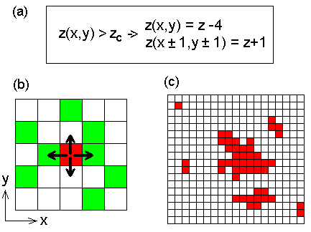

Fig. 1. Sketch of the BTW sandpile
(a) Redistribution rule of the model [1];
(b) Active element (shown in red) interacting with its four nearest neighbors. The green elements are sub-critical and will become unstable after the interaction;
(c) Examples of scale-free avalanches - connected regions of unstable elements.

Particles are added to and lost from the simulation grid using the following procedure.
(1) A particle is randomly added to one of the boxes. Each box on the grid is assigned a number and a random-number generator is used to determine the box to which a particle is added. Thus, this is a statistical model.
(2) When a box has z_{c}=4 particles it goes unstable and the four particles are redistributed to the four adjacent boxes (see Fig.1b). If there is no adjacent box the particle is lost from the grid. Redistribution from edge boxes results in loosing of one particle from the grid. Redistribution from the corner boxes leads to the dissipation of two particles.
(3) If after a redistribution of particles from an unstable box any of the adjacent boxes has four or more particles, it is also considered unstable, and one or more further redistributions must be carried out. Multiple events are common occurrences for large grids (see Fig.1c).
(4) The system is in the state of marginal stability. On average, the input flux of particles being added to the grid is balanced by their output flux at the boundaries.
Being used as an educational tool, this model represents basic physical scenarios of self-organization in an easy-to-understand and illustrative way.

2.3 The block spring model of earthquakes
The SP model can be readily transformed into the “block spring” earthquake model. The principles of the block-spring model of earthquake generation (see [3-5] and references therein) can be understood from the picture presented in Fig.2.

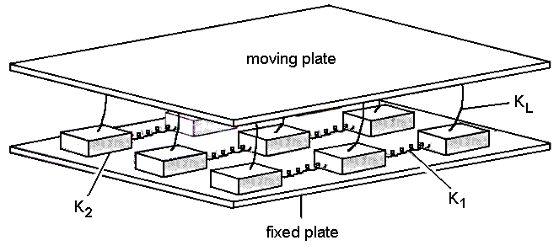

Fig. 2. Block-spring model of an earthquake fault [5].
The blocks are connected with a slowly moving plate by leaf springs. They are also connected with each other by springs. Parameters K₁, K₂, and K_{L} specify the strengths of the springs. The blocks are moving on a rough surface. A blocks slide when the force on it exceeds a critical value.

Following Bak and Tang [3], consider a two-dimensional array of particles representing segments of a sliding surface. The particles are subjected to a force from their neighbors plus a constantly increasing “tectonic” driving force. When the total force on a particle exceeds a maximum local pinning force at the fault, the particle slips to a nearby position. Let the maximum pinning force be an integer Z_{c}. If at time t the system is in the state Z(i, j), then the system at time t+Δt (where Δt is of the order of the distance between the locked elements divided by something like speed of sound) is given by the rule:

Z(i, j) → Z(i, j) - 4
Z(i ± 1,j) → Z(i ± 1,j) + 1
Z(i, j ± 1)→ Z(i, j ± 1) + 1 Z(i, j) > Z_{c} , (1)

where the first equation simulates the release of strain (in proper reduced units) on the slipping particle and the subsequent equations represent the increase of force on the neighbor particles.
Starting with a situation with no force, Z = 0, one can simulate the increase in the driving force by letting

Z(i, j) → Z(i, j) + 1 (2)
at a random position (i, j). This process is repeated until somewhere the force exceeds the pinning force Z_{c} and the rule (1) is applied: unit energy is released. This may lead to instability at the neighbor position, in which case the rule (1) is applied to that position, and so on. Eventually, the system will come to rest, namely when all Z values are less than Z_{c}. The total “domino” process initiated by (1) is the earthquake. Then (supposedly at a random much later time) the rule (1) is applied again, and so on. In the beginning there will be only small events, since Z values are generally small and a local slip is unlikely to propagate very far. But eventually, following rule (1), the average force ‹Z› will reach a statistically stationary value which just allows the chain process to continue indefinitely. At that point there is no length scale and rule (1) may trigger earthquakes of all sizes limited only by the size of the system. This is the SOC (self-organized critical) state.

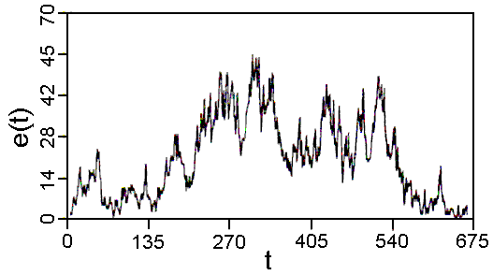

Fig. 3. Energy release versus time during a typical earthquake (from [3]).

Fig.3 shows the temporal evolution of the activity (energy release) during a typical earthquake. The distribution of energy released during earthquakes has been found to obey the famous Gutenberg-Richter law [13]. The law is based on the empirical observation that the number N of the earthquakes with size greater than m is given by the relation

log₁₀N = a – bm (3)

The precise values of a and b depend on the location, but generally is in the interval 0.8 < b < 1.5. The energy released during the earthquake is believed to increase exponentially with the size of the earthquake,

log₁₀E = c - dm (4)

so the Gutenberg-Richter law is essentially a power law connecting the frequency distribution function with the energy release E

dN/dE ∝ m^{-1-b/d} = m ^{-τ} (5)

with 1.25 < τ < 1.5.

In the considered block-spring model, a measure of the total energy, E, released during the earthquake, is the total number of segments, which have slipped during the event. Fig.4 shows the simulated distribution of energy released at the stationary critical state.

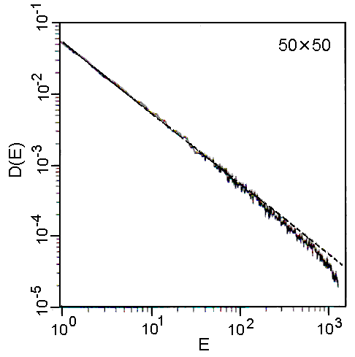
Fig. 4. Distribution of the total energy release E, obtained in the block-spring model of earthquakes.

It is seen that the distribution function indeed fits a power law D(E) ≈ E^{-τ} with τ ≈ 1. (The falloff at large E is a finite size effect.). So the energy distribution law for simulated earthquakes is in agreement with Gutenberg-Richter law (5) for real earthquakes, but the value of τ ≈ 1 for simulated earthquakes in two-dimensional (2D) case appears to be slightly outside the range of τ values obtained experimentally (1.25 < τ < 1.5). Actually, it might be useful to think of the crust in the earthquake region as a three-dimensional (3D) medium developing ever-changing fault structures rather than considering a single fault. It is the crust as a whole rather than a single fault, which is critical. The model can easily be generalized to three dimensions where one finds τ ≈ 1.35 in even better agreement with observation. Therefore, we can conclude that the model of self-organized criticality is suitable for description of the physical processes in the earthquake focal zone.

2.4 Advanced SOC model based on HP sandpile
It is now recognized that seismic systems can exhibit scale-invariant (fractal) patterns in a number of ways (see [12] and references therein). The scale-free dynamics of tectonic systems includes: power-law distribution of earthquake magnitudes (Gutenberg-Richter statistics), fractal clustering of seismic hypocenters in space, temporal clustering of the earthquake onset times, power-law decay of aftershock activity (the Omori law), fractal matrix of faults (see a scheme in Fig.5). Therefore, it is necessary to develop such SOC models, which represent the mentioned power-law statistics in the most completely way (most completely).

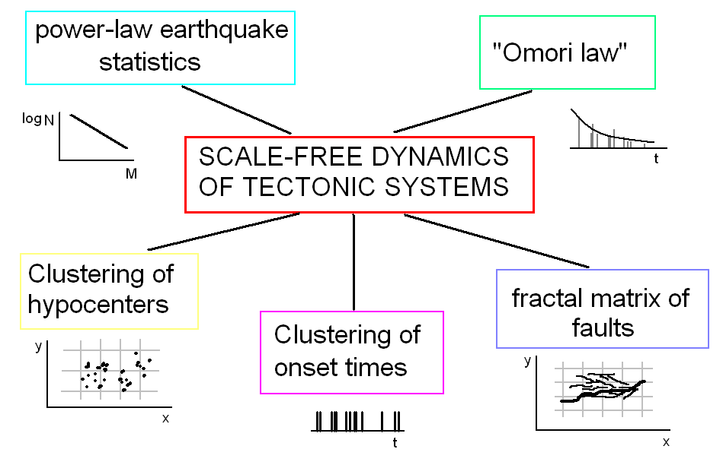

Fig. 5. Manifestation of scale-invariant (fractal) dynamics of the tectonic systems.

Most of the developed SOC models of distributed seismicity are concentrated on the dynamics of scale-free avalanches (discrete energy release events) considered as a model for earthquakes. However, although the avalanches are a cooperative effect involving many spatial degrees of freedom, they do not lead to the emergence of large-scale spatial correlations over periods of time longer than a life time of a single avalanche. As a result, SOC models turned out to be unable to explain fractal clustering of earthquake hypocenters and their relation to the evolution of fault systems, which seem to play an important part in real seismic systems. Several attempts have been made to introduce pre-define ("quenched") fault matrixes in SOC simulations, but until recently, none of the developed models could mimic the dynamical coupling that exists between slowly evolving fault structures and seismic instabilities. The first SOC model that successfully incorporated scale-free avalanche activity with a fault matrix dynamics has been presented by Hughes and Paczuski [13]. The key component of this model is the absence of the Abelian symmetry. If the Abelian symmetry is violated, the avalanches begin to rearrange modal landscape in such a way that spatial distribution of close to instability threshold grid sites becomes strongly non-uniform, which creates a complex fractal network of preferred paths for propagation of future avalanches. In contrast to previous SOC models, the emerging spatial pattern is not static; it evolves slowly in accordance with the avalanche dynamics keeping the entire system in the vicinity of global critical point manifesting itself in power-law avalanche distributions over energy, size and lifetime.
Here we consider the SOC model based on a 2-dimensional sandpile algorithm proposed by Hughes and Paczuski (HP model). A sketch in Fig.6 gives its illustration. The HP model is defined on a two-dimensional grid. Each grid site is prescribed the integer-valued coordinates x=0…N_{x}-1 and y=0…N_{y}-1, as well as the state variable z(x,y) arbitrarily called energy. The amount of energy stored in a given element determines its ability to interact with other elements. When at any site the variable z_{c} exceeds constant instability threshold (z > z_{c}) it "topples" transferring certain amount of its energy to downstream nearest neighbors in accordance with the interaction rules:

(6)

Here p is a random variable distributed uniformly within the interval 0…1, and dz is the parameter controlling the Abelian property of the model: dz = d =2 - Abelian;
dz = z_{t} - non-Abelian.

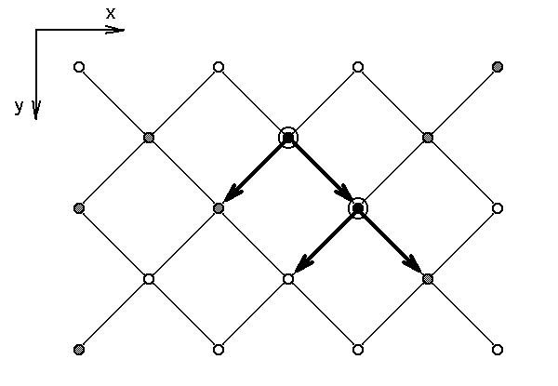

Fig. 6. A sketch illustrating the interaction rules in 2-D HP sandpile model [13]. Active grid sites (z > z_{c}) marked with large open circles interact with downstream nearest neighbors which can produce further activity provided their energy before the interaction exceeds the level z_{c} - dz (dashed circles).

After receiving a portion of energy from the excited element, one or two of its downstream nearest neighbors can also go unstable producing a growing avalanche of activity that propagates along the y direction. The avalanche stops when its front reaches "cold" grid sites whose z values is low enough to absorb the energy from the unstable elements without producing new activity, or when it reaches the open bottom boundary at y=N_{y}-1. The left and right edges of the grid are subject to the periodic boundary condition z(0,y)≡ z(N_{x}-1,y).
The model is driven randomly at y=0 until the condition z > z_{c} is fulfilled and an instability is initiated in some site. During the subsequent avalanche propagation, the driving is suspended which provides infinite separation between the driving and the avalanche time scales necessary for SOC in sandpile-type models. After a transient period, the model reaches the SOC state at which the probability distributions of avalanches over size s and lifetime t are given by
, (7)

where f and g are appropriate scaling functions controlling the cutoff behavior of the distributions; s_{c} and t_{c} are finite-size scaling parameters; and τ_{s} and τ_{t} are the avalanche scaling exponents.
In general, the scale-free avalanche statistics (8) does not necessarily imply any significant correlations between spatially separated grid sites over time scales exceeding avalanche lifetimes. Most of the known sandpile models do not exhibit any spatial correlations which means that spatial distribution of grid site energy z(x,y) between the avalanches is effectively random. In this context, the HP model presents a new opportunity to study the emergence of nontrivial large-scale structures appearing self-consistently in the SOC state.
We consider this HP algorithm as a generalized toy model of nonlinear interactions in the earth crust in seismic active regions. In particular, one can think of a qualitative analogy with cracking processes:
z ↔ stress field; "occupied" grid sites with z > 0 ↔ locally stable state (no cracks); "empty" sites with z = 0 ↔ developed cracks. An example of generated avalanches in the 2D HP model is shown in Fig.7.

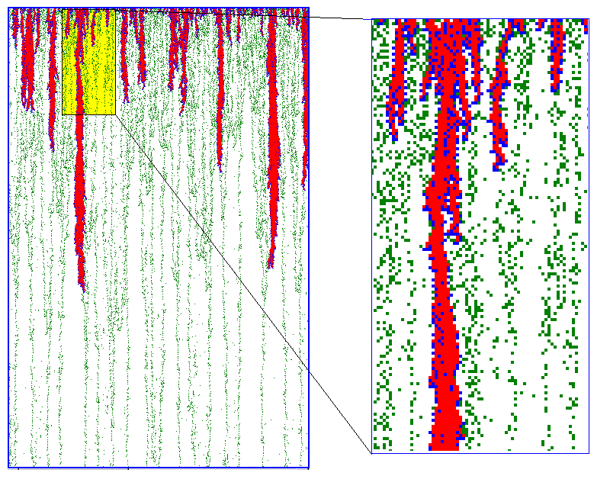

Fig. 7. Generation of sample avalanches in 2-D HP model:
Left panel: sample avalanches in the model (non-Abelian interaction rules, see subsection 2.5);
right panel: an enlarged portion of the same image.
Color coding: red – unstable grid sites; green – stable grid sites; blue – nearest neighbors of unstable sites.

2.6 Abelian versus non-Abelian sandpiles
The key parameter in the HP model that controls large-scale correlations in z(x,y) is dz, the fraction of energy involved in local interactions. Keeping the value of dz constant and independent of z makes the sandpile algorithm Abelian and eliminates any spatial structures. On the contrary, setting dz to the current value of energy z_{t}(x,y) at each point makes the algorithm non-Abelian and, as shown by Hughes and Paczuski [13], leads to the emergence of complex spatial patterns.
Fig.8 illustrates the difference between the behavior of the HP model in the Abelian and non-Abelian regimes.

Abelian non-Abelian

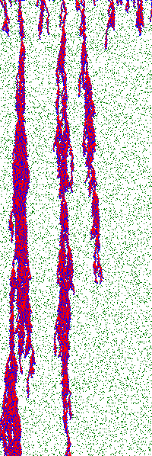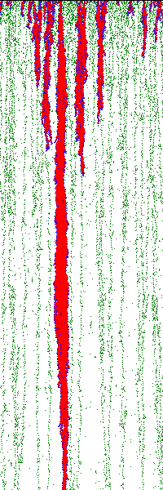

Fig. 8. Enlarged portions of HP model simulation grid showing avalanche traces in Abelian and non-Abelian cases.

As one can see, spatial distribution of energy stored by subcritical grid sites with z ≤ z_{c} differs dramatically in these regimes. In the Abelian case, the model has effectively no correlations in space; in the non-Abelian case, it shows distinct multiscale structures constituting complex branching network of interconnected subcritical elements. However, avalanche size probability distributions are nearly identical and follow power-law relations, signaling that the model reaches the SOC state in both regimes, and that the dynamics of excited grid elements on the time scale of individual instability propagation are strongly correlated in both regimes. So the Abelian symmetry does not affect avalanche statistics but does affect their interaction with the background field. In the non-Abelian case, avalanches leave traces of "empty" grid regions with z = 0, which leads to the appearance of a large-scale spatial structure of occupied sites.
To visualize the emergence of non-trivial large-scale correlations in the non-Abelian PH model, we have evaluated the entropy characterizing spatial disorder of subcritical grid sites as a function of spatial scale. The simulation grid was divided into square boxes of linear size l, for which mean values z of energy were calculated at every time step (i.e. after every avalanche). The degree of disorder associated with non-uniform energy distribution can then be characterized by the information entropy

(8)

where is the probability distribution of at the spatial scale l.
The comparison between the scaling of entropy in the discussed regimes is shown in Fig.9. As one can see, S decreases with the box size l much faster in the Abelian case. In the non-Abelian case, the entropy decays considerably slower, so that for large l it exceeds the entropy of the Abelian model by several orders of magnitude.

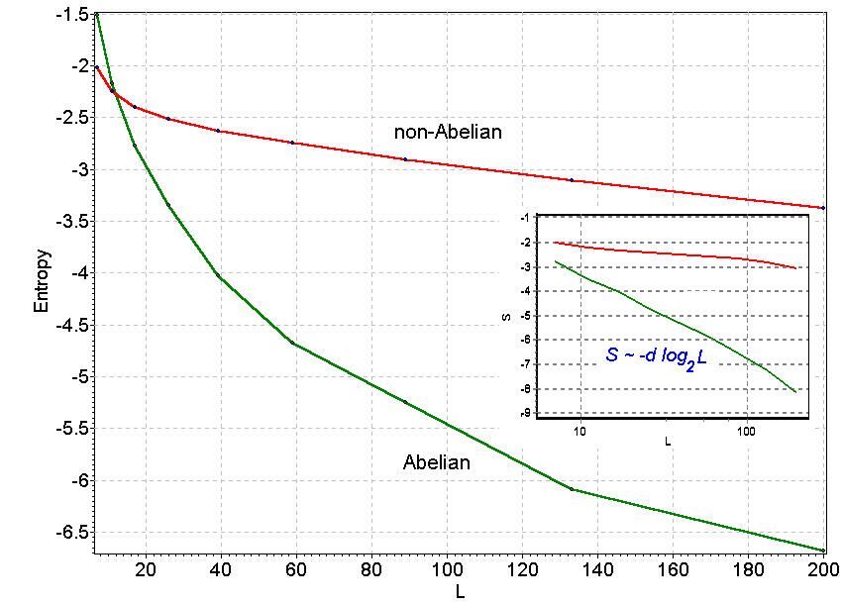

Fig. 9. Dependence of the information entropy S_{L} on the spatial scale L in Abelian and non-Abelian cases.

3 Application of the SOC Models to real Geophysical Systems
In this part we present our research advances in SOC modeling of the dynamical processes in complex geophysical systems.

3.1 Modeling of the critical dynamics of the fractal fault systems
Regional seismicity is known to demonstrate scale invariant properties in different ways. Some typical examples are fractal spatial distributions of hypocenters, Gutenberg-Richter magnitude statistics, fractal clustering of earthquake onset times, power-law decay of aftershock sequences, as well as scale-invariant geometry of fault systems. In some regions, the observed scale-free effects are likely to be connected to a cooperative behavior of interacting tectonic plates and can be described in terms of the SOC concept. In the works [8-10], we investigate a new SOC model incorporating short-term fractal dynamics of seismic instabilities and slowly evolving matrix of cracks (faults) reflecting long-term history of preceding events. The model is based on a non-Abelian HP sandpile algorithm described above, and it displays a self-organizing fractal network of occupied grid sites similar to the structure of stress fields in seismic active regions. Depending on the geometry of local stress distribution, some places on the model grid have higher probability of major events compared to the others. This dependence makes it possible to consider a time-dependent structure of the background stress field as a sensitive seismic risk indicator. We also propose a simple framework for modeling ULF electromagnetic emissions associated with abrupt changes in the large-scale geometry of the stress distribution before characteristic seismic events, and demonstrate numerically how such emissions can be used for predicting catastrophic earthquakes.
We have delineated two approaches to modeling pre-seismic stochastic electromagnetic signals based on a simple SOC model. Our simulations suggest that both conductivity and electric field fluctuations associated with local propagation of instability fronts can carry information on coupling effects between the evolution of fractal fault systems and the statistics of major earthquakes, which makes SOC a possible underlying mechanism of precursory nature of the ULF electromagnetic emissions.
In the model, one can associate different energy levels of grid elements with different values of Earth's crust electric conductivity. Assuming that stable (z = 0) and subcritical (0 < z ≤ z_{c}) grid sites represent two different phases (e.g. rocks and liquids filling up cracks in the rocks) having different conductivity. For the sake of simplicity, the conductivity of occupied sites was set to zero and the conductivity of empty sites was set to 1. The conductivity of a finite portion of the grid was estimated using one of the following approaches:

"Bulk" conductivity: C = ⟨θ (1-z(x,y))⟩_{x,y} (9)

Percolation conductivity: C_{p} = ρ⋅⟨θ (1-z(x,y))⟩^{P}_{x,y} (10)

Here ⟨⟩_{x,y} denotes averaging over all x- and y-positions within a chosen spatial domain and ⟨⟩^{P}_{x,y} is averaging over the elements involved in the percolation cluster. Factor ρ equals to 1 or 0 depending on whether or not a percolation through empty grid sites of the studied domain is possible.

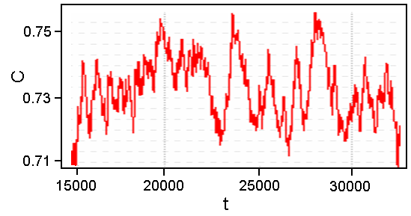

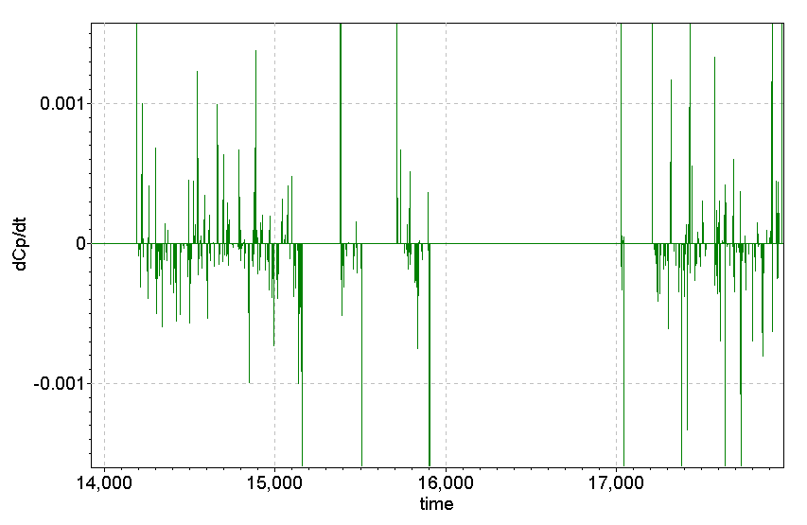

Fig. 10. An example of conductivity C fluctuations (9) in the non-Abelian model (top); and time evolution of dC_{p} /dt (11) in the stochastic directed sandpile model (bottom).

The conductivity C is proportional to the concentration of the conducting phase. In addition to that, C_{p} takes into account effects of connectivity, which play an important role in fractal-disordered materials [15, 16]. We have also considered time series of temporal derivatives of the introduced conductivity measures:

I = dC /dt; Ip= dC_{p} /dt (11)

An example of calculations is shown in Fig.10.
Time evolution of C(t) signals (Fig.10, top) reflects changes in model configuration due to SOC avalanches, and its dynamics is very similar to dynamics of the earthquake energy release presented in Fig.3. It has been suggested that fluctuations of the percolation conductivity defined above can be used for short-term prediction of the expected range of avalanche sizes, and represent a simple model of fractal precursor of major fault matrix reconfiguration due to strong earthquakes. Time derivatives of these signals (Fig.10, bottom) are reminiscent of pre-seismic ULF electromagnetic emissions displaying characteristic clustering of activity spikes before major events presented in Fig.11 (after [17]).

Fig. 15. Ultra-low frequency Lithospheric Emissions registered prior to the moderate (M=4) Racha aftershock of 3 June 1991 (marked as EQ). The observation point (Nikortsminda station) was located about 40 km from the epicenter [17].

Another method of building cellular automaton models of pre-seismic electromagnetic emissions can be based on the effect of moving charged dislocations (MCD), which was shown to accompany crack evolution before strong earthquakes [18]. We considered each local instability (an excited element with (z > z_{c}) as a crack event associated with a transient electric dipole generating an electric field pulse. The superposition of such pulses from multiple simultaneous sources gives rise to a complex stochastic electromagnetic signal in ULF frequency band. By assuming that active cracks can only emit short-lived pulses with durations of few seconds, the overall shape of the electric field signal detected on the ground can be represented by the convolution of such pulses with the long-period source time function n(t), where n is the time-dependent number of active grid sites. The shape of the obtained emission signal seems to display some distinctive features (sudden onset, rapid culmination and slower decay) of MCD electromagnetic precursors predicted theoretically by Tzanis and Vallianatos [18]

3.2 Modeling of the magnetosphere dynamics

In publications [19, 20], the effect of self-organized criticality has been considered as an internal mechanism of geomagnetic fluctuations accompanying the development of magnetospheric substorms. It has been suggested that spatially localized current sheet instabilities followed by magnetic reconnection in the magnetotail can be considered as SOC avalanches the superposition of which leads naturally to the 1/f power spectra of geomagnetic activity. A running 2D avalanche model with controlled dissipation rate is proposed for numerical investigation of the multi-scale plasma sheet behavior in stationary and nonstationary states of the magnetosphere. Two basic types of perturbations have been studied, the first induced by an increase in the solar wind energy input rate and the second induced by a decrease in critical current density in the magnetotail. The intensity of large-scale perturbations in the model depends on accumulated energy level and internal dissipation in a manner similar to the dependence characteristic of real magnetospheric substorms. A spectral structure of model dynamics exposed to variations of solar wind parameters reveals distinctive features similar to natural geomagnetic fluctuations, including a spectral break at 5h separating frequency bands with different spectral slopes.

Conclusion
Solution of global geophysical problems such as prediction of earthquakes, volcano eruptions etc, is possible only in frames of co-operation of the researchers from different countries. Such co-operation can only be efficient on the same educational basis. Therefore, the standardization of educational methods in worldwide geophysical institutions is of great importance. In this connection, the presented SOC models could be a good educational basis and a tool to unify the teaching approaches to modeling critical behavior of complex geophysical systems. This paper is the first attempt to unite the effort of the researchers from Russian and Greek institutions to create a common basis for professional training of specialists (both researchers and engineers) in modeling of complex processes developing in natural hazard systems.

Acknowledgements
The work has been supported by bilateral Greek-Russian research program, by grant 04-05-64938 of Russian Foundation for Basic Research, and by grant 760.2003.5 (The Leading Scientific School of Russia).

References:
[1] Bak P., C. Tang, and K. Wiesenfeld, Self-organized criticality: an explanation of 1/f noise, Physical Review Letters, Vol. 59, 1987, pp. 381-384.
[2] Bak P., C. Tang, and K. Wiesenfeld, Self-organized criticality, Physical Reviews, Vol.38, No.1, 1988, pp.364-374.
[3] Bak P. and C. Tang, Earthquakes as a Self-Organized Critical Phenomenon, Journal of Geophysical Research, Vol.94, No.B11, 1989, p.15,635-15,637.
[4] Sornette A. and D. Sornette, Self-Organized Criticality and Earthquakes, Europhysical Letters, Vol.9, No.3, 1989, pp.197-202.
[5] Bak P., How Nature Works: The Science of Self-Organized Criticality, Copernicus, New York, Oxford University Press, 1997, 210 pp.
[6] Jensen H.J., Self-Organized Criticality (Cambridge Lecture Notes in Physics, 10), Cambridge University Press, 1998, 153 pp.
[7] Troyan V.N., N.A. Smirnova, Yu.A. Kopytenko, Th. Peterson, and M. Hayakawa, Development of a Complex Approach for Searching and Investigation of Electromagnetic Precursors of Earthquakes: Organization of Experiments and Analysis procedures. In: Atmospheric and Ionospheric electromagnetic phenomena associated with Earthquakes, edited by M.Hayakawa, Terra Sci. Publ. Co, Tokyo, Japan, 1999, pp. 147-171.
[8] Uritsky V., N. Smirnova, V. Troyan, and F. Vallianatos, Critical dynamics of fractal fault systems and its role in the generation of electromagnetic emissions before major earthquakes, Physics and Chemistry of the Earth, Vol.29, 2004, pp. 473-480.
[9] Uritsky V., N. Smirnova, V. Troyan, A. Tzanis, and F. Vallianatos, Modeling pre-seismic electromagnetic emissions using a self-organized criticality approach, in: Proceeding of the 5th International Conference “Problems of Geocosmos” (St.-Petersburg, Russia, 24-28 May, 2004), edited by A.A. Kovtun, M.V. Kubyshkina, V.S. Semenov, V.A. Sergeev, V.A. Shashkanov, T.B. Yanovskaya, 2004, pp. 263-266.
[10] Uritsky V.M., A. Tzanis, and N.A. Smirnova, Using the Self-Organized Criticality Approach for Modeling Pre-Seismic Electromagnetic Emissions, in: Abstracts of International Workshop on Seismo-Electromagnetics (IWSE2005), Chofu Tokyo, Japan, March 15-17, 2005, pp.231-234.
[11] Feder J., Fractals, Plenum Press, New York, 1988, 283 pp.
[12] Turcotte D.L., Fractals and Chaos in Geology and Geophysics, Cambridge University Press, Second edition, 1997, 397 p.
[13] Hughes D., and M. Paczuski, Large scale structures, symmetry, and universality in sandpiles, Physical Review Letters, Vol.88, No.5, 2002, 054302-1 - 054302-4.
[14] Gutenberg B., and C.F. Richter, Magnitude and energy of earthquakes, Ann. Geofis., Vol.9, 1956, p.1.
[15] Bahr K., Electrical anisotropy and conductivity distribution functions of fractal random networks and of the crust: The scale effect of connectivity, Geophys. J. Int., Vol.130, 1994, pp.649-660.
[16] Bahr K., Percolation in the crust derived from distortion of electric fields, Geophysical Research Letters, Vol.27, No.7, 2000, pp.1049-1052.
[17] Kopytenko Yu.A., T.G. Matiashvili, P.M. Voronov, and E.A. Kopytenko, Observation of Electromagnetic Ultra-Low-Frequency Lithspheric Emissions (ULE) in the Caucasian Seismicallly Active Area and Their Connection with the Earthquakes, in: Electromagnetic Phenomena Related to Earthquake Prediction, edited by M. Hayakawa and Y. Fujinawa, Terra Sci. Pub. Co., Tokyo, 1994, pp.175-180.
[18] Tzanis A. and F. Vallianatos, A physical model of Electric Earthquake Precursors due to crack propagation and the motion of charged edge dislocations, in: Seismo Electromagnetics (Lithosphere-Atmosphere-Ionosphere Coupling), edited by M. Hayakawa and O.A. Molchanov, Terra Scientific Publishing, Tokyo, 2002, pp. 148-166.
[19] Uritsky V.M., A.J. Klimas, and D. Vassiliadis, On a new approach to detection of stable critical dynamics of the magnetosphere, in: Proceedings of 5th International Conference on Substorms, edited by A. Wilson, ESA, St.Petersburg, Russia, 2000, pp.213-216.
[20] Uritsky V.M., M.I. Pudovkin, and A. Steen, Geomagnetic Substorms as Perturbed Self-Organized Critical Dynamics of the Magnetosphere, Journal of Atmospheric and Solar-Terrestrial Physics, Vol.63, No.13, 2001, pp.1415-1424.

