Quantification of Mitral Regurgitation Using Magnetic Resonance Imaging

DR. M.KLONIZAKIS
Division of Vascular Medicine
University of Nottingham
Div. of Vascular Medicine, DCGH, Uttoxeter Road, Derby, DE22 3DT, UK
UK

Abstract: Many methods have been used in the past to quantify the backflow in patients with mitral regurgitation. However, clinical applications of most of them showed that their results were unreliable. A model was developed based on Control Volume Theory and MRI was used to quantify Mitral Regurgitation. Three different cases were studied simulating different physical conditions (mitral motion and MR, no mitral motion and MR, mitral motion without MR). The results prove that the CV method in association with MRI can measure accurately the regurgitant flow rate and hence the Regurgitant Volume (RV), in all of the three cases studied.
Key-words: Mitral regurgitation, MRI, Phase velocity, Control volume theory, Regurgitant flow.

1.Introduction
Mitral regurgitation (MR) is the back-flow or regurgitation of blood from the left ventricle into the left atrium due to a damaged mitral valve (i.e. mitral valve prolapse, cleft anterior mitral leaflet etc.) or ruptured chordae tendinae [1]. If the regurgitant volume (RV) is at a low level, it can be treated up to a point without any further danger. However, if the volume is high it can be life threatening, particularly if the condition is not treated. It is therefore, important to have an accurate and reliable method of quantifying the regurgitant flow.
Many methods have been used in the past to quantify the flow- however, clinical applications of most of them showed that their results were unreliable or their application have serious drawback their making their use questionable. Angiography was the first method to be used but it was soon realized that a better solution was needed. Angiography is at best semi-quantitative, it is invasive and it involves use of ionizing radiation [2]. Although the method is still being used it has been superceded by Doppler Ultrasound techniques.
Proximal isovelocity surface area (PISA) is one

ultrasound technique, which is used in conjunction with Color Flow Mapping [3]. However, it requires a simplification of the flow field to be valid, resulting in a limited use in the human heart. Also the technique suffers from the limitation that the assumptions used in the analysis of the flow convergence region are based on a nonviscous fluid regurgitating through an infinitely small orifice. Also it can be used to measure only a single velocity component (towards the transducer) making it impossible to measure the perpendicular velocity over the control surface without moving the ultrasound transducer [4].
The Jet area method is also based on ultrasound. Although it was initially thought to give good results, it was confirmed by several studies that the correlation between jet area and quantitative measures of the severity of MR, such as RV and fraction was weak (3). Additionally, this method tends to underestimate MR severity in eccentric jets.
Spain et al [5] have shown that jet momentum can be calculated from the velocities encoded in the color flow map. This method, the Jet momentum technique, was based on the fact that when these velocities were combined with orifice velocity, momentum estimates orifice flow rates and effective orifice areas in in-vitro models. However, this technique is fairly complicated and not readily accessible to the average clinician. Also it exhibits wide velocity variation with turbulent jets, and may not work well with eccentric jets because of momentum transference to adjacent structures [3].
Magnetic Resonance Imaging (MRI) can be the answer to most of these problems. It is a non-invasive technique for cardiac diagnosis, ionizing radiation is not required, and provides 3 separate insights into cardiovascular disease [6]. MRI can also measure all the three velocity components, is a safe method and gives full 3-d velocity information with a large velocity range. In addition it provides digital data, volume flow information and also-jet visualization [7].
Finally it can include a correction for valve motion, since the current methods do not to consider it in their results.

2. Method
2.1 Model Description
A model was constructed to simulate the left side of the heart. The left ventricle is represented as a V-shaped plastic case, which has inside a full bag of water, before the process is started. The water has an added substance, which gives a strong magnetic signal. A piston is connected to the walls of the rectangle, periodically squeezing the water that flows in and out of the plastic case. The mitral valve is represented by piston, which moves periodically. The mitral valve orifice is situated at the entrance of the ventricle and responds to the movement of the rest of the system while the aortic valve is situated at the exit to the ventricle. The connected output of the left ventricle is a tube, which recirculates the water from the left ventricle back to the system. A number of bags and bottles of water, which are situated around the actual model are used to correct any phase offset errors, to calibrate the magnet and help check where motion lies.

2.2 Image Specification
The MR investigations [8] were performed with a 1.5-tesla 15S Gyroscan HP Philips whole-body system. A conventional spin echo sequence was used to image the model from the coronal plane This was followed by a single angulation through the aortic valve and the apex of the heart to yield a long-axis view of the left ventricle. This plane lies at an angle between the two- and four-chamber planes and is comparable to the echocardiographic parasternal long-axis view [9]. The following settings were used for the flow measurements: in-plane resolution 3.125 mm x 3.125 mm (data acquisition matrix 128 x 128 points. 256 mm field of view), 45^{s} flip angle, 9.5-ms echo time. 7.1-ms acquisition time and 10-mm slice thickness. To avoid aliasing, the velocity sensitivity was set to produce a maximal phase shift at a velocity of ±1.25 m/s to ±1.67 m/s. Velocities outside the chosen velocity range (±180°) were unwrapped manually by adding or subtracting the value corresponding to a phase shift of 2π. The imaging procedure was done in slices, each of them having a thickness of 10 mm. The total number of slices taken in each case was 7 (only 7 used for our calculations), with the central being the most importan. Each case of the ones studied, consisted of 25 phases, with a time interval between each time phase being 39.6 ms.

2.3 Operating Procedure
In the first part of the procedure which involved visualization of images, the different cases studied, involved images having mitral valve motion with and without MR and images having no mitral valve motion with and without MR. The visualization procedure involved a number of steps most of which involved the conversion of images to a format that would "visible" for the software used, which was decided to be "Scion Image". For that purpose a number of C programs was established.
After that a program was written, following the theory for regurgitant flow calculation, expressed by Walker et al (4). This program constructed a control volume (CV) in the velocity images obtained previously and calculated the regurgitant blood flow, for various volume heights (1 to 20 pixels). This was achieved by calculating the flow rate individually for each of the 5 faces of the CV (the "regurgitant" face was excluded) using only the normal, to each face, velocity, and summing them altogether to find the regurgitant one, as the theory states. In total, 3 cases were studied, since from the ones mentioned above, the one with images having mitral motion and MR was excluded.

3. Results
3.1 Case Without Motion But With Mitral Regurgitation

The anchor point was decided to be (55,68) with the first step at that stage being the calculation of the RV for all heights. This was done, due to the directions regarded as positive, by multiplying all the positive values of the flow rate provided by the program by 39.6 ms (images were obtained every 39.6 ms), and then by 10~³ in order to change ms to seconds. Table 1 shows us the variation of regurgitant volume with height, while Fig. 1 is its graphical representation.
The y axis shows the calculated RV and the x axis shows the height of the CV The graph helps in the decision of the optimum height as 13. Based on that assumption, the graph of the flow rate against the cycle time was created (Fig.2), showing the pulsatile flow rate variation over the time, being inverted in way that the regurgitant flow rate is below the zero line and the normal flow rate above. The x axis represents the time
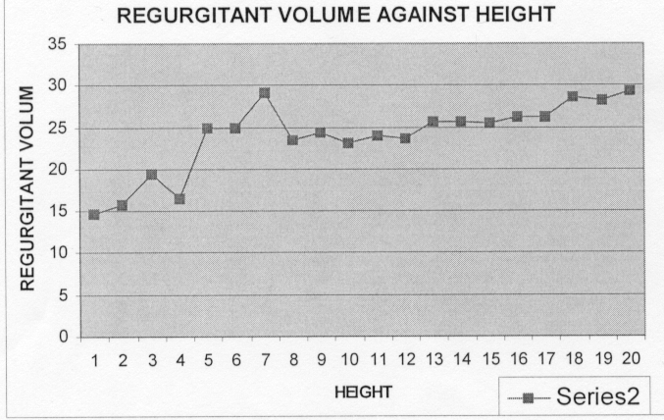
, Fig.1
divided in 25 phases, while the y axis represents the calculated flow rate.
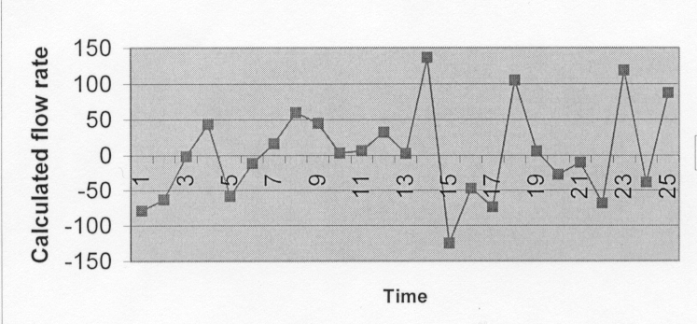
Fig. 2
Height | 1 | 2 | 3 | 4 |  | 5
RV | 14,6 | 16 | 19,5 | 16,5 |  | 24,9
 | 6 | 7 | 8 | 9 |  | 10
 | 25 | 29,1 | 23,5 | 24 |  | 23
Height | 11 | 12 | 13 | 14 |  | 15
RV | 24 | 23,6 | 23,8 | 25,6 |  | 25,5
 | 16 | 17 | 18 | 19 | 20
 | 26,2 | 26,2 | 28,6 | 28,3 | 29,3

Table 1

3.2 Case with mitral valve motion but without mitral regurgitation

From Fig.3, the optimum height of 10 was chosen. After that point, and provided that the extremely high values are neglected, the changes in the RV are minor and hence this can be thought as an optimum solution. Hence the Calculated Flow Rate vs Time graph can be drawn (Fig.4).
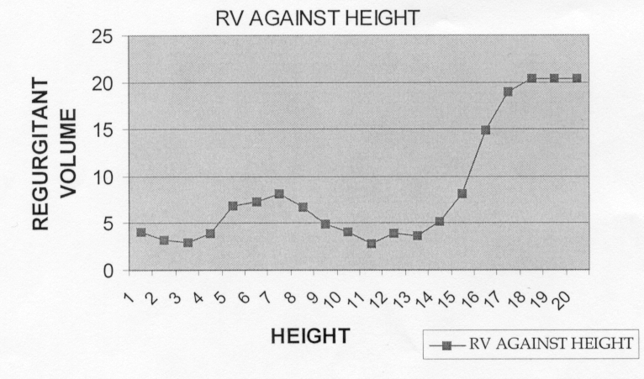
Fig. 3
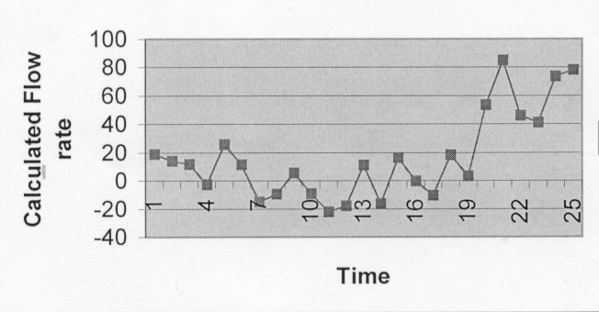
Fig. 4

Height | 1 | 2 | 3 | 4 |  | 5
RV | 4,0 | 3,2 | 3 | 3,9 |  | 6,9
 | 6 | 7 | 8 | 9 |  | 10
 | 7,3 | 8,1 | 6,7 | 4,9 |  | 4,1
Height | 11 | 12 | 13 | 14 |  | 15
RV | 2,8 | 3,9 | 3,7 | 5,1 |  | 8,2
 | 16 | 17 | 18 | 19 | 20
 | 14,9 | 19 | 20,3 | 20,4 | 20,4

Table 2:

3.3 Case with mitral valve motion but without mitral regurgitation

The anchor point was decided to be (55,66) and this was the input for phases 1-9 and 21-25. For phases 10-11 the anchor point was (53,58), for 12-14 the (53,59) and for 15-20 the (54,65). Then the normal operating procedure was followed and the regurgitant volume was plotted against the height (Fig. 5). Table 3 shows the calculated values for each height. In that case we find small values of regurgitant volume with a peak being at height 11 with 15,4 ml, something that was nearly expected. The optimum height for that case was decided to be height 14, since after that height the values seem to stabilize around the 9 ml value.
Fig. 6 shows the pulsatile flow rate variation over the time, being inverted in way that the regurgitant flow rate is below the zero line and the normal flow rate above. The x axis represents the time, which is divided in 25 phases, while the y axis represents the calculated flow rate.

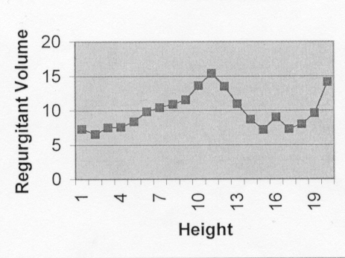
Fig. 5
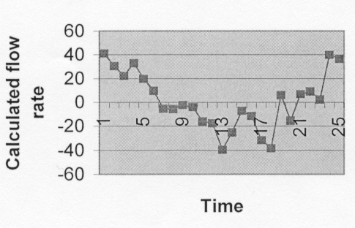
Fig. 6
Height | 1 | 2 | 3 | 4 |  | 5
RV | 7,3 | 6,5 | 7,5 | 7,5 |  | 8,4
 | 6 | 7 | 8 | 9 |  | 10
 | 9,9 | 10,4 | 10,9 | 11,6 |  | 13,6
Height | 11 | 12 | 13 | 14 |  | 15
RV | 15,4 | 13,5 | 11 | 8,7 |  | 7,2
 | 16 | 17 | 18 | 19 | 20
 | 9,1 | 7,3 | 8 | 9,6 | 14,2

Table 3

4. Discussion – Conclusions
In the first case assessed the optimum height was decided as 13, due to the stabilization of RV from that point onwards (only minor changes appear afterwards). The graph proves the existence of MR, which takes its maximum value for height 19. The RV range is 14.6 - 29.3 ml, which is significantly larger than the other cases, where MR was supposed to be small or non-existent. Fig. 1 shows that provided that the control volume is large enough not to include any aliasing regions, the correct flow rate is calculated. However, this is not always the case, proving the anchor point choice as crucial. In Fig. 2 the existence of MR can be observed by the large number of points existing below the zero line, validating the initial assumption, proving the method to work correctly.
For the 2nd case (Fig. 3) two things can be observed. Firstly, the amount of RV is small from the initial height up to height 15. However, after that point, the values rises dramatically. This is either because the control volume begins including regions of aliasing, hence resulting in false calculated flow rate or because the chosen anchor point was not appropriate for the case. Although none of the two presumptions should be neglected, an optimum height can be chosen, and this is height 10, since after that point, and provided that the aliasing values are neglected, the changes in the RV are minor. Fig. 4 shows that the regurgitant flow rate is quite small, since even the small number of points lying below the zero line has small values.
The 3rd case requires careful consideration due to the mitral valve movement. An observation on Fig. 5, proves the difficulty in tracing the anchor point path in time. Small values of RV can be found, with a peak being at height 11 with 15.4 ml. Although it is possible that with a second attempt to follow the path of the initial anchor point this peak value could be lower, Fig. 6 validates our assumption that a small amount regurgitant flow rate exists. since that the points lying below the zero line, have small values.
These results prove that the CV method in association with MRI can measure accurately, the regurgitant flow rate and hence the RV, in all of the three cases studied. The initial acceptance was confirmed for all the three cases on which experiments were performed: For the first case, MR was observed while for the other two, only small MR was experienced.
Although the assumptions are correct, it is possible to improve the calculated values. A different choice on the anchor point (i.e. case without mitral motion and MR), or a different trace of the anchor point's path (i.e. case with mitral motion and without MR) could improve the results which can be verified by other methods. Additionally, it is possible, that the inclusion of aliased velocities in the calculations had a slight effect. An improvement to the program could possible improve the situation. A final observation, is regarding the change in calculated flow rate in respect to the size of the CV. Although the effect on the values is minimal, the smallest possible CV existing outside the aliasing region should be chosen, to minimize the error. This should be done in accordance with the anchor point, the correct choice of which is extremely important.
However the above observations cannot diminish the fact that the method followed gave satisfactory results, which can be improved further. Further experiments undertaken on the data, would prove the method further.

References
[1]. Tortora G J, Grabowski S R, General Principles of Anatomy and Physiology- 8th edition, New York, Harper Collins, 1996.
[2]. Laudicina P, Wean D, Applied Angiography for Radiographers, New York, Saunders Company, 1994.
[3]. Hall A S, Brickner E, Willet D L, W N Irani, I Afridi, P A Grayburn, Assessment of mitral regurgitation severity by Doppler Color Flow Mapping of Vena Contracta, Circulation, 1997;95(3);636-642.
[4]. Walker PG, Oyre S, Pedersen E M, Houlind K, Guenet F S A, Yoganathan A J, A new control volume method for mitral regurgitation, Circulation, 1995; 92(3); 579-586.
[5]. Spain M, Smith M, Grayburn P, Harlament E, DeMaria A, Quantitative assessment of mitral regurgitation by Doppler flow imaging: Angiographic and hemodynamic correlations, J Am Coll. Cardiology, 1989; 13;585-590.
[6]. Higgins C B, Hricak H, Magnetic Resonance Imaging of the body. New York, Raven Press, 1987.
[7]. Pohost G M (ed.), Cardiovascular Applications of Magnetic Resonance, New York, American Heart Association, 1993.
[8]. Lufkin RB, The MRI manual 2nd Edition, Los Angeles, Mosby, 1998.
[9]. Cranney GB, Blackwell GG, Lotan CS, MRI: Cardiovascular System, New York, Gower, 1992.

